SCSI Pass-Through (spt) Tool
- 1. Overview
  - 1.1. Robin's SCSI History
- 2. Documentation
- 3. Tool Location
  - 3.1. Tool Invocation
    - 3.1.1. Basic Command Format
- 4. Scripts
- 5. Simple Examples
  - 5.1. Showing SCSI Devices
    - 5.1.1. Linux Show SCSI Devices Example
  - 5.2. SCSI Inquiry Examples
    - 5.2.1. Inquiry ASCII Format
    - 5.2.2. Inquiry JSON Format
      - 5.2.2.1. Python JSON Parsing
      - 5.2.2.2. Unpacking SCSI Data
  - 5.3. Test Unit Ready
    - 5.3.1. Test Unit Ready with Error Recovery
- 6. Enhancing SCSI Automation
- 7. Built-in (shorthand) SCSI Commands
- 8. Advanced SCSI Examples
  - 8.1. I/O Parameters
    - 8.1.1. Write and Verify Examples
    - 8.1.2. Extended Copy Example
- 9. SCSI Debugging
  - 9.1. Decoding SCSI Error Information
- 10. SCSI Information
  - 10.1. SCSI Statistics
- 11. List Disks Script
  - 11.1. lsdisks Help Text
  - 11.2. Example Brief Output Format:
  - 11.3. Example Long Output Format:
  - 11.4. Example JSON Output Format
  - 11.5. Remote Example

1. Overview
The SCSI Pass-Through (spt) tool is an open source tool, which I started developing in 2006.
What this tool provides is the ability to create any SCSI Command Descriptor Block (CDB), with appropriate parameters, controlling data direction, length, and timeouts, bypassing the host OS disk driver, and supporting built-in test functions. Constructing your own SCSI CDB's is permitted, in addition to built-in support for key SCSI commands (with more coming).
The initial spt version was single threaded, single device, much like the data test (dt) tool, and in fact both tools share a fair amount of source code, including the SCSI library.  Nonetheless, over the years, spt has been enhanced to be multi-threaded and extended with built-in SCSI command support for advanced testing, along with support for vendor unique (VU) extensions.
Note: VU extensions are not available in open source versions of dt or spt.
My hope when you review this tool, is that you'll see how it can make it easier and improve your SCSI testing, over many host OS SCSI tools used today!
Key spt features include: (common across all OS's)
- ability to send any SCSI CDB, controlling data direction, and parameters
- internal support for CDB's requiring varying parameters for looping:
  - read, write, verify, xcopy, unmap, etc
- multi-threaded for generating high load and stress
- supports both extended copy methods (xcopy and token based PT/WUT)
- copy/verify between disks, and support for mirror verification
- supports Storage Enclosure Services (SES) diagnostic pages
- output is available in ASCII or JSON (not all operations support JSON yet)
- ability to decode SCSI status, sense keys, and asc/ascq codes
- ability to verify data returned automatically (much faster than scripts)
- ability to repeat commands while waiting for specific SCSI status returns
- Python script named lsdisks.py wrapper around spt for displaying SES/disk information
- on Linux, spt is built as a shared object (.so), using Python CTYPES API to call directly into spt!
- spt is feature rich, mature, and provides a unique set of features most SCSI tools only dream about!
Please Note: Unlike dt, spt lacks dynamic jobs control, I/O monitoring, triggers, and others. The hope has always been to integrate spt into dt as an I/O behavior, so all the dt features would be available. This may still happen in the future, we'll see if there's sufficient demand to justify the effort.
UPDATE: Not likely to happen now that I’m retired with limited hardware available.

1.1. Robin's SCSI History
My start with SCSI started in 1986, upon working on Sun Microsystems SunOS. This style SCSI is known as parallel SCSI (pSCSI) today and had a limited number of target devices and the target ID's even provided a bus priority, with the host initiator normally at the highest ID (7 on an 8-bit SCSI bus).
I learned much from studying the SunOS SCSI drivers and the associated format utility, which I updated to support extended SCSI commands beyond normal Format and Defect management. I then wrote a simple SCSI I/O stack for System V, from a WD HBA to disk and tape drives for a embedded typesetter product.
Later when I joined DEC, I did SCSI device qualification and driver development, wrote a cdr tool with CD audio support, then later wrote the SCSI CAM Utility (scu) starting around 1990. Scu ships with DEC's Tru64 Unix OS, for field service SCSI device maintenance and FW updates. Later I ported Scu to most Unix OS's for the Data Product Group for testing and later ported Scu to Windows. Thereafter I enhanced the CAM configuration driver, developed a tape library driver, and a special IOCTL interface for handling user level SCSI requests, used by Scu as well (re-use of kernel code in user level tools).
From the original CCS/SCSI-2 ANSI standards to the current SCSI Primary Commands (SPC-5) and other SCSI specs, trying to keep up with ever changing SCSI improvements is a full-time job. SCSI is wrapped by many protocols, from iSCSI to FC, FCoE, to SAS, but the basic SCSI CDB's are contained within each.
Even though NVME appears to be the future, which will not wrap SCSI packets, the SCSI protocol will likely live on long after I'm retired and gone!

2. Documentation
Most of the documentation is in the "spt help" text and in these TOI's: (sorry, never wrote a users' manual)
- Small Computer System Interface (SCSI)
- spt-TOI-2017.pptx – Transfer of Information (TOI) 2017
- spt-TOI-2019.pptx – Transfer of Information (TOI) 2019

3. Tool Location
My tools are available here: https://github.com/RobinTMiller
For help type: # spt help

3.1. Tool Invocation
There are multiple ways to invoke spt, including:
- Command Line Interface (CLI) - most tools support this, of course
- Script Files - these can be nested five (5) levels deep
- Pipe Interface - send commands and receive output via pipes
- Interactive - enter interactive mode when no command is provided
- Python API - shared library supporting Python CTYPES API

3.1.1. Basic Command Format
spt uses similar parsing to dt, that is keyword=value pairs and enable/disable= for flags:
# spt dsf=/dev/... cdb=hex,hex... [ dir={none|read|write} [ length=value ] ...
The device special file (dsf=) is required, along with a CDB to send. (see "spt help")
Beware: While many of us use /dev/mapper or /dev/sd* devices for issuing SCSI commands, my recommendation is to use the associated "sg" device on Linux, since drivers can and do occasionally "steal SCSI state" information, such as SCSI status, request sense, etc. spt supports an enable=mapscsi to do this automatically (I may change this to the default). Even system daemons such as smartd and multipathing, send SCSI commands at intervals that may interfere with your SCSI testing.
Also Note: The Linux block "sg" (/dev/bsg) interface is not supported today (maybe in the future, has not been high priority so far).

4. Scripts
You can add spt commands to a script file to perform a set of advanced workloads:
- scripts have a default extension of .spt
- environment variables can be expanded in the form of ${VAR}
- environment variables can be set using this syntax:
  - $VAR="text" - Always set variable.
  - $VAR=${VAR:-"text"} - Only set variable, if not already set.
  - $VAR=${VAR:?message} - Report a message and exit w/failure.
- add "enable=scriptverify" to trace script execution, otherwise it's silent.
- use the "script=FILE[.spt]" command to execute the script file.
While the current script support is limited, it's sufficient for simple dt scripts. Extended scripts are expected to be written in other languages such as Bash, Perl, Python, etc, since these languages provide all the looping and variable substitution constructs desired by advanced script writers.

5. Simple Examples
The "spt help" has a long set of example commands. Please know these key points:
- The "dsf=" option is required for a single device for the Device Special File (dsf):
  - e.g.: /dev/sdbx, /dev/sg76, /dev/dm-7, or /dev/mapper/mpathae
- The environment variable SPT_DEVICE can be defined for the spt device.
  - e.g.: # export SPT_DEVICE=/dev/mapper/mpathae
- spt does not display statistics automatically (roll your own, see SCSI section below)
Here's a few examples from the spt help text:
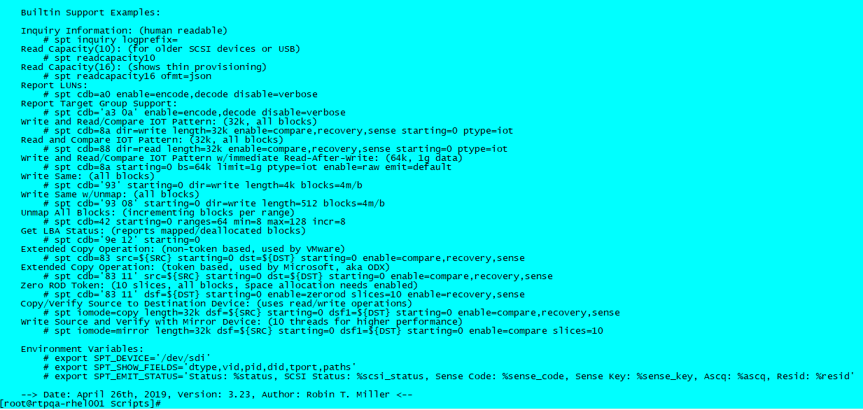

5.1. Showing SCSI Devices
Every Host OS has its own tools for showing devices attached to the system. On Linux for SCSI, the most popular are lsscsi and multipath for DM-MP (MPIO) devices. Unlike lsscsi which displays cached SCSI information from the /sys file system, spt requests its' information directly from the SCSI device. Please keep this in mind, since sending SCSI commands to be misbehaving or disconnected devices, WILL cause spt to hang even with its' default 60 second timeout. 
While OS tools are useful, oftentimes those working with SCSI want more SCSI specific information, and/or may desire an output format other than ASCII to avoid "screen scraping" and simplify parsing.
Therefore, for Linux and Windows today, I've added a "show device" command to spt with options for filtering and various output formats.
Show Devices Filters:
device(s)=string - The device path(s).
device_type(s)={value|string},... - The device type. (or dtype=)
exclude=string - The exclude path(s). (for bad or decommissioned drives)
product=string - The product name. (or pid=)
vendor=string - The vendor name. (or vid=)
revision=string - The revision level. (or rev=)
fw_version=string - The firmware version. (or fwver=)
serial=string - The serial number.
show-fields=string - Show devices brief fields. (or sflds=).
show-format=string - Show devices format control. (or sfmt=).
show-path=string,... - Show devices using path. (or spath=).

5.1.1. Linux Show SCSI Devices Example
Here's what the default output looks like:
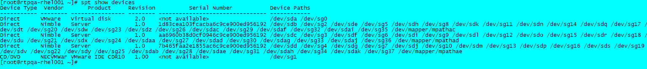
Since Linux has many SCSI device names, the last field can be rather long. Below, you'll see the lsdisks script which provides an alternate format.
Here's an example of JSON output for a single device:
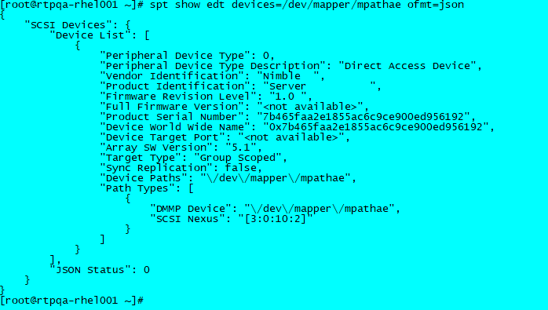
The lsdisks script can be used as a reference for parsing JSON in Python.
Here's another example to find all the Nimble SCSI devices and create a list of same:
# export DISSKS=$(spt show devices spaths=/dev/mapper/mpath sfmt='%paths' vid=Nimble)
# echo $DISKS
/dev/mapper/mpathac /dev/mapper/mpathad /dev/mapper/mpathae
#
There are many other formats, including a roll-your-own output format and configuring the summary fields, but alas I'll save covering these for a future deep dive!

5.2. SCSI Inquiry Examples

5.2.1. Inquiry ASCII Format
Notice the Nimble specific information that's been decoded, since spt was enhanced:
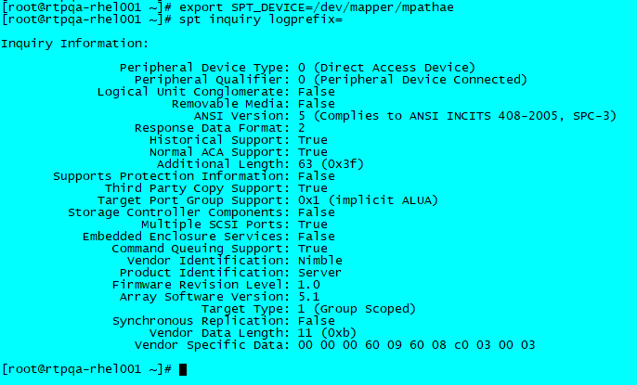

5.2.2. Inquiry JSON Format
For scripting languages, I prefer JSON format versus "screen scraping", thus:
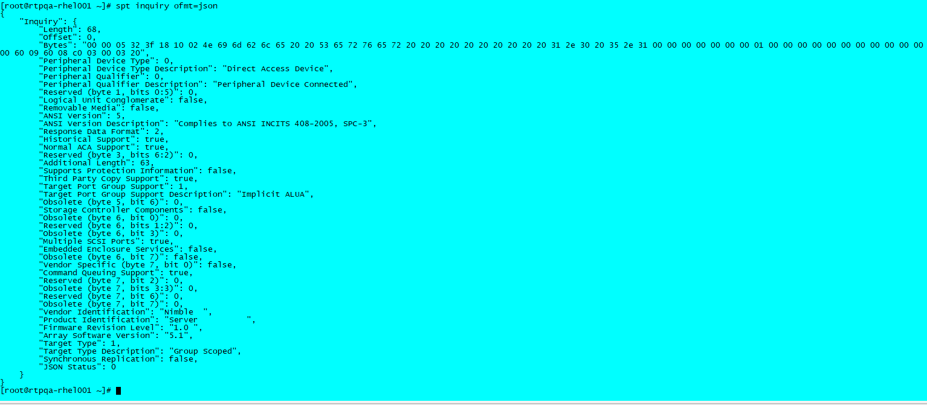
You'll notice the hex data is also reported, since SCSI engineers often wish to see the raw data bytes.

5.2.2.1. Python JSON Parsing
Snippet from lsdisks script:
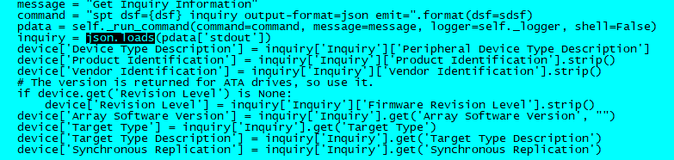

5.2.2.2. Unpacking SCSI Data
There are many SCSI commands, and spt does not support them all. Therefore, to prevent scripts from decoding hex or raw data bytes, there's an unpack option to help you define how spt can unpack data for you. Of course, you still need to know the data format returned for each SCSI command, usually taken from the SCSI or vendor specs. Please know, today we do not have a Nimble SCSI spec, one needs to reference the product include files.
Unpack Data Options:
unpack=string - The unpack format string.
unpack_fmt={dec,hex} - The unpack data format. (Default: dec)
Where unpack format string is:
C[HAR]:[index]:length - Character of length.
F[IELD]:[index]:[start]:length - Extract bit field.
O[FFSET]:index - Set the buffer offset.
B[YTE][:index] - Decode byte (8 bit) value.
S[HORT][:index] - Decode short (16 bit) value.
W[ORD][:index] - Decode word (32 bit) values.
L[ONG][:index] - Decode long (64 bit) values.
Inquiry Unpack Examples:
# spt dsf=/dev/mapper/mpathac inquiry disable=decode \
unpack='Device Type: %BYTE, Vendor: %CHAR:8:8, Product: %C::16, Revision: %C::4\n'
Device Type: 0, Vendor: Nimble , Product: Server , Revision: 1.0
OR Create your own JSON: (multiple unpack's permitted)
# spt dsf=/dev/mapper/mpathac inquiry disable=decode \
unpack='{ "Device Type": %BYTE, "Vendor": "%C:8:8",' \
unpack=' "Product": "%C::16", "Revision": "%C::4" }\n'
{ "Device Type": 0, "Vendor": "Nimble ", "Product": "Server ", "Revision": "1.0 " }

5.3. Test Unit Ready
Often the next SCSI command issued after an Inquiry, is often a SCSI Test Unit Ready (TUR) to see if the device is ready to accept commands:
# spt showopcodes test
Opcode Subcode Direction Encode Decode Default Opcode Name
------ ------- --------- ------ ------ --------- -----------
0x00 0x00 none no no 0 Test Unit Ready
# spt cdb=0
Since spt does not provide built-in support for all SCSI commands, for those missing, you need to specify the SCSI operation code (opcode).
The commands used above, showopcodes allows you to search for a SCSI command, cdb=0 executes TUR.

5.3.1. Test Unit Ready with Error Recovery
Then to force an error, lun_reset sends a LUN Reset TMF, with another TUR with error recovery enabled. Pretty cool, eh?
# spt op=lun_reset ; spt cdb=0 enable=recovery
spt (j:1 t:1): Warning: Error occurred on Sun Jul 28 12:00:42 2019
spt (j:1 t:1): Test Unit Ready failed on device /dev/mapper/mpathae
spt (j:1 t:1): SCSI Status = 0x2 (SCSI_CHECK_CONDITION)
spt (j:1 t:1): Host Status = 0 (DID_OK), Driver Status = 0x8 (DRIVER_SENSE)
spt (j:1 t:1): Sense Key = 6 = UNIT ATTENTION, Sense Code/Qualifier = (0x29, 0x3) - Bus device reset function occurred
spt (j:1 t:1): Warning: Retrying Test Unit Ready after 2 second delay, retry #1...
#
OR, you can instruct spt through a its’ built-in test option, to wait for a specific SCSI status with delays and retries: (even cooler! )
# spt op=lun_reset ; spt cdb=0 status=good retry=100 msleep=100 enable=wait
Note: You won't see the errors or retries unless you enable=debug, unless all retries fail (of course).
For shits and grins, let's force retries to be exhausted so we can see the resulting error messages:
# spt op=lun_reset ; spt cdb=0 status=cc retry=100 msleep=100 enable=wait
spt (j:1 t:1): Result for Test Unit Ready
spt (j:1 t:1): Expected:
spt (j:1 t:1): SCSI Status: 02h = SCSI_CHECK_CONDITION
spt (j:1 t:1): Sense Key: 00h = NO SENSE
spt (j:1 t:1): asc/ascq: 00h/00h = No additional sense information
spt (j:1 t:1): Actual:
spt (j:1 t:1): SCSI Status: 00h = SCSI_GOOD
spt (j:1 t:1): Sense Key: 00h = NO SENSE
spt (j:1 t:1): asc/ascq: 00h/00h = No additional sense information
spt (j:1 t:1): ERROR: Error number 1 occurred on Sun Jul 28 12:19:00 2019
spt (j:1 t:1): ERROR: Retry limit of 100 reached for SCSI opcode 0x0 (Test Unit Ready)
# echo $?
255
#
BEWARE: The LUN Reset likely re-enumerated your SCSI "sd" and "sg" devices, a not so wonderful Linux behavior!
Ok, I'd need a full presentation to cover all the test specific options with examples, but the point is by moving such things into spt, the tool can do most of the heavy lifting, and do it much faster than script wrappers! And because spt has a roll your own emit status string, your automation can parse resulting error information much easier, without "screen scraping"! (I'm not a fan of)

7. Built-in (shorthand) SCSI Commands
spt was originally written to send any CDB without internal support for encoding and/or decoding SCSI commands.
But eventually, it became clear that shorthand commands make it more user friendly, towards the scu tool mentioned.
First various I/O type CDB's were enhanced, mainly since they require CDB updates when looping across a wide range of data.
Next, a set of SES and these SCSI commands were enhanced, since they were used in automation at my last company:
Shorthand Commands: (with more to come)
- inquiry {page=value} - Show Inquiry or specific page.
- logsense {page=value} - Show Log pages supported or page.
- zerolog {page=value} - Zero all Log pages or specific page.
- readcapacity10 - Show disk capacity (10 byte CDB).
- readcapacity16 - Show disk capacity (16 byte CDB).
- requestsense - Show request sense information.
- rtpg - Report target port groups.
Storage Enclosure Services (SES) Specific Options:
- rcvdiagpage=value - Issue a receive diagnostic command.
- senddiag page=value - Issue a send diagnostic command.
- showhelp - Show enclosure help text diagnostic page.
- ses {clear|set}={devoff|fail/fault|ident/locate|unlock} - Modify SES control elements.
As you may know, some SCSI opcodes support numerous pages as shown above, and not all pages are decoded, but rather the ones requested to date.

8. Advanced SCSI Examples
As mentioned above, a set of options were added to allow I/O type commands across a set of blocks:
I/O Options:
- lba=value - The logical block address.
- bs=value - The number of bytes per request.
- blocks=value - The number of blocks per request.
- limit=value - The data limit to transfer (bytes).
- ptype=string - The pattern type (only 'iot' now).
- ending=value - The ending logical block address.
- starting=value - The starting logical block address.
- slices=value - The slices to divide capacity between.
- step=value - The bytes to step after each request.
Those of you familiar with my dt tool, will recognize most of these options, while several are specific to SCSI.

8.1. I/O Parameters
The I/O parameters are used in conjunction with the CDB operation, here are SCSI write opcodes:
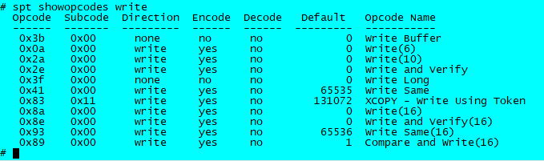
FYI: Eventually I'll enhance the parsing to lookup opcodes by names, just need to find/make the time!

8.1.1. Write and Verify Examples
Here's a simple single threaded Write and Verify command line:
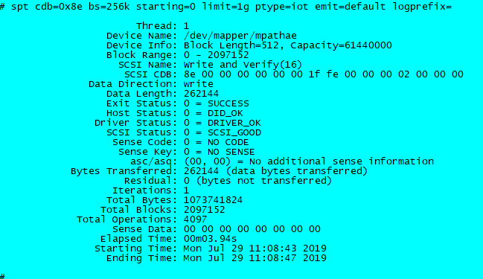
Remember unlike dt, if a data pattern is not specified, then the pattern written is zeros! (unmaps Nimble blocks)
Also know, that spt does not do error recovery by default, since as a test tool usually want the error status.
Therefore, add enable=recovery if you like certain SCSI errors such as SCSI_BUSY or Unit Attention (UA) to be retried automatically. Otherwise errors such as this one will cause a failure, even though the UA is retryable: (even I the author, often gets bit by this lack of automatic error recovery )
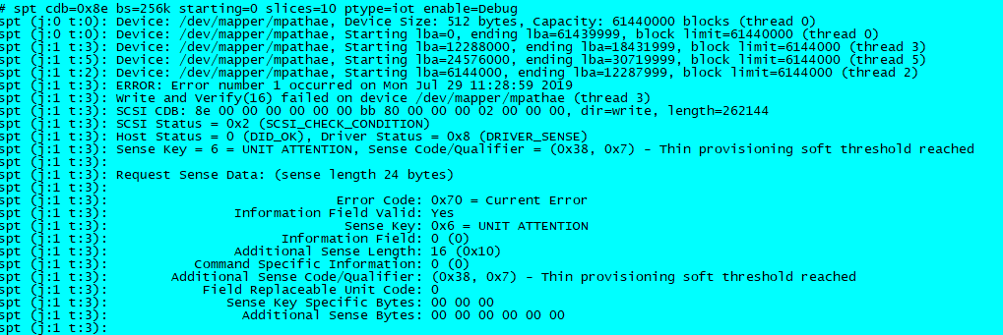
And here's an example of using slices (multiple threads) across the entire capacity of the drive:
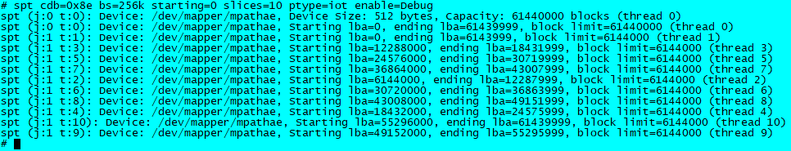
You can imagine the load and stress generated when doing multi-threaded SCSI operations across a larger set of disks!

8.1.2. Extended Copy Example
There are two styles of extended copy operations, the original XCOPY and the token based XCOPY.
Here is an example of doing an image mode copy between two disks:
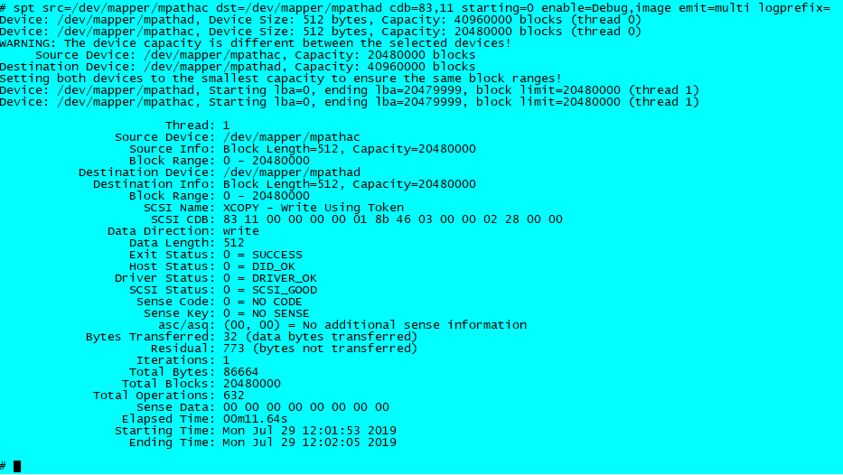
For proper testing, the source disk should be pre-populated with valid data, then destination verified via:
# spt dsf=/dev/mapper/mpathad cdb=88 starting=0 bs=256k pattern=iot limit=20480000b
OR you can simply verify the source and destination disks via this command:
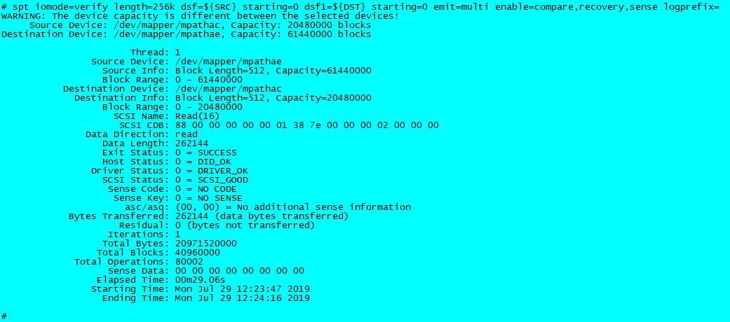
I often find scu convenient for dumping LBA's via:
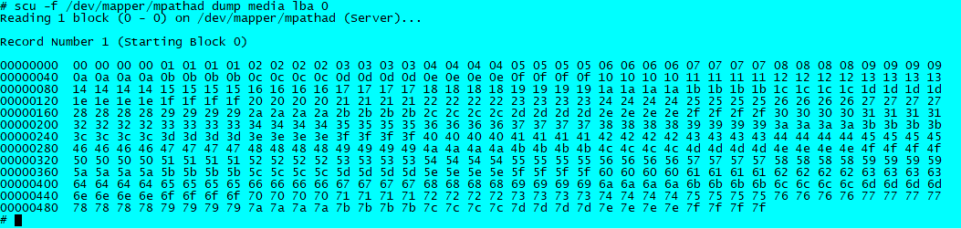

9. SCSI Debugging
Using the SCSI Inquiry example above, add debug options will provide more information:
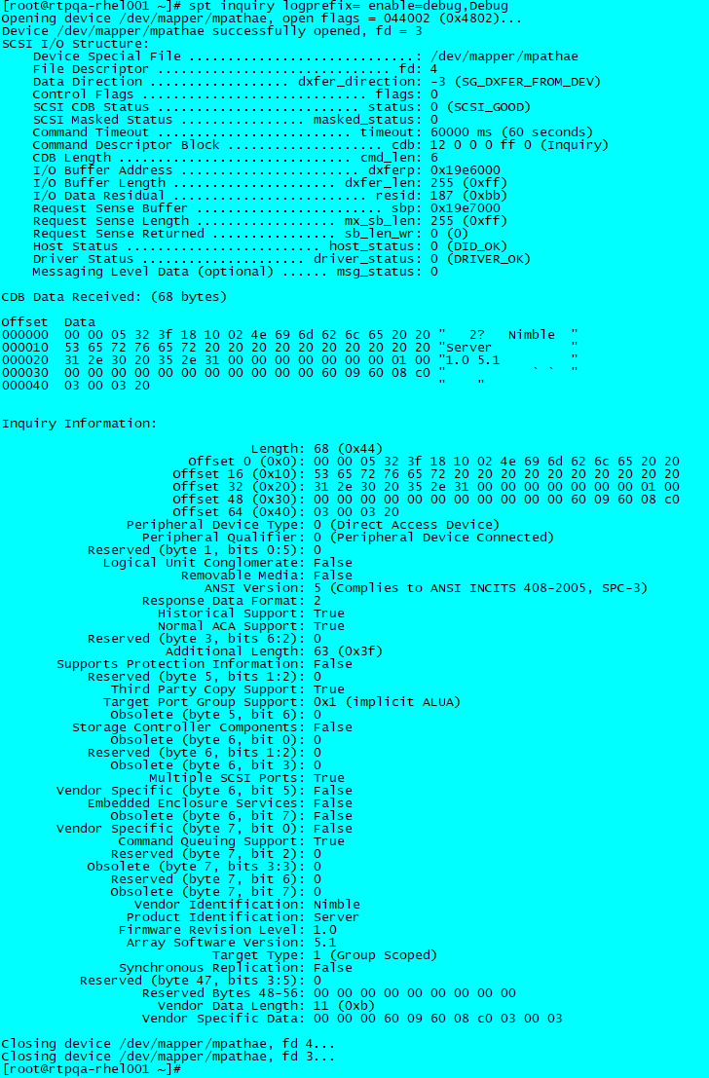
Please Note: Some of the bits may appear incorrect, since I updated Inquiry to ANSI SPC-5 spec.

9.1. Decoding SCSI Error Information
These simple commands can be useful to decode SCSI errors when tools have not translated to a message:
[root@rtpqa-rhel001 ~]# spt show scsi status=0x2
SCSI Status = 0x2 = SCSI_CHECK_CONDITION
[root@rtpqa-rhel001 ~]# spt show scsi key=0x2
Sense Key = 0x2 = NOT READY
[root@rtpqa-rhel001 ~]# spt show scsi ascq=0x040B
Sense Code/Qualifier = (0x4, 0xb) = Logical unit not accessible, target port in standby state
[root@rtpqa-rhel001 ~]#

10. SCSI Information
Similar to the dt tool, reporting SCSI information is available, but you need to enable it via:
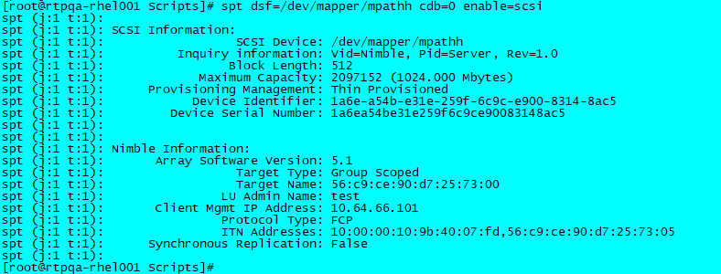

10.1. SCSI Statistics
Note that spt does not display statistics automatically. The reporting of statistics is via the "emit=" option, and is a free form that you the user must define. Special format control strings control the information reported, and "spt help" shows these under the heading "Emit Status Format Control:" section:
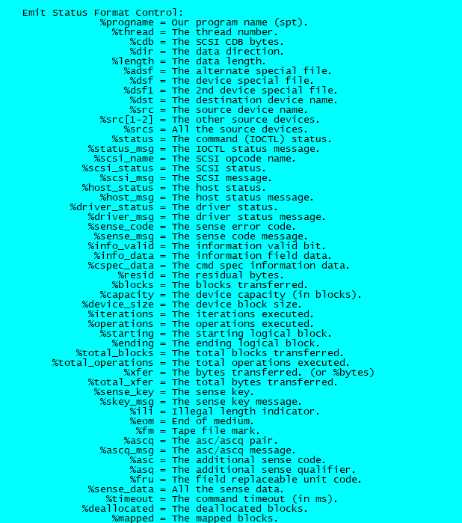
While parsing the emit string, spt accepts "default", which results in the following:
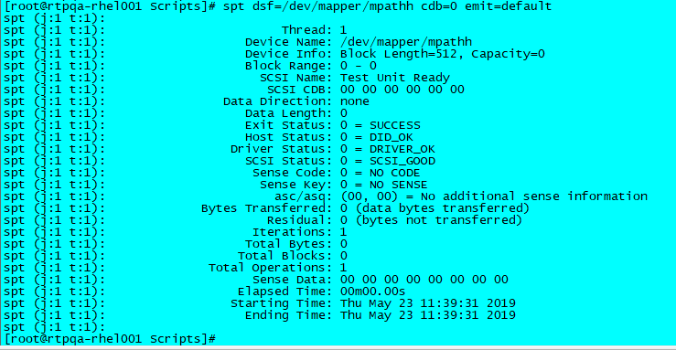

11. List Disks Script
A Python 2.7 script was developed around the Linux spt tool, utilizing "spt show devices" output plus acquiring additional information.
Key Points:
- expects spt in same directory as lsdisks script, or in $PATH
- options exist to specify devices and/or output format
- this script supports storage enclosures and disk devices
- lsdisks talks to spt over a pipe, avoids process overhead, so is very fast!
  - single threaded tight now, so could be made faster for large configs

11.1. lsdisks Help Text
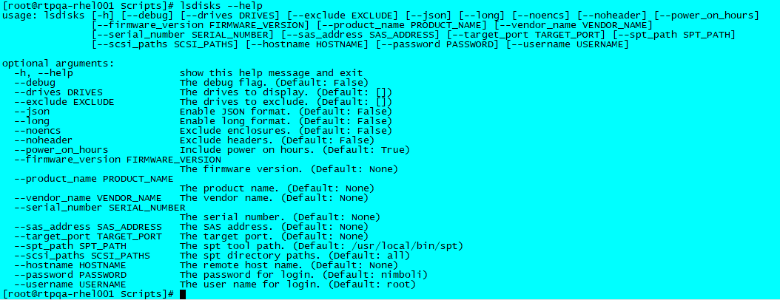

11.2. Example Brief Output Format:
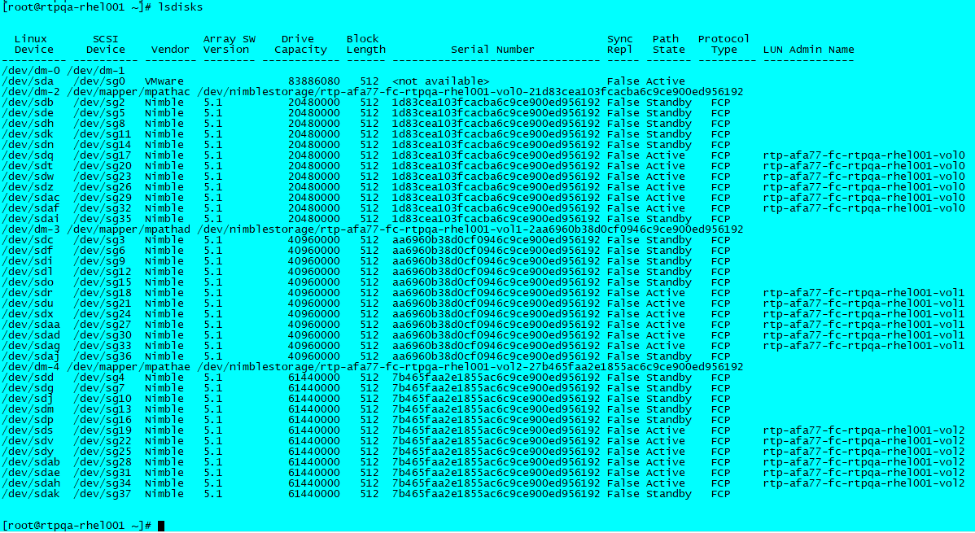

11.3. Example Long Output Format:
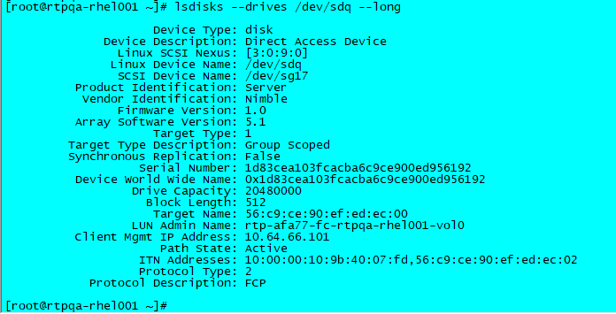

11.4. Example JSON Output Format
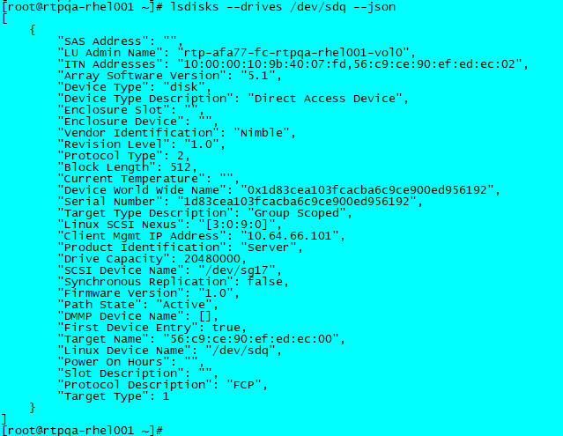

11.5. Remote Example
Internally, lsdisks is talking to spt via pipes, so assuming an ssh connection can be established, one can query remote systems:
