Plots of Various Quantities
Figures 7–13 show one complete 2.592 s cycle with AB rotating counterclockwise at 23.148148 rpm. The five link masses and centroidal inertias come from SOLIDWORKS. A constant 200 N downward force acts at H, together with link self-weight.
In the comparison plots, solid lines denote MATLAB and dashed lines with open markers denote native PMKS+ exports. Colors identify links or components. The MATLAB and PMKS+ datasets contain 721 and 361 samples, respectively. Markers are shown every 12 PMKS+ samples for readability; the dashed curves use every sample. No phase or amplitude adjustment is applied.
The reported percentage is the maximum absolute difference divided by the maximum absolute MATLAB value for the same component, evaluated at the PMKS+ sample times. It is not a pointwise relative error near zero crossings. Differences greater than 1% are retained. The fully loaded cycle does not model startup, dwell, or artifact pickup and release.
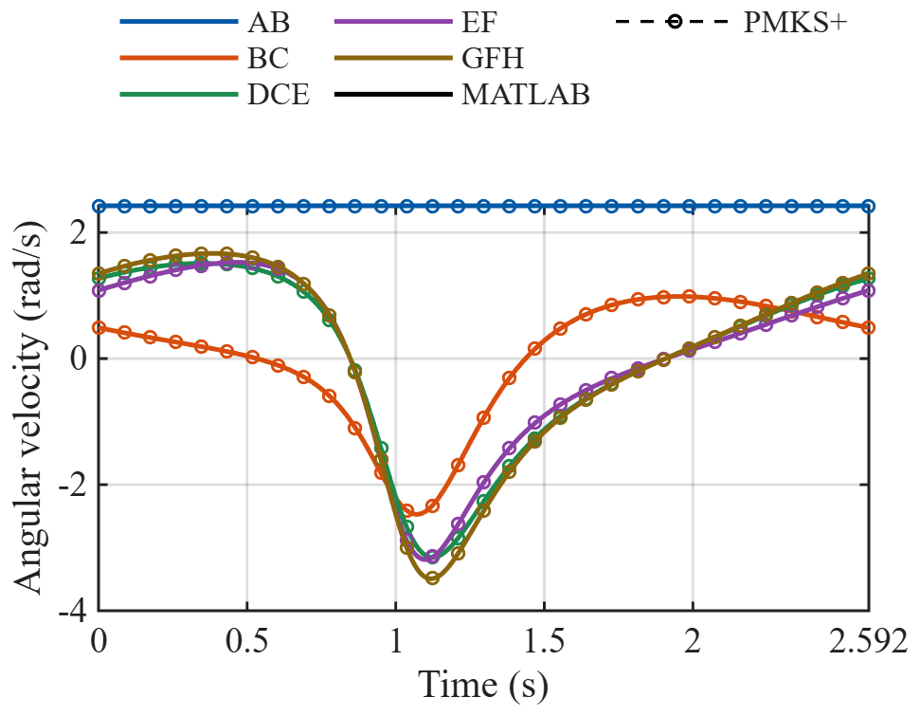
Fig. 7. Angular velocities of all five links.
AB maintains a constant angular velocity of 2.4241 rad/s. The other four links change speed and reverse direction during the cycle. MATLAB and PMKS+ reproduce the same reversal pattern; the largest peak-normalized component difference among these angular-velocity curves is 0.49%.

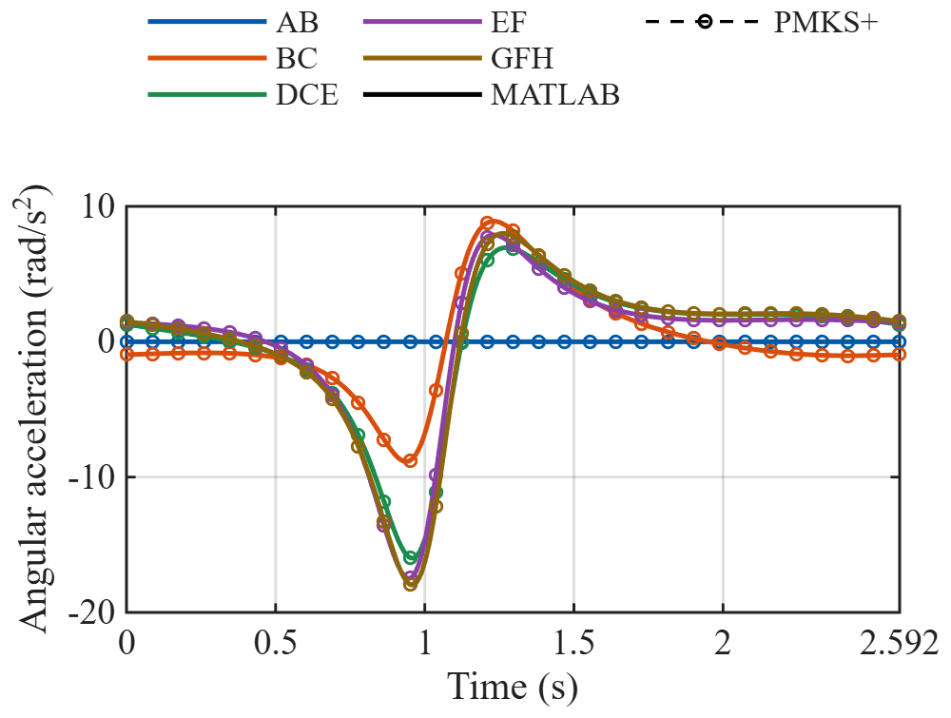
Fig. 8. Angular accelerations of all five links.
The input angular acceleration is zero, but the remaining links have nonzero angular accelerations because their transmission ratios vary with configuration. The strongest variations occur around 0.9–1.2 s. The largest peak-normalized angular-acceleration difference is 0.42%.
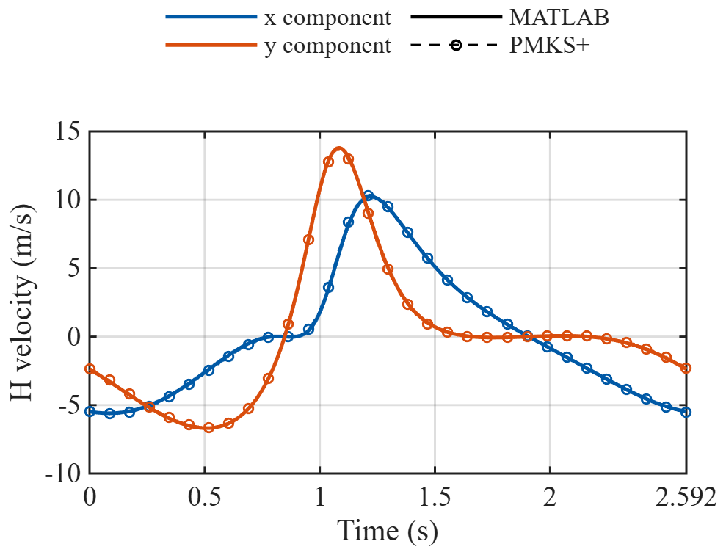
Fig. 9. Global velocity components at H.
The x and y velocity components describe the motion of the load-application point on the GFH extension. Their sign changes indicate reversals in the corresponding coordinate directions. The PMKS+ and MATLAB curves have similar shapes, with a maximum peak-normalized component difference of 2.64%.

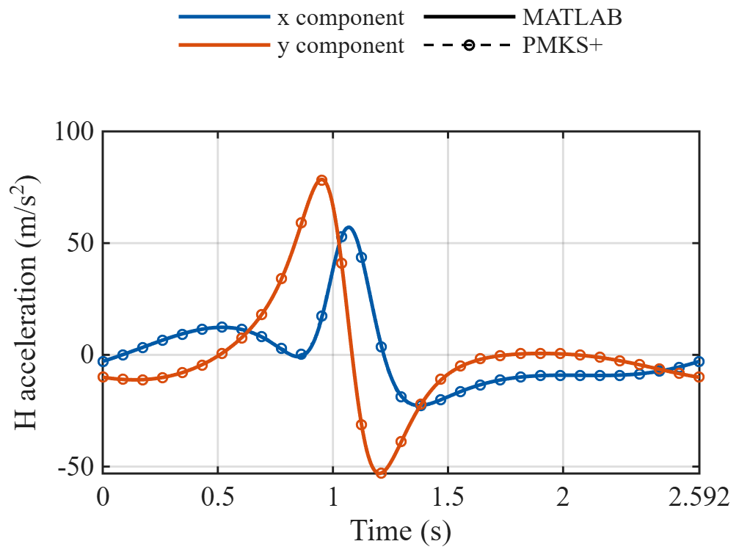
Fig. 10. Global acceleration components at H.
Both tangential and centripetal acceleration contribute to the H-point acceleration. The pronounced positive and negative peaks show that a constant input speed does not produce constant output-point acceleration. The maximum peak-normalized component difference is 2.49%.
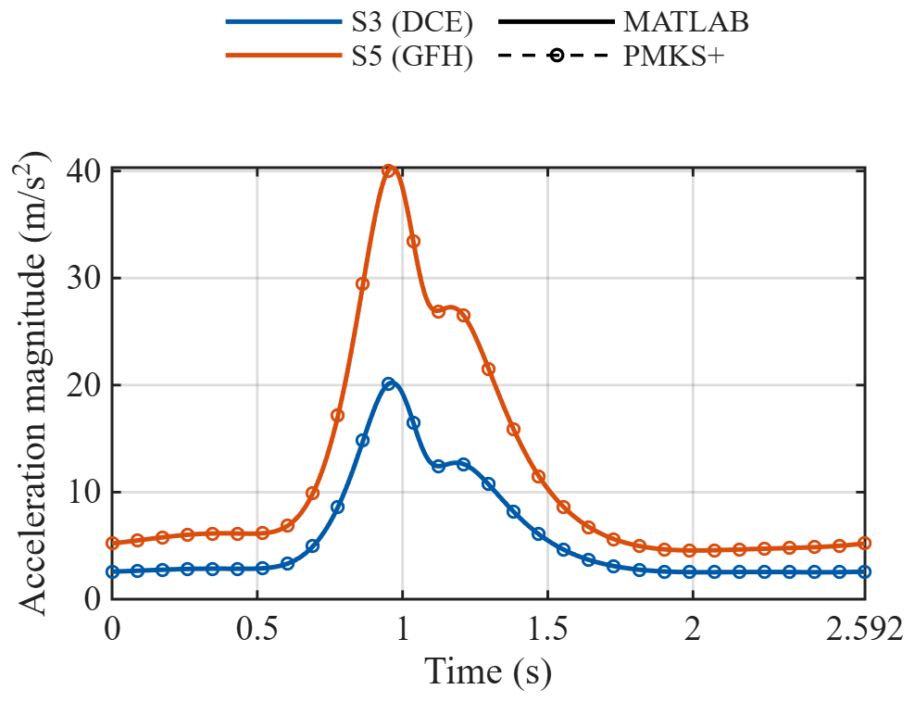
Fig. 11. Acceleration magnitudes at S3 and S5.
S3 and S5 are the mass centers of DCE and GFH, respectively. S5 experiences the larger acceleration peak in this cycle. These mass-center accelerations enter the translational inertia terms in Newton’s second-law analysis. The exported curves show similar timing and peak shapes in both programs.

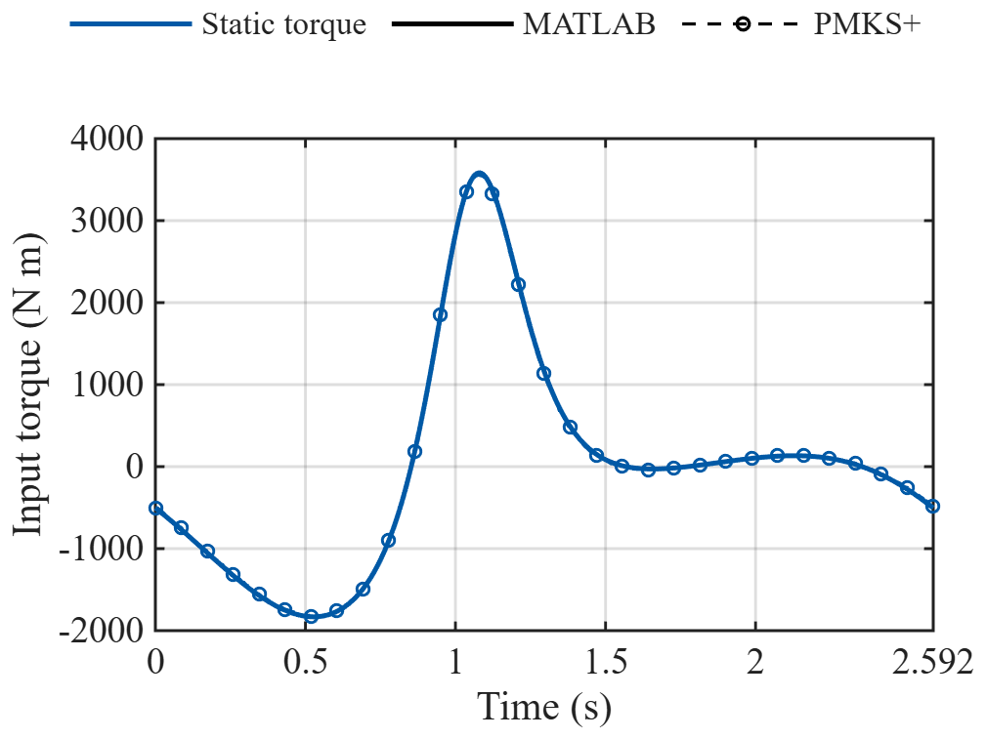
Fig. 12. Static input-torque comparison.
The holding torque changes sign with linkage configuration. At the initial position, MATLAB gives −504.373 N·m and PMKS+ gives −504.264 N·m. Differences in gravity (9.81 versus 9.80665 m/s²), saved coordinate precision, and the numerical motion calculations contribute to the residual difference. Its cycle-wide peak-normalized value is 1.20%.
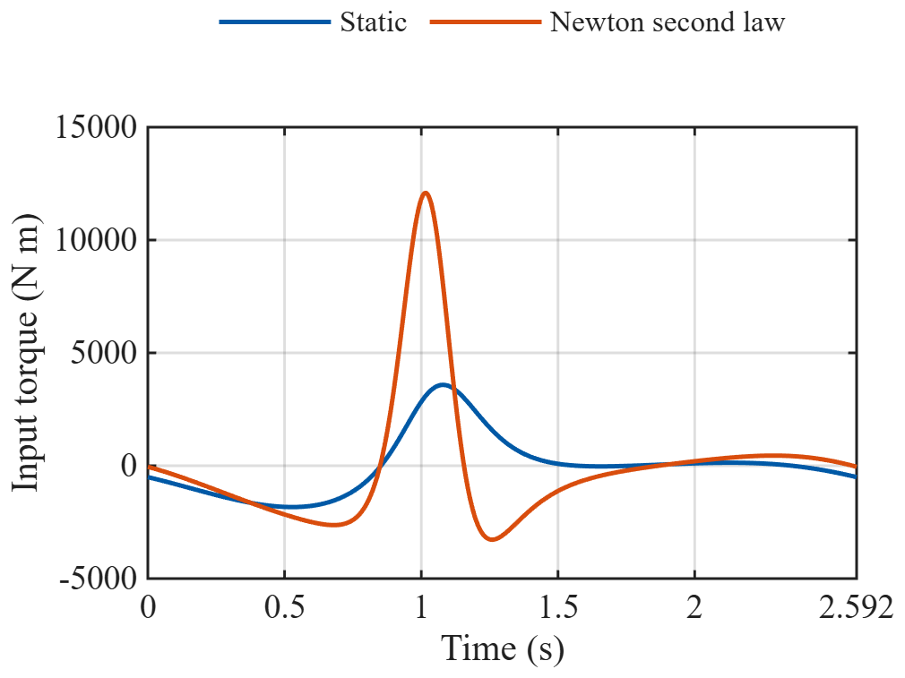
Fig. 13. MATLAB static and Newton’s second-law input torques.
Newton’s second-law analysis includes the translational and rotational inertia of all five links under the same prescribed force at H. Its initial torque is −47.175 N·m, compared with −504.373 N·m for static equilibrium. The largest absolute cycle torques are 12.09 kN·m dynamic and 3.58 kN·m static. No PMKS+ dynamic curve is included in this report comparison.

