**EXERCISE NO.1**

**DATE: 14/10/2020**

**AIM:**

To print the calendar of given month and year, month must be in digit format, year in four digits format and if the given month and year are not in the specified format print “Invalid Input”.

**PROGRAM:**

import calendar

year = int(input())

month = int(input())

if(year<10000 and year>999 and month<13 and month>0):

print(calendar.month(year,month))

else:

print("Invalid Input")

**LINK:**

http://103.53.53.18/mod/vpl/forms/edit.php?id=229&userid=1722

**OUTPUT:**

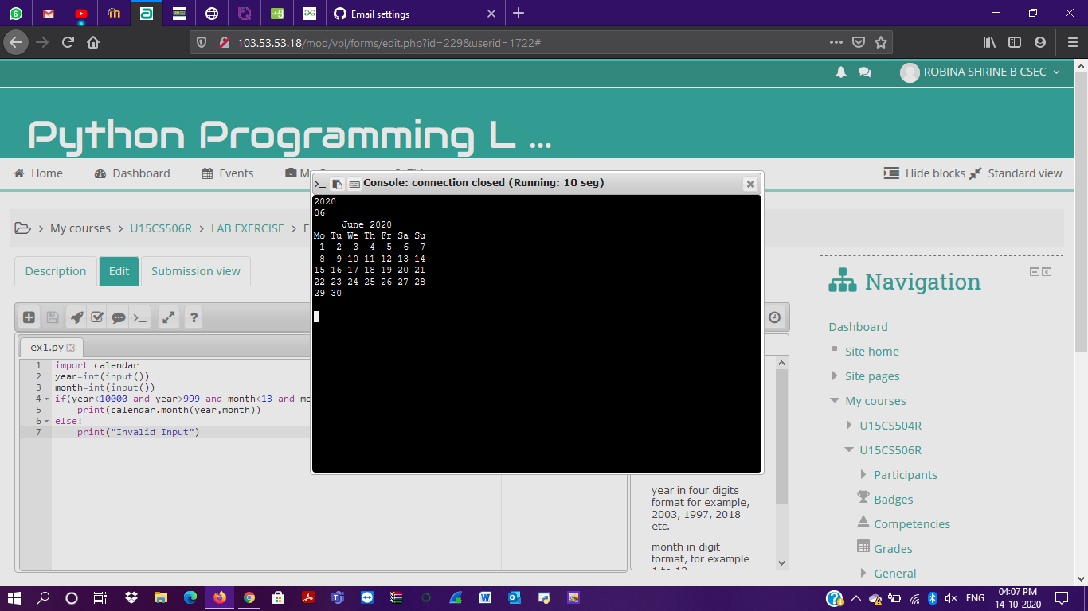

**RESULT:**

The calendar for the specified month and year is displayed.