**EXERCISE: 14**

**DATE: 20.11.2020**

**AIM:**

To write a Python class to find validity of a string of parentheses, '(', ')', '{', '}', '[' and '].

**PROGRAM:**

def areBracketsBalanced(expr):

stack = []

for c in expr:

if c in ["(","{","["]:

stack.append(c)

else:

if not stack:

return False

current_c = stack.pop()

if current_c =="(":

if c!=")":

return False

if current_c == "{":

if c!="}":

return False

if current_c == "[":

if c!="]":

return False

if stack:

return False

return True

if __name__ == "__main__":

expr = input("input:")

if areBracketsBalanced(expr):

print("Output: Valid")

else:

print("Output: Invalid")

**LINK:**

[**http://103.53.53.18/mod/vpl/forms/submissionview.php?id=327&userid=1722**](http://103.53.53.18/mod/vpl/forms/submissionview.php?id=327&userid=1722)

**OUTPUT:**

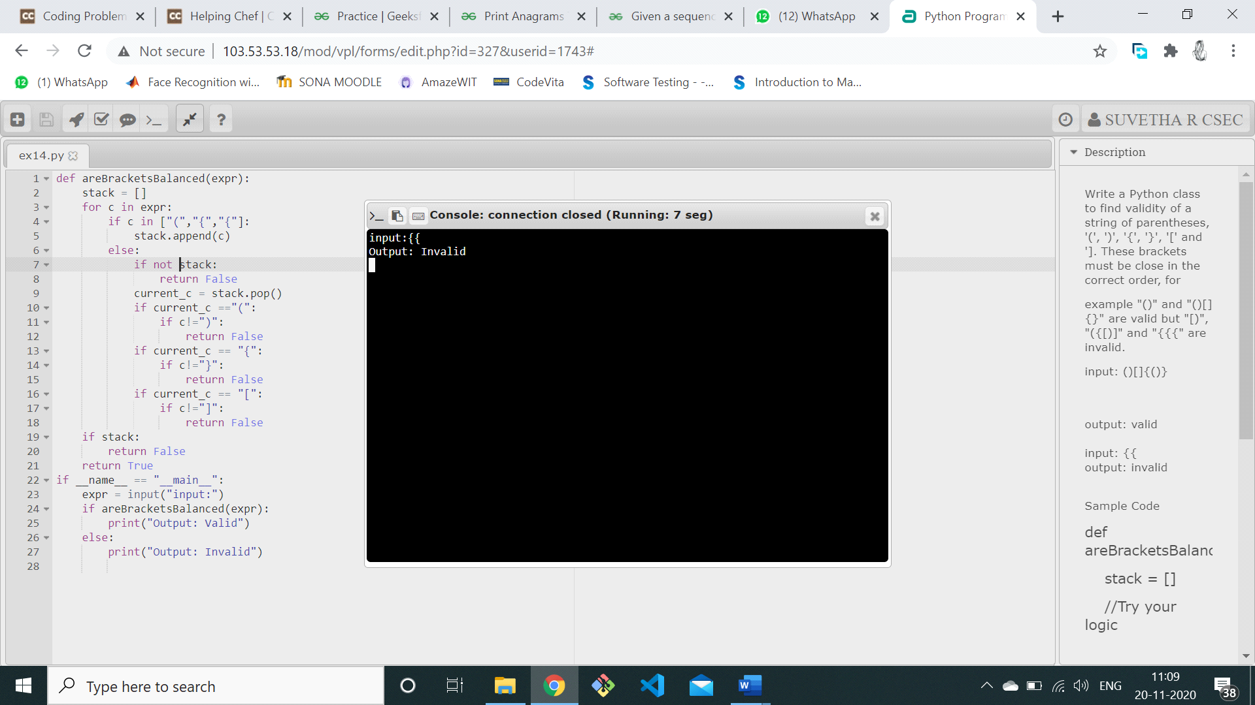

**RESULT:**

The validity of a string of parentheses is successfully verified.