**EXERCISE NO.2**

**DATE:14/10/2020**

**AIM:**

To write a python program, to count the number x in a given list of numbers.

**PROGRAM:**

def count(lst,x):

count = 0

for ele in lst:

if ele==x:

count=count+1

print(count)

lst = []

n = int(input())

for i in range(0,n):

ele = int(input())

lst.append(ele)

x = int(input())

count(lst,x)

**LINK:**

<http://103.53.53.18/mod/vpl/forms/edit.php?id=230&userid=1722#>

**OUTPUT:**

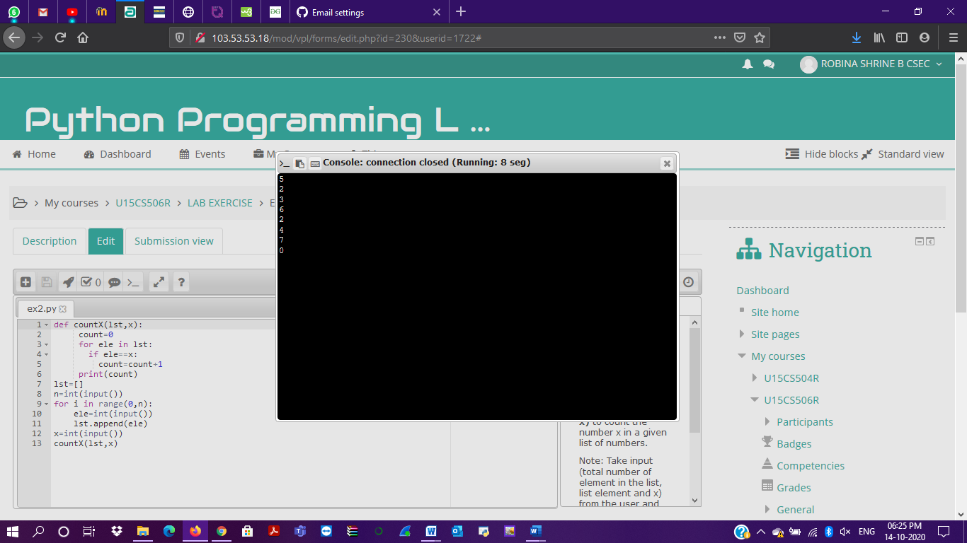

**RESULT:**

Counting the number x in a given list of numbers is done.