**Manual**

With this game you can play animal sounds, guess the right animal sound and play some kids song.

When you start the game it will look like this.

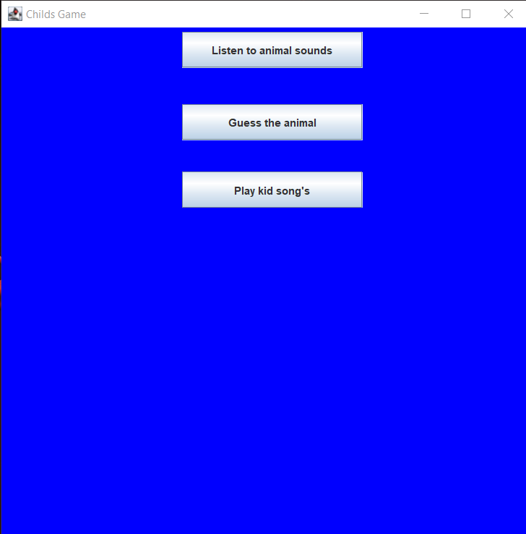

To Play animal sounds you simply press the first button(Listen to animal sounds). When you press the button you will get some pictures of animals where you can press them to get their sounds. If you want to go back just press the button at the lower left corner called Back.

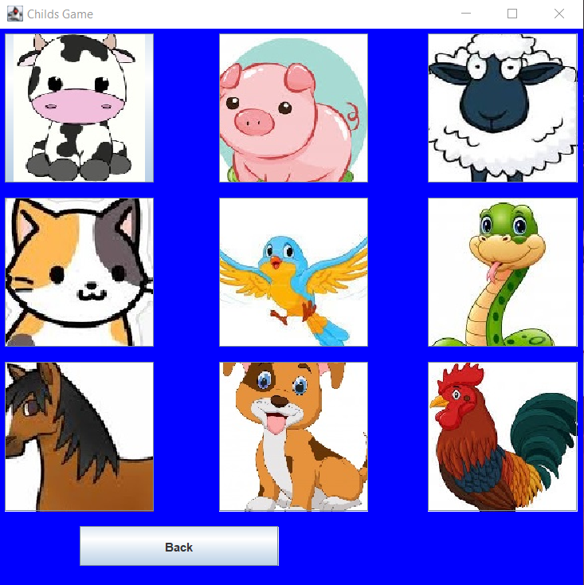

To guess the right animal sound you press the second button(Guess the animal). When you press the button you will get the same pictures as the first button but this time there will be an button at the lower right corner where you can press “play”. When you press play you get an animal sound and then you are ready to guess. If you guess wrong there will be a wrong sound and if you guess right there will be a right sound. If you want to go back press the button Back in the lower left corner.

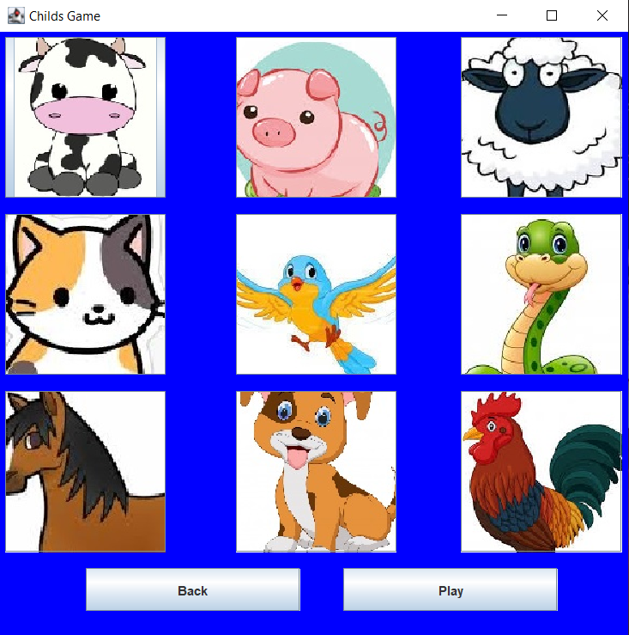

To play kids songs press the third button(Play kid song’s). When you press the button you will se some buttons. If you press the buttons in the middle at the top you will get to hear some music. You can Pause/Play with the button named Pause/play at the bottom of the window. If you want to go back press the button Back in the lower left corner.

