IPF PAPER – Master document – please save old versions in 'old-versions'

The performance of Iterative Proportional Fitting for spatial microsimulation: applying new tests to an old technique

Robin Lovelace and Dimitris Ballas, University of Sheffield; Eveline van Leeuwen, VU Amsterdam

Abstract

The fundamentals of Iterative Proportional Fitting (IPF), otherwise known as 'matrix raking', 'biproportional fitting' or the 'RAS algorithm', have been established and refined since the first theoretical work by statisticians dating back to 1940. The technique has a history in Regional Science and related fields that dates back to the 1980s. Since then IPF has been used for generating small area microdata for a variety of applications, primarily for combining individual-level microdata with aggreg ate count data about administrative zones. In this context, the procedure works by creating a matrix that assigns each individual from a non-geographical survey a set of weights, one weight for each area under investigation. It is a mature, widely used and relatively straight-forward method. However, there have been few studies focussed on evaluating the performance of the IPF procedure under a variety of conditions. An additional research problem that has rarely been tackled is the tendency of researchers to 'start from scratch', and create their own implementation of IPF in a programming language of their choosing. Instead of starting from a blank slate each time, we argue that new systems of collaborative coding could benefit all researchers using IPF and lead to a reduction in implementation error.

This gap in the literature has important implications for researchers using IPF. Answers to many methodological questions must be guessed or assumed, and many researchers simply follow pre-existing conventions. Under what conditions can a 'perfect' match be expected, and how can one test whether these conditions exist in the input datasets? How many iterations should be used for any given application? What is the impact of initial weights on the final results? And what impact will integerisation have on accuracy? This paper tackles each of these questions in turn, using a systematic methodology and sample datasets that have been made freely available online. The use of the collaborative coding site Github makes it easy for other researchers to fork our test runs and test the method on their own datasets or against their own performances metrics.

The results confirm IPF's status as robust and widely applicable method for combining areal and individual-level data. We have also been able to generate simple rules of thumb, and transferable tests of performance, that should be of use to researchers using IPF in the future.

Keywords: iterative proportional fitting, spatial microsimulation, commuting, model testing

JEL Code: C13

Planning page (to keep updated during writing process)

Paper outline

- Introduction
- IPF: Theory and Applications (Dimitris)
- Input data (could be 'data and methods')
- Model experiments (Robin)
- Results and Benchmarks
- Concluding comments

Introduction

Ideas
Use US PUMS data
Present at Cambridge!
Provide hyperlinks to github document and line numbers when describing code

Action points (keep this updated)
Robin: Continue to improve code and create preliminary results
Dimitris: Make a start on section 2
Introduction
The aggregation of individual-level data has a long history. The most common form of aggregation conducted by national statistical agencies collecting data about citizens is 'flattening'. To convert data from 'long' to 'flat' form involves a) converting all variables into discrete categories, b) assigning a column to each category and c) assigning integer counts to cells in each column (Fig. 1). Each row in this aggregated form can represent the entire dataset or subsets thereof. (Geographical aggregation – one row per zone – is the most common form of aggregation, but any subsets, from social class to time period can be used).

The main advantage of 'flat' data is that it can summarise a large amount of information in a small number of rows; the main disadvantage is that is usually associated with data loss. Both types of data representation are common in the sciences, although the raw data is usually available in long-form. Due to the history of and confidentiality issues surrounding census data – in which characteristics of every individual are recorded – the long form is sometimes unavailable for the best datasets in social science.

A related long-standing research problem within geography and regional science is the scale of analysis. There is often a trade-off between the quality and resolution of the data, which can result in a compromise between detail and accuracy of results (Ballas and Clarke, 2003). A common scenario facing researchers investigating a spatial problem is being presented with two datasets: one 'long' aspatial survey table where each row represents an individual, and another of 'flat', geographically aggregated count data where each row represents an area.

One approach to deal with this problem is through the generation of small area microdata. The result of this process of population synthesis (in its 'long' form) is a table in which rows represent each individual in the study region, with an additional column indicating the area of residence (Table 1).

Table 1: Illustration of area microdata in 'long form'.

Individual id | X1 | ... | Xm | Area
1 |  |  |  | 1
2 |  |  |  | 1
...
n |  |  |  | a

Storing the data in this form offers a number of advantages (Clarke and Holm, 1987). These include:

- The ability to investigate intra-zone variation (by analysing a the variable after sub-setting a single area from the data frame), as well as inter-zone variation in the same dataset.
- Cross-tabulated contingency tables can be created for any of the variables; in geographical count data, cross-tabulation are not always available, and use many columns when they are available, sometimes containing empty cells. (For example, a cross-tabulation of mode of travel to work by sex and social class would contain 12 * 3 * 15 columns, if this many categories were present in each variable. In disseminating the UK Census, the column numbers extend up to 564, although not all of these are available).
- The presentation of continuous variables such as income as real numbers, rather than as categorical count data, in which there is always data loss.
- The data is in a form that is ready to be passed into an individual-level model. For example individual behaviour could simulate traffic, migration or the geographical distribution of future demand for healthcare.

These benefits have not gone unnoticed by the spatial modelling community. In fact, the sub-discipline of spatial microsimulation has emerged to take advantage of the new possibilities opened up by such small area individual-level data.

Various strategies for generating small area microdata are available. However, it is not always clear which one is most appropriate: “It would be desirable if the spatial microsimulation community were able to continue to analyse which of the various reweighting/synthetic reconstruction techniques is most accurate – or to identify whether one approach is superior for some applications while another approach is to be preferred for other applications” (Clarke and Harding, p. 270). The longest-established and most straight-forward of these is Iterative Proportional Fitting (IPF), the performance of which is the subject of this paper...

IPF: theory and applications (Dimitris)

Input data

Method: model experiments

Baseline scenarios
In order to perform a wide range of model experiments, in which only one factor is altered at a time, it was necessary to clearly define baseline scenarios. These are model runs with sensible defaults, which can be referred back to as a reference point and re-used at any point in the future.

The baseline 'small-area' scenario consists of two iterations of IPF, in which all three constraints were used. The results, illustrated in Fig. X, show that IPF successfully brings the simulated cell counts in-line with the census after each constraint is applied and that the fit improves with each iteration (only two iterations are shown here, as the fit improves very little beyond two, and to avoid clutter).
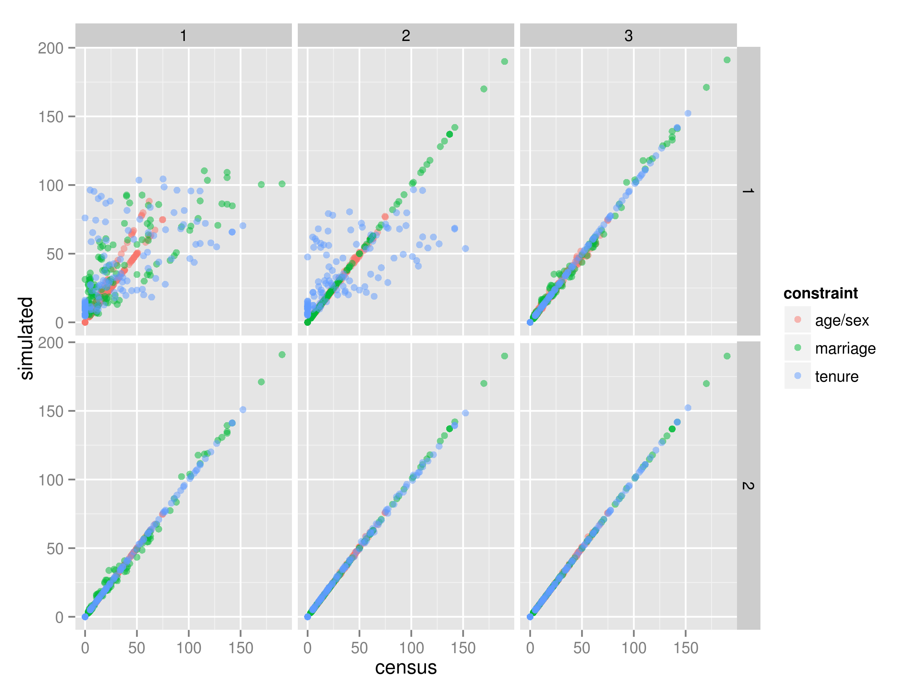

Fig. X IPF in action: simulated vs census zone counts for the small-area baseline scenario after each constraint (columns) and iteration (rows).

Number and order of constraints

Number of iterations

Initial weights

Integerisation

This was the next variable that was altered, following ref. In the simplest scenario, the initial weight of a single individual was altered repeatedly, in a controlled manner. The code enabling this model experiment is contained in the folder “small-area-weights” (see “etsim.R”). The number of different initial weights can be controlled by the parameter “num.ws” which is set to 5 as an arbitrary default. Initial weights are set to k, which can be set to any function of N+, by altering the following line of code:

k = u/5 + 0.5 # initial weight of sample individuals for testing

In this case the resultant weights are set to 0.7, 0.9, 1.1, 1.3 and 1.5 for each model experiment. For factors of one million, for example, the above would be replaced by k = u*10^6 . To observe the impacts of altering the weights in this way the usual tests of model fit were conducted. In addition, the capacity of initial weights to influence an individual's final weight/probability of selection was tested by tracing its weight into the future after each successive constraint and iteration. This enabled plotting original vs simulated weights under a range of conditions (see Section x).
Results (same structure as above)

Weights
It was found that initial weights had little impact on the overall simulation. Taking the simplest case, a random individual was selected from the 'small area' data and his/her initial weight was modified iteratively. Holding all other factors constant, the relationship between initial and 'final' weights (after repeated iterations) can be seen Fig. x. The same test was conducted for four other randomly selected individuals and the overall results were the same:

To analyse the impacts of changing the initial weights of multiple individuals, the same experiment was conducted, but this time the initial weights were applied to the first five individuals. The results are illustrated in Fig. X, which shows the relationship between initial and final weights for the first two individuals and another two individuals (randomly selected to show the impact of altering weights on other individual weights).
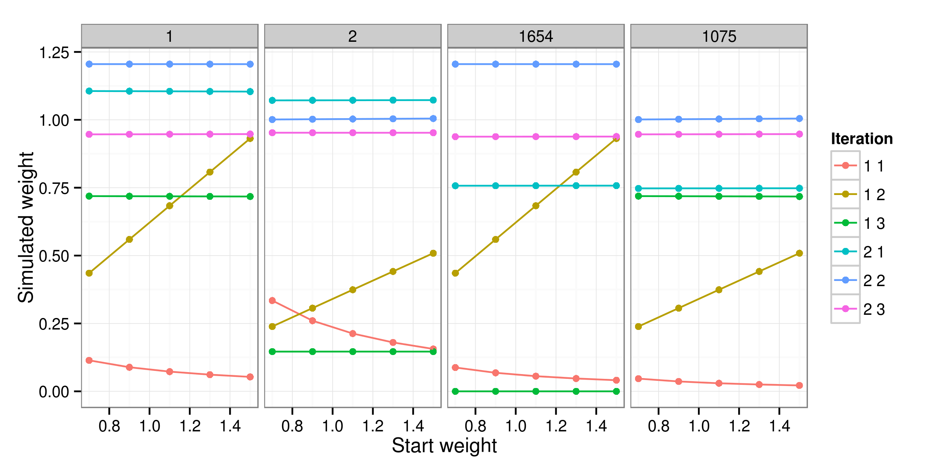
Fig. X: Initial vs simulated weight of four individuals for a single area (zone 1).

Fig. X shows that the vast majority of the impact of altered starting weights occurs in iteration.constraint 1.1 and 1.2, before a complete iteration has occurred. After that, the initial weights continue to have an influence, of a magnitude that cannot be seen in Fig. X. For individual “1”, the impact of a 53% difference in initial weights (from 0.7 to 1.5) shrinks to 2.0% by iteration 1.3 and to 1.1% by iteration 2.3. The general impact of initial weights on simulated weights in IPF can be described as...

%%% Illustrate impact of weights as a proportion of the original weight.
Conclusions

