IPF PAPER – Master document – please save old versions in 'old-versions'

The performance of Iterative Proportional Fitting for spatial microsimulation: applying new tests to an old technique

Robin Lovelace and Dimitris Ballas, University of Sheffield; Eveline van Leeuwen, VU Amsterdam

Abstract

The fundamentals of Iterative Proportional Fitting (IPF), otherwise known as 'matrix raking', 'biproportional fitting' or the 'RAS algorithm', have been established and refined since the first theoretical work by statisticians dating back to 1940. The technique has a history in Regional Science and related fields that dates back to the 1980s. Since then IPF has been used for generating small area microdata for a variety of applications, primarily for combining individual-level microdata with aggreg ate count data about administrative zones. In this context, the procedure works by creating a matrix that assigns each individual from a non-geographical survey a set of weights, one weight for each area under investigation. It is a mature, widely used and relatively straight-forward method. However, there have been few studies focussed on evaluating the performance of the IPF procedure under a variety of conditions. An additional research problem that has rarely been tackled is the tendency of researchers to 'start from scratch', and create their own implementation of IPF in a programming language of their choosing. Instead of starting from a blank slate each time, we argue that new systems of collaborative coding could benefit all researchers using IPF and lead to a reduction in implementation error.

This gap in the literature has important implications for researchers using IPF. Answers to many methodological questions must be guessed or assumed, and many researchers simply follow pre-existing conventions. Under what conditions can a 'perfect' match be expected, and how can one test whether these conditions exist in the input datasets? How many iterations should be used for any given application? What is the impact of initial weights on the final results? And what impact will integerisation have on accuracy? This paper tackles each of these questions in turn, using a systematic methodology and sample datasets that have been made freely available online. The use of the collaborative coding site Github makes it easy for other researchers to fork our test runs and test the method on their own datasets or against their own performances metrics.

The results confirm IPF's status as robust and widely applicable method for combining areal and individual-level data. We have also been able to generate simple rules of thumb, and transferable tests of performance, that should be of use to researchers using IPF in the future.

Keywords: iterative proportional fitting, spatial microsimulation, commuting, model testing

JEL Code: C13

Planning page (to keep updated during writing process)

Paper outline

- Introduction
- IPF: Theory and Applications (Dimitris)
- Evaluation
- Input data (could be 'data and methods')
- Model experiments (Robin)
- Results
- Concluding comments

ToC

1 Introduction 4
2 IPF: theory and applications 5
3 Evaluation techniques 5
3.1 Simple (Spearman) correlations expressed by R 5
3.2 Standard Error around Identity (SEI) 6
3.3 Total Absolute or Standardized Error (TAE/SAE) 6
3.4 Z-score 6
3.5 Alternative evaluation metrics 6
4 Input data 6
5 Method: model experiments 7
6 Results 8
7 Conclusions 10

Introduction

Ideas
Use US PUMS data
Present at Cambridge!
Provide hyperlinks to github document and line numbers when describing code

Action points (keep this updated)
Robin: Continue to improve code and create preliminary results
Dimitris: Make a start on section 2

Introduction
The aggregation of social survey individual-level data has a long history. The most common form of aggregation conducted by national statistical agencies collecting data about citizens is 'flattening'. To convert data from 'long' to 'flat' form involves a) converting all variables into discrete categories, b) assigning a column to each category and c) assigning integer counts to cells in each column (Fig. 1). Each row in this aggregated form can represent the entire dataset or subsets thereof. (Geographical aggregation – one row per zone – is the most common form of aggregation, but any subsets, from social class to time period can be used).

The main advantage of 'flat' data is that it can summarise a large amount of information in a small number of rows; the main disadvantage is that is usually associated with data loss. Both types of data representation are common in the sciences, although the raw data is usually available in long-form. Due to the history of and confidentiality issues surrounding census data – in which characteristics of every individual are recorded – the long form is sometimes unavailable for the best datasets in social science.

A related long-standing research problem within geography and regional science is the scale of analysis. There is often a trade-off between the quality and resolution of the data, which can result in a compromise between detail and accuracy of results (Ballas and Clarke, 2003). A common scenario facing researchers investigating a spatial problem is being presented with two datasets: one 'long' aspatial survey table where each row represents the characteristics of an individual (e.g. age, sex, employment status, income), and another of 'flat', geographically aggregated count data where each row represents the attributes of an area (e.g. total number of people living in the area, total number of employed, educational qualifications, unemployed etc). However, in most cases a combination of the information in both datasets is needed to address policy-relevant questions (e.g. what is the total number of unemployed people in each geographical area who at the same time have a university degree, are female and 22 years old)

One approach to deal with this problem is through the estimation of small area microdata by combining the small area data with national survey data. The result of this process of population synthesis (in its 'long' form) is a table in which rows represent each individual in the study region, with an additional column indicating the area of residence (Table 1).

Table 1: Illustration of area microdata in 'long form'.

Individual id | X1 | ... | Xm | Area
1 |  |  |  | 1
2 |  |  |  | 1
... |  |  |  | ...
n |  |  |  | a

Storing the data in this form offers a number of advantages (Clarke and Holm, 1987). These include:

- The ability to investigate intra-zone variation (by analysing a the variable after sub-setting a single area from the data frame), as well as inter-zone variation in the same dataset.
- Cross-tabulated contingency tables can be created for any of the variables; in geographical count data, cross-tabulation are not always available, and use many columns when they are available, sometimes containing empty cells. (For example, a cross-tabulation of mode of travel to work by sex and social class would contain 12 * 3 * 15 columns, if this many categories were present in each variable. In disseminating the UK Census, the column numbers extend up to 564, although not all of these are available).
- The presentation of continuous variables such as income as real numbers, rather than as categorical count data, in which there is always data loss.
- The data is in a form that is ready to be passed into an individual-level model. For example individual behaviour could simulate traffic, migration or the geographical distribution of future demand for healthcare.

These benefits have not gone unnoticed by the spatial modelling community. In fact, what can be described as a sub-discipline of spatial microsimulation has emerged to take advantage of the new possibilities opened up by such small area individual-level data.

Various strategies for generating small area microdata are available (for recent overviews see Tanton and Edwards, 2012; Ballas et al., 2013; Hermes and Poulsen, 2012; Lovelace and Ballas, 2013) . However, it is not always clear which one is most appropriate: “It would be desirable if the spatial microsimulation community were able to continue to analyse which of the various reweighting/synthetic reconstruction techniques is most accurate – or to identify whether one approach is superior for some applications while another approach is to be preferred for other applications” (Clarke and Harding, p. 270). The longest-established and most straight-forward of these is Iterative Proportional Fitting (IPF), the performance of which is the subject of this paper...

IPF: theory and applications

The IPF method has a long history of use in statistics as well as in the social sciences (especially in Economics and Geography) for the adjustment of statistical tables to fit known margins. The method is also known as matrix raking or scaling, biproportional fitting, RAS, entropy maximising and there are a number of texts discussing the method in a mathematical formal way in some detail (Deming and Stephan 1940; Fienberg 1970; Wong 1992; Johnston & Pattie, 1993; Mosteller, 1968, Pritchard and Miller, 2012). A relatively succinct and simple way to present the method formally is provided by Birkin and Clarke (1988) who argued that
IPF can be seen as a method that can be employed to carry out the basic task of generating a vector of individual characteristics, x = (x₁, x₂, …, x_{m}) on the basis of a joint probability distribution p(x). Once the probability distribution for such a vector is generated it is then possibly to synthetically create or extract individuals. However, given that information is typically not available for the full joint distribution, there is a need to construct a product of conditional and marginal probabilities, by building one attribute at a time, so that the probability of certain attributes is conditionally dependent on existing attributes (Birkin and Clarke, 1988):

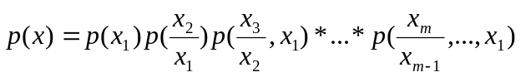 (1)

IPF could be used to model the joint probability distribution p(x₁,x₂,x₃) subject to known probabilities p(x₁,x₂) and p(x₁,x₃). Following Birkin and Clarke (1988), if pi(x₁,x₂,x₃) is the ith approximation to the three-attribute joint probability vector then:

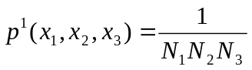 (2)

where Nj is the number of possible states associated with the attribute vector x. The vector can then be adjusted in proportion to the following known constraints:

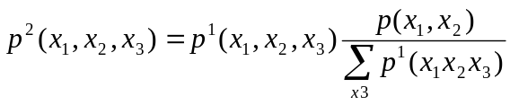 (3)

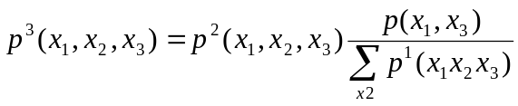 (4)

IPF involves iterating through the above equations (3) and (4) until a fitted distribution is obtained when the probabilities are convergent within some acceptable limit (Birkin and Clarke, 1988; Fienberg, 1970). This procedure can be generalised to a larger number of attributes: following Birkin and Clarke (1988), if we let Z_{k}(x) be a subset of the set of attribute vectors, E(x), for which marginal joint probabilities are known and let W_{k}(x) be the complement of Z_{k}(x), that is, W_{k}(x) = E(x) – Zk(x) then:

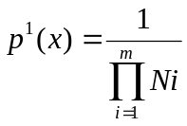 (5)

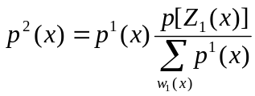 (6)
.
.
.
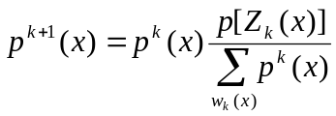 (7)
IPF would involve iterating between equations (6) and (7) until convergence (Birkin and Clarke, 1988). The mathematical and statistical properties of the IPF method are discussed in some detail by Fienberg (1970).

In its simplest form IPF can be used to adjust a simple two dimensional table derived from a sample survey so that the row margins (sums) and the column margins (sums) fit other known values. In any case, IPF typically produces maximum likelihood estimates of disaggregated conditional probabilities for the attributes of interest.

TO ADD MORE DISCUSSION INCLUDING MORE RECENT EXAMPLES HERE

Evaluation techniques

Generally, to verify the integrity of any model, it is necessary to validate the model outputs, using both internal and external validation methods (Edwards et al. 2010). Internal validation is the process whereby the variables that were used in the estimation of the output data are compared, so the input dataset is compared with the output dataset for those variables. This process examines the data from which the simulated dataset is drawn. External validation is the process whereby the variables that are being estimated are compared to data from another source, external to the estimation process, so the output dataset is compared with another known dataset for those variables.

Simple (Spearman) correlations expressed by R
To do a simple linear scatter plot, converting the data to percentages can be a useful technique (Ballas et al. 2005; Edwards and Clarke 2009). These results can be presented as scatter plots, with the simulated proportion on the x-axis and the actual (census) data on the y-axis with a trend line drawn through the datapoints. The R-squared statistic (the coefficient of determination) (R2) is an indicator that ranges in value from 0 to 1, and it reveals how closely the simulated values for the regression trend line fit the actual (census) data. A trend line is most reliable when its R 2 is at or close to 1. Thus, with this technique, we would expect to see a high coefficient of determination for the constraint/benchmark variables (i.e. variables used in the input dataset for the model) and, if known data is available, for the variable(s) being estimated.
However, regression analysis does not give any information about the fit of the simulated data to the ‘ideal’ line (i.e. where y = x and the simulated data is the same as the actual data). Rather, R 2 expresses the fit of the data to the ‘best fit’ line through that data. That is, the coefficient of determination is providing information about precision, not accuracy (Edwards and Tanton, 2013).

One way to do this is with a t test. With a spatial microsimulation model validation, the data are paired (given we are comparing simulated with actual data), thus an equal variance 2-tailed t test can be used to determine if there is any significant difference between the two datasets (i.e. simulated and actual). Thus, if the simulation is robust, we would expect to see no significant differences between the simulated and actual values for the input variables (and estimated/output variables, if known data are available). This enables the model accuracy to be assessed, as opposed to simply its precision.

Standard Error around Identity (SEI)
where SEI is the standard error around identity, y est are the estimated values for each area, y rel are the reliable estimates for each area from a census or other data source and y rel is the mean estimate for all areas where reliable data are available. This estimate has been used in validation by both Ballas and Tanton (see Ballas et al. 2007; Tanton et al. 2011).

Total Absolute or Standardized Error (TAE/SAE)
The SAE addresses this issue by using the population size as the denominator, but generally, authors seem to use total population, rather than the population for that categorization of the variable, which may be deemed to understate the size of the errors. Also, this measure does not provide any information on whether any differences are statistically significant (Edwards and Tanton, 2013).

Z-score

Here, the evaluation mainly takes place at the cell level (for a single constraint in a single area). However, there should also be attention for the overall picture like spatial concentration.

Alternative evaluation metrics

Input data
The input data used for this paper consists of two sets of aggregate constraints and two corresponding individual-level survey tables. The latter are both anonymous and have been ‘scrambled’ to enable their publication on the internet. The reason for doing this is to enable the results to be replicated by people anywhere worldwide, without breaching the user licenses of the data. To this end, all the input data (and code) used to generate the results reported in the paper are available online on github.

The smallest input dataset is ‘small-area-eg’. The area constraints consist of 24 Output Areas (the smallest administrative geographical unit in the UK), with an average population of 184 people aged over 16. Three files describe the number of hours worked, the marital status and the tenancy of these individuals (although tenancy in fact counts houses, not people): “hrs_worked”, “marital_status” and “tenancy”, all of which are stored as comma delimited text files (with the affix .csv) on github. A sample of these constraint variables is presented in table x below.

Table x: Sample of constraint variables from the first 5 rows of the small-area-eg input dataset

Cons. | Hrs worked/sex |  |  |  |  |  |  |  | Marriage status |  |  | Tenancy
area | m1 | m6 | m16 | m31 | m38 | m49 | f... | f49 | single | married | … | own | mort | … | other
1 | 0 | 3 | 3 | 6 | 24 | 30 | … | 8 | 40 | 137 | … | 88 | 30 | … | 3
2 | 0 | 3 | 4 | 4 | 37 | 28 | … | 6 | 55 | 115 | … | 66 | 46 | … | 22
3 | 3 | 5 | 4 | 5 | 26 | 18 | … | 5 | 40 | 137 | … | 67 | 44 | … | 3
4 | 0 | 0 | 3 | 7 | 19 | 29 | … | 5 | 38 | 111 | … | 51 | 30 | … | 3
5 | 0 | 0 | 5 | 10 | 35 | 26 | … | 7 | 43 | 118 | … | 51 | 49 | … | 8

The individual-level table that compliments these geographically aggregated count constraints is taken from Understanding Society wave 1. These have been randomized to avoid confidentiality issues, but they are still roughly representative of real data. The table consists of 1768 rows of data and is stored in R’s own space-efficient form (see “ind.RData”, which must be opened in R to be viewed properly). As shown in Table x below, the table consists of the same 3 constraint variables as provided in Table x above at the aggregate level, in addition to one ‘target variable’: monthly pre-tax income in pounds.

Table x: Randomly selected sample of 5 individuals taken from the individual-level dataset.

id | age | sex | marstat | jbhrs | house | income
69288603 | 64 | male | divorced | 25 | own | 1018.33
1088167963 | 63 | female | widowed | 3 | own | 1828
69224003 | 31 | male | single | 37.5 | own | 1761.2
136629683 | 39 | male | single | 32.5 | mort | 4752.5
816340683 | 27 | female | married | 14 | letting | 1194.27

... More here on loading-up this data.
Method: model experiments

Baseline scenarios
In order to perform a wide range of model experiments, in which only one factor is altered at a time, it was necessary to clearly define baseline scenarios. These are model runs with sensible defaults, which can be referred back to as a reference point and re-used at any point in the future.

The baseline 'small-area' scenario consists of ten iterations of IPF, in which all three constraints were used. The results, illustrated in Fig. X, show that IPF successfully brings the simulated cell counts in-line with the census after each constraint is applied and that the fit improves with each iteration (only two iterations are shown here, as the fit improves very little beyond two, and to avoid clutter).
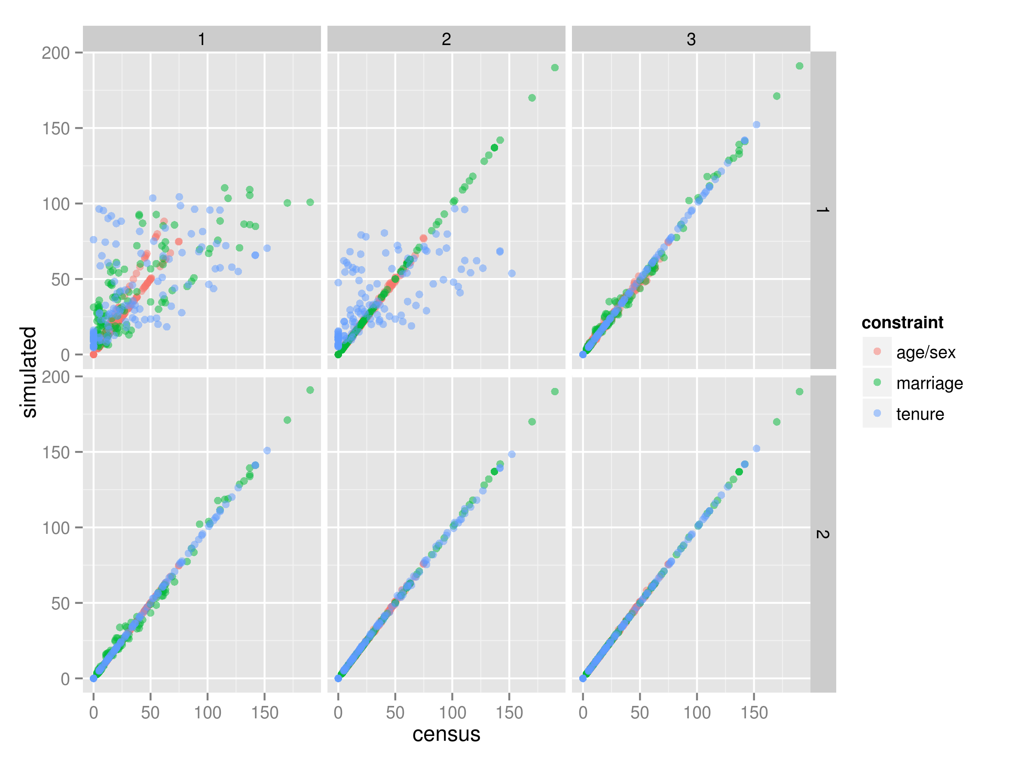
http://www.monbiot.com/
Fig. X IPF in action: simulated vs census zone counts for the small-area baseline scenario after each constraint (columns) and iteration (rows).

The baseline ‘Sheffield’ scenario consists of the same

Number and order of constraints

Number of iterations

Initial weights

Integerisation

This was the next variable that was altered, following ref. In the simplest scenario, the initial weight of a single individual was altered repeatedly, in a controlled manner. The code enabling this model experiment is contained in the folder “small-area-weights” (see “etsim.R”). The number of different initial weights can be controlled by the parameter “num.ws” which is set to 5 as an arbitrary default. Initial weights are set to k, which can be set to any function of N+, by altering the following line of code:

k = u/5 + 0.5 # initial weight of sample individuals for testing

In this case the resultant weights are set to 0.7, 0.9, 1.1, 1.3 and 1.5 for each model experiment. For factors of one million, for example, the above would be replaced by k = u*10^6 . To observe the impacts of altering the weights in this way the usual tests of model fit were conducted. In addition, the capacity of initial weights to influence an individual's final weight/probability of selection was tested by tracing its weight into the future after each successive constraint and iteration. This enabled plotting original vs simulated weights under a range of conditions (see Section x).

Results

Baseline scenario

As expected from fig. X above, the correlation of the baseline scenario improves over time, with each constraint and from one iteration to the next. Through the course of the first iteration, the correlation improves from 0.67 (the correlation between the frequencies of variables in the survey dataset and their frequencies in the census dataset, for each zone) to 0.9981. As illustrated in fig. X, the marginal improvement reduces from one iteration to the next: at the end of iteration 2, the correlation has improved to 0.999978.
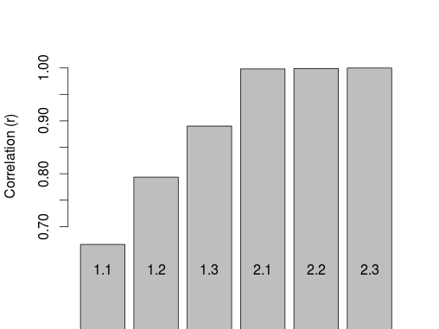
Number and order of constraints

Number of iterations
As illustrated above, the number of iterations required to reach a very close fit between the census and simulated data is very low, with rapid reductions in the marginal accuracy return on additional computing power. After four iterations, the result in R is indistinguishable from 1, with its default accuracy of 7 decimal places. The decay in the rate of improvement with additional iterations and constraints was found to super-exponential.

Initial weights
It was found that initial weights had little impact on the overall simulation. Taking the simplest case, a random individual (id = 228) was selected from the 'small area' data and his/her initial weight was set to 2 (instead of the default of 1). The impact of this change on the individual’s simulated weight decayed rapidly, tending to zero after only 5 iterations in the small-area scenario. It was found that altered initial weights affect the simulated weights of all other individuals; this is illustrated in Fig. X, which shows the impact on individual 228 and a randomly selected individual whose initial weight was not altered, for all areas.
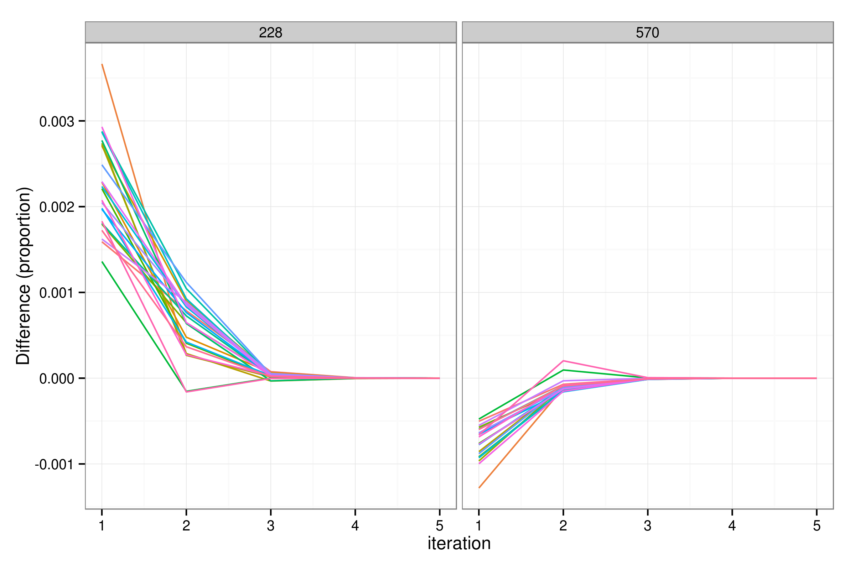
Fig. X: The impact of changing the initial weight of individual 228 on the simulated weights of two individuals after 5 iterations. Each of the 24 coloured lines represents a single zone.

Fig. X shows that changing initial weights for individuals has a limited impact on the results that tends to zero from one iteration to the next. After iteration one the impact of a 100% increase in the initial weight of individual 228 had reduced to 0.3%; after 3 iterations the impact was negligible. The same pattern can be observed in the control individual 570, although the impact is smaller and in the reverse direction. The same pattern can be observed for other individuals, by altering the ‘analysis.min’.

To analyse the impacts of changing the initial weights of multiple individuals, the same experiment was conducted, but this time the initial weights were applied to the first five individuals. The results are illustrated in Fig. X, which shows the relationship between initial and final weights for the first two individuals and another two individuals (randomly selected to show the impact of altering weights on other individual weights).
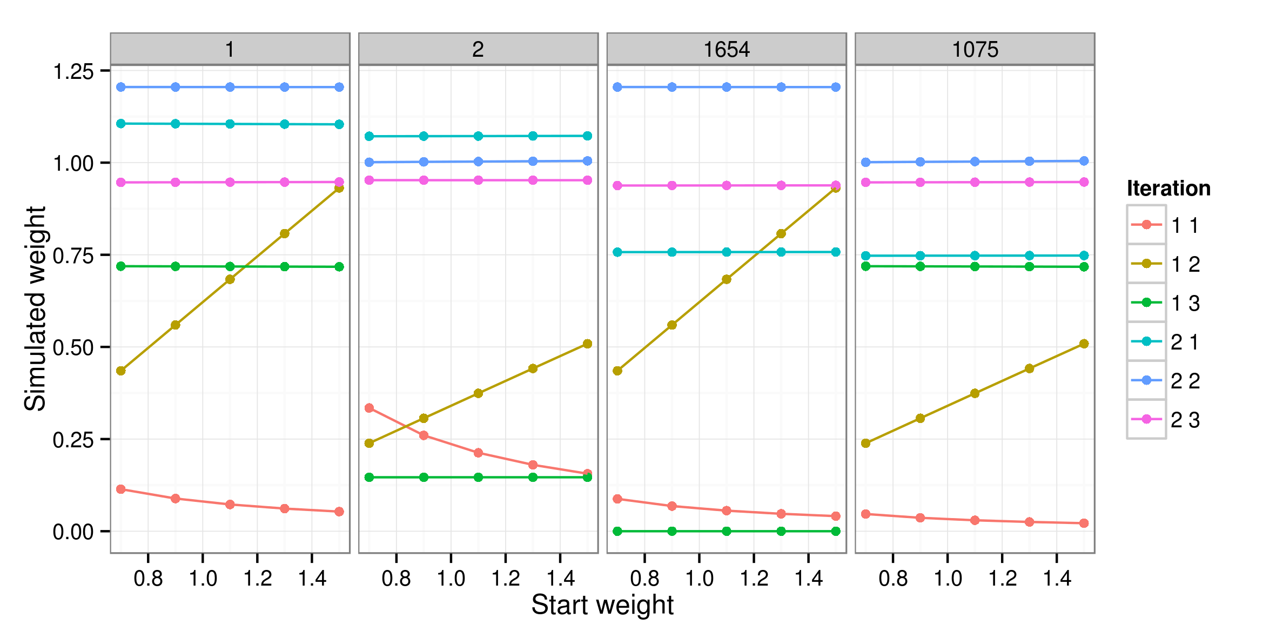
Fig. X: Initial vs simulated weight of four individuals for a single area (zone 1).

Fig. X shows that the vast majority of the impact of altered starting weights occurs in iteration.constraint 1.1 and 1.2, before a complete iteration has even occurred. After that, the initial weights continue to have an influence, of a magnitude that cannot be seen in Fig. X. For individual “1”, the impact of a 53% difference in initial weights (from 0.7 to 1.5) shrinks to 2.0% by iteration 1.3 and to 1.1% by iteration 2.3.

These results suggest that initial weights have a limited impact on the results of IPF, that declines rapidly with each iteration.

Empty cells

Integerisation
(same structure as above)

Initial weights

Summary of results

Experiment | Correlation | SEI | TAE | SAE | Z-score

Conclusions
Rubbish (deleted or unused content that may be useful)
Holding all other factors constant, the relationship between initial and 'final' weights (after repeated iterations) can be seen Fig. x. The same test was conducted for four other randomly selected individuals and the overall results were the same:

