Cycling projections in the National Transport Model - Briefing document

Context

With recent policy announcements on cycling and increased uptake in many urban areas, now is a good time to think about future scenarios of active travel. Quantitative models are a powerful tool in the transport planner's toolkit for developing policies to maximise the potential benefits of cycling. This briefing sets out the government aspirations, describes the NTM and its (lack of) cycling projects and, finally, outlines possibilities to create more ambitious scenarios of bicycle use at the national level.

Government aspirations

The UK government has has committed to increase the rate of cycling from its current level for economic, health and environmental benefit. This was set-out in the press release of a fresh tranch of money to promote cycling as a form of transport in target cities and national parks.

"Currently, only 2% of trips in the UK are made by bike, compared with 14% in Germany and almost a third in the Netherlands" ([Prime Minister's office](https://www.gov.uk/government/news/government-shifts-cycling-up-a-gear)).

In the press release, David Cameron stated that "we want to see cycling soar". "This government wants to make it easier and safer for people who already cycle as well as encouraging far more people to take it up".

These aspirations are echoed by the All Party Parliamentary Cycling Group (APPCG), which recommended concrete and measurable targets to accompany the investment: "The government should set national targets to increase cycle use from less than 2% of journeys in 2011, to 10% of all journeys in 2025, and 25% by 2050". These targets relate to *the proportion of all trips* made by cycling, so are robust to shifts in the demand for travel and population growth.

Cycling in the National Transport Model

Despite the recent high-level interest in cycling, the Department for Transport (DfT) did not publish its projections for the cycling rate in the latest report of NTM's findings (DfT 2013), in contrast to its 2012 report on NTM projections (DfT 2012). Cycling is mentioned 3 times in the extensive 2013 report on the NTM (DfT 2013). Yet projections of the actual cycling rate were omitted from the report, despite “cycle lanes and schemes” being mentioned as a “major” factor influencing road travel.

Information about cycling projections in the NTM was made public following a [parliamentary question](http://www.publications.parliament.uk/pa/cm201314/cmhansrd/cm131031/text/131031w0001.htm" \l "131031w0001.htm_wqn6), tabled on behalf of CTC, the national cycling charity. The ministerial response stated: “These [NTM] forecasts assume that the impact of smarter measures will increase cycling trips by 5% in 2015, 7.5% in 2025, and 10% in 2035.”

However, cycle use currently accounts for less than 2% of trips in Britain. So, all other things being equal, increasing cycle use by just 5-10% would still leave it at around 2% of trips in 2035. This lack of ambition to boost cycle use contrasts starkly with the APPCG's aspirations. The recommendations of their 'Get Britain Cycling' report [ref/hyperlink] aim to achieve a proposed target to increase cycle use from its current level to 10% of trips by 2025 and to 25% of trips by 2050. Note that even the first target is much more than simply a 10% increase - increasing cycle use to 10% of trips amounts to roughly a 500% increase in cycle use, and 25% of trips is roughly a 1250% increase. Many cities have experienced double-digit percentage increases in cycling per year, suggesting at least a doubling in cycle use within a decade in many areas if current trends continue (Lovelace et al. 2011). In Germany the distance cycled per inhabitant rose by 67% ( from 0.6 to 1.0 km per year) between 1978 and 2005 (Pucher & Buehler 2008), an annual rate of ... . In the Netherlands, the distance cycled per citizen rose by 25% in the years between 1978 and 1982, 5% *per year.,* from a much higher baseline (Pucher & Buehler 2008).

However, in discussion with CTC, DfT has since clarified that the NTM's predicted 5-10% increases are merely **relative** increases cycle use - due to DfT's programme of 'smarter choices' measures (e.g. promoting cycle use in schools and workplaces) - compared with a baseline scenario without those measures.

Meanwhile (and more seriously), other data in the parliamentary answer show that the NTM's predictions are in fact for cycle use to fall in absolute terms between 2015 and 2025 - despite the impact of those 'smarter choices' measures. It follows that the NTM's baseline projection would be for an even steeper fall over this period without those measures, raising the question, why are the NTM’s baseline scenarios so pessimistic regarding cycling? From a starting point of 2.9 billion miles, the total distance cycled is expected to peak at 3.4 billion miles around 2015, but then fall to 3.0 billion miles in 2025, before stabilising at 3.1 billion miles through to 2040.

Moreover, the Government's estimate of future population levels (DfT 2013) is for growth of 20% between 2010 and 2040. Hence the above cycle mileage figures correspond to a 14% drop in the distance cycled per person over this time frame, after accounting for population growth. CTC has described these projections as “[planning to fail](http://www.ctc.org.uk/news/government-planning-to-fail-on-cycling)”on cycling.

!!!Add image of cycle projections by APPCG

The National Transport Model

The [National Transport Model](http://webarchive.nationalarchives.gov.uk/20110202223628/http://www.dft.gov.uk/pgr/economics/ntm/) (NTM) is designed to provide a "a systematic means of comparing the national consequences of alternative national transport policies or widely-applied local transport policies". The model should provide a range of scenarios that "take into account the major factors affecting future patterns of travel."

The central projections of the NTM are influential, because they are the highest-level model results on which many decisions are made.

accounting for "" scenarios which take into account the major factors affecting future patterns of travel."

The NTM has a modular structure, with a central demand model interacting with rail and road modules (Chatterjee & Gordon 2006):

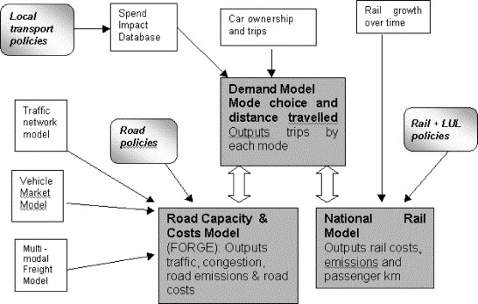

NTM's structure

Assumptions of the NTM

The NTM, like any model, makes simplifying assumptions in order to produce quantitative projections of change. Rather than setting the travel patterns directly, trip rates are set as a function of "background scenarios", taken from other sources. Primary among these are gross domestic product (GDP) and population growth assumptions (DfT 2013). Key to the NTM's outputs are these inputs and the link between GDP and travel patterns via car ownership and use: "The main determinant of car ownership is income and the car ownership results strongly reflect GDP growth" (Chatterjee and Gordon, 2006, p. 258).

This vision of a 'return to normality' driven by stable oil prices and a strong economic recovery for the many is starkly illustrated in the following figure (DfT 2012).

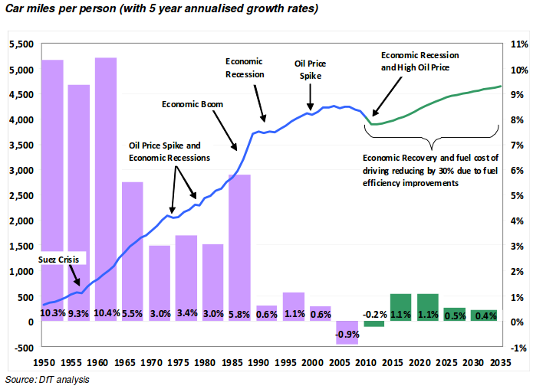

Projections of car use in the NTM

These projections contrast sharply with discussion of systemic changes in transport behaviour in advanced economy, labeled as "peak travel" and "peak car" in the academic literature (Millard-Ball & Schipper 2010; Goodwin 2012).

Possibilities for more ambitious NTM scenarios

With cycling so high on the agenda and evidence from other countries suggesting that sustained investment in cycling can lead to a substantial modal shift, there is an opportunity to use the NTM to create a more optimistic vision of the future regarding cycling. Like any model, the NTM is only as good as the input data and assumptions so, to gain a wide spectrum of possibilities, for which the model was designed, some of its core assumptions may need to be temporarily altered. The approach of allowing as many variables as possible to be altered was used by DECC in its 2050 planning tool, which has been popular with the public, encouraging them to engage in the process of long-term projections of future change.

The two main possibilities creating a more optimistic scenario are to alter the assumptions underlying the modal split in the model, or to deliberately assume that the rate of cycling reaches a certain share of trips by a certain date (e.g. 25% of trips by 2050) and ‘backcast’ to investigate how the target could be reached. This process of backcasting has been used in many models to inform policy, especially in situations where there is a long-term target to aim for (DfT 2005).

References

Chatterjee, K., & Gordon, A. (2006). Planning for an unpredictable future: Transport in Great Britain in 2030. Transport Policy, 13(3), 254–264. doi:10.1016/j.tranpol.2005.11.003

Department for Transport (2005). Visioning and Backcasting for UK Transport Policy (VIBAT). Stage 1 Baseline Report. Department for Transport, Crown Copyright 2005.

Department for Transport (2012). Road Transport Forecasts 2011. Results from the Department for Transport's National Transport Model. [www.gov.uk](https://www.gov.uk/government/uploads/system/uploads/attachment_data/file/4243/road-transport-forecasts-2011-results.pdf)

Department for Transport (2013). Road Transport Forecasts 2013 Results from the Department for Transport's National Transport Model. Accessed from [www.gov.uk](https://www.gov.uk/government/uploads/system/uploads/attachment_data/file/260700/road-transport-forecasts-2013-extended-version.pdf)

Lovelace, R., Beck, S. B. M. B. M., Watson, M., & Wild, A. (2011). Assessing the energy implications of replacing car trips with bicycle trips in Sheffield, UK. Energy Policy, 39(4), 2075–2087. doi:10.1016/j.enpol.2011.01.051

Goodwin, P. (2012). Peak travel, peak car and the future of mobility: evidence, unresolved issues, and policy implications, and a research agenda. In International Transport Forum Discussion Papers (No. 2012/13). OECD Publishing.

Millard-Ball, A., & Schipper, L. (2010). Are We Reaching a Plateau or “Peak” Travel? Trends in Passenger Transport in Six Industrialized Countries. Transportation Research Record, 2(1), 1–26. Retrieved from http://www.stanford.edu/~adammb/Publications/Millard-Ball Schipper 2010 Peak travel.pdf

Pucher, J., & Buehler, R. (2008). Making Cycling Irresistible: Lessons from The Netherlands, Denmark and Germany. Transport Reviews, 28, 495–528.