Cycling projections in the National Transport Model - Briefing document

Context

With recent policy announcements on cycling and increased uptake in many urban areas, now is a good time to think about future scenarios of active travel. Quantitative models are a powerful tool in the transport planner's toolkit for developing policies to maximise the potential benefits of cycling. This briefing sets out the government aspirations, describes the NTM and its (lack of) cycling projections and, finally, outlines possibilities to create more ambitious scenarios of bicycle use at the national level.

Government aspirations

The UK government has has committed to increase the rate of cycling from its current level for economic, health and environmental benefit. This was set-out in the press release of a fresh tranch of money to promote cycling as a form of transport in target cities and national parks.

"Currently, only 2% of trips in the UK are made by bike, compared with 14% in Germany and almost a third in the Netherlands" ([Prime Minister's office](https://www.gov.uk/government/news/government-shifts-cycling-up-a-gear)).

In the press release, David Cameron stated that "we want to see cycling soar". "This government wants to make it easier and safer for people who already cycle as well as encouraging far more people to take it up".

These aspirations are echoed by the All Party Parliamentary Cycling Group (APPCG), which recommended concrete and measurable targets to accompany the investment: "The government should set national targets to increase cycle use from less than 2% of journeys in 2011, to 10% of all journeys in 2025, and 25% by 2050". These targets relate to *the proportion of all trips* made by cycling, so are robust to shifts in the demand for travel and population growth.

Recent evidence shows that the distance cycled per person has surged rising by around 37% between 2005 and 2012, an annual growth rate of 6.5% during that period (DfT 2013b) (figure 1).[[1]](#footnote-0) As we shall see later, the NTM expects this trend to reverse.

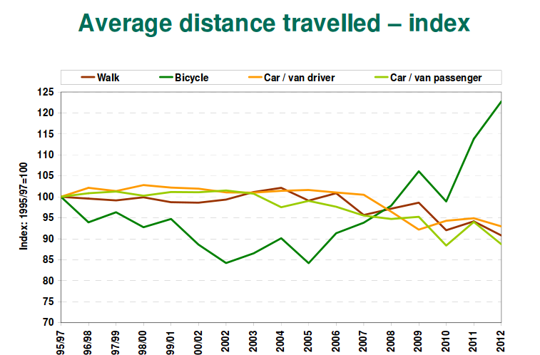

Figure 1. Distance travelled per person per year by mode relative to 1995/7 (DfT 2013b).

Cycling in the National Transport Model

Despite the recent high-level interest in cycling and evidence of its growing popularity throughout society, the Department for Transport (DfT) did not publish its projections for the cycling rate in the latest report of NTM's findings (DfT 2013a). This is in contrast to its 2012 report on NTM projections, in which no growth occurs in the share of trips made by bicycle up to 2035 (DfT 2012, figure 2) and the average length of bicycle trips is projected to fall after a peak in 2015 (DfT 2012, Fig. 4.6 in the report), with no explanation provided as to why. These counter-intuitive findings were presented graphically but not discussed. Cycling is even less prominent in the extensive 2013 report, being mentioned only 3 times (DfT 2013a). Projections of the actual cycling rate were omitted from the report, despite “cycle lanes and schemes” being mentioned as a “major” factor influencing road travel.

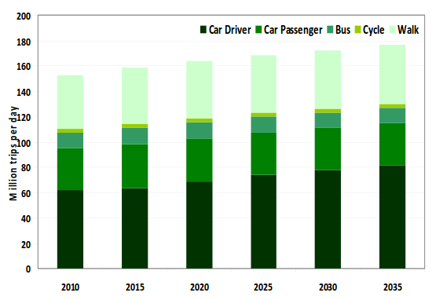

Figure 2. The modal split of trips from the 2011 NTM model runs (DfT 2012).

More information about cycling projections in the NTM was made public following a [parliamentary question](http://www.publications.parliament.uk/pa/cm201314/cmhansrd/cm131031/text/131031w0001.htm" \l "131031w0001.htm_wqn6), tabled on behalf of CTC, the national cycling charity. The ministerial response stated: “These [NTM] forecasts assume that the impact of smarter measures will increase cycling trips by 5% in 2015, 7.5% in 2025, and 10% in 2035”compared with an unspecified baseline. The reason for “boosting” the rate of cycling compared with the baseline scenario (by less than 0.5% per year on average), the DfT explained to the CTC subsequently, was government cycle schemes. This hardly suggests that cycle schemes are have a major influence on road transport.

Cycle use currently accounts for less than 2% of trips in Britain. All other things being equal, increasing cycle use by just 5-10% from its current rate would still leave it at around 2% of trips in 2040. This lack of ambition to boost cycle use contrasts starkly with the APPCG's aspirations. The recommendations of their 'Get Britain Cycling' report (APPCG 2013) aim to achieve a proposed target to increase cycle use from its current level to 10% of trips by 2025 and to 25% of trips by 2050. Note that even the first target is much more than simply a 10% increase - increasing cycle use to 10% of trips amounts to roughly a 5 fold rise in cycle use, and 25% of trips is more than ten times the current rate. Many cities have experienced double-digit percentage increases in cycling per year, suggesting at least a doubling in cycle use within a decade in many areas if current trends continue (Lovelace et al. 2011). In Germany the distance cycled per inhabitant rose by 67% (from 0.6 to 1.0 km per year) between 1978 and 2005 (Pucher & Buehler 2008), an annual rate of 1.9% (over 20% per decade). In the Netherlands, the distance cycled per citizen rose by 25% in the years between 1978 and 1982, over 5% *per year,* from a much higher baseline (Pucher & Buehler 2008).

Meanwhile (and more seriously), other data in the parliamentary answer show that the NTM's predictions are in fact for cycle use to fall in absolute terms between 2015 and 2025 - despite the impact of those 'smarter choices' measures. It follows that the NTM's baseline projection would be for an even steeper fall over this period without those measures, raising the question, why are the NTM’s baseline scenarios so pessimistic regarding cycling? From a starting point of 2.9 billion miles, the total distance cycled is expected to peak at 3.4 billion miles around 2015, but then fall to 3.0 billion miles in 2025, before stabilising at 3.1 billion miles through to 2040.

The Government's estimate of future population levels (DfT 2013a) is for growth of 20% between 2010 and 2040. Hence the above cycle mileage figures correspond to an 11% drop in the distance cycled per person over this time frame, after accounting for population growth.[[2]](#footnote-1) This implies that the baseline scenario must have projected an even greater drop in the rate of distance cycled per person by 2040, of around 30%. The CTC has described these projections as “[planning to fail](http://www.ctc.org.uk/news/government-planning-to-fail-on-cycling)”on cycling.

!!!Add image of cycle projections by APPCG

The National Transport Model

The [National Transport Model](http://webarchive.nationalarchives.gov.uk/20110202223628/http://www.dft.gov.uk/pgr/economics/ntm/) (NTM) is designed to provide a "a systematic means of comparing the national consequences of alternative national transport policies or widely-applied local transport policies". The model should provide a range of scenarios that "take into account the major factors affecting future patterns of travel." The central projections of the NTM are influential, because they are the highest-level model results on which many decisions are made. It is therefore important not only that they are realistic, but that they contain a *range* of future scenarios.

The NTM has a modular structure, with a central demand model interacting with rail and road modules (Chatterjee & Gordon 2006).

The assumptions of the National Transport Model

The NTM, like any model, makes simplifying assumptions in order to produce quantitative projections of change. Rather than setting the travel patterns directly, trip rates are set as a function of "background scenarios", taken from other sources. Primary among these are gross domestic product (GDP) and population growth assumptions (DfT 2013a). Key to the NTM's outputs seem to be these inputs and the link between GDP and travel patterns via car ownership and use: "The main determinant of car ownership is income and the car ownership results strongly reflect GDP growth" (Chatterjee and Gordon, 2006, p. 258).

This vision of a 'return to normality' driven by stable oil prices and a strong economic recovery for the many is starkly illustrated in the following figure (take from DfT 2012).

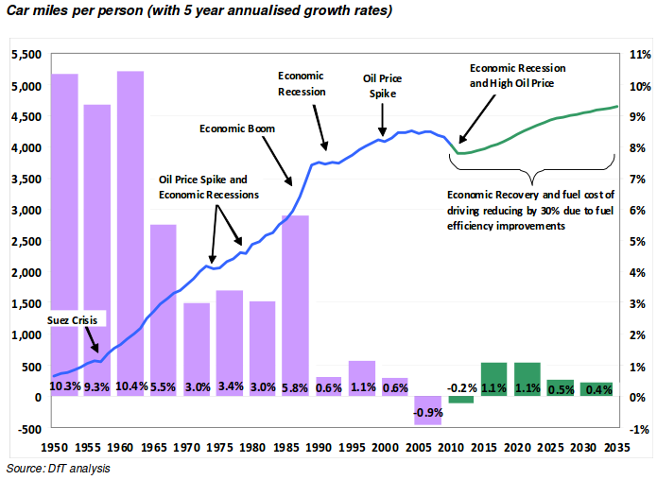

Figure 3. Projections of car use in the NTM

These projections contrast sharply with discussion of systemic changes in transport behaviour in advanced economy, labeled as "peak travel" and "peak car" in the academic literature (Millard-Ball & Schipper 2010; Goodwin 2012). DfT (2013a) references a report sponsored by the Royal Automotive Club into “peak car” (Le Vine & Jones, 2012) which notes “the lack of growth in car driving during the years of steady economic growth since the mid-1990s”, implying that car use may not grow, even under optimistic scenarios of economic growth. In addition, Le Vine and Jones presented evidence that “rate of decline [in car travel] is faster for higher income groups”, another indication that GDP alone may not be a good indication of the future modal split. Because most demand for additional driving comes from lower income brackets (figure 4) it is suggested that the NTM should focus on the income of this group into the future. This may provide more realistic results than the current focus on GDP.

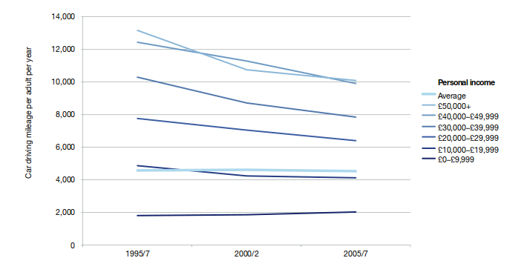

Figure 4: The income dependence of changing driving rates over time (Le Vine and Jones 2012).

The precise details of the assumptions underlying NTM projections are not known because an open source implementation of the model has not been made available. It would be interesting to run a wider range of scenarios than those reported in DfT (2013a), including runs specifically designed to explore of high cycle usage, continuing the recent trend towards increased distance travelled by bicycle per year. The main parameters determining the rate of driving per person are GDP (seemingly without heed to its distribution) and the price of oil. DfT (2013a) shows the results of sensitivity analysis of alterations in these parameters, yet all of the runs show essentially the same thing: a recovery and then steady growth (figure 5). The rate of change converges from around 2020 in any case, suggesting that the underlying *structure* of the model have not been altered. To capture the true diversity of possible futures, diverging model runs should be included.

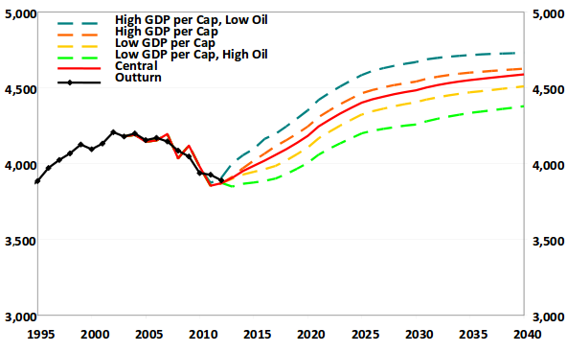

Figure 5. Car miles per person in alternative model runs of the NTM (DfT 2013a).

Possibilities for more ambitious NTM scenarios

With cycling so high on the agenda and evidence from other countries suggesting that sustained investment in cycling can lead to a substantial modal shift, there is an opportunity to use the NTM to create a more optimistic vision of the future regarding cycling. Like any model, the NTM is only as good as the input data and assumptions so, to gain a wide spectrum of possibilities, for which the model was designed, some of its core assumptions may need to be temporarily altered. The approach of allowing as many variables as possible to be altered was used by DECC in its 2050 planning tool, which has been popular with the public, encouraging them to engage in the process of long-term projections of future change. The NTM scenarios, by contrast, seem to alter only a few assumptions, rather than providing a fundamentally different vision of the future, that is needed for cycling to truly soar.

The two main possibilities creating a more optimistic scenario are to alter the assumptions underlying the modal split in the model, or to deliberately assume that the rate of cycling reaches a certain share of trips by a certain date (e.g. 25% of trips by 2050) and ‘backcast’ to investigate how the target could be reached. This process of backcasting has been used in many models to inform policy, especially in situations where there is a long-term target to aim for (DfT 2005).

Regardless of the approach used to create more ambitious NTM scenarios regarding active travel, it offers substantial benefits for policy makers. An explicitly pro cycling model run will not only increase the breadth of what policy makers see as possible (fulfilling the NTM’s role as providing “a means of comparing the national consequences of alternative national transport policies”.

Not only is it recommended that specific NTM scenarios are developed for increased cycling, there is also potential to include cycling rates into the report. At present the NTM is very car-orientated, which may not be appropriate in the context of increased priority allocated to the wider health, economic and environmental impacts of transport planning decisions.

References

All Party Parliamentary Cycling Group (APPCG) (2013). Get Britain Cycling. http://allpartycycling.files.wordpress.com/2013/04/get-britain-cycling1.pdf

Chatterjee, K., & Gordon, A. (2006). Planning for an unpredictable future: Transport in Great Britain in 2030. Transport Policy, 13(3), 254–264. doi:10.1016/j.tranpol.2005.11.003

Department for Transport (2005). Visioning and Backcasting for UK Transport Policy (VIBAT). Stage 1 Baseline Report. Department for Transport, Crown Copyright 2005.

Department for Transport (2012). Road Transport Forecasts 2011. Results from the Department for Transport's National Transport Model. [www.gov.uk](https://www.gov.uk/government/uploads/system/uploads/attachment_data/file/4243/road-transport-forecasts-2011-results.pdf)

Department for Transport (2013a). Road Transport Forecasts 2013 Results from the Department for Transport's National Transport Model. Accessed from [www.gov.uk](https://www.gov.uk/government/uploads/system/uploads/attachment_data/file/260700/road-transport-forecasts-2013-extended-version.pdf)

Department for Transport (2013b). National Travel Survey: 2012. https://www.gov.uk/government/uploads/system/uploads/attachment\_data/file/243957/nts2012-01.pdf

Le Vine, S., & Jones, P. (2012). On the move: Making sense of car and train travel trends in Britain.

Lovelace, R., Beck, S. B. M. B. M., Watson, M., & Wild, A. (2011). Assessing the energy implications of replacing car trips with bicycle trips in Sheffield, UK. Energy Policy, 39(4), 2075–2087. doi:10.1016/j.enpol.2011.01.051

Goodwin, P. (2012). Peak travel, peak car and the future of mobility: evidence, unresolved issues, and policy implications, and a research agenda. In International Transport Forum Discussion Papers (No. 2012/13). OECD Publishing.

Millard-Ball, A., & Schipper, L. (2010). Are We Reaching a Plateau or “Peak” Travel? Trends in Passenger Transport in Six Industrialized Countries. Transportation Research Record, 2(1), 1–26. Retrieved from http://www.stanford.edu/~adammb/Publications/Millard-Ball Schipper 2010 Peak travel.pdf

Pucher, J., & Buehler, R. (2008). Making Cycling Irresistible: Lessons from The Netherlands, Denmark and Germany. Transport Reviews, 28, 495–528.

1. Annual rate of interest was calculated as 1.37^(1/(2012-2007)). [↑](#footnote-ref-0)
2. 2.9 \* 1.2 = 3.48, the distance cycled overall in 2040 if the distance cycled per person remains constant. (3.1 - 3.48) / 3.48 = -0.109, an 11% drop. [↑](#footnote-ref-1)