The Title of the Paper

Author A[1]1, Author B[2]1 and Author C[3]2

1Department for Author A

2Department for Author C (if different)

June 20, 2014

**Summary**

Summary of no more than 100 words *(this needs to be pasted into the ‘Abstract’ box on EasyChair)*.

**KEYWORDS:** up to 5 keywords or short phrases relevant to the work (*these need to be pasted into the ‘Keywords’ box on EasyChair).*

# Introduction to guidelines

The purpose of providing these notes is to standardise the format of the short papers submitted to GISRUK 2015. These notes are based on author guidelines previously produced for the GISRUK conference series which in turn were based on other guidelines.

The pages should have margins of 2.5 cm all round. The base font should be Times New Roman 11pt, or closest equivalent and text should be single spaced. Each section of the paper should be numbered. Section headings should be left-justified and given in bold type. A slightly larger font should be used for the title of the paper and the authors (16pt and 14pt respectively). The first line of each paragraph in each section should **not** be indented.

## Sub-sections

Sub-sections should also be numbered as shown here. The sub-section heading should be left-justified and given in bold type (11pt).

# Figures, Tables and Equations,

Tables should be as shown below (or as close as possible) and should be referenced as Table 1 in the text.

**Table 1** GISRUK Conferences

|  |  |
| --- | --- |
| Year | City |
| 2007 | Maynooth |
| 2008 | Manchester |
| 2009 | Durham |
| 2010  2011 | UCL  Portsmouth |
| 2012 | Lancaster |

Equations should be centred on the page and numbered consecutively in the right-hand margin, as below. They should be referred to in the text as Equation 1.

|  |  |
| --- | --- |
| *E=mc*2 | (1) |
|  |  |

Figures should be presented as an integral part of the paper and should be referred to as Figure 1 in the text.

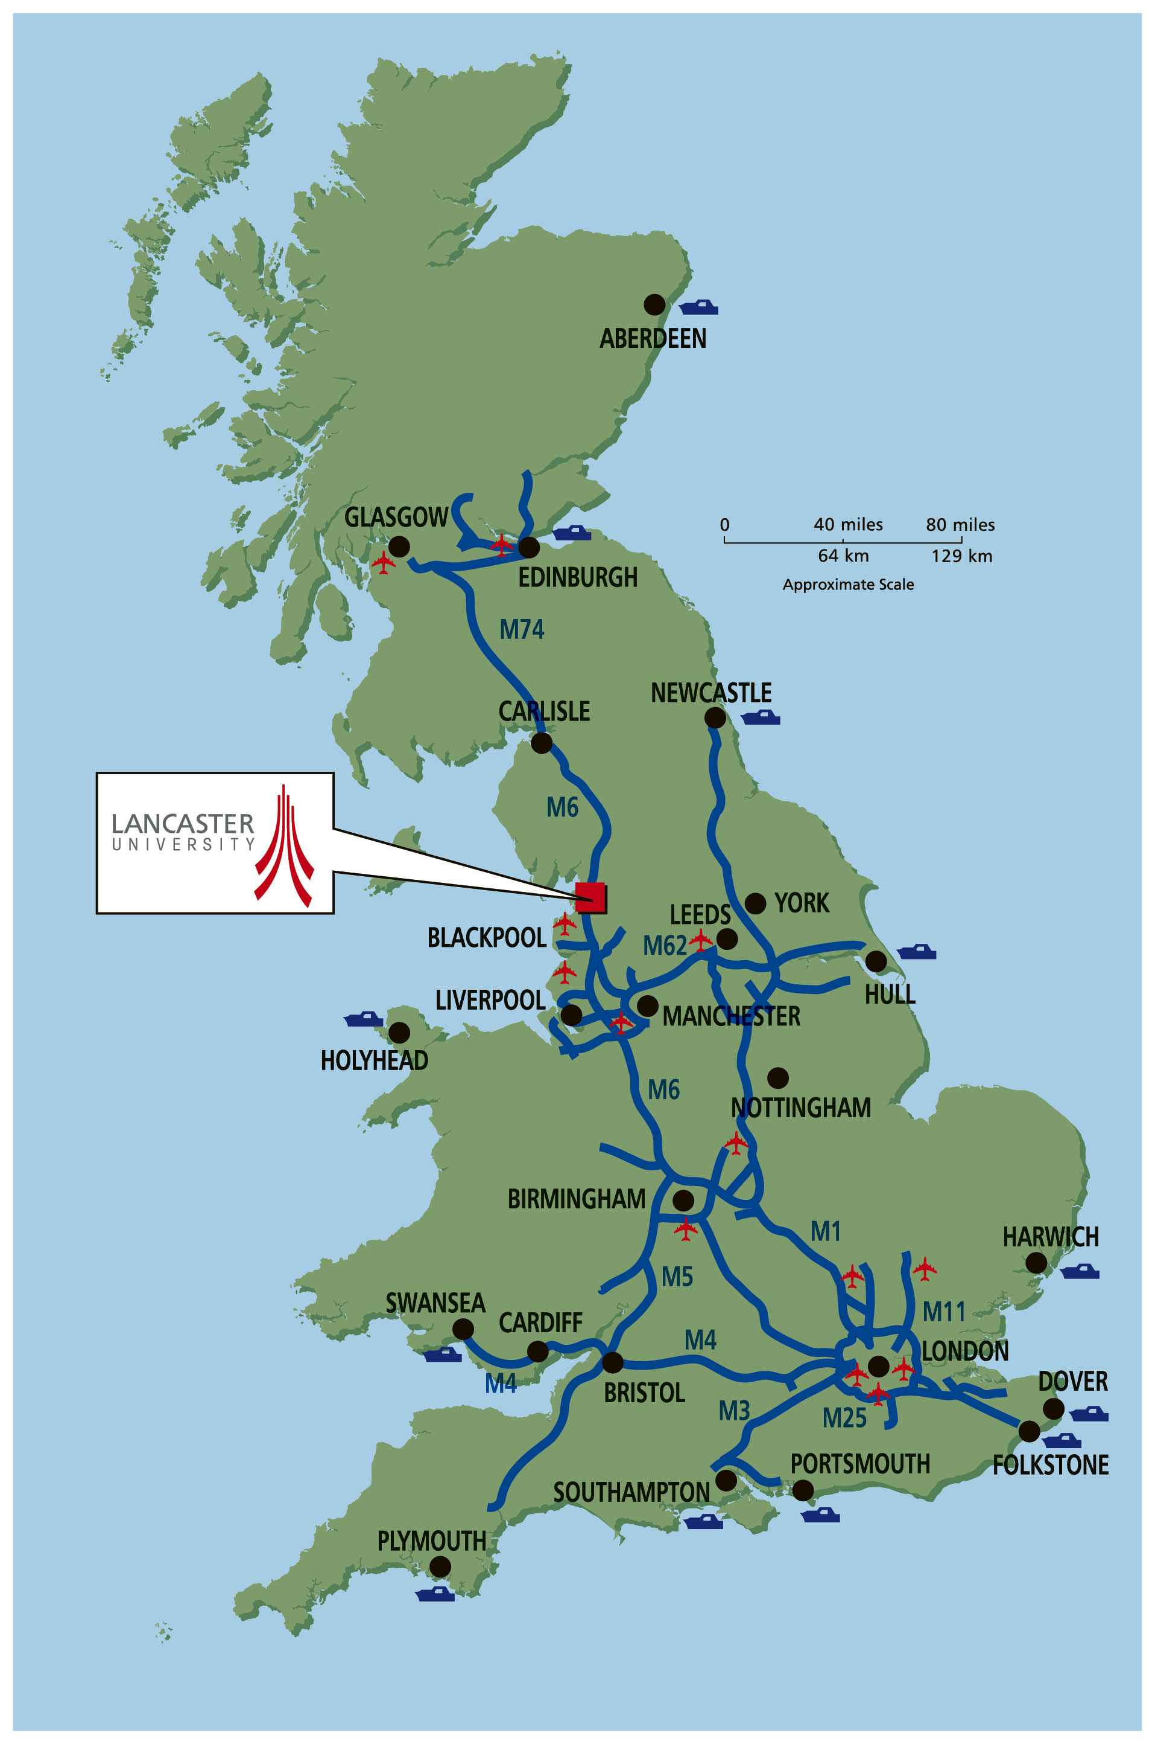

**Figure 1** Location of Lancaster University

# References and Citations

A list of references cited should be provided at the end of the paper using the Harvard format as shown below. Citations of these within the text should be given as follows: papers such as an interesting one by Harvey and Tulloch (2006) and also interesting books (Day, 1995).

# File format

Papers should be submitted in unrestricted **pdf** format. Authors are requested to keep to the word limit of 1500 words.

# Acknowledgements

Acknowledgement should be made of any funding bodies who have supported the work reported in the paper, of those who have given permission for their work to be reproduced or of individuals whose particular assistance is due recognition. Acknowledge data providers here where appropriate.

# Biography

All contributing authors should include a biography of no more than 50 words each outlining their career stage and research interests.

# References

Day R A (1995). *How to write and publish a scientific paper*. Cambridge University Press, Cambridge.

Harvey F and Tulloch D (2006). Local-government data sharing: Evaluating the foundations of spatial data infrastructures. *International Journal of Geographical Information Science,* 20(7), 743-768.

1. author.a@university.edu
2. author.b@university.edu
3. author.c@university.edu