ANALYZING THE POTENTIAL OF ‘BIKE & RIDE’ TO PRIORITISE INVESTMENT IN SUBURBAN CYCLING AND PUBLIC TRANSPORT INFRASTRUCTURE: A CASE STUDY OF SEVILLE

ABSTRACT
Methods for estimating cycling potential for single-mode trips are well-established. Less attention has been paid to the question of how to promote cycling as the first leg of multi-stage trips involving public transport (PT). This ‘bike & ride’ option has many potential benefits: boosting the level of cycling beyond that attainable through promotion of single-mode cycle trips alone; reducing car dependency in suburban areas not generally viewed as having high cycling potential; and reviving demand for PT services. But how to plan for ‘bike & ride’ uptake? This paper presents a reproducible method for estimating bike & ride potential, based on geographic analysis of catchment areas and stated preference surveys of the relevant population. We illustrate the method using a case study of Seville, with insights into suitable locations for new cycle paths and appropriately sized cycle parking facilities to encourage bike & ride uptake. Deployed in other cities, we conclude that these methods could provide a strong evidence base for the cost-effective investment in new suburban cycling infrastructure.
1. INTRODUCTION

The positive impacts of utilitarian cycling on public health and environment are well-known (Pucher & Buehler, 2012a). Mounting evidence of the public health benefits of active travel has triggered a growing interest on policies aimed to promote bicycles as a mean of transport worldwide (Pucher et al., 2010). The high potential uptake of cycling as a mode of transport in urban areas derives from three main interrelated attributes. Cycling is highly efficient compared to motor vehicles, and often faster for trips shorter than 5 km (Dekoster & Scholaert 1999); is accessible to a wide range of people, regardless of age and income; and has broad possibilities of combination with public transport (PT), enabling cycling to form part of longer-distance trips (Dekoster & Scholaert 1999; ECMT, 2004; Pucher & Buehler, 2012b). The last of these attributes, the focus of this paper, is important for cycling uptake in low density settlements where average trip distances tend to be prohibitive for many potential cyclists, provided PT options are available.

Moreover, if cycling to bus stops and rail stations were more attractive, PT could become a far more viable option in many settlements outside central city areas. This ‘bike & ride’ option, whereby “people outside of town use their bikes to get to a conveniently located transit stop and continue from there by PMT [public mass transit]” (Krel, 1989, p. 218) has several knock-on benefits in related to reduced car dependency. Often, potential PT journeys are not made due to the time taken to walk to and from PT nodes, and the perceived need for multiple waits for taxis and buses in multi-stage trips. This paper argues that the combination between cycling and PT has great potential to improve the sustainability and efficiency of public transport systems, by increasing the catchment area of the stations and by reducing delays caused by changes between multiple public and private motorized modes. Such potential can be expected to be greatest in low population density areas, where distances between homes and public transit stations may be excessive for walking.

Cycling-PT integration can happen in three ways: by carrying the bike on board the public transit vehicle (bike & carry), by taking the bike at the activity-end station (ride & bike), and by parking the bike at the home-end public transit station (bike & ride). There are several reasons for the focus on this last option. Except for ferries, public transport vehicles generally have limited capacity for carrying cycles, limiting the potential of bike & carry options (Krizek & Stonebraker, 2010). For this reason, the most common infrastructures for massive bicycle and PT combinations are safe cycle parking facilities at stations (Martens, 2004; Martens, 2007; Ploeger et al., 2007; Pucher & Buehler, 2012b). Another reason for focusing on bike & ride solutions rather than activity-end interventions is that cycling has already experienced substantial levels of interest and (in some more progressive cities) investment in city centers, while cycling in residential suburbs remains comparatively neglected.

In some areas bike & ride is already common. In The Netherlands 42% of trips to train stations are made by cycling. Denmark and Germany also have high levels of intermodality between cycling and PT (Martens, 2004; Martens, 2007). In Asia, China and Japan also have high percentages of combined use of bicycles and public transport (Pucher & Buehler, 2012b). In Japan, most of the infrastructure aimed to the promotion of cycling is related with bicycle and public transport links (Pucher & Buehler, 2012b). In China, the growing problems of congestion and pollution, as well as the associated increase of road accidents, have lead to substantial changes in the mobility policy of the Government, including a return to policies promoting bicycles (Pucher et al., 2007) also aimed to the promotion of bicycle and public transport links (Sheena et al., 2011, Peng et al., 2012). Nevertheless, in most cities around the World, links between bicycle and public transport are poorly developed. For this reason, methods to estimate the potential of cycle-PT uptake are needed to provide an evidence base for sustainable transport planning in those cities which currently lack proper support for these mutually-beneficial modes.

An apparent limiting factor for such demand is distance. The average distance a cyclist would be willing to travel to access or egress from a public transit station has been estimated by Dekoster and Schollaert (1999) as 3.2 km, on the basis of an average speed of 20 km/h and a travel time of 10 minutes. Rietveld (2000) estimated a distance of 3.5 km. Krygsman et al., (2004) estimated a distance of 1.8 km for access and of 2.4 km for egress from the analysis of metropolitan public transport in the region of Amsterdam-Utrecht. Martens (2004) evaluated the distances traveled by cyclists to access public transit stations in several countries for different transport modes. Martens’ results are consistent with an average distance of 3 km, which is, in fact, the distance recommended by the Dutch Manual for Bicycle Traffic Design (Ploeger et al., 2007).

The above distances are significantly larger than catchment distances for pedestrians. . Krygsman et al. (2004) give estimates of 500 and 600 meters, respectively, for the pedestrian access and egress distances of metropolitan public transit stations in the region of Amsterdam-Utrecht. O'Sullivan and Morrall (1996) recommended catchment distances ranging from 400 to 900 meters for the planning of metropolitan transport stations in the area of Calgary (Canada). From these studies there is clear evidence that pedestrian catchment distances vary between 300 and 900 meters, taking larger values for higher capacity modes and for farther stations. In Spain, where our case study is located, handbooks recommend distances ranging from 300 meters for bus stations to 500 meters for rail stations Therefore, it can be concluded that intermodality between bicycle and public transport extends the radius of influence of public transit stations from 300-900 meters to approximately 3 km. This implies that catchment areas accessible to citizens could increase by 11 to 100 times if cycling to and from PT nodes becomes an attractive option.

Regarding the influence of high social status and automobile availability on the likelihood of using bike & ride, most studies in Europe suggest that these factors have little impact (Martens, 2004; Debrezion et al., 2009) or even show a positive correlation (Krygsman & Dijst, 2001). However, studies in North America (Bachand-Marleau et al., 2011) show a small negative correlation between the availability of a motor vehicle and bicycle use in combination with public transport. Cultural factors may influence these findings, although it is also quite possible that they are linked to specific policies. Thus, Krizek & Stonebraker (2004) question whether the supply of free car parking lots at stations, a very common in policy in the US, could discourage bike & ride. In any case, there is little evidence for links between socio-demographic factors and willingness to bike & ride, implying the option could be beneficial from a transport equity perspective.

Census data on cycling mode split suggests that adverse weather conditions such as extreme temperatures and precipitation reduce the attractiveness of cycling (Parkin et al., 2007). Studies made in Northern Europe show a decline of cycling as mode ‘feeding’ public transport nodes by up to 50% in winter (Martens, 2004). In countries at lower latitudes the behavior could be the opposite, enhanced by the usual coincidence between summer and holidays. In any case, these findings are of limited relevance for our analysis, because the infrastructure for cycle and public transport links should be designed around the optimal conditions of operation, not for the average.

Slope is one of the most decisive factors discouraging bicycle use (Rodriguez & Joo, 2004; Parkin et al., 2007) and should be considered in any analysis of the potential of cycling as a mode of transport. The Dutch manual for bicycle traffic (Ploeger et al., 2007; Figure 9) sets at 8% the upper limit for slopes tolerable by utilitarian cyclists and at 2% the slope without no effect on utilitarian cycling in the absence of wind. Other studies (Broach et al, 2009; Aultman-Hall et al., 2012) analyze the detour that most cyclists would be willing to make in order to alleviate a continued slope. It is clear that gradient influences catchment distances of public transit stations and should thus be included in the analysis.

For the analysis and design of bike & ride infrastructures it is important to differentiate (Martens, 2004) between access trips (at the home-end of the combined trip) and egress trips (at the activity-end of the combined trip). Obviously, the expected number of access trips that could be made using bike & ride is the relevant parameter for designing parking infrastructure at each station. Providing safe cycle paths to access from homes to public transit stations is also an important part of policies aimed to promote bicycle and public transport links (Pucher & Buehler, 2012b)

This paper aims to develop a method to estimate the potential uptake of bike & ride between suburban areas and city centers. We focus on cycling to enable suburban access to PT, as opposed to ‘ride & bike’ and ‘bike and carry’ options (defined above), because such trips take most advantage of the longer distances enabled by cycling, (distances between homes and PT stations are often greater than between PT stations and destinations such as work places and shops). Additional reasons for this focus include the fact that egresses by bike (transferring from PT to cycling at the ‘activity end’) are less common than cycling the first stage of PT trips (Martens, 2007); that expensive overnight storage of cycles is not needed for bike & ride systems to work, as cycles can usually be stored in citizens’ homes and garages; and that much research has already focused on cycling potential in city centers. However, some aspects of the present method could be extended to analyze these other types of cycle-PT integration.

The method presented is well-suited to areas where there is little cycling infrastructure at suburbs, as demonstrated with reference to a case study in the city of Seville, Spain. In fact, Seville can be considered as an example of city with a well-developed cycling infrastructure at the central area, but lacking of such infrastructure at the suburbs (Marques et al. 2015). The method’s use of available secondary data for the determination of the catchment areas for the most relevant public transit stations using open source Geographic Information Systems (GIS) software, makes it widely applicable to other countries around the world. An additional primary data source, a stated preference survey of residents in the study area, is used to augment the spatial data and demonstrate how attitudinal data can be used in combination with geographic analysis for robust estimates of latent demand for bike & ride.

GIS has been previously used for the analysis of cycling infrastructure (Aultman-Hall et al., 1997; Larsen et al., 2013), accessibility to public transport (O’Sullivan et al., 2000) and also for the planning of links between bicycle and public transport (Adjei, 2010). Since we are trying to evaluate the impact of a policy not currently existing in the city, that implies the introduction of a new solution for its mobility, stated preference surveys are the most appropriate tool for the evaluation of the potential demand (Ortúzar & Willumsen, 2011).

The city of Seville is a relevant case study because it is a medium size city, with a monocentric structure found in many parts of the world. It has a central area (the Municipality of Seville) with a population of 700,000, for whom cycling is a viable form of transport for many everyday trips. The city is surrounded by a much more extensive suburban area, comprising many other municipalities, with approximately the same population and with intensive transport links with the central area. Seville is a particularly interesting case study as it has experienced a cycling boom, in which the mode share of cycling increased from less that 1% to more than 5% for utility trips in the Municipality of Seville (Castillo-Manzano & Sánchez-Braza, 2013a; Castillo-Manzano & Sánchez-Braza, 2013b; Castillo-Manzano et al., 2015; Marqués et al., 2015). The historical development of this boom is described by Marqués et al. (2015).

Public policies enabling this boom were mainly focused on the development, between 2006 and 2011, of a network of segregated bike paths (Marqués et al., 2015) followed by the implementation, at the end of 2007, of a successful bike sharing system (Castillo-Manzano & Sánchez-Braza, 2013a; Castillo-Manzano et al., 2015). However, no public policies to improve cycling outside the Municipality of Seville, nor cycling and PT integration has been developed to date. The lack of attention given to cycling and PT links is particularly surprising in Seville due to the growing pollution and congestion associated to trips from the suburbs to the central city area, and to the evidence that the impact of current policies aimed to further promote cycling may be stagnating (Marques et el., 2016). These features of Seville’s cycling policies, focused on trips internal to the central area and neglecting trips with origin at the suburbs, are common to many cities aiming to increase the mode share of cycling. Therefore, although the present analysis targets overcoming these difficulties in the area of Seville, it could also provide a source evidence, methodology and inspiration in other similar contexts.

The paper is organized as follows: In Section 2 the proposed methodology is described. This includes the determination of the catchment areas for each public transit station, the relevant population, the number of trips that could be made by combining bicycle and public transport and, finally, the potential demand for such trips, using a modified version of a method for estimating cycling potential at the ‘desire line’ level (Lovelace et al., 2017). In Section 3 this methodology is applied to the metropolitan area of Seville. In the last Section we briefly discuss our main results and present the conclusions of our work.
2. METHODOLOGY
We consider the latent demand (potential) for combined bicycle and public transport trips per PT station as a function of the following variables:
- The catchment area for the considered station.
- The population living in this area, which is the population living at a “cycling distance” from the public transit station.
- The total number of trips that this population do on a daily basis between the considered catchment area and the city center.
- The stated preferences of the population living at a cycling distance of the stations.

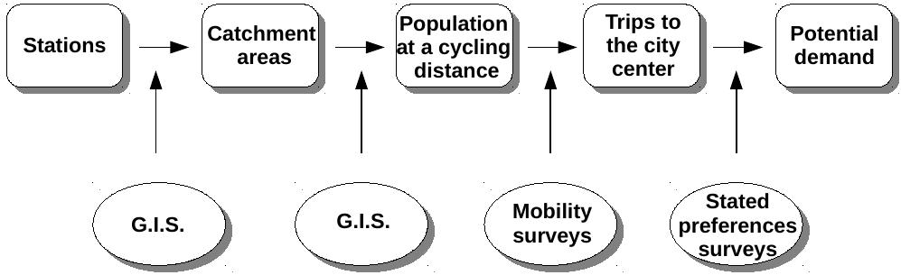
Figure 1: Schematic of the steps of the proposed methodology.

Figure 1 presents a schematic representation of the main steps of the methodology. The defines the catchment areas for the considered stations. As a first approximation, circles of 3 km radii around each station can define the catchment areas (Ploeger et al., 2007). We followed this method, with the following adjustments:
- For reasons of available space, location, etc., not all stations are appropriate conditions for bicycle and public transport integration and can be omitted. Since the aim is connecting the suburbs with the central area of the city, a natural is to consider only high capacity public transit stations, where interventions would be worthwhile.
- After this first selection stage the catchment areas of some stations are merged, because their individual catchment areas overlap (this is common in this context because stations are usually located considering walking distances, not cycling distances).
- The primary catchment areas, which are simply circles of 3 km of radii around the stations, are corrected to account for barriers to cycling, including:
  - Natural barriers like rivers without appropriate bridges for cyclists.
  - Artificial barriers like highways or restricted areas.
  - Steep slopes
Natural and artificial barriers can be easily included in the GIS by omitting affected areas. Slopes, however, need of a more complex analysis. Broach et al. (2009) state that most cyclists in the presence of a continued slope would be willing to make an additional detour of a 27% for each 1% of additional slope. Following this analysis, the detour ΔD an average cyclist would be willing to do in the presence of a continued slope will be given by:
D+ΔD = D⨯(1+0.27)^{p} (1)
where D is the straight distance and p is the slope expressed as a percentage. This will reduce the catchment distance by a factor
D/(D+ΔD) = (1+0.27)^{-p} (2)
which means that a slope of a 3% will reduce the catchment distance by a 50%. In practice, implementing Eq. 2 in the GIS analysis would be difficult. Therefore, as a first approximation, we can assume that slopes of 3%, that require cyclists to double the distance they have to travel, represent a psychological limit for most cyclists, so that they will refuse to use their bicycles to access or to egress from the public transit stations. Of course this limit is cultural, and may change from one region to another (a steeper slope, of 5% for instance, could be used in hill-tolerant areas such as Switzerland).
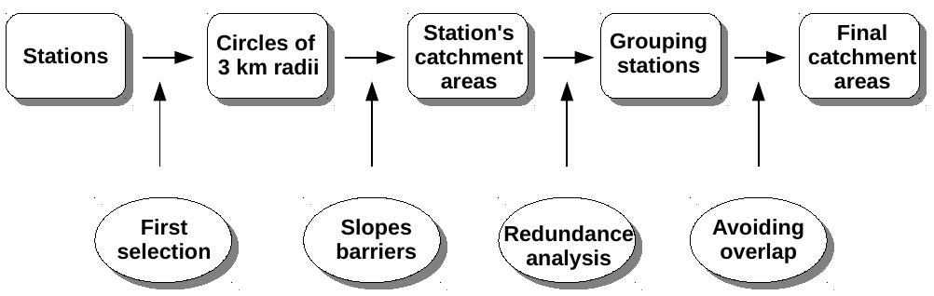
Figure 2: Graphic outline of the process of determining the catchment areas

Figure 2 shows a graphic illustration of the process of determining the final catchment areas. The final result is the division of the territory in a number of catchment areas that do not overlap between them.

The total population living in each catchment area must then be determined from the census or other appropriate dataset. The next step is to subtract from this population the number within walking distance of the stations. This provides the population at a cycling distance, that is, the population that could potentially combine bicycle and public transportation for trips to the central city are.

The next step is to determine the total number of trips that such population actually makes to the central city area, regardless of the specific mode they use. For this purpose mobility surveys (pre-existing or ad hoc) can be used. These should count only trips generated at home, because these are the trips that determine the upper limit for the potential number of accesses to the public transit stations.

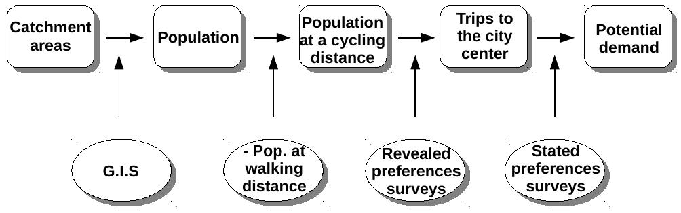
Figure 3: Sketch of the lasts steps for the determination of the potential demand.

The potential for combined bicycle and public transport trips is then determined from the stated preferences of the population involved in the aforementioned trips to the city center. Ideally, this survey should be made alongside the mobility survey or, if this is not possible, on the same population. This stated preference survey must be directed to people already traveling to the central city area on any transport mode and include questions on willingness to make combined bicycle and public transport trips. Typically, the stated preference survey would contain questions on:
- Willingness (yes or no) for using their bicycle in combination with the public transport provided there were safe bicycle parking at home-end stations.
- The same provided there were safe cycle paths connecting homes and home-end stations.
- The same provided there was any other infrastructure of interest.
- How many times they travel to the city center per week
- The frequency of use of the bike for any purpose, with at least four possible answers:
  - Never or almost never.
  - Several times each month.
  - Several times each week.
  - Daily or almost daily.
as well as on any other information of interest for each particular study.

Analysis of the survey data provides the final estimate of potential demand D_{ijk} of a given piece of infrastructure i (for instance safe parking at stations) under the scenario of change j (for instance, short or long therm demand) at catchment area k:
D_{ijk} = C_{ijk} × Τ_{k} ≤ T_{k} (3)
where T_{k} is the total number of trips made daily from area “k” to the city center and C_{ijk} is a coefficient given by:
C_{ijk} = Σ_{n}(N_{kn} × W_{ikn} × B_{jkn}) / Σ_{n}(N_{kn}) (4)
where N_{kn} is the weekly number of trips to the city center made by each respondent of the area “k”, W_{ikn} is the willingness of each respondent of the area “k” to use the infrastructure “i” (W_{ikn}=1 if the answer was “yes” and W_{ikn}= 0 if the answer was “no”), B_{jkn} is a coefficient B_{jkn}= 1 if the hypothesis “j” is fulfilled and B_{jkn}= 0 if it is not, and “n” varies from 1 to the total number of respondents for the k-th catchment area. The summation is extended over all participants in the survey.

As an example illustrating the usefulness of coefficient B_{jkn}, consider the short, medium and long term demands as a function of the present use of the bike by the population. In such case, we can use the results of the proposed survey to determine long-term demand (j = 1) by taking B_{1kn} = 1 when the participant would use the bike (irrespective of the frequency) and B_{1kn} = 0 when the participant would not cycle. The short term demand (j = 3) could be determined by taking B_{3kn} = 1 only for respondents that declare to use the bike at least several times each week. For the intermediate demand (j = 2), B_{2kn} will be taken as 1 for people using the bike at least several times each month. More multiplicative coefficients B'_{lkn} can be added or other scenarios (j = 1, 2...). The overall process is sketched in Figure 4.

Figure 4: Sketch of the procedure for the stated preferences survey and the final estimation of the demand.
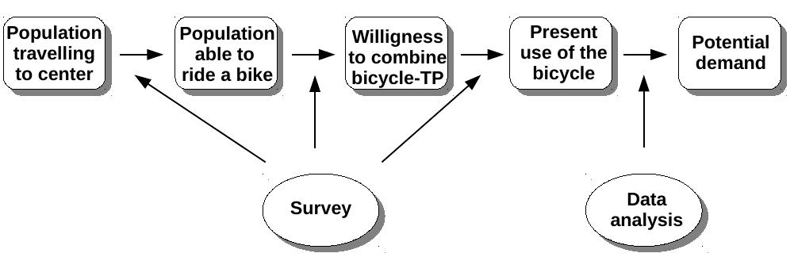

At this point, the demand of potential bike & ride trips to the central area of the city is already determined for each catchment area. The next step is to assign this demand to the different stations inside each catchment area, in order to provide the necessary parking infrastructure, as well as the necessary access infrastructure (bike paths for instance) or any other relevant infrastructure at each station. For this purpose, a modified version of the method for estimating cycling potential at the route level recently proposed by one of the authors (Lovelace et al., 2017) is used. The main purpose of this last step is to assign to each station inside each catchment area a given fraction of the population of the whole area, through the identification of the best cycle routes to each station. The analysis provides the potential demand for safe parking and/or any other infrastructure under analysis at each station, and insight about where cycle paths leading to the station should be prioritised.

Following this procedure, the potential demand for infrastructure i (for instance, safe parking) at station n (n = 1, 2, …) inside area k (k = 1, 2, …) in the scenario j (j = 1,2, …) d_{n1jk} is given by:
d_{ijkn} = f_{kn} × D_{ijk} (5)
where f_{kn} is the fraction of the total population of area k assigned to station n. The potential demand d_{ijkn}, gives the daily expected number of bicycle access trips that need some infrastructure (i) in some hypothesis (j) at some station (n, k).

3. APPLICATION TO THE AREA OF SEVILLE

Seville is a medium size city with approximately 700,000 inhabitants in the central area (the Municipality of Seville) and a similar population in its suburban areas. The most recent mobility survey (2007) reports a total of 497.000 trips between the suburbs and the city center, from which only 92.500 were made by public transport (CTMAS, 2008). These figures indicate the high asymmetry between public and private transport such trips, which causes congestion and pollution problems in Seville. Local and regional governments are facing these problems by promoting new lines of high capacity public transport, mainly rail transport, between the city and the surrounding populations. Our method demonstrates that promoting combined bicycle and public transport trips can also made an important contribution to solve these problems. This alternative is especially attractive in the context of the efforts currently made by the local and public administrations to promote utilitarian cycling in the main metropolitan areas of Andalusia (CFVJA, 2014).

Figure 5 shows the network of high capacity metropolitan public transit stations and their respective catchment areas for walking access. Stations are mainly rail stations (including light rail and subway) and also include two bus stations at the south of the metropolitan area. Bus stops were excluded from the present analysis, because of the lack of space for massive bicycle parking, although they could be included in subsequent analyses using a similar methodology. According Spanish planning criteria, the pedestrian's catchment areas are circles of 500 m radii for rail stations and circles of 300 m radii for bus stations. Figure 5 also shows the main transport infrastructure (rail, roads and bike paths), as well as the main populated areas, which are marked in gray.

Figure 5: High capacity metropolitan public transit stations with catchment areas for pedestrians (in green). Main transport infrastructures are also shown. Bike paths are shown in green Populated zones are in gray.
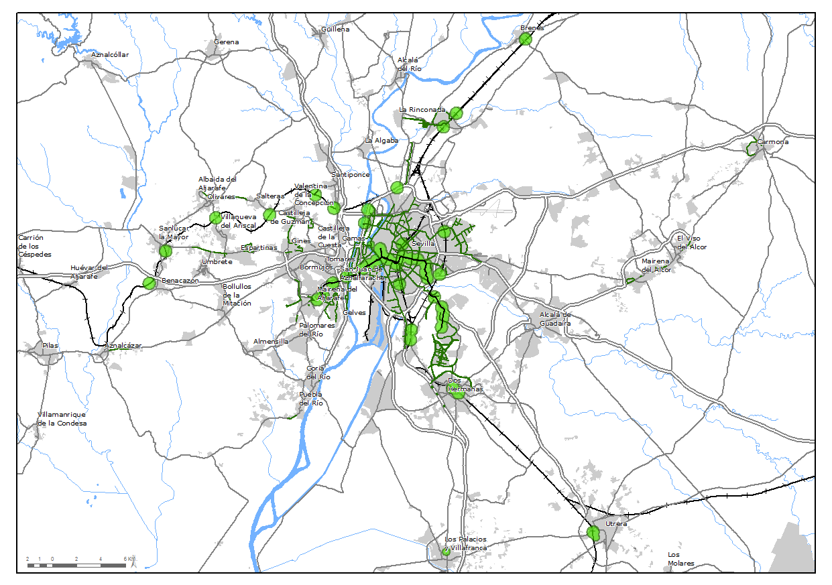
The catchment areas for cycling were determined for the stations shown in Figure 5 using the method described in the previous section. Three rail stations, that were located on hilly terrain and/or too far from populated areas were discarded. For the remaining stations, the process sketched in the two first steps of Figure 2 were undertaken using a GIS. This process led the data presented in Figure 6. where, for a better understanding of this process, the hydrographic and orographic main accidents are also shown. A comparison between Figures. 5 and 6 shows substantial changes in the catchment structure of the high capacity public transport system when trips combined with bicycle are considered, with the sparse chain of walking catchment areas transforming into a globular form, covering a larger portion of the case study area.

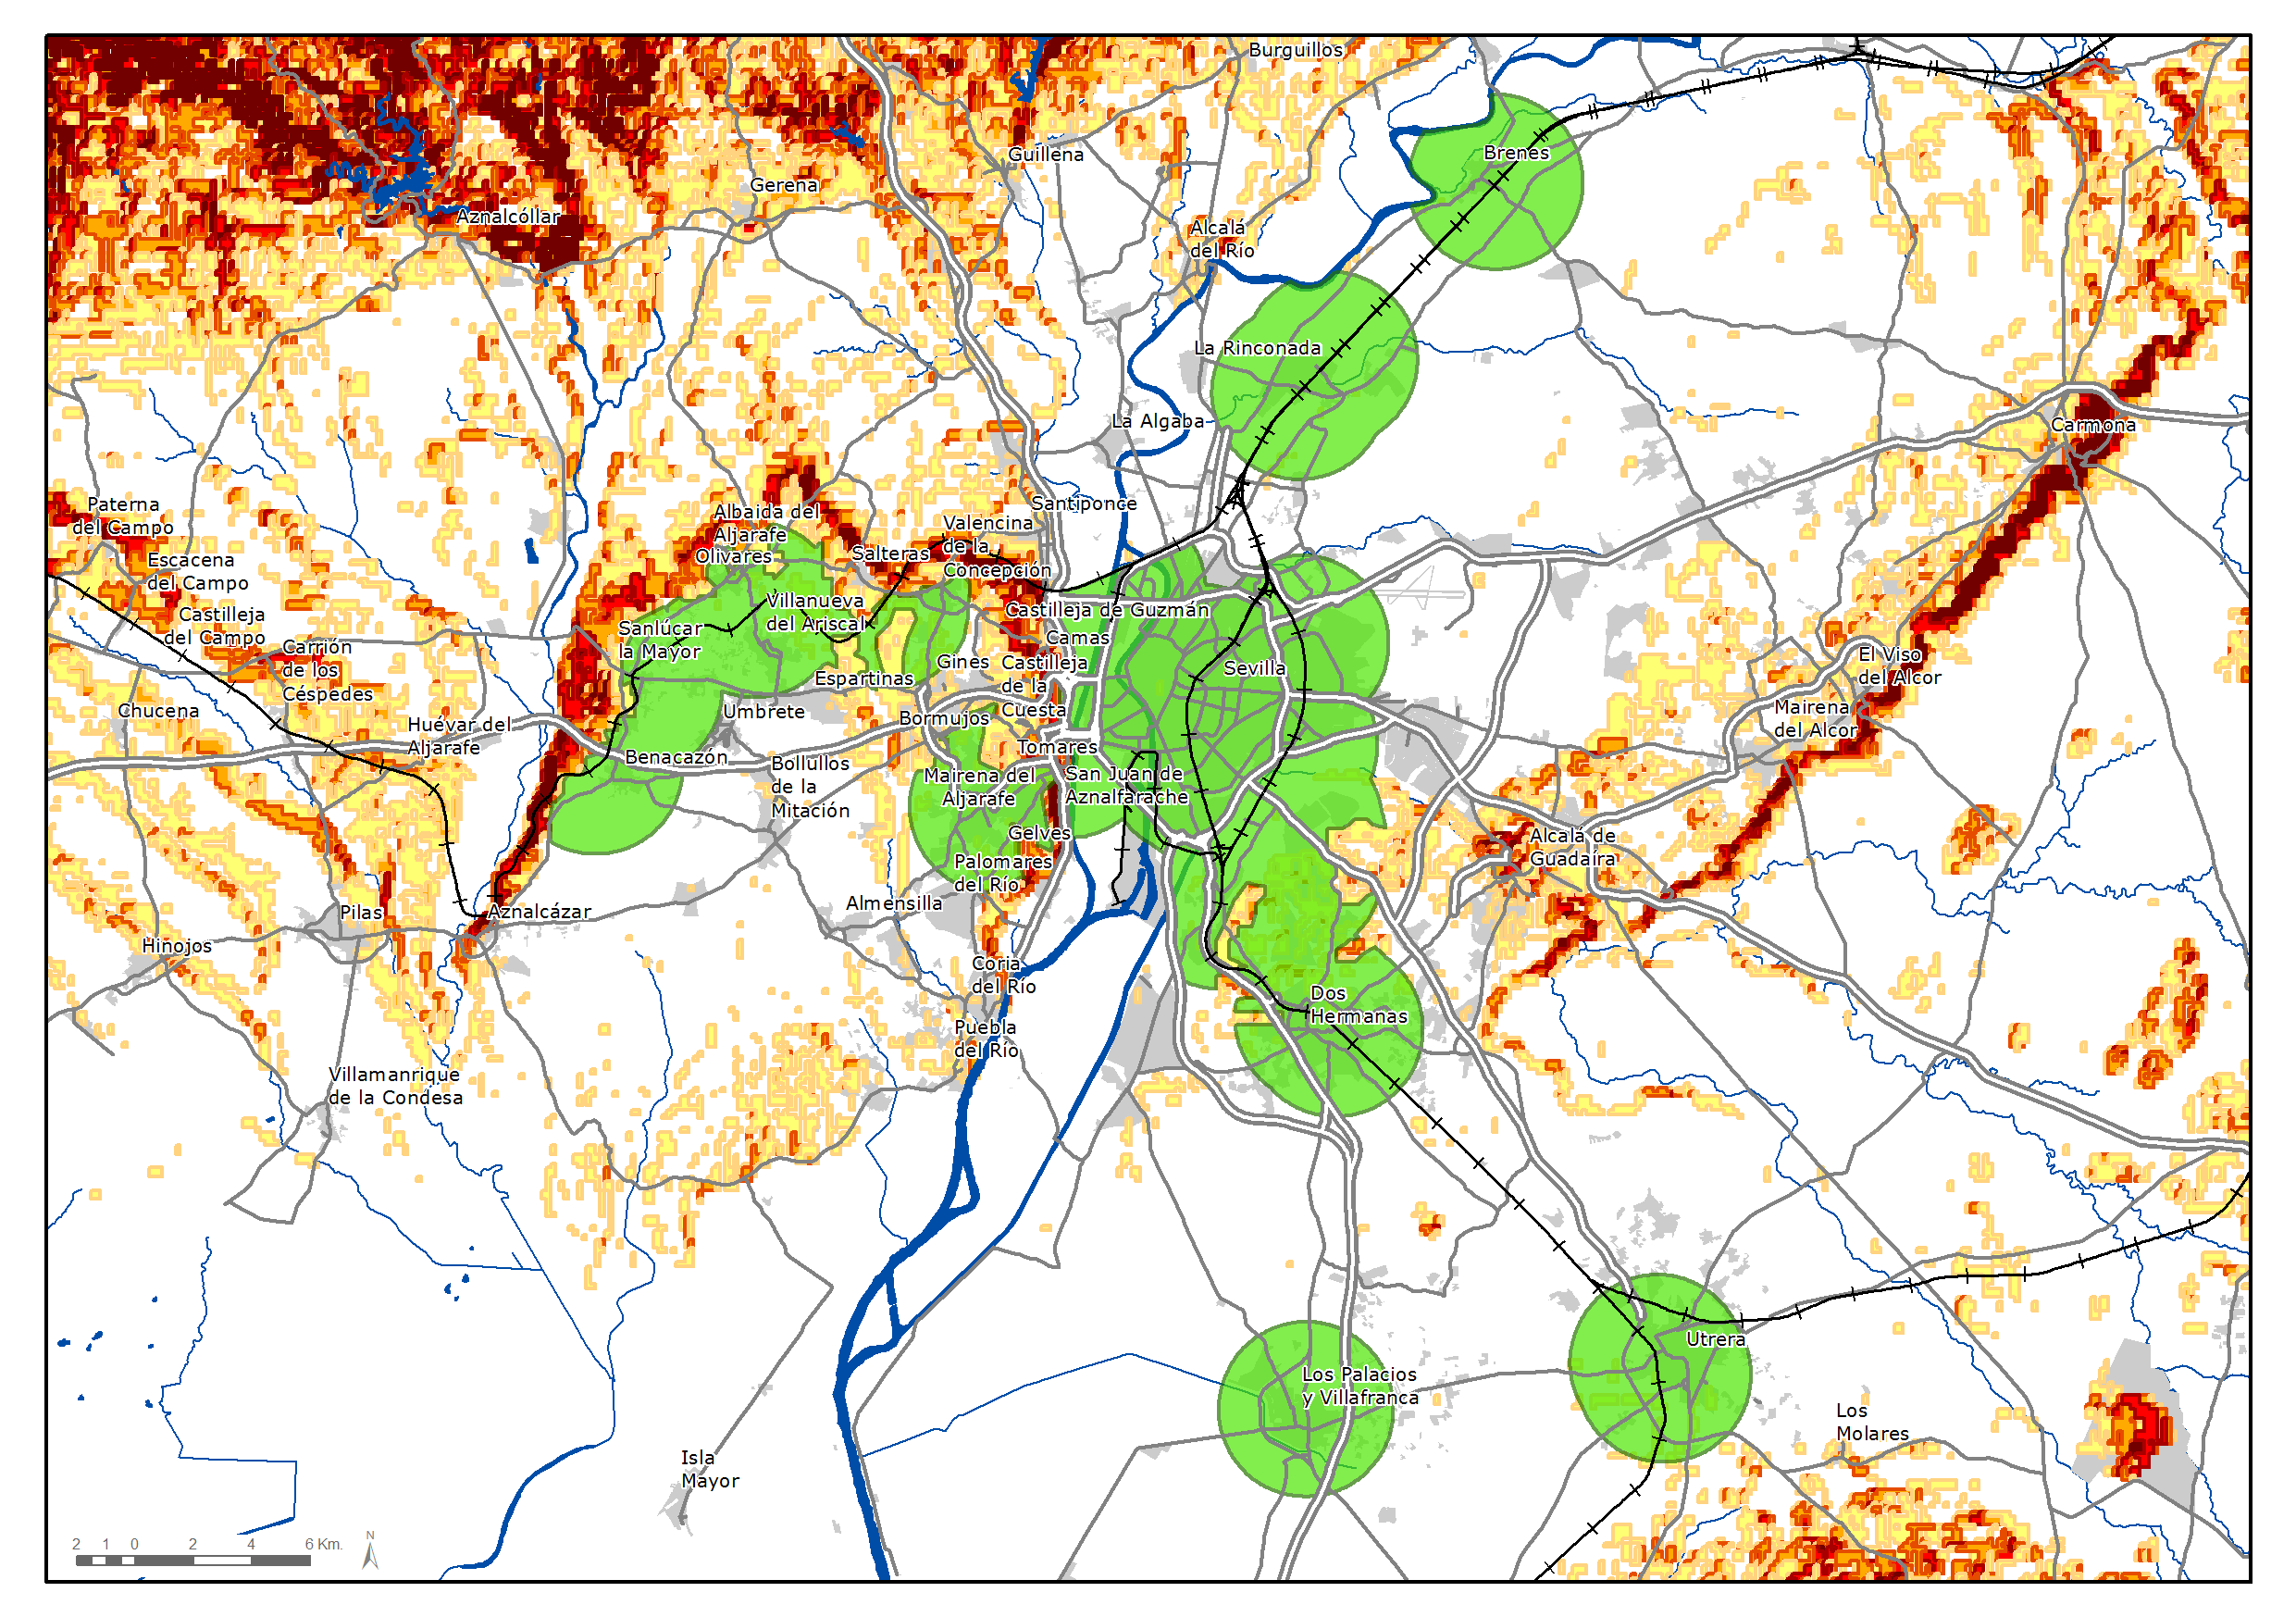
Figure 6: Catchment areas for the considered public transport stations. The main rivers and orographic accidents are also shown in the Figure.
The high degree of redundancy between the different single-station catchment areas is apparent in Figure 6, leading to grouping stations and defining new non-overlapping catchment areas (see Figure 2). Such final catchment areas include several public transit stations and are defined accounting for the populated areas inside each of them: borders are traced through less populated areas. The final result is shown in Figure 7, which shows 14 non overlapping catchment areas that are defined in addition to the city central area. These 14 catchment areas group a total of 24 high capacity public transit stations. Most of such stations are placed outside the Municipality of Seville.

Figure 7: Final catchment areas. The stations inside each area are shown as white circles (subway and light train), squares (train) and triangles (bus).
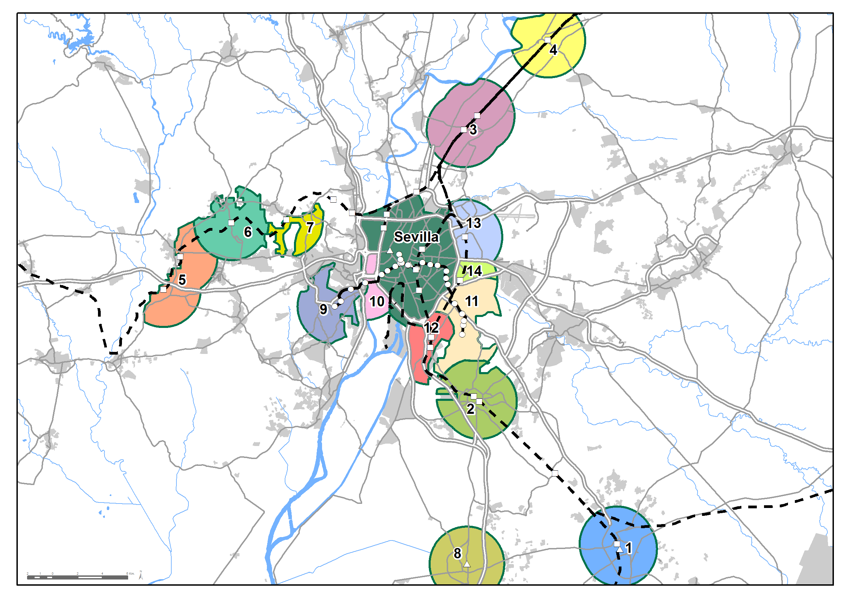
The total population living inside each catchment area was calculated using the grid of population developed by the regional government of Andalusia. This grid divides the territory in 250x250 m square cells and provides the total population living inside such cells. A population proportional to the portion of the cell included in the area was assigned to cells at the boundaries of the catchment areas. The population assigned to each catchment area is shown in Table 1.

Following the procedure sketched in Figure 3, the next step is the determination of the total number of trips made on all modes from each catchment area to the central city area. These trips were obtained from the last mobility survey made in the Metropolitan Area of Seville (2007) by counting all trips made on all mode with home ends at each catchment area, and activity ends at the central city area. Since the aforementioned survey used a division of the territory different from the catchment areas shown in Figure 7, the results from the mobility survey were adjusted in order to match these areas. The results are shown in Table 1. Overall, the population living in the considered catchment areas is the 31% of the total population of the whole metropolitan area, whereas the population at a walking distance of the PT stations inside such areas is just the 6% of the population of the whole metropolitan area. It is thus clear that improving bicycle and PT links at these stations could substantially improve the capacity of the public transport system of the city. The last column of Table 1 shows the total number of trips made by the population living at a cycling distance of the stations to the city center (central area of Figure 7) regardless of the mode used.

Table 1: Population inside each catchment area, population at a walking distance of the public transit stations of each area, population at a cycling distance from these stations, and trips daily made to the city center by this last population.
Catchment areas | Population in the area | Population at a walking distance | Population at a cycling distance | Trips to the city center
1 (Utrera) | 46,061 | 5,897 | 40,164 | 6,828
2 (Dos Hermanas) | 88,684 | 14,472 | 74,212 | 14,100
3 (La Rinconada) | 27,173 | 2,972 | 24,201 | 6,292
4 (Brenes) | 12,863 | 3,729 | 9,134 | 1,187
5 (Benacazón – Sanlúcar) | 11,091 | 1,830 | 9,261 | 1,667
6 (Villanueva – Olivares) | 15,977 | 92 | 15,885 | 3,336
7 (Salteras) | 10,166 | 0 | 10,166 | 2,846
8 (Los Palacios) | 35,266 | 3,551 | 31,715 | 4,123
9 (Ciudad Expo) | 63,663 | 16,862 | 46,801 | 14,508
10 (San Juan Bajo) | 1,702 | 368 | 1,334 | 534
11 (Quintos) | 36,532 | 20,904 | 15,628 | 5,157
12 (Bellavista) | 16,496 | 4,011 | 12,485 | 6,118
13 (Palacio de Congresos) | 86,234 | 5,630 | 80,604 | 41,108
14 (Padre Pío) | 20,253 | 4,960 | 15,293 | 2,447
Total | 472,161 | 85,278 | 386,883 | 110,251

As shown in Figures 3 and 4, the next step is a survey determining the stated preferences of the population living at a cycling distance of the public transport stations inside each catchment area (fourth column of Table 1). The sample was extracted from respondents of the aforementioned 2007 mobility survey, living at the considered catchment areas, and that declared to make regularly some kind of trip to the central area on any kind of mode.

Once the sample was identified, a survey following the guidelines sketched in Section 2 was conducted on such sample. Due to budget limitations we only made, in practice, three surveys on three significant areas, and the results were extrapolated to other similar areas in terms of the characteristics mentioned below. These areas were:
- Area k = 2 (Dos Hermanas), an example of a peripheral town with strong connections with the central area but also with a strong internal relational structure (extrapolated to areas 1 to 8).
- Area k = 9 (Ciudad Expo) as an example of a recently urbanized area outside the municipality of Seville with characteristics of residential suburbs (extrapolated to areas 9 to 11).
- Area k = 13 (Palacio de Congresos) as an example of an urban area inside the municipality but clearly separated from the city center (extrapolated to areas 12 to 14).

On each one of these areas, a telephone survey was conducted for participants in the 2007 mobility survey who regularly traveled to the city center. Respondents were first asked if they still made trips to the city center . After discarding participants not traveling to the city center , a sample of more than 300 respondents (345 for Area 2, 355 for Area 9 and 367 for Area 13) was selected for each Area.

Table 2 shows the coefficients C_{ijk} calculated using Eq. (4), and Tables 3 and 4 show the long, medium and short term demands (j = 1, 2, and 3, respectively) estimated for the two considered infrastructures: safe parking at home-end stations (I = 1) and cycle paths to access from homes to home-end stations (i = 2) using Eq. (3). Participants were not asked by cycle paths at the activity-end stations because these stations are supposed to be in the municipality of Seville, where a complete network of cycle paths already exists (Marqués et al., 2015).

Table 2: Computed coefficients C_{ijk} for k=2,9,13 in (4)
Catchment areas | C_{11k} | C_{12k} | C_{13k}
2 (Dos Hermanas) | 0.513 | 0.293 | 0.174
9 (Cudad Expo) | 0.556 | 0.247 | 0.137
13 (Palacio de Congresos) | 0.454 | 0.168 | 0.071
Catchment areas | C_{21k} | C_{22k} | C_{23k}
2 (Dos Hermanas) | 0.565 | 0.296 | 0.186
9 (Cudad Expo) | 0.574 | 0.248 | 0.139
13 (Palacio de Congresos) | 0.468 | 0.170 | 0.060

Table 3: Long (D₁₁k), medium (D₁₂k) and short (D₁₃k) term potential demand (trips) for safe parking infrastructure at home-end stations.
Catchment areas | Trips to the city center | D₁₁k | D₁₂k | D₁₃k
1 (Utrera) | 6,828 | 3,502 | 2,000 | 1,188
2 (Dos Hermanas) | 14,100 | 7,232 | 4,130 | 2,454
3 (La Rinconada) | 6,292 | 3,227 | 1,843 | 1,095
4 (Brenes) | 1,187 | 609 | 348 | 207
5 (Benacazón – Sanlúcar) | 1,667 | 855 | 488 | 290
6 (Villanueva – Olivares) | 3,336 | 1,711 | 977 | 581
7 (Salteras) | 2,846 | 1,460 | 834 | 495
8 (Los Palacios) | 4,123 | 2,115 | 1,208 | 718
9 (Cudad Expo) | 14,508 | 8,060 | 3,580 | 1,995
10 (San Juan Bajo) | 534 | 297 | 132 | 73
11 (Quintos) | 5,157 | 2,865 | 1,273 | 709
12 (Bellavista) | 6,118 | 2,777 | 1,028 | 436
13 (Palacio de Congresos) | 41,108 | 18,658 | 6,906 | 2,926
14 (Padre Pío) | 2,447 | 1,111 | 411 | 174
Total | 110,251 | 54,477 | 25,158 | 13,340

Table 4: Long (D₂₁k), medium (D₂₂k) and short (D₂₃k) term potential demand (trips) for cycle paths connecting with home-end stations.
Catchment areas | Trips to the city center | D₂₁k | D₂₂k | D₂₃k
1 (Utrera) | 6,828 | 3,859 | 2,020 | 1,271
2 (Dos Hermanas) | 14,100 | 7,969 | 4,171 | 2,624
3 (La Rinconada) | 6,292 | 3,556 | 1,861 | 1,171
4 (Brenes) | 1,187 | 671 | 351 | 221
5 (Benacazón – Sanlúcar) | 1,667 | 942 | 493 | 310
6 (Villanueva – Olivares) | 3,336 | 1,885 | 987 | 621
7 (Salteras) | 2,846 | 1,608 | 842 | 530
8 (Los Palacios) | 4,123 | 2,330 | 1,220 | 767
9 (Cudad Expo) | 14,508 | 8,331 | 3,592 | 2,024
10 (San Juan Bajo) | 534 | 307 | 132 | 74
11 (Quintos) | 5,157 | 2,961 | 1,277 | 719
12 (Bellavista) | 6,118 | 2,860 | 1,042 | 369
13 (Palacio de Congresos) | 41,108 | 19,220 | 7,000 | 2,481
14 (Padre Pío) | 2,447 | 1,144 | 417 | 148
Total | 110,251 | 57,644 | 25,403 | 13,330

Tables 3 and 4 show the potential demand for trips to the city center combining bicycle and public transport for the different catchment areas shown in Figure 7. As can be seen by comparing such tables the stated demand for both infrastructure types are very similar, ranging approximately from a 50% (long term) to a 10% (short term) of the total number of trips to the city center. These results show a high potential for bike & ride infrastructure in the periphery of the city, that could be launched by the appropriate investments. Such investments will probably be much less costly than investing in new high capacity public transport infrastructure. They will also help to reduce the cost per trip of the already existing infrastructure.

Figure 8: Populated cells in area 9 and the best (shortest) cycle routes to the stations inside such area. Red routes lie all inside the area and blue routes lie partially outside the area. The thickness of the routes is proportional to its expected use (the population using it). The number n of each station is marked in the Figure 7.
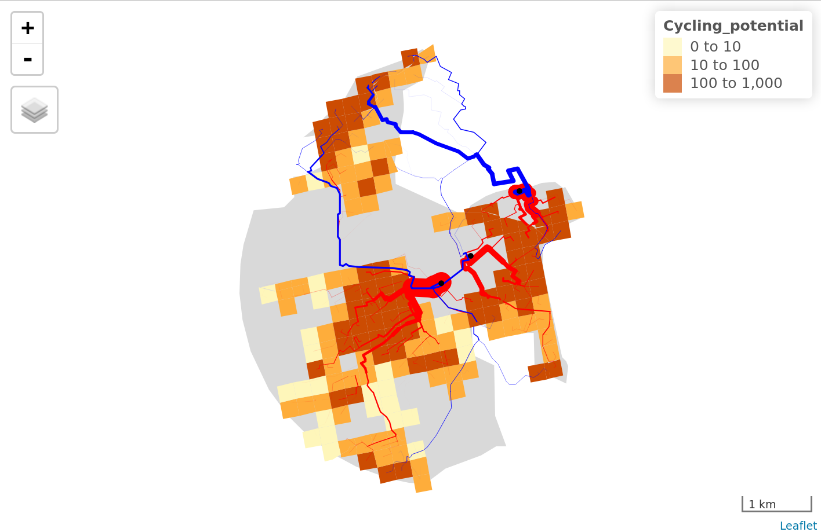

Next step is to determine the potential demands at the station leve (5). In order to make the paper readable and not too long, in the following we will just illustrate the application of this procedure to a specific area, namely area 9 of Figure 7. This area includes three stations (Ciudad Expo, Cavaleri y San Juan Alto). The area is, once again, divided into the aforementioned 250×250 m cells, and the best (the shorter) cycle route to each station is then determined for each cell following a procedure similar to that reported in (Lovelace et al., 2017). Figure 8 shows the populated cells of area 9, altogether with the best routes to the stations (the thickness of each route is proportional to its expected use). In the Figure, routes lying all inside the area are shown in red and routes going through regions excluded from the area are shown in blue. Since such regions were excluded from the area because they are too hilly, it can be assumed that most cyclists living in the corresponding cells will make a detour through the flattest regions inside the area in order to access to the public transport, a fact that may change the final destination station.

The routes shown in Figure 8 provide by itself useful guidelines for the implementation of cycle paths for accessing to the different stations inside area 9. According (5), the potential demands of access trips d_{ij9n} can be estimated by assigning to each station a fraction f_{9n} (n=1, 2, 3) of the overall demand for the area D_{1j9}. This fraction must be proportional to the total population of the cells connected to each station through the “best” routes of Figure 8 (see below for a deeper discussion). Of course, the demands d_{ij9n} must match, in total, the overall demand for the area 9, D_{1j9} (given in Table 3).

For the considered area (k=9), defining:
- n=1 for the station of Ciudad Expo.
- n=2 for the station of Cavaleri, and
- n=3 for the station of San Juan Alto
Table 5 shows the fractions f_{9n} for the different stations. In Table 5 we have considered two hypotheses:
- Scenario 1: All cyclists travel to each station following the “best” route shown in Figure 8.
- Scenario 2: Cyclists avoid the routes through hilly areas (blue routes in Figure 8) making a detour through flatter zones inside the area 9, mainly to station n=1 (Ciudad Expo).

Table 5: Values of the different fractions of demand f_{9n} in (5) for the different stations (n=1, 2, 3) in area k=9,
 | f₉₁ (Ciudad Expo) | f₉₂ (Cavaleri) | f₉₃ (San Juan Alto)
Scenario 1 | 0.37 | 0.26 | 0.37
Scenario 2 | 0.50 | 0.26 | 0.25

Table 5 allows for the determination of the potential demand of safe parking at the different stations in area k=9 using Eq. (5). From the different hypothesis included in Table 5, the most coherent with the proposed methodology is Hypothesis 2. Hypothesis 1 is included because, in practice, some cyclists will choose the shorter route, even if it is through a hilly zone. Therefore, this hypothesis may have some practical implications for the final estimation of the actual demand of parking, mainly at stations n=1 and n=3. The convenience of considering both scenarios illustrates the importance comparing results with local knowledge, instead of blindly applying a methodology.

4. DISCUSSION AND CONCLUSIONS
This paper has introduced a methodology for the a priori evaluation and planning of ‘bike & ride’ as an alternative to cars for trips from a settlements’ periphery into central areas that are too far for most people to cycle. Bike & ride can reduce congestion and parking at popular destination, with multiple benefits for the environment, society and human health. Bike & ride is also preferable in many ways to its better-know cousin ‘park & ride’: it reduces car traffic at trip origins (through increased cycling), and can free public space for car parking at stations, with knock-on benefits for public transport. We contend that, used judiciously, the proposed method could benefit transport planners searching for methods and data to help evaluate the potential benefits of bike & ride schemes at city, regional and national levels.

The method relies on three main inputs:
- The catchment areas for the different public transport stations
- The actual volume of trips to the city center made in all modes with home-end at the aforementioned catchment areas.
- The stated preferences of the population living in the aforementioned catchment areas.
The method thus has a moderate requirement for data collection in the study region (although ‘parameter free’ versions of the method, which estimate travel behaviour using methods such as spatial interaction models could be used), and encourages researchers to understand the preferences of local residents before estimating the potential for bike & ride.

We have centered our analysis in the planning of bike & ride infrastructure at peripheral public transport stations because bike & ride is the most usual combination between bicycle and public transport (Martens, 2004; Martens, 2007), and because we feel that the lack of this infrastructure can be one of the main deterrents to cycling in peripheral suburbs. However, some features of the proposed method could be useful for the planning of other kind of bicycle and public transport links. For instance, our methodology for the estimation of the potential demand for bike & ride infrastructure at the peripheral stations could be useful for the prioritisation of interventions for ‘bike & carry’ (such as the addition of train carriages to carry cycles) for trips between the periphery and the city center , or to estimate the demand of links between public transport and shared bikes systems at the city center public transport stations. Consideration of activity-end trips instead of home-end trips at the peripheral catchment areas, can provide a useful methodology for the estimation of the demand for ride & bike infrastructure at such areas. Conversely, considering stations at the city center instead of stations at the periphery, a similar methodology could be built in order to estimate bike & ride demands at the city center.

During recent years, the use of electric cycles (e-bikes)has increased in many countries, such as UK and The Netherlands (Jones, T. et al., 2016). The proposed method could be extended to help planfor e-bikes-PT integration, by accounting for the increased trip distance (catchment area radius)that e-bike enable. Furthermore e-bikes make cycling potential less gradient-averse, a fact that will simplify the analysis.

Seville is an appropriate case study because of the recent increase of cycling in the central area of the city, which was not followed by a similar increase of cycling in the peripheral neighbors (Marqués et al.,, 2015). The lack of infrastructure linking cycling and public transport stations can be one of the reasons for this failure and our analysis shows that there is a high potential demand of combined bicycle and public transport trips in such areas. It also shows that public transport will also benefit from the effective realization of this potential demand, mainly through the increase in the served population.

We believe that our analysis is a good starting point for the planning for the extension of in cities where cycling provision and use tends to focus on the city centre. Furthermore, we have demonstrated the great potential for mutually benefit by combining investment in cycling with investment in public transport.

5. ACKNOWLEDGMENTS: Junta de Andalucía, Consorcio de Transportes (Spain), Department for Transport (UK).

REFERENCES
Adjei, E. (2010). Multi-modal urban transport: Integrating non-motorized and bus transport (Thesis submitted to the International Institute for Geo-information Science and Earth Observation).

Aultman-Hall, L., Dowds, J., & Lee, B. H. (2012). Innovative Data Collection for Pedestrians, Bicycles, and Other Non-Motor Vehicle Modes. TR News-Transportation Research Board, (280), 8.

Aultman-Hall, L., Hall, F.L., & Baetz, B.B. (1997). Analysis of bicycle commuter routes using geographic information systems: implications for bicycle planning. Transportation Research Record: Journal of the Transportation Research Board, 1578 (1), pp. 102-110, 1997.

Bachand-Marleau, J., Larsen, J., & El-Geneidy, A. M. (2011). Much-Anticipated Marriage of Cycling and Transit. Transportation Research Record: Journal of the Transportation Research Board, 2247(1), 109-117.

Broach, J., Gliebe, J., & Dill, J. (2009). Development of a multi-class bicyclist route choice model using revealed preference data. Presented at the 12th International Conference on Travel Behavior Research, Jaipur, India, December 2009.

Castillo-Manzano, J. I., & Sánchez-Braza, A. (2013a). Managing a smart bicycle system when demand outstrips supply: the case of the university community in Seville. Transportation, 40(2), 459-477.

Castillo-Manzano, J. I., & Sánchez-Braza, A. (2013). Can anyone hate the bicycle? The hunt for an optimal local transportation policy to encourage bicycle usage. Environmental Politics, 22(6), 1010-1028.

Castillo-Manzano, J. I., Castro-Nuño, M., & López-Valpuesta, L. (2015). Analyzing the transition from a public bicycle system to bicycle ownership: A complex relationship. Transportation Research Part D: Transport and Environment, 38, 15-26.

CFVJA (2014) Plan Andaluz de la Bicicleta 2014-2020 (in Spanish) Consejería de Fomento y Vivienda, Junta de Andalucía, 2014.

CTMAS (2008) Encuesta de Movilidad en Día Laborable de 2007 en el Área Metropolitana de Sevilla (in Spanish) Consorcio de Transporte Metropolitano del Área de Sevilla, 2008.

Debrezion, G., Pels, E., & Rietveld, P. Modelling the joint access mode and railway station choice. Transportation Research Part E: logistics and transportation review, 45 (1), pp. 270-283, 2009.

Dekoster, J., Schollaert U. (1999). Cycling: the way ahead for towns and cities. European Comission

ECMT (2004) National Policies to Promote Cycling Report to European Conference of Ministers of Transport, Liubliana, 2004.

Jones, T., Harms, L., & Heinen, E. (2016). Motives, perceptions and experiences of electric bicycle owners and implications for health, wellbeing and mobility. Journal of transport geography, 53, 41-49.

Krel, Karl (1989). “Passenger Transport Trends.” In Transportation for the Future, edited by David F. Batten and Roland Thord, 211–24. Berlin, Heidelberg: Springer Berlin Heidelberg. http://dx.doi.org/10.1007/978-3-642-74866-0_13.

Krizek, K. J., & Stonebraker, E. W. (2010). Bicycling and Transit. Transportation Research Record: Journal of the Transportation Research Board, 2144(1), 161-167.

Krygsman, S., & Dijst, M. (2001) Multimodal Trips in the Netherlands: Microlevel Individual Attributes and Residential Context. In Transportation Research Record: Journal of the Transportation Research Board, 1753, 11–19 .

Krygsman, S., Dijst, M., & Arentze, T. (2004). Multimodal public transport: an analysis of travel time elements and the interconnectivity ratio. Transport Policy, 11(3), 265-275.

Larsen, J., Patterson, Z. and El-Geneidy, A (2013). “Build It. But Where? The Use of Geographic Information Systems in Identifying Locations for New Cycling Infrastructure.” International Journal of Sustainable Transportation 7, no. 4: 299–317.

Lovelace, R., Goodman, A., Aldred, R., Berkoff, N., Abbas, A., Woodcock, J., (2017). The Propensity to Cycle Tool: An open source online system for sustainable transport planning. Journal of Transport and Land Use. doi:10.5198/jtlu.2016.862

Marqués, R., Hernández-Herrador, V., Calvo-Salazar, M., & García-Cebrián, J. A. (2015). How infrastructure can promote cycling in cities: Lessons from Seville. Research in Transportation Economics, 53, 31-44.

Marqués, R., Calvo-Salazar, M., Hernández-Herrador, V. (2016) Análisis sobre la movilidad ciclista en Sevilla. Año 2015 (in Spanish). Sistema Integral de la Bicicleta de la Universidad de Sevilla (SIBUS).

Martens, K. (2004). The bicycle as a feedering mode: experiences from three European countries. Transportation Research Part D: Transport and Environment, 9(4), 281-294.

Martens, K. (2007). Promoting bike-and-ride: The Dutch experience. Transportation Research Part A: Policy and Practice, 41(4), 326-338.

Ortúzar, J., & Willumsen, L. G. (1994). Modelling transport. New Jersey: Wiley.

O'Sullivan, S., & Morrall, J. (1996). Walking distances to and from light-rail transit stations. Transportation research record: journal of the transportation research board, 1538(1), 19-26.

O'Sullivan, D., Morrison, A., & Shearer, J. (2000) Using desktop GIS for the investigation of accessibility by public transport: an isochrone approach. International Journal of Geographical Information Science, 14 (1), pp. 85- 104.

Parkin, J., Ryley, T., & Jones, T. (2007). Barriers to cycling: an exploration of quantitative analyses. En D. Horton, P. Rosen and P. Cox Cycling and society, Ashgate, UK and USA, 2007, pp. 67-82.

Peng, Z. R., Sun, J., & Lu, Q. C. (2012). China's public transportation: Problems, policies, and prospective of sustainability. ITE Journal, 82(5).

Ploeger, J., Kroeze, P.A., Ditewig, R., Dijkstra, A., Godefrooij, T.P.F., Immerzeel, J.W., Salomons, W., Vink, E.D., Zeegers, Th., Design Manual for Bicycle Traffic, CROW, The Netherlands, 2007.

Pucher. J. and Buehler, R. (2012a) “City Cycling” MIT Press, 2012.

Pucher. J. and Buehler, R. (2012b) Integration of Cycling with Public Transportation en Pucher, J. & Buehler, R. “City Cycling” MIT Press, 2012.

Pucher, J., Dill, J., & Handy, S. (2010). Infrastructure, programs, and policies to increase bicycling: an international review. Preventive Medicine, 50, S106-S125.

Pucher, J., Peng, Z. R., Mittal, N., Zhu, Y., & Korattyswaroopam, N. (2007). Urban transport trends and policies in China and India: impacts of rapid economic growth. Transport Reviews, 27(4), 379-410.

Rietveld, P. The accessibility of railway stations: the role of the bicycle in The Netherlands. Transportation Research Part D: Transport and Environment, 5 (1), pp. 71-75, 2000.

Rodríguez, D. A., & Joo, J. (2004). The relationship between non-motorized mode choice and the local physical environment. Transportation Research Part D: Transport and Environment, 9(2), 151-173.

Sheena, S. A., Zhang, H., Martin, E., & Guzman, S. (2011) China’s Hangzhou Public Bicycle: Understanding Early Adoption and Behavioral Response to Bikesharing. Transportation Research Record: Journal of the Transportation Research Board, (2247), 33-41.

Private Communication, Mr. Piero Winters, NS-Stations, Utrecht, The Netherlands, 2013.

