The ESPRIT function codes:

function mu = Esprit(X,d)

%Input:

%where X is the M * N matrix containing the array measurements

%and d is the number of signal directions to look for.

%

%Output:

%The return value mu is a vector containing the estimated

%spatial frequencies of the d wavefronts, sorted in a ascending order.

**%% Selection Matrices**

M = 16;

N = 500;

%subarray number small m(d+1<=m<M) when m=M-1 we have maximum overlap

m = M-1;

B = zeros(1,m).';

J1 = [eye(m),B];

J2 = [B,eye(m)];

[U,S,V] = svd(X);

Us = U(:,1:d);

**%% Least Square Solution**

pphi_LS = (pinv(J1*Us))*(J2*Us);

phi_LS1 = eig(pphi_LS);

phi_LS = sort(phi_LS1);

mu = angle(phi_LS);

mu = sort(mu);

Main Program:

%%Intialization

%Snapshot number

N=500;

%element number

M=16;

%uncorrelated impinging signals number

d=4;

%directions of d impinging signals

mu_desired=[-0.6;-0.2;0.1;0.3];

%SNR in dB

SNR=10;

%the correlation coefficient

rho=0;

NumberOfRuns=100;

X = GetArrayOutput(M,mu_desired,SNR,N,rho);

mu = Esprit(X,d);

norm(mu_desired(:)-mu(:))^2

In SNR = 10 dB, the estimation error is 10-5

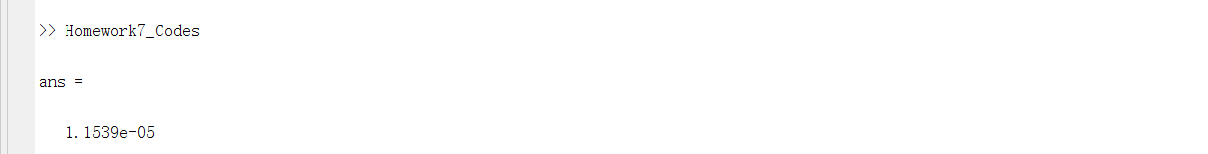

In SNR = 50 dB, the estimation error is 10-8

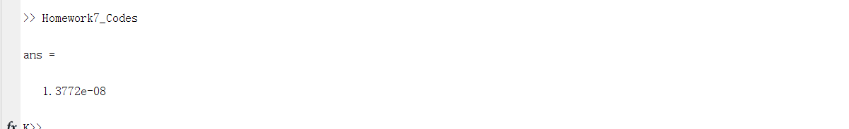

From the simulation, we can see that with increased SNR, the estimation error will be smaller , the estimates will be more accurate because in higher SNR the influence of noise becomes less and less important.

## B

The averaging squared estimation error VS. the SNR

%%Intialization

%Snapshot number

N=500;

%element number

M=16;

%uncorrelated impinging signals number

d=4;

%directions of d impinging signals

mu_desired=[-0.6;-0.2;0.1;0.3];

%SNR in dB

SNR_matric=1:1:50;

%the correlation coefficient

rho=0;

errors = zeros(length(SNR_matric), NumberOfRuns);

%% ITERATION SNR

iter=0;

for i=1:50

SNR=SNR_matric(i);

for j=1:NumberOfRuns

%% GetArrayOutput

X = GetArrayOutput(M,mu_desired,SNR,N,rho);

%% Estimation of Signal Parameters via Rotational Invariance Techniques(ESPRIT)

mu = Esprit(X,d);

%% RMSE

errors(i,j)=norm(mu_desired(:)-mu(:))^2;

end

iter=iter+1

end

semilogy(SNR_matric, mean(errors,2))

grid on

xlabel('SNR');ylabel('Error');

title('Estimation Error VS SNR in rho=0.99');

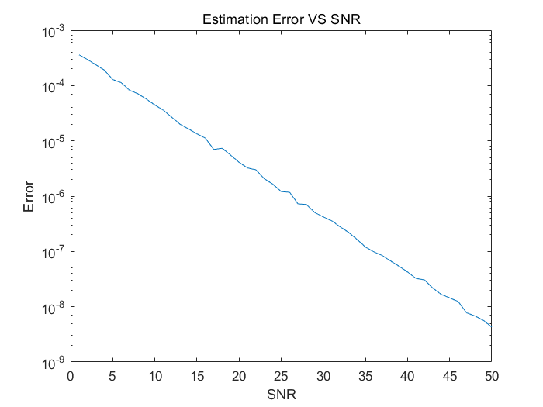

We can see that in higher SNR we always have lower Estimation Error.

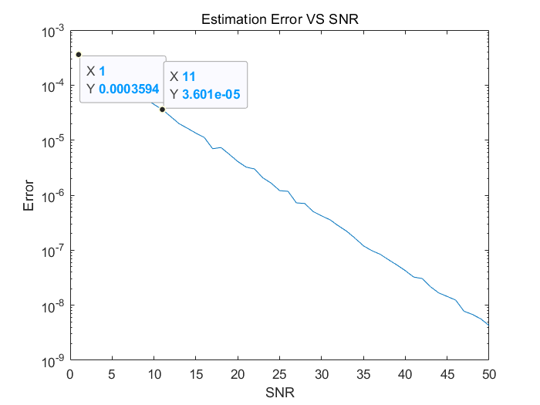

We can see that in order to lower the estimation error by one decade(factor 10), the SNR need to be increased about 10 times in logarithmic coordinate. It means, the SNR need to be increased double in linear coordinate.

## C

Compare the MSE of Standard ESPRIT with and without FBA VS. SNR

%%Intialization

%Snapshot number

N=500;

%element number

M=16;

%uncorrelated impinging signals number

d=4;

%directions of d impinging signals

mu_desired=[-0.6;-0.2;0.1;0.3];

%SNR in dB

SNR_matric=1:1:50;

%the correlation coefficient

rho=0.99;

errors1 = zeros(length(SNR_matric), NumberOfRuns);

errors2 = zeros(length(SNR_matric), NumberOfRuns);

%% ITERATION SNR

iter=0;

for i=1:50

SNR=SNR_matric(i);

for j=1:NumberOfRuns

%% GetArrayOutput

X = GetArrayOutput(M,mu_desired,SNR,N,rho);

%% Forward-Backward-Averaging

Z = [X,flip(eye(M))*conj(X)*flip(eye(N))];

%% Estimation of Signal Parameters via Rotational Invariance Techniques(ESPRIT)

mu1 = Esprit(X,d);

mu2 = Esprit(Z,d);

%% RMSE

errors1(i,j)=norm(mu_desired(:)-mu1(:))^2;

errors2(i,j)=norm(mu_desired(:)-mu2(:))^2;

end

iter=iter+1

end

semilogy(SNR_matric, mean(errors1,2))

hold on

semilogy(SNR_matric, mean(errors2,2))

grid on

legend('Without FBA','With FBA');

xlabel('SNR');ylabel('Error');

title('Estimation Error VS SNR in rho=0.99');

#### Rho=0

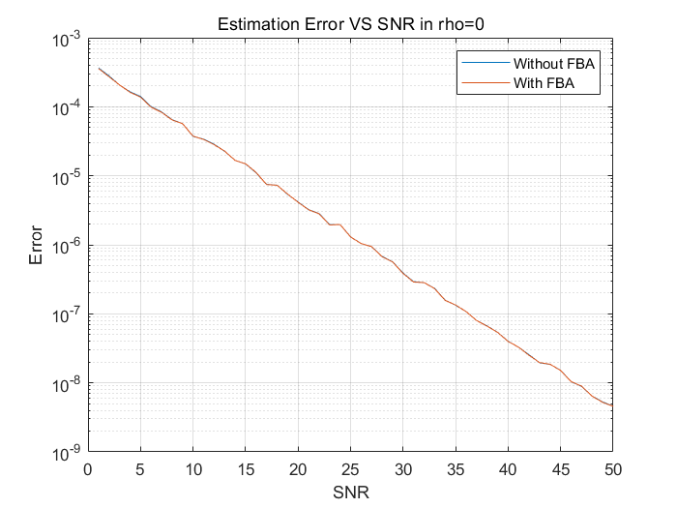

When the impinging signals are uncorrelated, the estimation error with and without FBA is totally same in different SNRs.

By adding FBA:

%% Forward-Backward-Averaging

Z = [X,flip(eye(M))*conj(X)*flip(eye(N))];

We can see different results when the impinging signals are correlated(rho=0.9,rho=0.95,rho=0.99):

#### Rho=0.9

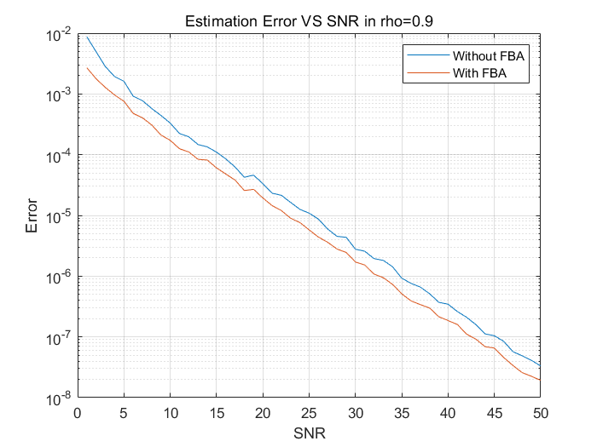

#### Rho=0.95

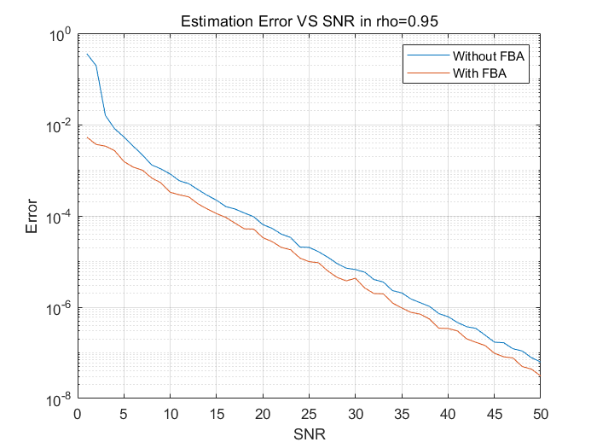

#### Rho=0.99

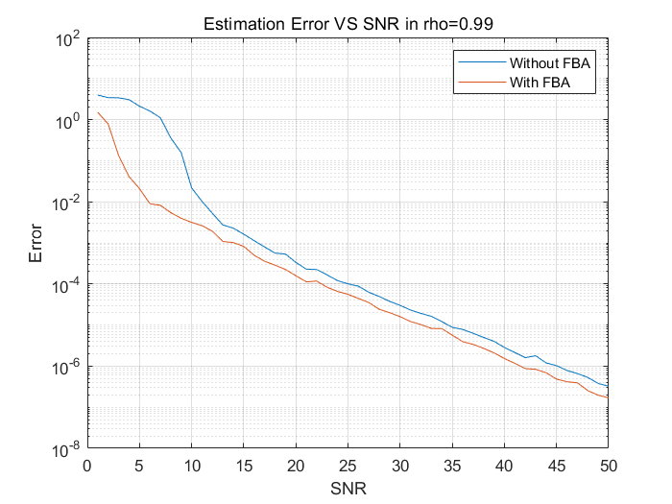

From the above figures we can find that FBA enhances the performance(lower estimation error, better accuracy) if the impinging signals are correlated. But the difference will not be greater when the SNR increased, the difference in estimation error with and without FBA is fest fixed in SNRs.