Codes:

%% Initialization

%ULA antenna numbers M

M=16;

% numbers of impinging signals

d=3;

% numbers of snapshots

N=500;

%standard beamwidth mub

mub=2*pi/M;

mu=mub.*[-3,0,3];

%SNR

SNR=10;

% channel parameters

S = ( sign(randn(d,N)) + j * sign(randn(d,N)) ) / sqrt(2);

W = ( randn(M,N) + j * randn(M,N) ) / sqrt(2) * 10^(-SNR/20);

A=zeros(M,d);

c=(0:M-1);

%a=amu(1,:) represents first row

for i=1:d

A(:,i)=exp(j*c*mu(i));

end

%Input of filters

X=zeros(M,N);

X=A*S+W;

Rxx_est_new=0;

for i=1:N

Rxx_est_current=X(:,i)*X(:,i)';

Rxx_est_new=Rxx_est_current+Rxx_est_new;

end

Rxx_est=Rxx_est_new/N;

%% Sampling

NS=1000;

mus=-pi:2*pi/(NS-1):pi;

%% MVDR

S_MVDR=zeros(M,NS);

S_MVDR_mus=zeros(1,NS);

for i=1:NS

S_MVDR(:,i)=exp(j*c*mus(i))

S_MVDR_mus(i)=1/(S_MVDR(:,i)'*inv(Rxx_est)*(S_MVDR(:,i)))

end

hold on

semilogy(mus,normalize(S_MVDR_mus))

%% DFT

d=0;

f=0;

for n=1:N

for k=0:M-1

d1=X(k+1,n)*exp(-j*mus*k)

d=d1+d

end

f1=abs(d).*abs(d)

f=f1+f

end

S_DFT=f/(N*M);

hold on

semilogy(mus,normalize(S_DFT))

%% MUSIC

U0=null(A');

S_MUSIC=zeros(M,NS);

S_MUSIC_mus=zeros(1,NS);

for i=1:NS

S_MUSIC(:,i)=exp(j*c*mus(i))

S_MUSIC_mus(i)=(S_MUSIC(:,i)'*S_MUSIC(:,i))/(S_MUSIC(:,i)'*U0*U0'*(S_MUSIC(:,i)))

end

semilogy(mus,normalize(S_MUSIC_mus))

legend('MVDR','DFT','MUSIC');

xlabel('mu');ylabel('power spectra');

ylim([-2 10]);

title('Estimation of Direction of Desired Signal with (i)');

1. Answers of question 1

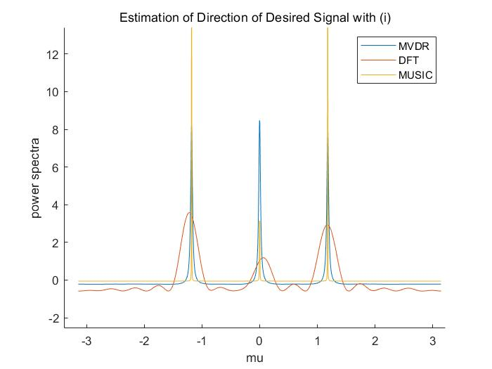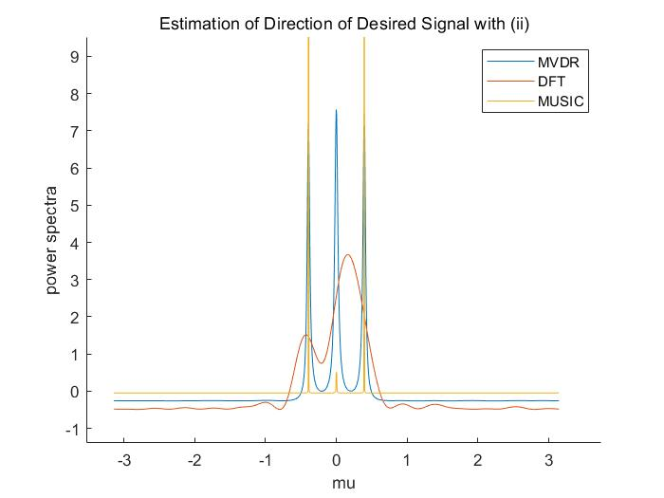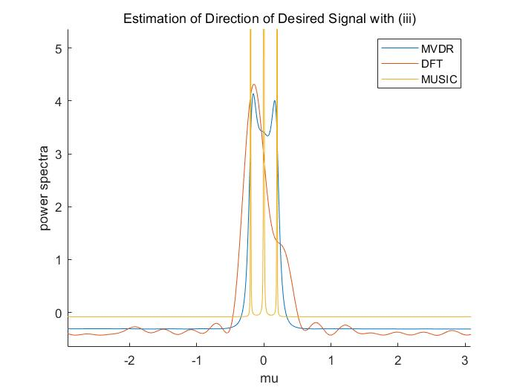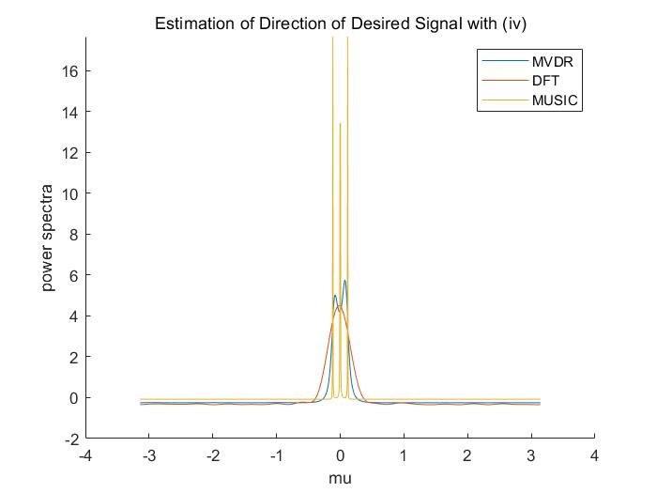

2.Answers of question 2(repeat again with 25dB SNR)

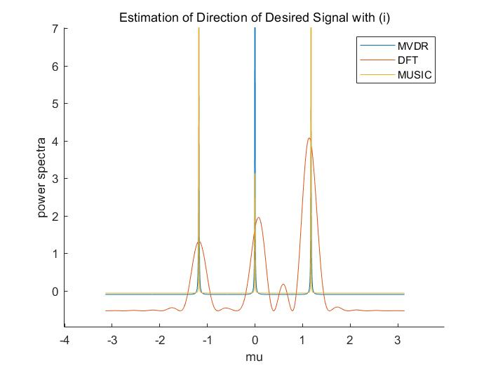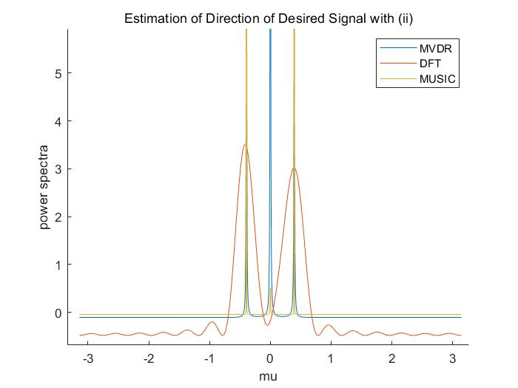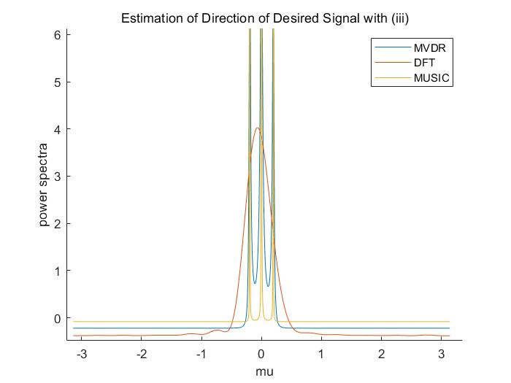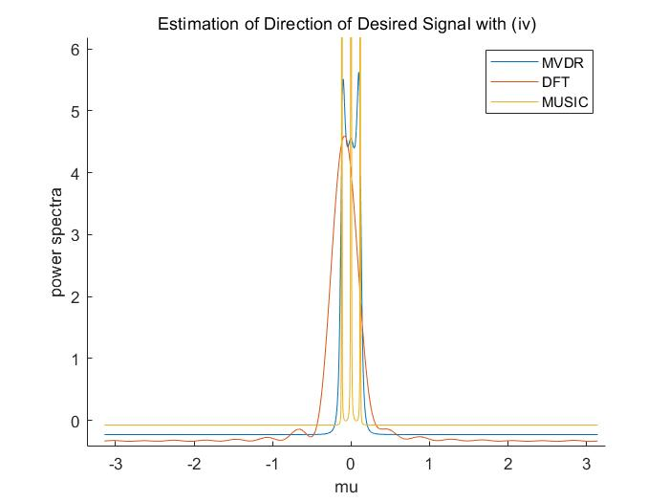

3.As in the following figure, SNR is infinity(108),we can find that the curve(the result of estimation) of MVDR is absolutely overlapping as MUSIC, and DFT can not distinguish the 3 different directions.

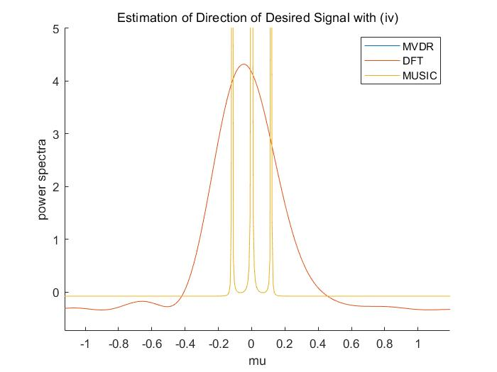

4.From the above results we can find that: with a fixed SNR and N, when the direction of two desired signals getting closer(from i to iv),the performance of DFT is getting worse and even cannot distinguish two directions of signals(low resolution). The performance of MVDR is better as DFT but also can not distinguish two signals with two closer signals. However, the performance of MUSIC is best. It can distinguish all the above 4 desired compact signals(high resolution parameter estimation). Two incoherent waves can be resolved if different of their spatial frequencies is at least 2π/M(Rayleigh Resolution Limit).

Modern HRPE techniques(MUSIC,ESPRIT) provide resolution that exceed traditional Rayleigh Resolution Limit.

5. As in the following figure, with a fixed SNR(25dB) and a larger N(2000),we can see MUSCI benefits from a larger N.

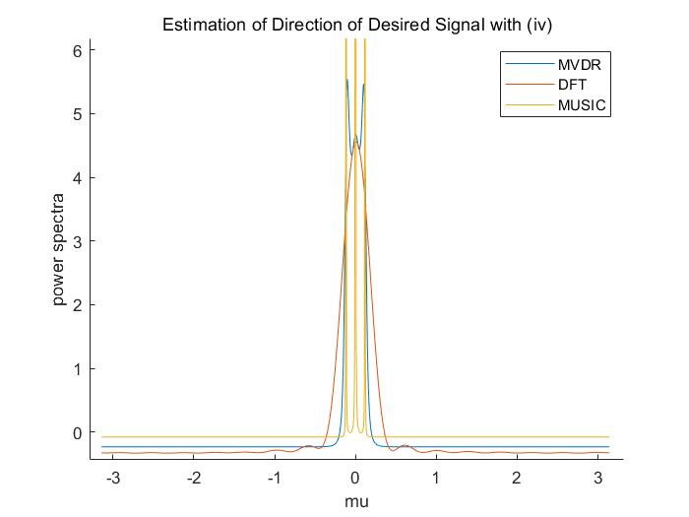

6.We compare with fixed SNR(20dB) but different N(1,10,100,500), which shown as follow. We can see that the performance of MUSIC stays good always(because MUSIC can exceed Rayleigh Resolution Limit). It doesn’t benefit from larger N. And the performance of DFT stays worse always(because in case iv Rayleigh Resolution Limit was broken and DFT needs to follow it, otherwise Ambiguity). So DFT cannot benefit from larger N. Only the performance of MVDR can getting better with larger N.

