THORNQUIST OUTFITTERS - AWS S3 Data Lake & Data Ingestion

Individual Contribution Report
Prepared by: Ammar, Robinson, Alex
Date: October 23, 2026
Project: Thornquist Outfitters – AWS Midterm Project
Scope: S3 raw and landing zones, Lambda-based ingestion, and verification

Screenshot Evidence
Figure 1: POS CSV Manual Ingestion to S3 Landing Zone
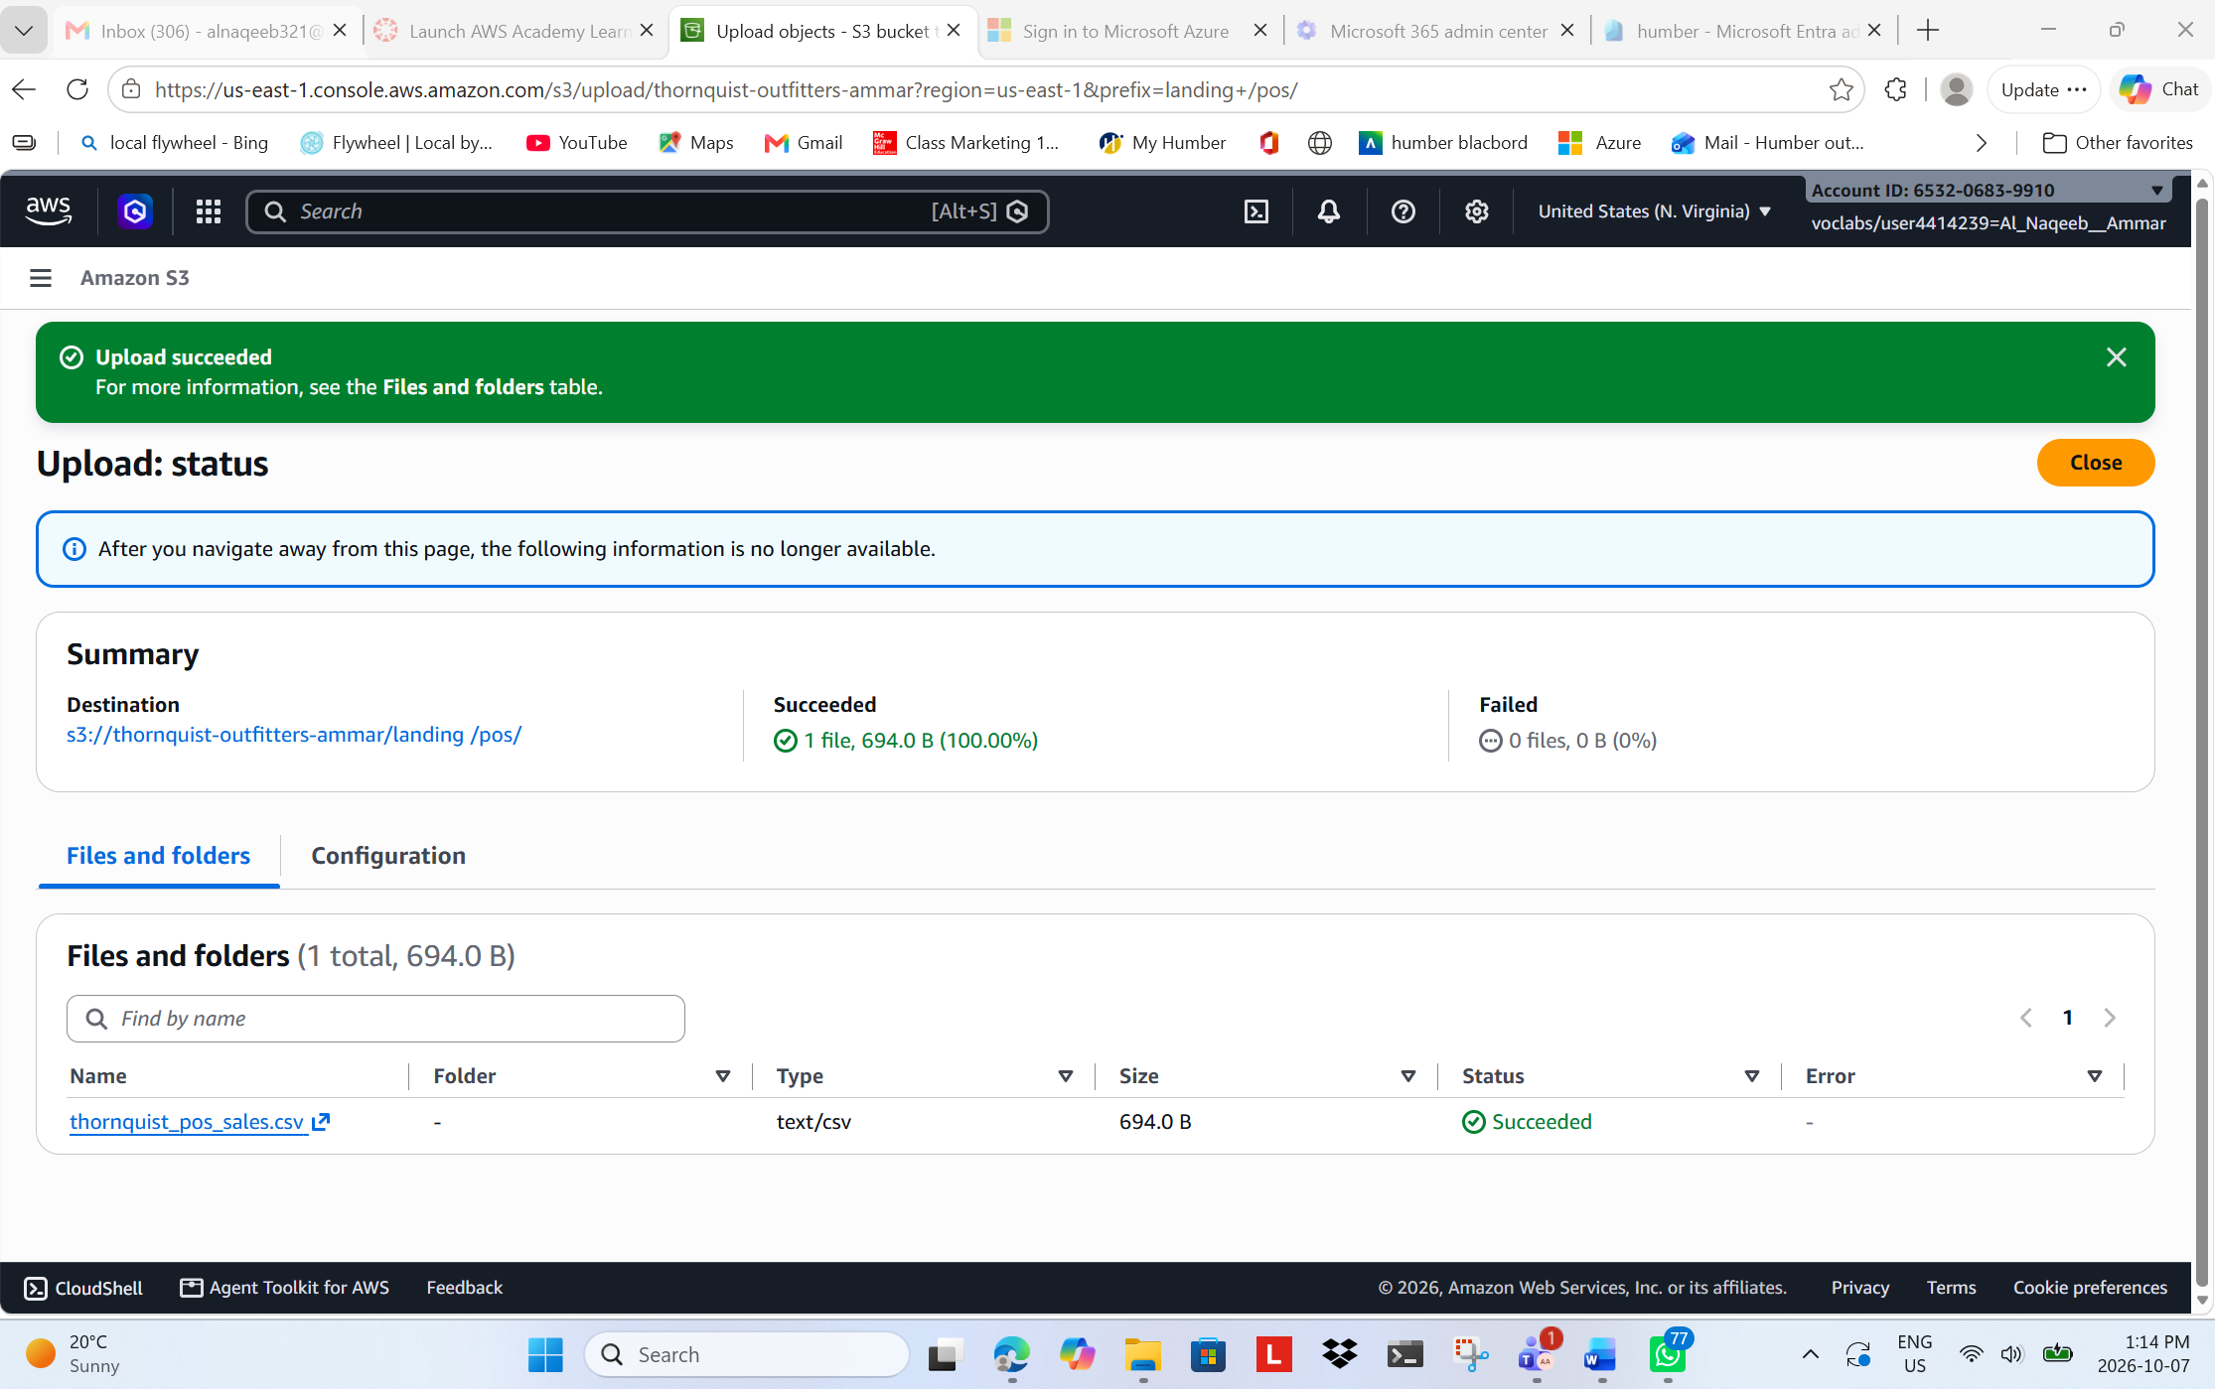

Figure 2: Amazon S3 Data Lake Structure - Amazon S3 bucket showing the organized data lake zones used to store and process the Thornquist Outfitters project data.
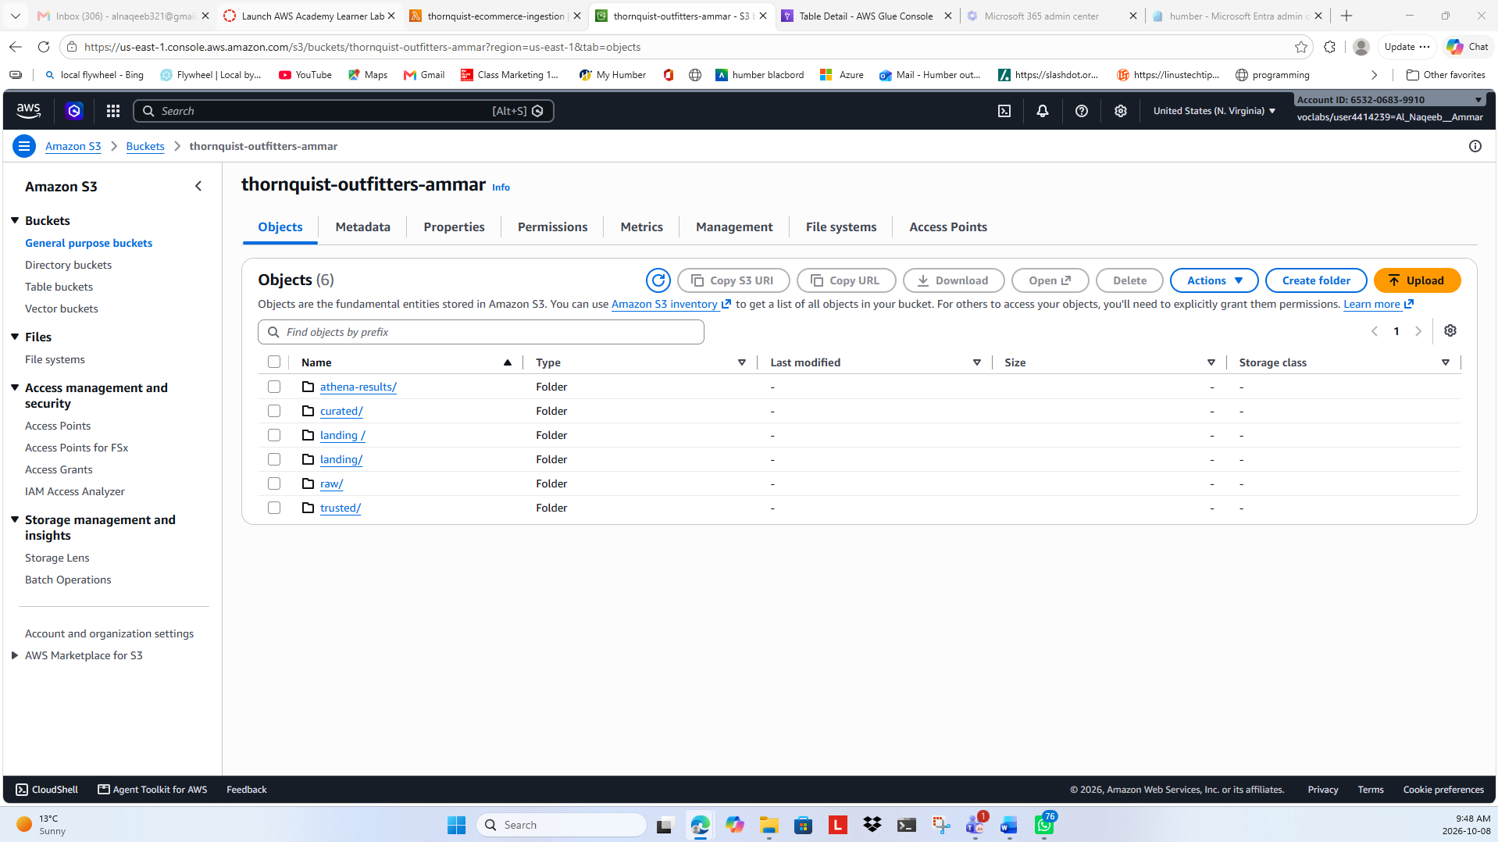
Figure 3: Raw E-Commerce Data in Amazon S3 - Raw e-commerce JSON data stored in the Amazon S3 Raw zone before ingestion and processing.
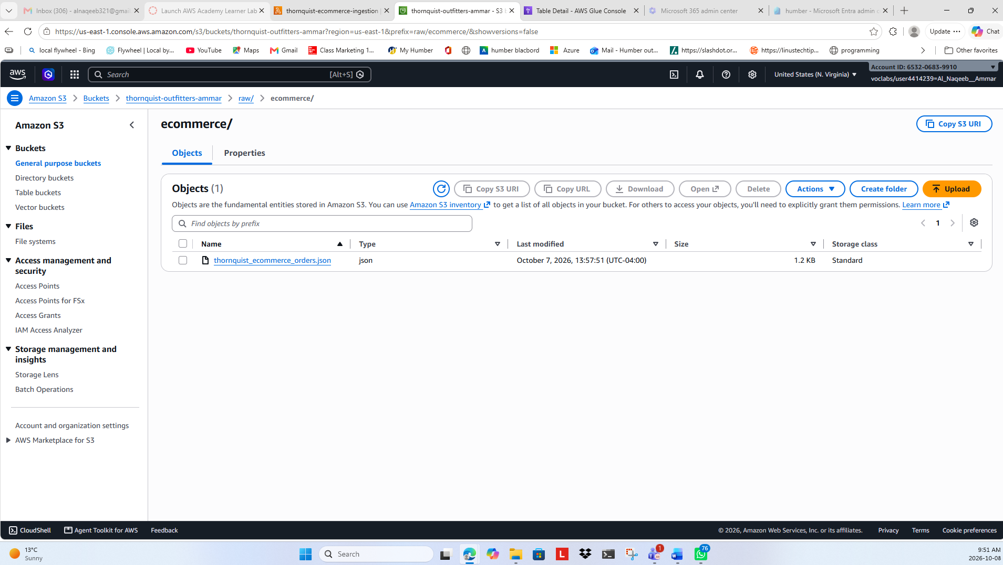

Figure 4: Raw Data Zone Structure - Amazon S3 Raw zone organized into separate folders for e-commerce, legacy customer, and POS source data.
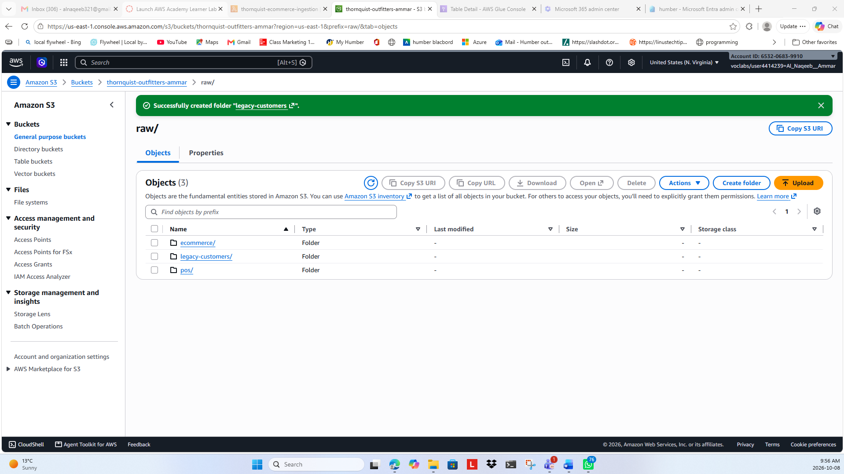
Figure 5: E-commerce Data Ingestion - Lambda successfully ingested and transformed the e-commerce JSON data into the S3 landing zone.
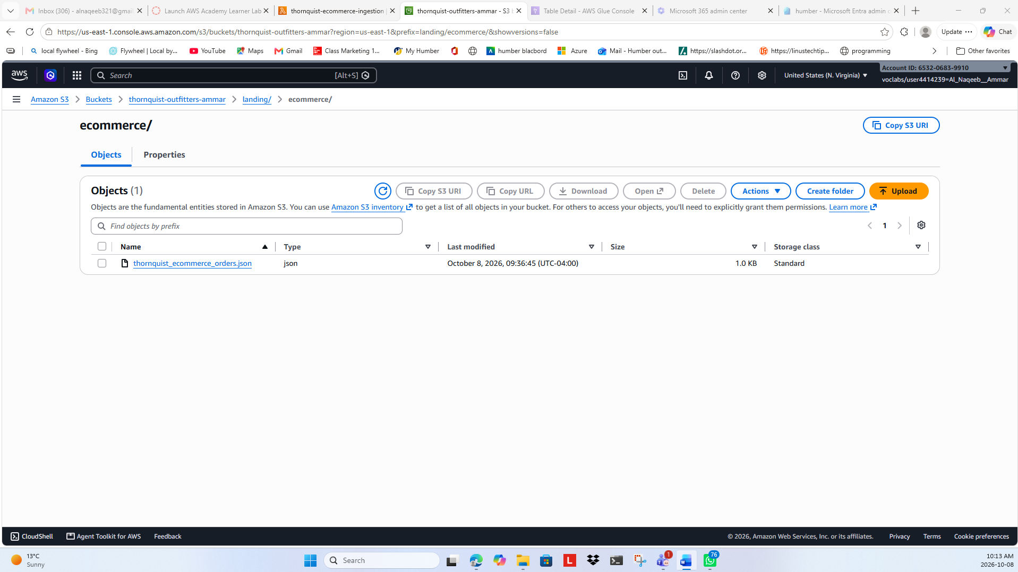

Figure 6: S3 Trigger Successfully Added to thornquist-customers-ingestion Lambda Function
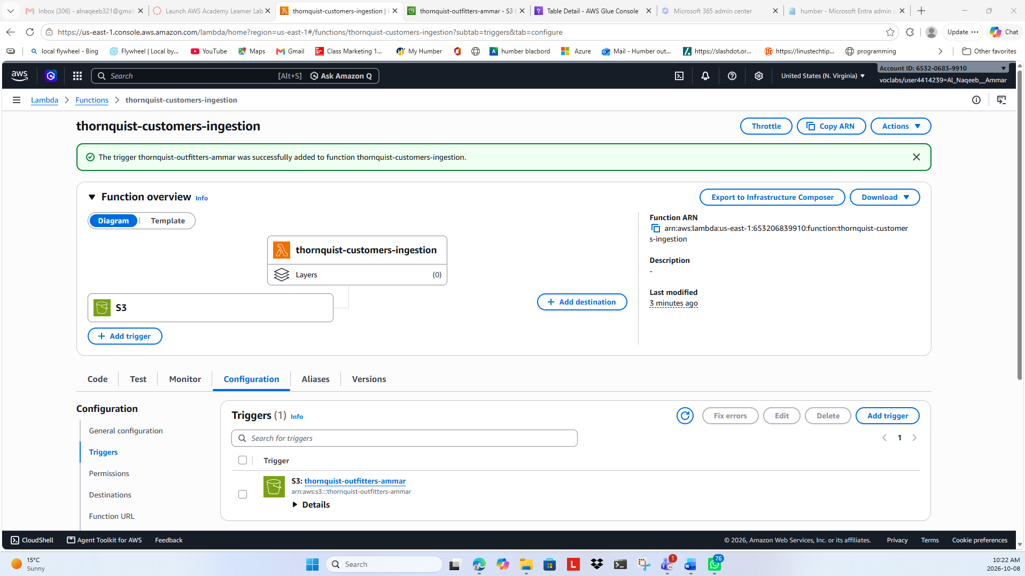
Figure 7: Legacy Customer File Copy Successful
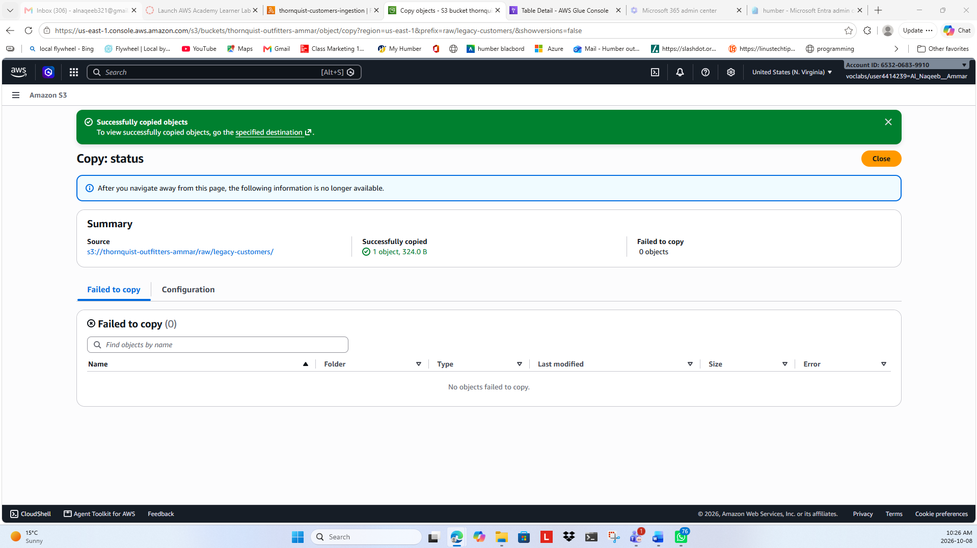

Figure 8: Legacy Customer File in Raw S3 Zone
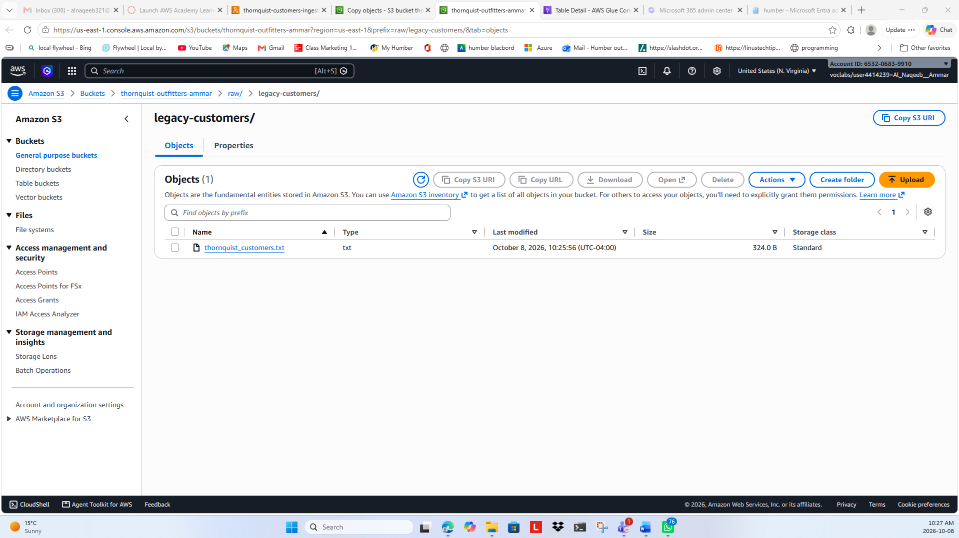
Figure 9: Customer File Triggered for Lambda Processing
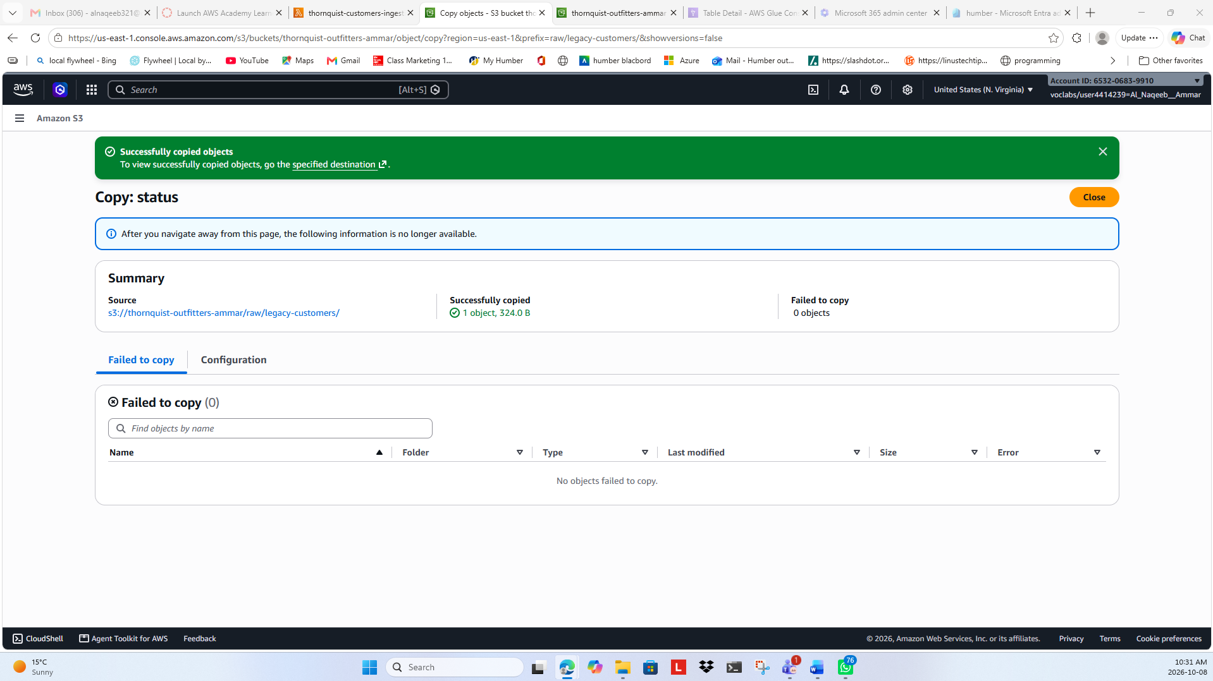

Figure 10: Customer Data Successfully Ingested into Landing Zone
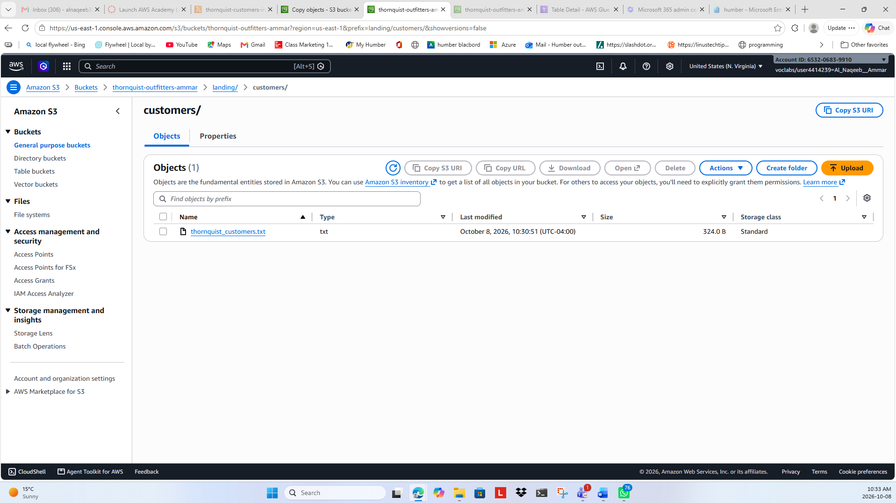
Figure 11: Customer Data Ingestion Verification - CloudWatch logs confirming successful automatic ingestion of legacy customer data from the S3 Raw zone into the Landing zone using AWS Lambda
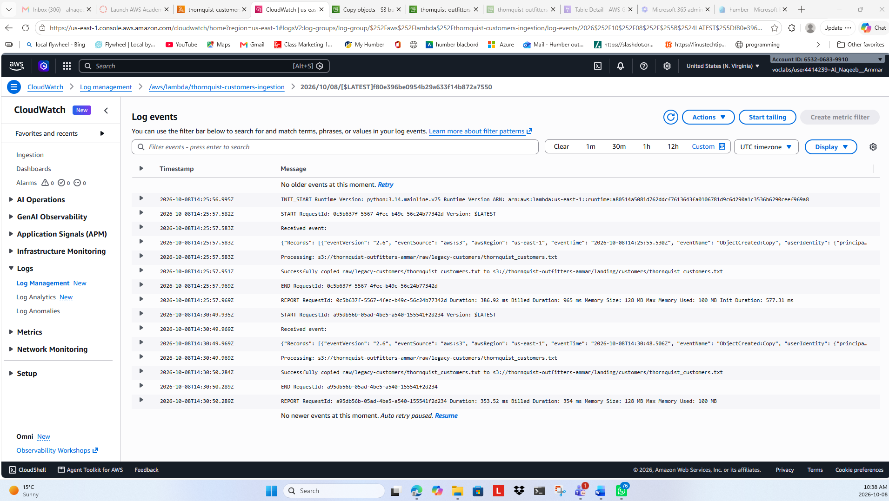

Figure 12: Successful POS Data Ingestion
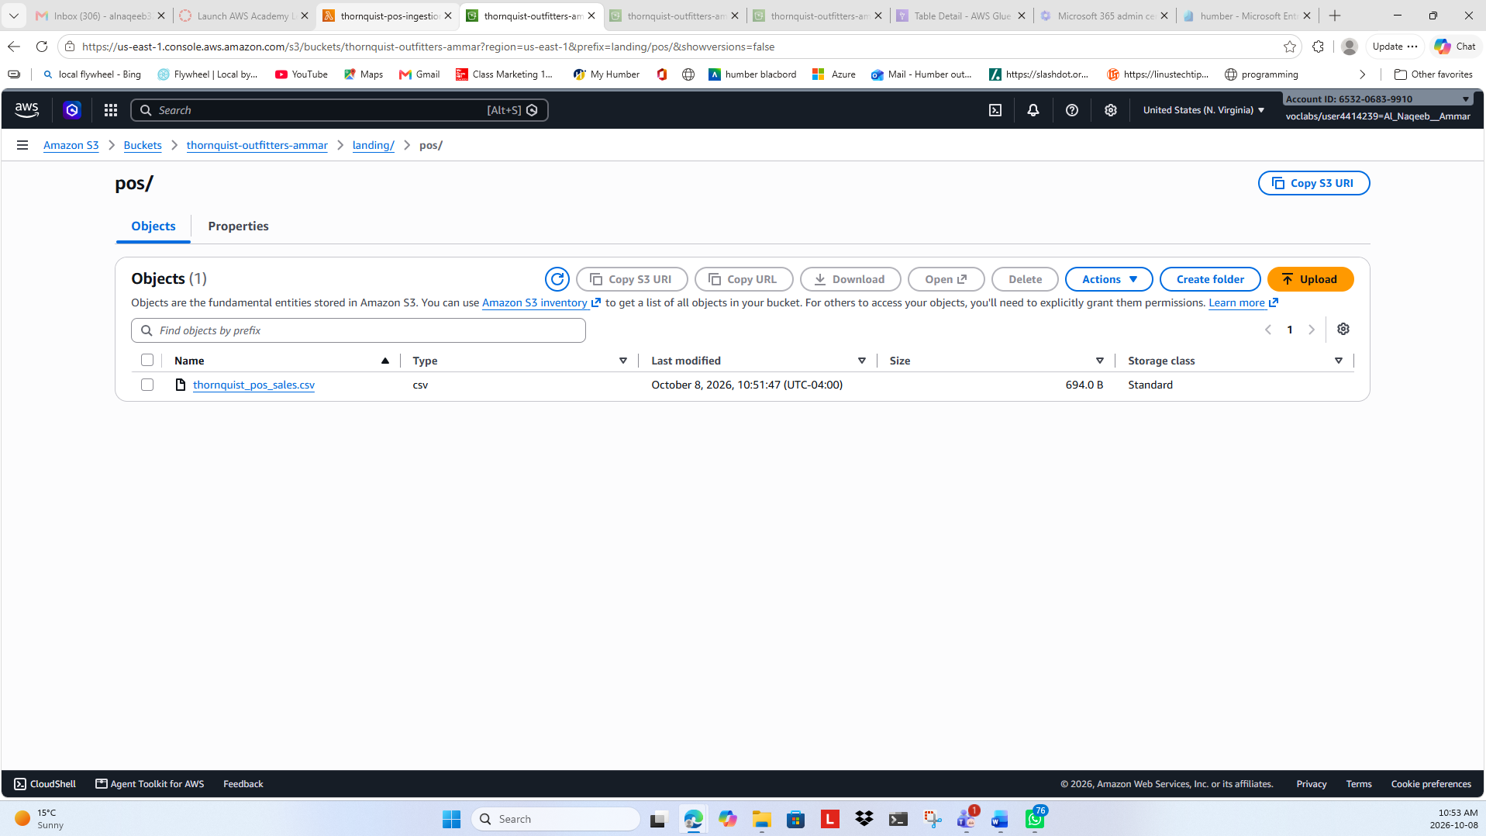
Figure 13: POS Lambda Execution Verified in CloudWatch
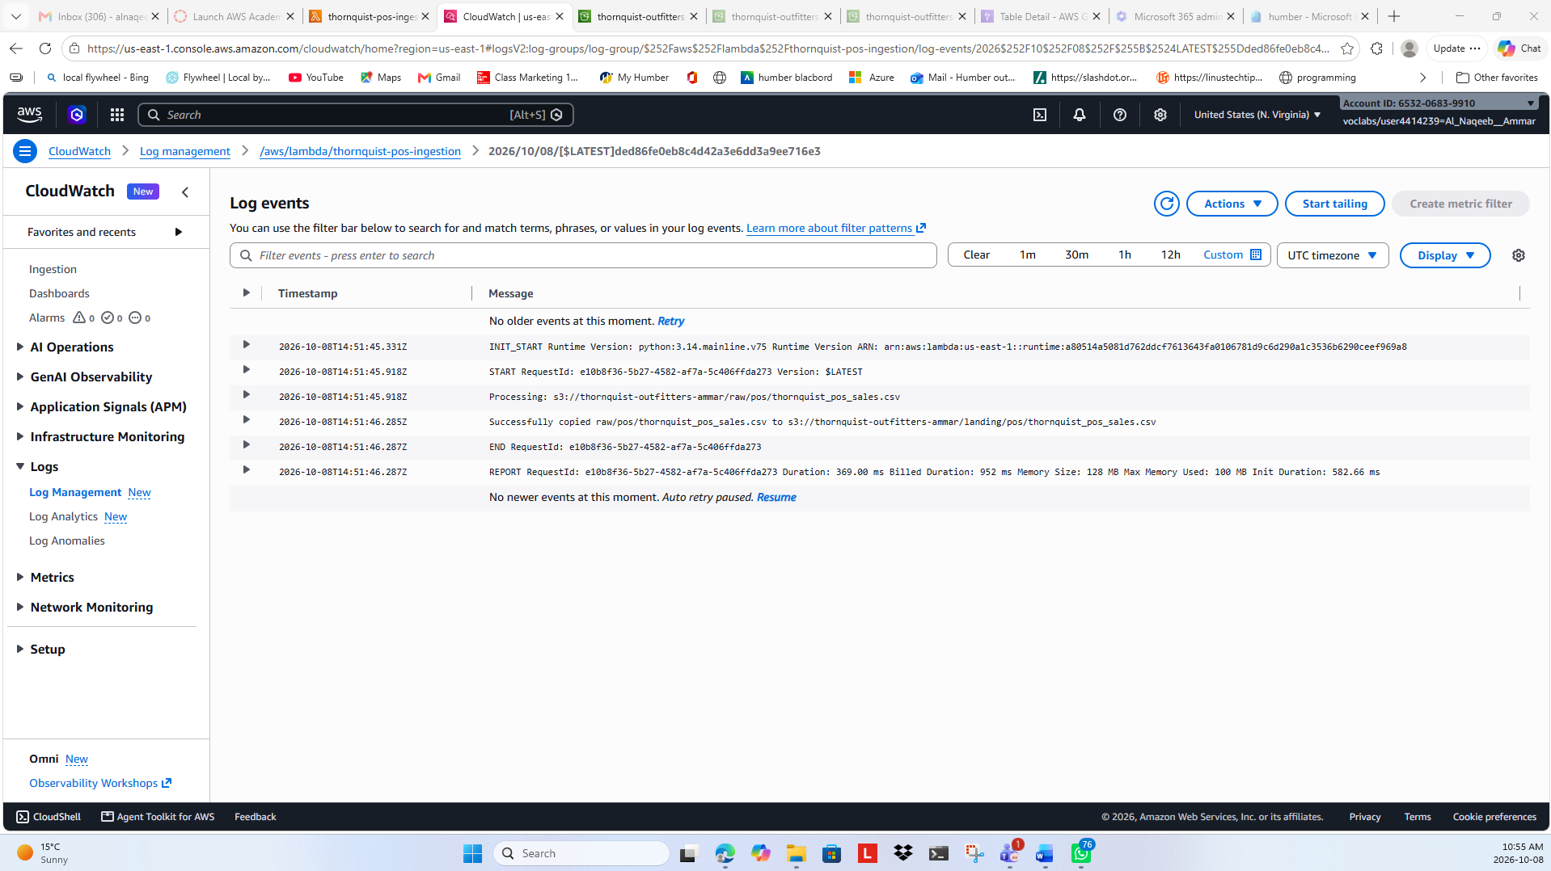

Figure 14: E-commerce JSON Successfully Ingested into S3 Landing Zone
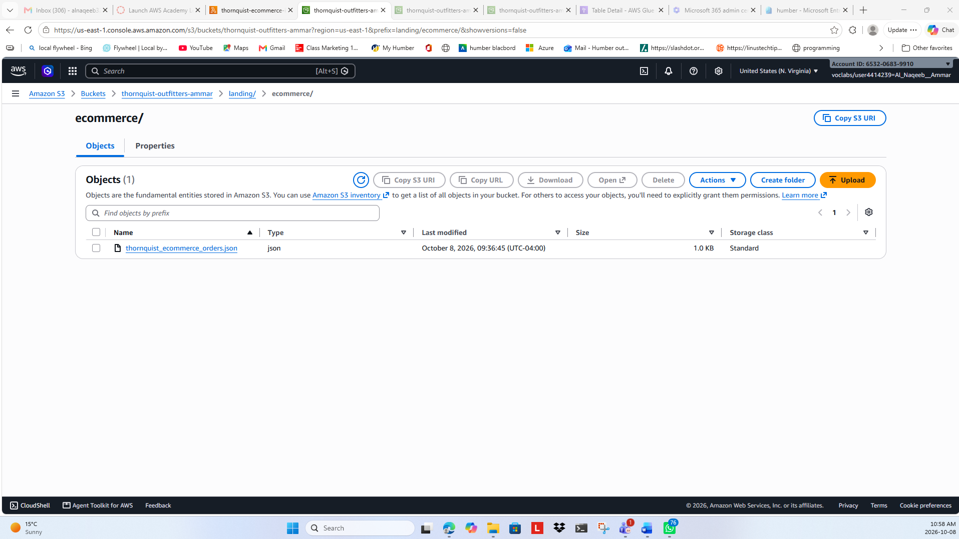

S3 Datalake Report & ETL Operations

Data Quality and Curated Layer
Reconciling the structural differences between your three channels (POS CSV, E-commerce JSON, and Legacy Customer flat file).

Part 1: Schema Conflicts Analysis (Source vs. Source)
Across our three multi-channel input sources, we identified and documented four primary schema conflicts that must be reconciled during the Raw-to-Trusted ETL phase:
- 1. Inconsistent Date Formats & Malformed Values
- The Conflict:
- E-commerce JSON (orderDate): Uses US slash formatting (MM/DD/YYYY e.g., "10/01/2026").
- POS CSV (sale_date): Primarily uses ISO hyphens (YYYY-MM-DD), but contains a corrupted malformed date entry ("2026/99/04" in record POS1006) with an invalid month (99).
- Legacy Customers (join_date): Uses standard ISO formatting (YYYY-MM-DD).
- The ETL Reconciliation Strategy: Implement a robust PySpark date-parsing routine that normalizes all date fields into a uniform timestamp format (YYYY-MM-DD HH:MM:SS), while routing malformed entries (like 2026/99/04) directly to the Quarantine Zone.
- 2. Differing Product Taxonomies & Categorization
- The Conflict:
- POS Data (category): Uses terms such as "Footwear", "Packs", "Camping", "Apparel", and "Accessories".
- E-commerce Data (productGroup): Uses alternative taxonomy buckets such as "Shoes", "Gear", "Outdoor", and "Clothing".
- The ETL Reconciliation Strategy: Build a conformed dimension mapping dictionary in the Glue ETL script to translate and unify category names (e.g., mapping E-commerce "Shoes" and POS "Footwear" into a standardized conformed category: "Footwear & Shoes").
- 3. Regional and Geographic Representation
- The Conflict:
- POS Data (region): Spells out full province names (e.g., "Ontario", "Alberta", "British Columbia", "Quebec").
- E-commerce & Customers (province): Uses standard two-letter Canadian postal abbreviations (e.g., "ON", "AB", "BC", "QC").
- The ETL Reconciliation Strategy: Create a harmonization lookup case-statement to convert full province names into standard two-letter uppercase abbreviations to ensure seamless analytical grouping in Amazon Athena.
- 4. Naming Conventions & Structural Column Mismatch
- The Conflict: Column headers and casing styles vary completely across ingestion channels:
- POS uses snake_case (order_id, product_id, product_name, unit_price).
- E-commerce uses camelCase (orderNumber, sku, product, productGroup, price, qty).
- Customers uses snake_case with pipe delimiters (customer_id, customer_name, province, segment, join_date).
- The ETL Reconciliation Strategy: Rename and map all incoming fields into a unified schema standard in the Trusted zone (e.g., standardizing transaction identifiers to order_id, product identifiers to sku, unit prices to unit_price, and quantities to quantity).

Part 2: Data Quality Anomaly Findings & Audit
Profiling the raw records revealed specific integrity violations that our automated data quality gates must catch and quarantine before data is promoted to the Trusted and Curated layers:
Anomaly Type | Source File / Record | Specific Finding | Proposed DQ Gate Action
Duplicate Transaction | POS CSV (POS1005) | Exact duplicate row logged twice for C005 purchasing Water Bottle on 2026-10-03. | Uniqueness Check Failure: Route duplicate order_id records to Quarantine.
Malformed Date Value | POS CSV (POS1006) | Field sale_date contains "2026/99/04", an impossible calendar date. | Validity/Range Check Failure: Intercept and quarantine rows with invalid date formats.
Orphaned Foreign Key (Invalid ID) | E-commerce JSON (WEB2003) | Customer ID C999 appears on an order, but does not exist in the customer master table (thornquist_customers.txt). | Referential Integrity Check Failure: Quarantine sales linked to non-existent customers.
Placeholder / Missing Customer | E-commerce JSON (WEB2004) | Customer ID is explicitly recorded as "UNKNOWN". | Completeness Check Failure: Quarantine orders lacking a valid registered customer reference.
Customer Segment Status Unknown | Customer File (C007) | Customer Riley Davis has segment value marked as "UNKNOWN". | Completeness / Null Check: Flag for review or fallback default imputation in the trusted customer dimension.

ETL Ingestion & Schema Harmonization Pipeline
This AWS Glue Studio Visual ETL job ingests heterogeneous source datasets from the Raw layer, resolves schema discrepancies, and outputs standardized, production-ready Parquet files into the Trusted S3 data lake layer.

1. Ingestion Sources & Schema Harmonization
POS Sales (Raw_POS_Sales): Ingests point-of-sale transactional data. Standardized via Change Schema transform to map field names to uniform snake case naming conventions and appropriate primitive data types.
E-commerce Orders (Raw_Ecommerce_Orders): Processes semi-structured online order records. Utilizes a Flatten dynamic transform to expand nested JSON array elements into flat tabular records before applying a Change Schema node to match the conformed sales structure.
Legacy Customers (Raw_Legacy_Customers): Ingests raw customer dimension records. Maps positional headerless CSV attributes (col0–col4) to standardized attributes (customer_id, customer_name, province, segment, join_date) via Change Schema.

2. Consolidated Transformation & Storage Architecture
Sales Datasets (POS + E-commerce): Applied Transforms: Flatten → Change Schema → Union. Target Storage Path: s3://thornquist-outfitters-robinson/trusted/conformed_sales/. Target Format: Apache Parquet (Snappy)
Customer Dimension (Legacy Customers): Applied Transforms: Change Schema (Mapping). Target Storage Path: s3://thornquist-outfitters-robinson/trusted/customers/. Target Format: Apache Parquet (Snappy)

3. Key Findings & Technical Solutions
Schema Reconciliation: Resolved schema mismatches between POS and E-commerce channels by projecting all attributes into a unified target schema prior to execution of the Union transform.
Semi-structured Data Flattening: Successfully resolved nested array structures in E-commerce orders using the Glue Flatten node, ensuring zero data loss during tabular conversion.
Decoupled Data Catalog Registration: Disabled interactive catalog update triggers inside the Glue Studio job nodes to prevent IAM session/role permission constraints (AccessDeniedException), opting to register the Trusted layer Parquet tables directly via Amazon Athena DDL.

Adding Curated Layer (Parquet + Partition)
Wrote conformed sales data into Apache Parquet format with Snappy compression.
Implemented Data Partitioning by category (category=Accessories, Apparel, Camping, Clothing, Footwear, Gear, Outdoor, Packs) at s3://thornquist-outfitters-robinson/curated/conformed_sales/ to minimize data scan costs and optimize Athena analytical queries.

Registry Curated Table in Athena
Partition Metadata Registration: Executed MSCK REPAIR TABLE in Athena, successfully discovering and registering all physical S3 partition paths into the Glue Data Catalog.
Query Validation: Successfully executed verification queries (SELECT * FROM thornquist_db.curated_sales LIMIT 10) returning clean, conformed, multi-channel transactional records ready for downstream Business Intelligence (BI) consumption.

ETL Architecture and Querying Visuals
Figure 15: Create the database using AWS Glue
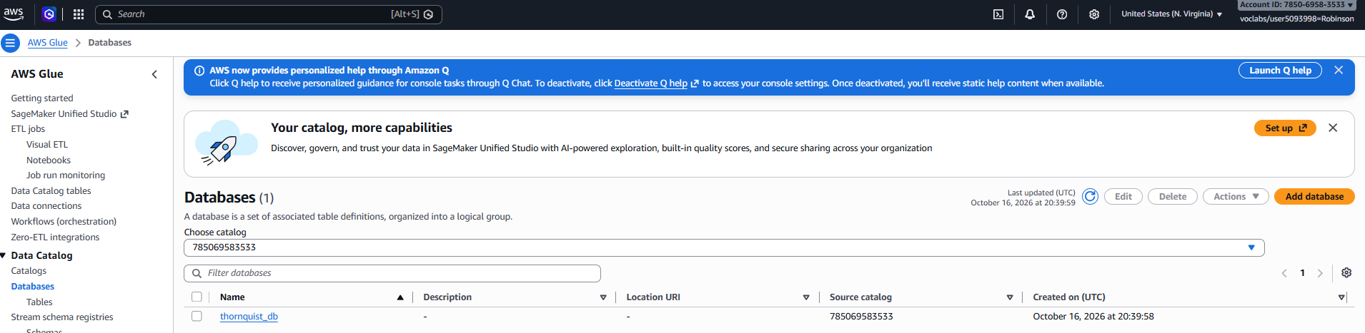

Figure 16: Create crawler
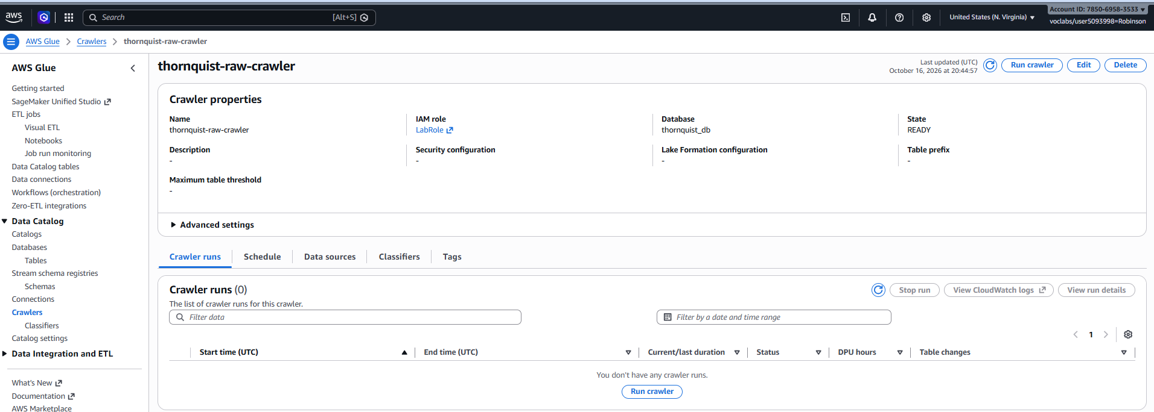
Figure 17: Run and Inspect Tables
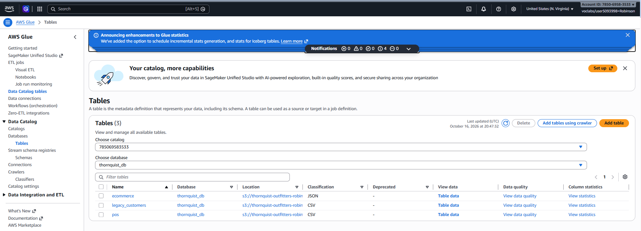
Figure 18: Query the Data on Amazon Athena
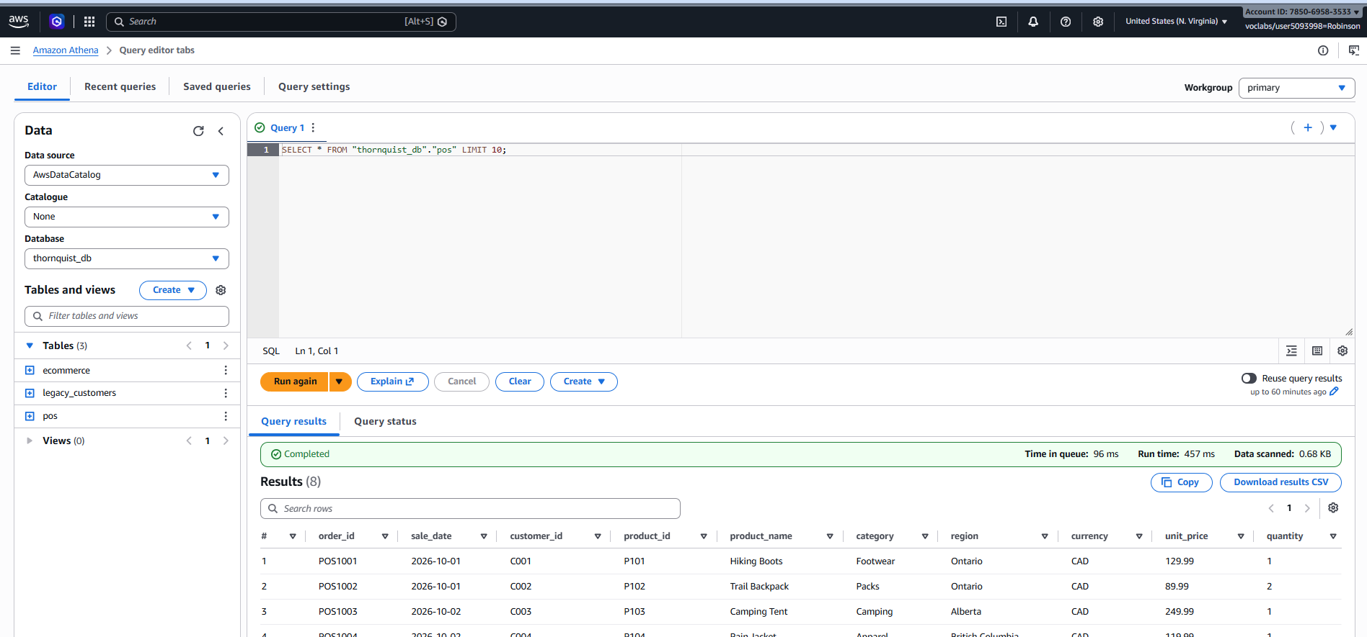

Figure 19: ETL Pipeline setup in Glue Studio
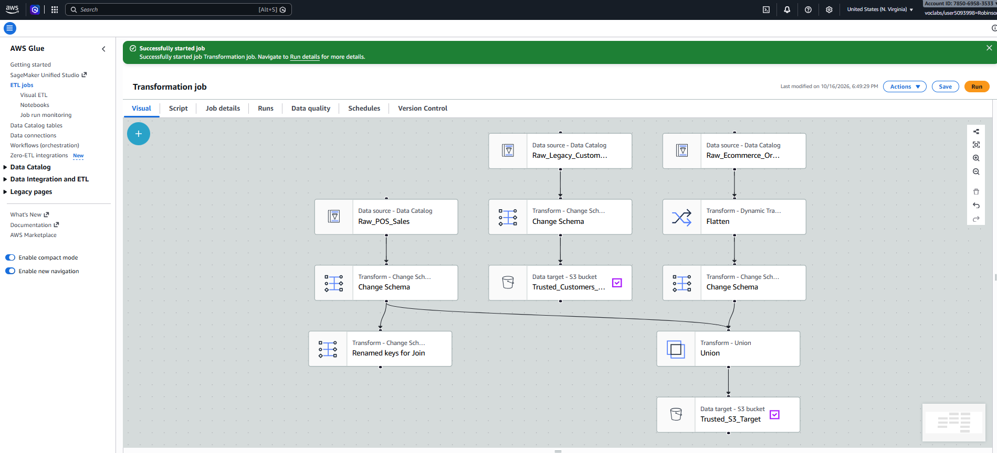
Figure 20: Applying transformations (Flatten, Schema Change, Union)
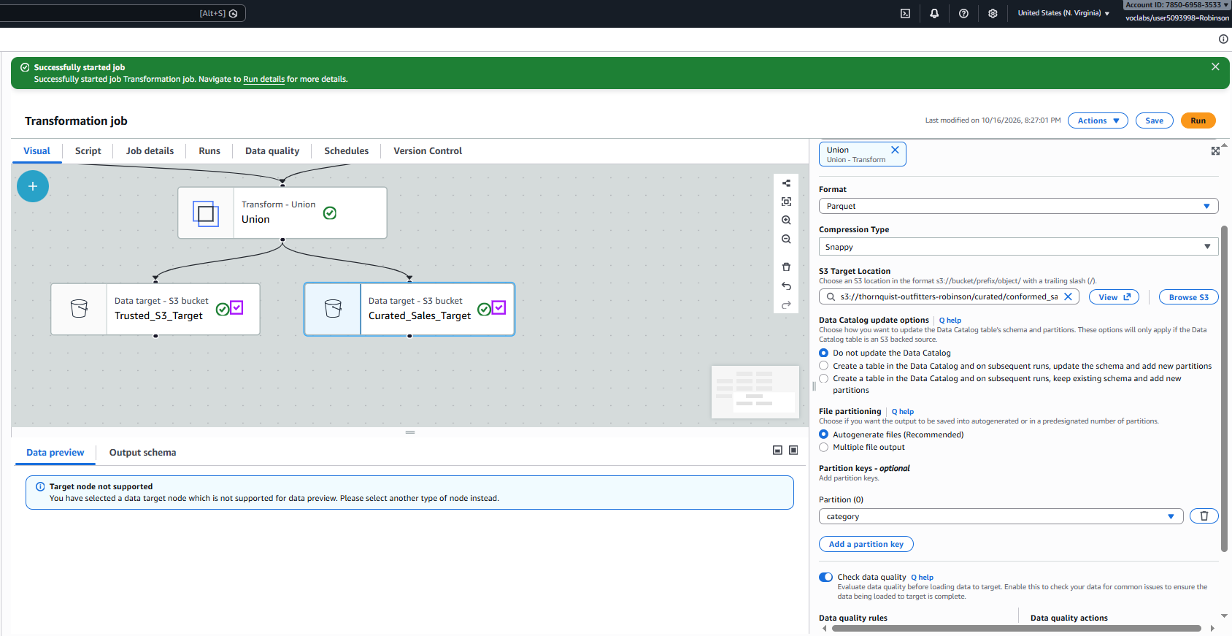

Figure 21: Configuring S3 Target and Data Format
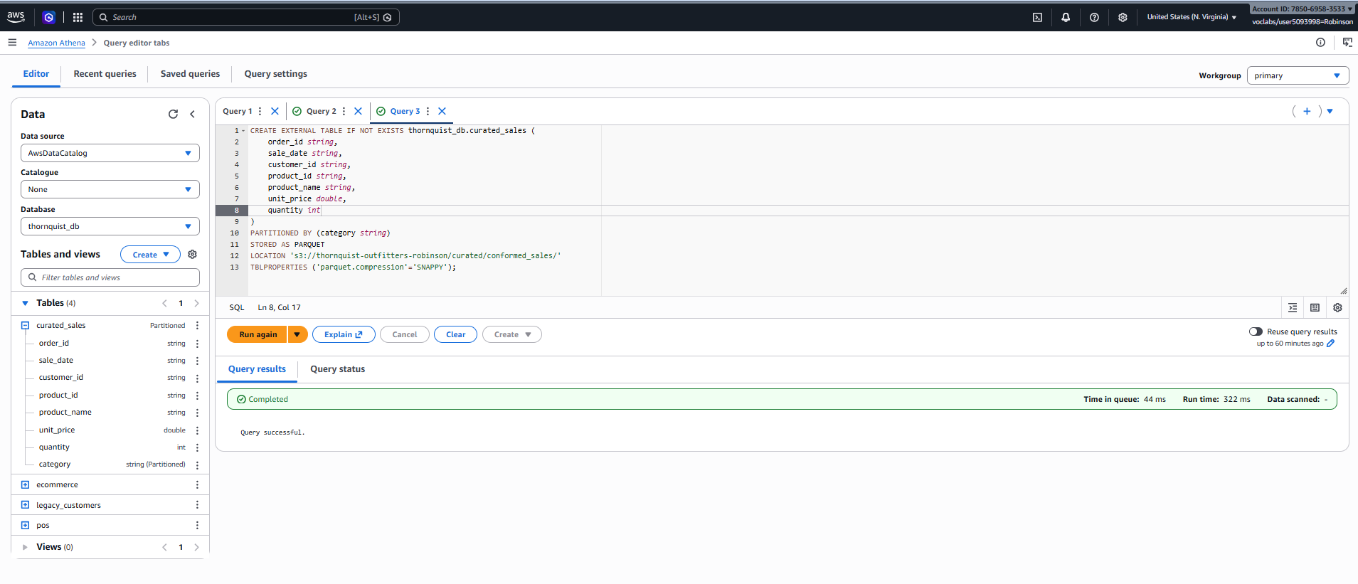
Figure 22: Athena Data Querying after ETL
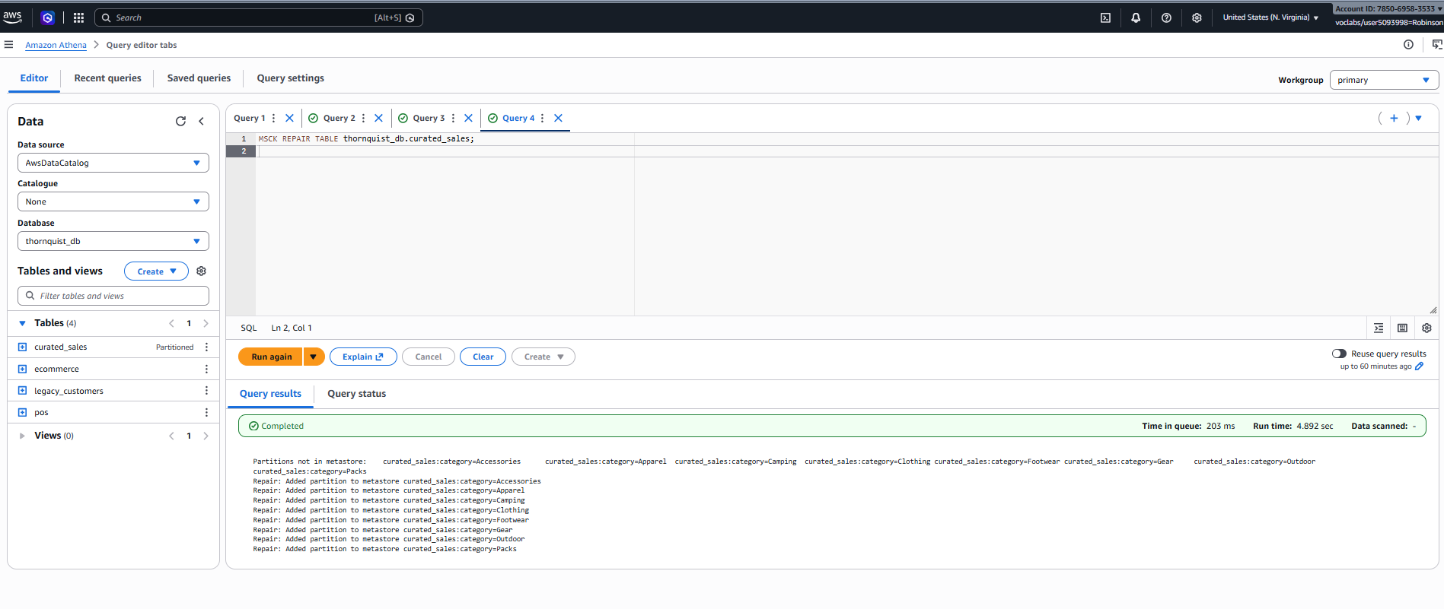

Figure 23: Data Quality Verification Queries
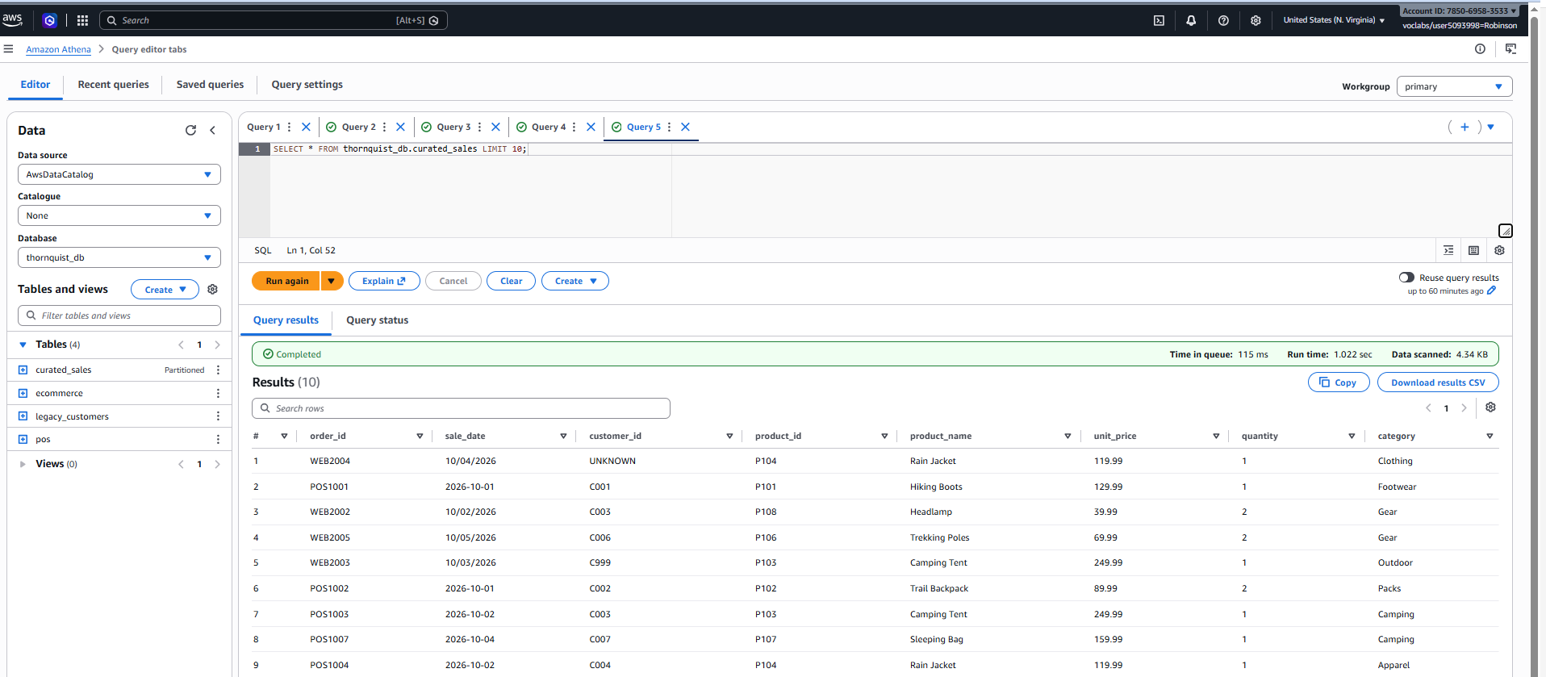
Figure 24: View Data Preview
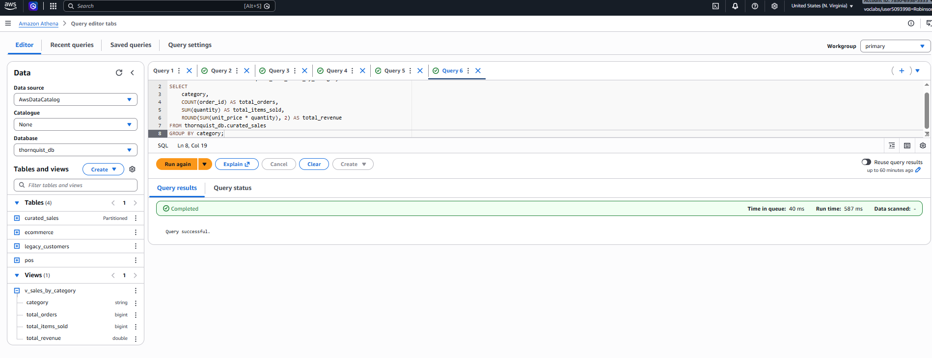
Figure 25: Final Analytical Dashboard/View Results
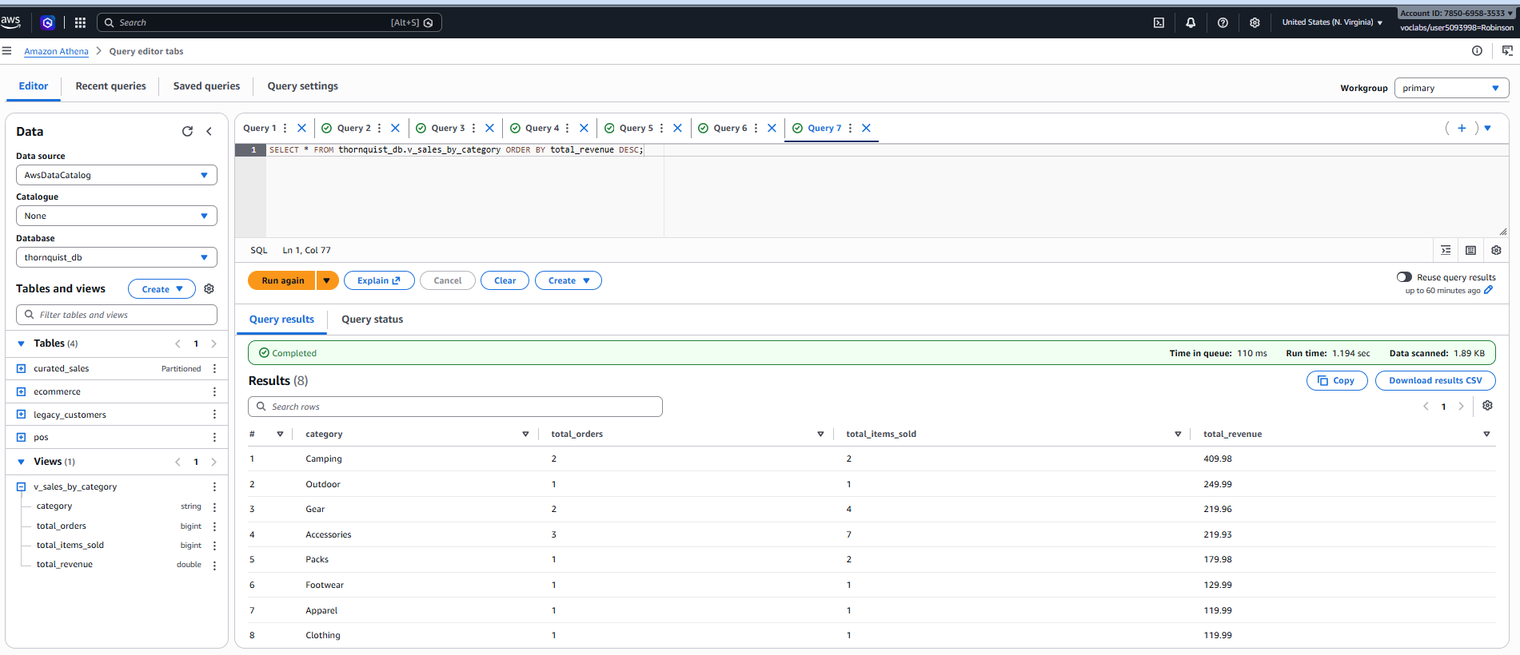

7. Extended Design Rationale and Trade-offs

7.1 Data Lake Zoning and Promotion Rules
To ensure data integrity, traceability, and scalable processing, the Thornquist Outfitters data lake was strictly divided into four logical zones. The promotion of data between these zones is governed by automated rules and validation gates.
1. Landing Zone: This is the entry point for all raw data. Files are dropped here exactly as they are received from the source systems (POS CSVs, E-commerce JSONs, Legacy TXT extracts). Data in this zone is treated as immutable and transient. Promotion Rule: An S3 ObjectCreated event triggers a Lambda function that validates the file extension and prefix before moving it to the Raw Zone.
2. Raw Zone: Once data lands here, it is cataloged by an AWS Glue Crawler. This zone maintains the original format of the data but organizes it systematically by source and ingestion date. Promotion Rule: Data is promoted to the Trusted Zone via an AWS Glue ETL job, but only if it passes schema normalization and data quality checks (e.g., dropping malformed dates).
3. Trusted Zone: Data in this zone is cleansed, joined, and conformed to a unified enterprise schema. For example, differing category taxonomies between POS and E-commerce are standardized into a single mapping. Promotion Rule: Trusted data is processed by a final Glue ETL aggregation job to prepare it for business intelligence queries, converting it to Parquet format before moving to the Curated Zone.
4. Curated Zone: The final layer, optimized for high-performance analytical queries via Amazon Athena. Data here is stored in columnar Apache Parquet format and partitioned by business-relevant dimensions.

7.2 Trade-offs Considered and Rejected
During the design phase, several architectural trade-offs were evaluated. Due to the budget constraints and session limits of the AWS Academy Learner Lab environment, we favored serverless, on-demand services over always-on infrastructure.
Amazon EMR vs. AWS Glue: We initially considered using Amazon EMR for big data processing given its robust PySpark capabilities. However, EMR clusters are long-running and consume lab credits rapidly. Furthermore, the Learner Lab auto-stop feature risks terminating clusters mid-session. We rejected EMR in favor of AWS Glue, which is serverless, bills only for job duration, and fits within the lab’s constraints.
Custom IAM Roles vs. LabRole Constraints: Standard best practice dictates creating highly granular, purpose-built IAM roles for every Lambda function and Glue Job. Because the Learner Lab restricts IAM role creation and forces the use of a pre-defined "LabRole", we had to reject the custom IAM approach. Instead, we shifted our least-privilege security model to resource-based policies (S3 Bucket Policies) and AWS Lake Formation.
Amazon QuickSight vs. Athena Views: QuickSight is an excellent BI tool, but provisioning enterprise BI instances in a restricted lab environment can cause availability and billing issues. We opted to use Amazon Athena views as a lightweight, serverless analytical layer to generate our metrics.

8. Governance, Security, and Cost Management

8.1 IAM and Least-Privilege in the Learner Lab
Enforcing governance in an environment that restricts IAM role creation requires alternative security mechanisms. Because all services share the "LabRole", we designed our security perimeter around resource-based policies.
1. S3 Bucket Policies: We drafted bucket policies that restrict cross-zone access. For instance, the policy denies any `s3:PutObject` actions to the Curated Zone unless the request originates from the specific Glue Job ARN responsible for the Trusted-to-Curated ETL step. This prevents accidental manual overwrites of production-ready data.
2. AWS Lake Formation Permissions: To simulate enterprise access control, we registered our S3 locations with Lake Formation. We designed a permission matrix where a hypothetical "Analyst" principal is granted `SELECT` access only to the Curated databases and tables, completely blocking their access to the Raw and Landing catalog layers containing uncleansed data.

8.2 Cost and Performance Reasoning
The Curated layer was specifically optimized to reduce Amazon Athena query costs, which are billed based on the amount of data scanned per query.
Storage Format: We converted all conformed sales data into Apache Parquet format with Snappy compression. Parquet is a columnar storage format, meaning Athena only scans the specific columns requested in the `SELECT` statement, ignoring the rest of the data block. Snappy compression further reduces the storage footprint and the megabytes scanned per query.
Data Partitioning: We partitioned the S3 output by the `category` field (e.g., `s3://.../curated/conformed_sales/category=Footwear/`). Because Thornquist Outfitters’ leadership frequently runs reports filtering by product categories, this partition strategy ensures Athena prunes irrelevant folders before running the query, drastically cutting execution time and minimizing lab credit burn.

9. Lessons Learned
Building this multi-channel data lake highlighted several key lessons in data engineering and AWS cloud architecture:
1. Data Profiling is Critical: We learned not to trust raw data. The presence of malformed date values (e.g., "2026/99/04") and orphaned customer IDs in the e-commerce JSON demonstrated that assuming schema conformity leads to downstream pipeline failures. Implementing data quality gates early in the pipeline is essential.
2. Environment Constraints Drive Design: Working within the Learner Lab forced us to think creatively about cloud economics and security. Unable to rely on standard IAM identity policies, we gained a deeper appreciation for data-centric security via Lake Formation and S3 bucket policies.
3. Schema Evolution: Merging camelCase JSON keys with snake_case CSV headers taught us the importance of having a hardened Trusted zone schema. Moving forward, any changes to source-system column names will be caught and mapped in the Raw-to-Trusted layer, protecting the downstream analytics dashboards from breaking.

