Introduction
Hello dear reader! Mathematics is a field of study that has a reputation for being difficult, and it is awesome that you are reading into it despite that.
Before reading this, I want you to know that learning math is not meant to be a crash course on how to become a computer. We stopped employing computers—people who would manually solve math problems—because we made cheaper, faster, digital computers (we don’t deal with large numbers manually unless we want to).
Math beyond your 4 basic operations—aka arithmetic—exists as a field of study to describe and relate things; or as a physicist and data scientist would say ‘to model stuff’. Any math outside of this applied math is called pure math, or math that has yet to find an application.
My case and point is that mathematics, while difficult, is not impossible or pointless. Despite what your peers and/or what your friends may say. Math is a tool; a tool that we use to say how much something moves over time, how much gravity pulls stuff down at some location, or how many volts (zappy zaps) are required to power a light-bulb versus an LED bulb. We use math to express certain ideas more concisely, accurately, and literally than what can be done with words.
It is my hope that this packet will assist you in tying up any loose ends in your arithmetic and in your algebra work. Remember, its just shapes and beats.

Parts
‘Essential’ Vocabulary
Graphing Essentials
More Graphing
Exponents and -1
Polynomials and Rats
Factoring
Unit Circle and Trig
Image of The Unit Circle
Light Combinatorics
Extensions
Logic & Set Builder Notation!
Math Tools!
Further Investigation & SoME
‘Essential’ Vocabulary
Operation
Think of a medical operation where you are actively modifying a body in order to save or improve it. You are in some way changing or modifying this body with an operation: a tool. From stitches and needles to scissors and chainsaws, there are numerous operations that can be performed on your medical problem.
You may apply different operations or groups of operations depending on what ails your patient and what you are trying to do to your patient (kill cancer, plastic surgery, amputation, extraction, pain relief, pimple popping, etc).
The order you apply your operations matters too! For example, you may increase the amount of blood in a body, amputate a limb, and then add a bunch of saline (salty water) to get your blood -water ratio back to normal levels. If you do not change the amount of saline you are adding In relation to the amount of blood lost through amputation though, you may delude the blood so much that your patient dies (you will probably change the math expression’s validity).
In short think of a singular operation like a singular modification; a modification that you can manually choose to do and a modification that you can make a computer automatically do for you,
Expression
Think of a politician expressing a viewpoint, or really anyone expressing any emotion or idea. The general theme here would be that these expressions are connecting (expressing a relationship) one thing to another thing. (example: I think politicians are bad when they say “I hate puppies more than I hate math, therefore we should get rid of puppies and replace them with math worksheets.”)
Did you notice any constraints within the verbal expression? Any clarifying language? Did you notice how the main thought was limited in scope by using the word “I” and how the main thought is only negative when a certain condition (hate) is fulfilled? Did you notice how the speaker expressed a connection between puppies and math? Those are all relationships between things, in this case being elements of a verbal, opinionated expression!
Thing is, in math we aren’t talking about ideological views or personal views. We tend to gather a bunch of expressions through the collection of data from things such as nuclear tests to polls and surveys which we then organize and analyze in a variety of different ways (often with the help of computers).
Calculation
Not just limited to arithmetic, calculation is often what you are tested on in high school and low level college math exams.
This is because calculation is a great way to test your ability to apply math rules that can be applied to any math problem to a specific problem. Calculation also keeps numbers of things, where all of math is derived from, in your mind.
Arithmetic
“Arithmetic is the branch of mathematics dealing with numerical computation.” - REF 15
It is important to note thought that variables can be used in arithmetic, and that it is not just 3rd grade times tables grinding math; it is also computers and the bedrock of our digital world!
These variables tend to follow one of two trends in arithmetic, given you are solving for something.
1. solving for really simple variables/identities | 2. brute-force
Algebra
“the mathematics of generalized arithmetical operations” – REF 14
Unlike arithmetic, algebra uses variables most of the time, Instead of focusing on operations and the 1-dimensional number-line, we ‘algebraists’ look at things that always stay true and solve for our variables as efficiently as possible, looking at a 2d number-line (a number square, if you will).
Beyond computation, we apply what we know to be true (ex. The Pythagorean Theorem) to show that other stuff must be true because what we know to be true is true (ex. The Unit Circle & Trigonometry).
Even more generally, we use arithmetic to prove that certain things are true/false either all of the time or some of the time: to prove a conditional or unconditional statement. We then make things easier to read with new ways of writing/expressing (notating) what things are, which we then analyze to find more patterns and identities.
A good example of this would be Summation Notation where we rewrite very long but repeated with pattern(s) addition with a (A capitalized “sigma” from the Greek alphabet).
Simplistic Examples of Summation Notation being used to add from the number on the bottom (the lower bound) to the number on top (the upper bound).

Identity
Think of a person and think of who they are. Maybe they have an identifying name ‘Sal’; maybe they have an identifying phone or license plate; or maybe their body and brains are their identity.
Regardless of how you chose to identify this person, you (hopefully) did so successfully.
Math has plenty of identities too, but at its simplest an identity is what something is.
A thing can be defined as itself or as its parts rearranged into some cohesive thing, like a phone defined as a small computer or as a symbol of human rights violations in mineral rich African countries by exploitative foreign powers.
In math, you can make your own identities with variables, so long as you constrain them so that contradictions aren’t made. For instance, you can set , but if z were to equal 2 anywhere else in the massive field of mathematics, you would need to change or restrict your identity to keep it true.
An example of a false identity would be since their graphs are not equal for every output value.

Constant – Something that cannot vary, usually a number or an a, b, or c term.
Variable – Something that can vary; usually an i, n, x, y, or z term.
Pure Math – math that is not applied to our world (note: modern encryption is based in old pure math; pure math that eventually became applied math)
Applied Math – math that is applied to our world, typically through the sciences or customer service.

What is Commutativity, and what makes something Commutative?
In Mathematics, when an operation is communicative we can operate on any two numbers or variables without changing our result. 1-2, for instance, is not communicative unless we rewrite it as an addition statement like -2+1 since 2-1 = 1 while -2+1 = -1 = 1-2. In general, multiplication and addition are commutative but exponentiation, division, and subtraction are not. - Ref 43 & 44
What is Associativity, and what makes something Associative?
For the purposes of this course, associativity is a property that is reserved for addition and multiplication. The property exists when changing what is surrounded by parentheses does not change your result. (ex. ). - Ref 45 & 46

Note: This property will be more thoroughly defined on wiki pages or higher level math courses.
The Distributive Property
For the purposes of this course, the distributive property states that given that - Ref 46 & 47
Where, When, and Why do these properties break down? (ignoring the y)
A lot of these properties break down when dealing with a set of numbers call the “quaternions”; however, seeing that this set will not appear in algebra 2 or calculus 3, you will often see these properties break down when performing subtraction, division, and exponentiation.

Graphing ‘Essentials’
Graphs
Graphs show the relationships between the x and y values of a function rather nicely when you are explaining one in terms of the other.
Despite some of their quirks, graphs are very useful throughout the sciences and in presentations.
Function – An equation or graph where each ‘input’ (x value) has only one ‘output’ (y value).
Graph – Go to desmos.com; type in x=y on the sidebar; see what happens.
Range – The set of valid (y) values a graph has.
(ex. has a range of , while has a range of since if then y = 9 would be false).
Domain – The set of valid (x) values a graph has.
(ex. has a domain of , while has a domain of since if then would be false).

The Origin – (0, 0) on a coordinate plane
Vertex – the central coordinate of a graphed expression: when unchanged the vertex of a graph is (0,0)
Translation – a change in the coordinates of the vertex of a graph.
(Note: horizontal translations can be thought of as either making a graph hit its vertex sooner or later.) For example, only when , meaning x has to be further to the right to have an output of 0.
The Zero Product Property
You have an expression Because this expression is entirely multiplication, whenever one parenthesized expression, x, or generally speaking multiplier = 0, this expression is true.
Because x can equal any number so that x equal 0, -a, or +b, this equation has 3 zeros and x=-a,0,+b are those zeros (when the expression outputs a 0)
Delta
A triangle that is oftentimes next to some variable. This triangle represents ‘change’.
(ex. In science classes (looking , is used to describe a ‘change in temperature’)
Slope
(aka ‘the gradient’ or the ‘rise over run’)
Note: derivatives arise by combining slopes and limits; a common occurrence in calculus.

More Graphing
Absolute Value – often notated with straight lines || or abs(), absolute value is defined as the distance from 0 of a coordinate or number. (ex. abs(-1)=1) (ex. |-20|=20) (ex. |x| = x)
Direct Variation – A proportion (not necessarily an equality) where as an input (x) and its output (y) increase together or decrease together.

Inverse Variation – A proportion where an input (x) changes in opposition to an output (y) to equal a constant (c)
(ex. and are examples of inverse variation because both variables cannot increase together or decrease together)

Regression - “A method for fitting a curve (not necessarily a straight line) through a set of points using some goodness-of-fit criterion.” - Ref 3
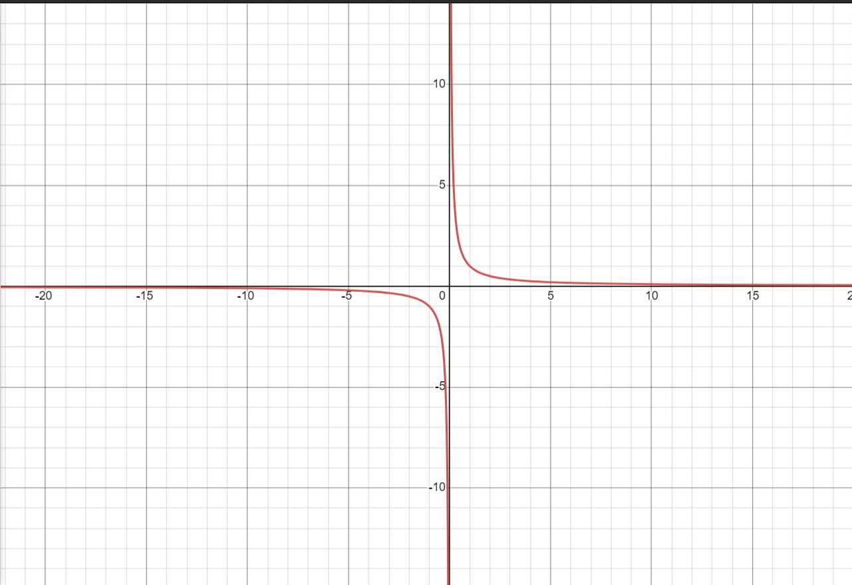
Asymptote
Personally, I’ve found 2 definitions of an asymptote that work really well.
The first definition I stumbled upon in my algebra 2 class, which I at least defined as some line (or more curvy line) that was approached by a group of continuous outputs.
The second definition was one that I found on a site called “Wolfram Alpha” whilst working on this Algebra 2 sheet. Instead of defining an asymptote as something that a function approaches, Wolfram Alpha had defined it as a curve (a fancy line) that approaches (gets closer and closer) to a function.
has two asymptotes, and is graphed to the right.
Global Bound – A upper or lower bound/limit for the graph of an entire equation (unrestricted domain and range)
Regional Bound – A upper or lower bound/limit for a region of the graph of an equation (where domain and/or range is restricted)
Locus
The curve made by graphing points on a graph (wolfram alpha has a way better definition, so check it out!) Note that this definition isn’t critical in an algebra 2 course.
Point
A 0-dimensional part of a coordinate plane that describes position based on its own position in relation to the many number-lines of a graph. You can have a point with 2 defined dimensions, 3 defined dimensions, 4 defined dimensions, or 100000 defined dimensions (regardless of how impossible that would be to visualize).
Exponents and -1

The Parts of an Exponential Equation
An equation involves 3 main parts. A Base, A Power, and A Product (since exponentiation is repeated multiplication.) (ex. )
(In the below example, 3 = base, 2 = power, 9 = product)
These three parts--the base, power, and product—can all be rewritten into equally true statements that change the order of how we read the parts of an expression like this.
Rewriting an Exponential Equation
And
The above equations are restatements of the prior exponential equation.
The one to a left is called a ‘radical’ expression.
The one to the right is called a ‘logarithmic’ expression.
THE ‘Radical’ Expression
The radical expression previously mentioned can be rewritten as .
Radical expressions generally equal the number(s) that when multiplied by each other n number of times gives the number under the radical, assuming in our example .
In algebra textbooks, you may see a unit called rational roots and rational exponents where you see numbers higher than 2 in both roots and exponent slots alongside numbers lower than one.
Importantly, you will be asked to convert between radical and exponential expression and to add these two types of expressions together, or alternatively to find the numerical value of some variable in both of these expressions.
Also note that you will graph these as functions where any of the 3 can be variable.
THE ‘Logarithmic’ Expression
The logarithm expression in the above logarithm is a rewrite of an exponential that moves the three parts of an exponential again.
Typically seen in the form , we append our base to our log via subscript and put our product to the right of our logarithm. We then move our power to the other side of the equality.
The logarithm asks “what number does my base need to be raised to output my product?”
Raising a base to a negative power
Think of negating a power as inverting repeated multiplication so that you are repeatedly dividing a number by itself. and
Raising a base to the 0th power
From our previous example, you can think of raising a base to the zeroth as multiplying or dividing 1 by your number 0 times! ex.
A Powerful Video By 3Blue1Brown regarding Exponents, Roots, and Logarithms
https://www.youtube.com/watch?v=sULa9Lc4pck
It’s okay if you don’t get it the first time, I didn’t either.
I advise slowing down where you don’t understand what is happening; take about what you don’t know. You can always check back here or elsewhere for things you didn’t quite get.
The square root of a negative number?
The square roots of negative numbers are called ‘imaginary numbers’ and were first used as some sort of ‘hacky’ solution to an old math problem. It worked, but the guy who first used them thought that what he did was so hacky and mathematically immoral that he called them ‘imaginary’.
Currently, we understand them to be perfectly good numbers alongside other sets of numbers (quaternions and p-adics just to name a few), but we still have that really awful name ‘imaginary’, making these numbers seem as useful as the name implies.
Definition of
Definition of
You may hear ‘I’ being referred to as the “imaginary unit”, meaning that you can’t add your real numbers (the ones without I) and your imaginary numbers together into one very neat number.
We can, however, add and subtract these numbers so long as we keep the sign adding or subtracting them intact.
We call these numbers “Complex Numbers”: numbers that a teenager should be able to relate to.
Note: when people call numbers 2-Dimensional, you have the Imaginaries to thank.
The Real Numbers – Any number between
Can be more concisely expressed as (see logic)
The Imaginary Numbers – Any number between
Typically written in form where b is a real number, and I is the imaginary unit.
The Complex Numbers – Any number expressed in form
Can be expressed as (see logic)
Occasionally, you may see specific complex numbers represented with a (z) later on in math.
Why do roots have two solutions when n is even? (excluding zero)
Roots have two solutions when n is even because negatives multiplied by each other an even number of times produce positive results. This means that the square roots of 4 include both +2 and -2!
Graphing Imaginary Numbers
When graphing imaginary numbers, we oftentimes use 2D graphing methods since it is the only dimension where we can have a 1:1 ratio of reals to imaginaries while D < 3.
We set 1 line to the reals (Re) and another perpendicular line to the imaginaries (Im).
The infinite number square made by plotting these lines on individual axis intersecting at the origin gives us the complex plane; a place where numbers with imaginary and real properties (2 defining traits so 2 dimensions) come to life.
Generalization – The restatement of an idea or definition that allows it to be applied to more cases.
An Awesome Video by Armando Arredondo – Visualizing Imaginaries impacting exponentials
https://www.youtube.com/watch?v=_lb1AxwXLaM
Q: Why Did We Ignore ?
Where Can I Find Exponential, Root, and Log Properties?
On Wikipedia, Youtube, The Brilliant Wiki, and Your Textbook
From my experience, Youtube tends to have more novel and visual explainers for why certain properties work while Wikipedia and Brilliant tend to have tables listing properties akin to what you would find in textbooks alongside proofs using Algebraic simplification and substitution.
They’re both great, free resources; I encourage you to use them alongside your textbook.

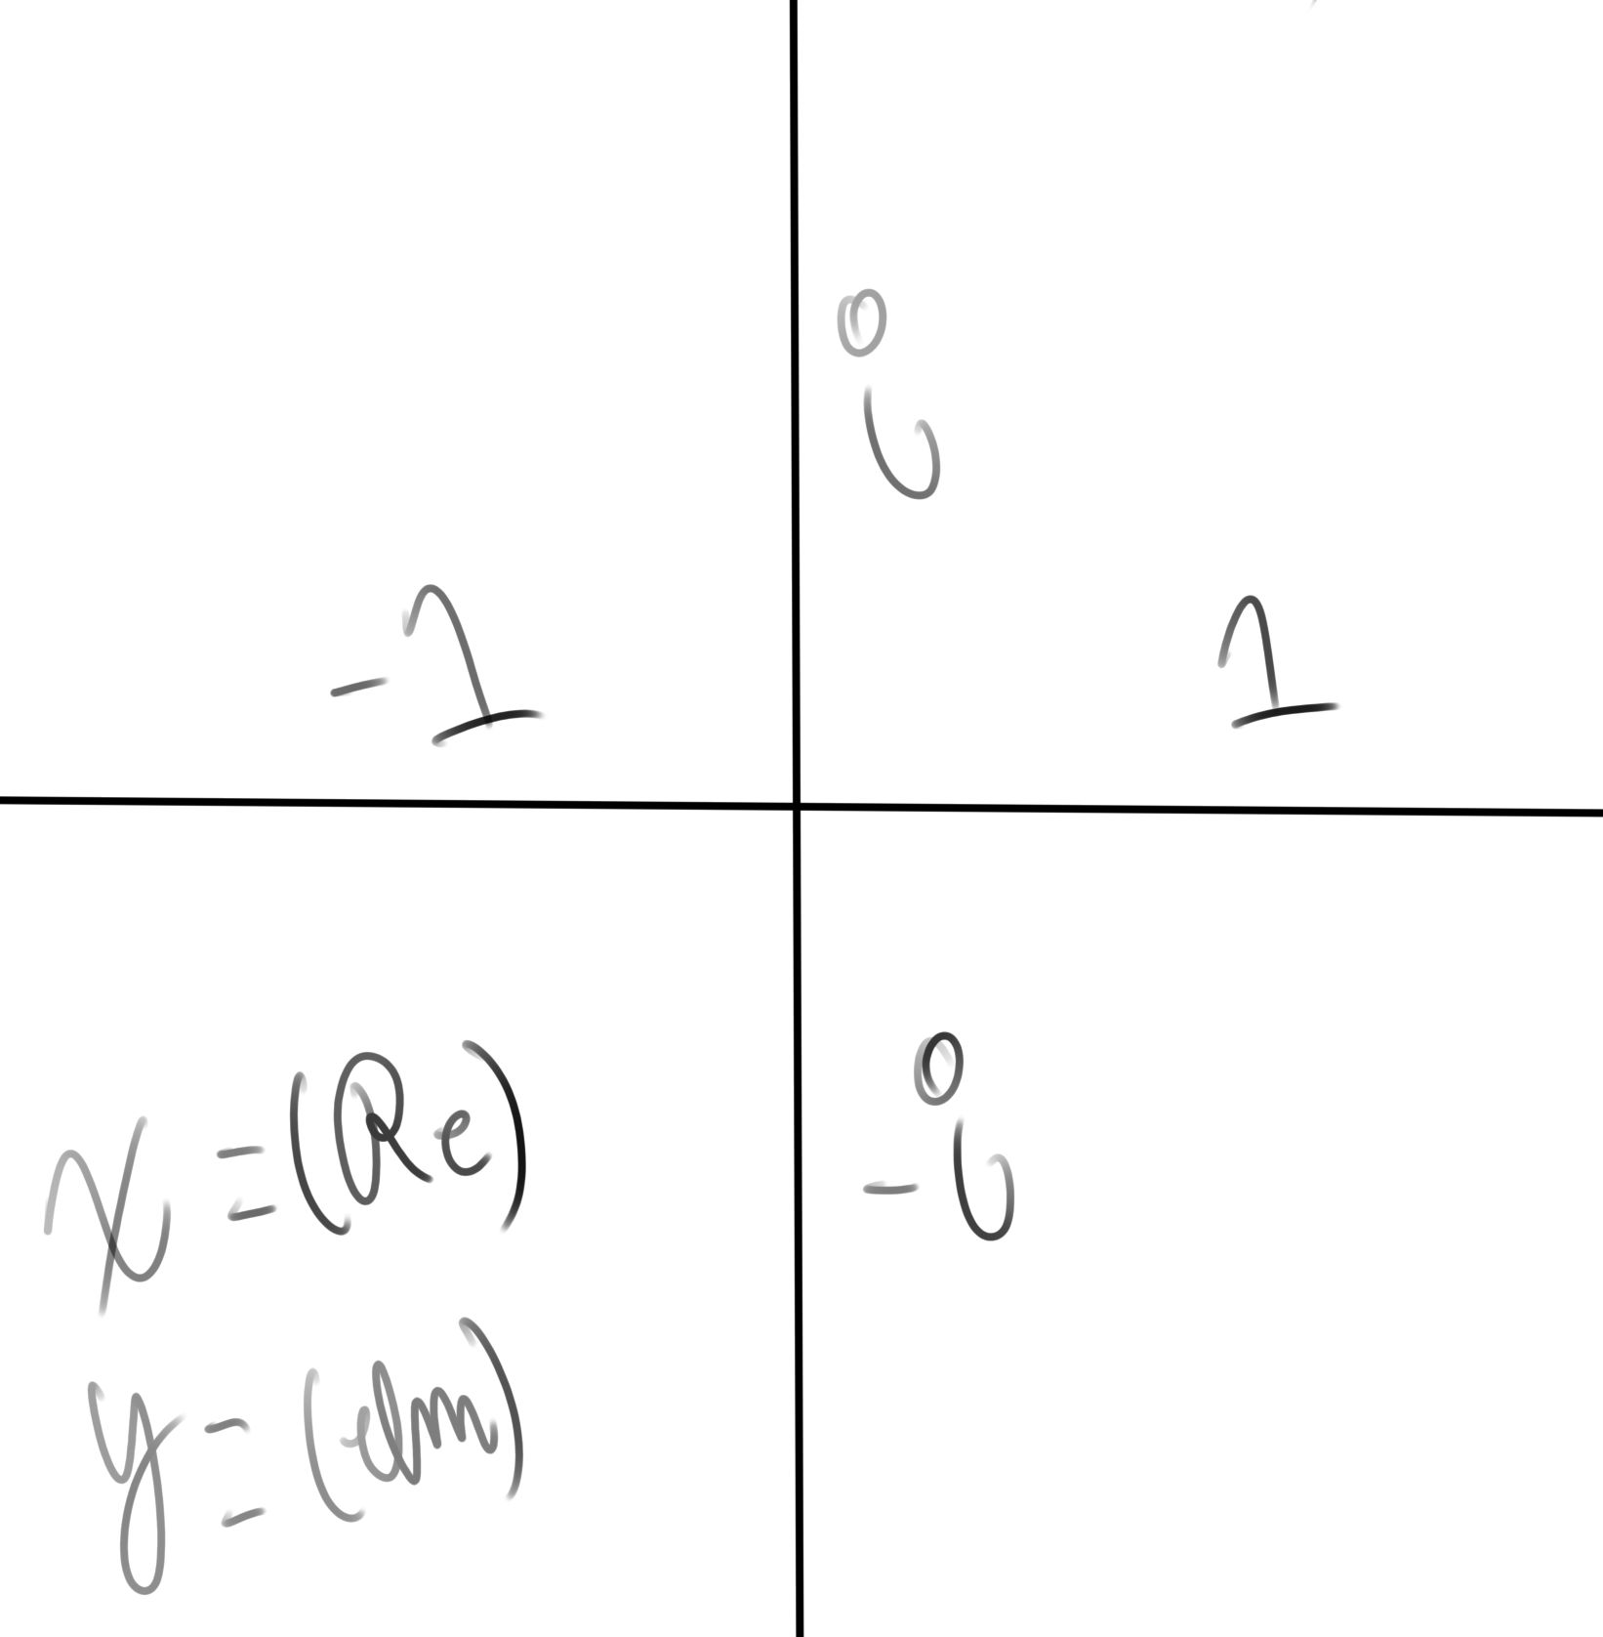

Polynomials and Rats
Poly – “many: several: much: multi” – Ref 40
Nomial - “(mathematics, algebra) a name or term” – Ref 38
Polynomial – “A polynomial is a mathematical expression consisting of variables, coefficients, and the operations of addition, subtraction, multiplication, and non-negative integer exponents.”
Rational Numbers – See ‘logic’
Rational Function – “a rational function is any function that can be defined by a rational fraction…” - Ref10
Rational Fraction | Algebraic fraction - “...an algebraic fraction [is a fraction where] both the numerator and the denominator are polynomials” – Ref 10
What makes polynomials rational?
While x can be any number—even an irrational number—the exponents of a polynomial cannot be irrational! They also cannot be negative in their exponents. This means that an algebraic fraction (aka a rational function) can have its rationality defined by the division of polynomials: expressions with integer exponents.
System of Equations – A collection of equations who share variables that must be the same across all equations in the system. (Note: the same general premise is applied to systems with inequalities.)

Solving Inequalities – When you are solving an inequality, flip the inequality whenever you are changing all + and – values for each number and variable. (ex. therefore therefore )
(Note: It may be helpful to think of negating an inequality like turning a very heavy positive number into a very heavy negative number.)

Even – Symmetric in respect to the y-axis
Odd – Symmetric in respect to the origin
Neither - Neither even nor odd.
Q: is even, odd, or neither?
Quadratic - a polynomial function whose highest exponent is 2; it’s also a parabola
The general form is:
Can also be written as
The Quadratic Formula - - Finds the zeros of quadratics (aka parabolas)
Equidistance – Equal distance; Congruent lines and/or curves.
Hyperbola – part of the conics series alongside parabolas. is an example of a hyperbola and a rational function. You may see more of this in Pre-calculus (algebra 3)
Division by Zero – Is Undefined
Discontinuity – An instance of being an output of some mathematical expression being undefined when a specific input is specified, thus making the expression when graphed discontinuous.
Holes – Points on a graph which are undefined, and that are not behaving like asymptotes.
A good example would be an undefined point on an x=y like line.
Excluded Value(s) – a value where an expression would be undefined, thereby excluding it and leaving it undefined when graphing said expression
Asymptote(s) – some line or curve that a function approaches and exhibits some kind of dependent behavior around and where this function is undefined upon hitting the needed output value.
Limit – represented as , a limit asks what some expression (b) outputs (y) as some input variable (x) gets closer and closer (approaches (represented by the arrow)) to some constant (c).
Numerator – the thing in the top of a fraction
Denominator – the thing in the bottom of a fraction
Ratio – how much of something there is to something; a fraction in its simplest form.
Least Common Denominator – The smallest shared denominator out of a set of some fractions. You can get this by factoring out all common factors between the denominators of each fraction, and then distributing the difference among the rest of the expression.
“It simplifies adding, subtracting, and comparing fractions” - REF 12
Inverse functions
Often denoted in function notation with a negative above the f,
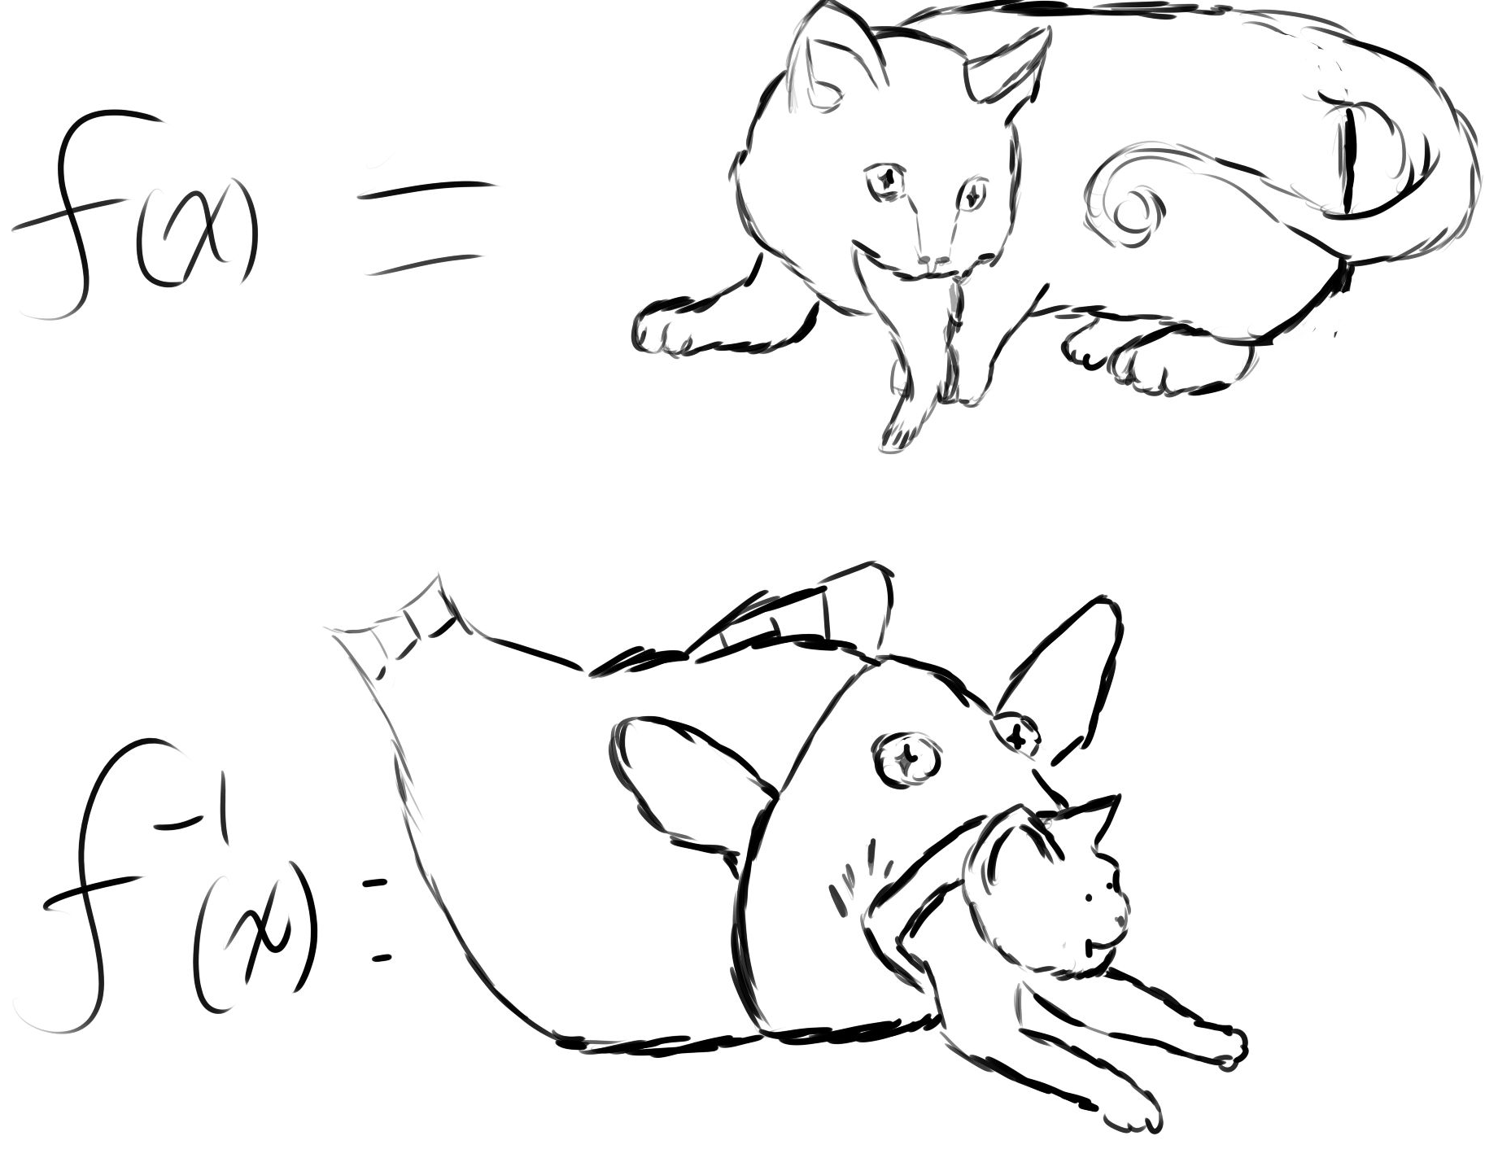
An inverse function can be taken when you change all the x’s of an expression to y’s.
This leads to the function more often than not reflecting over the x=y line.
You can check if a function is an inverse of another by checking if the composition of these two functions equal one when composed in each order.
Composition
There are 2 main ways to notate a composition of functions.
A. You can use a tonne of parentheses like so
B. You can use a hollowed out multiplication dot
Note: Composition becomes more important as you delve further into math that focuses on functions and other graphs as opposed to just numbers and variables.
Factoring
PEMDAS – Parentheses, Exponents, Multiplication & Division, Addition and Subtraction
FOIL – First, Outside, Inside, Last or First, Outer, Inner, Last - A clear cut and memorable way to multiply expressions stuck in parentheses. (ex. )
(Note: it can be useful to think of an expression stuck inside of parentheses as just being a number, so that instead of seeing some sprawling and scary expressions that you need to somehow multiply, you just see 2 numbers or variables)
(ex. let and .) )
Punnet Square – A square that can be used to neatly FOIL out expressions (AKA the ‘square method’)
Common – shared; a similarity
Factor – “A factor is any integer that can be multiplied by another integer to get the integer you are looking for” - REF 11
Factoring – writing an expression in terms of its factors. (ex. )
Prime Number – A number that only has itself and 1 as integer factors (ex. )
Greatest Common Factor - “the highest value [shared] factor” – REF 11
Prime Factor – a factor that cannot be simplified into further integers due to it being prime
Perfect Square Identity -
Completing the Square – Turning some expression into a perfect square: while adding or subtracting some constant to preserve the identity of said expression.

Factoring the Sum or Difference of Squares - =
Factoring the Sum or Difference Cubes - =
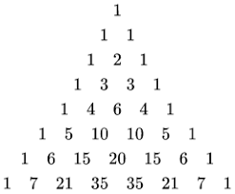
Factoring by Grouping - Therefore Therefore
Binomial – an expression with 2 (Bi) variables.
Binomial Formula - - REF 36
REF 37 - Pascal’s Triangle
Note: Pascal’s triangle is deeply connected with
combinatorics and the binomial formula.
Q: What would a ‘pascal’s pyramid’ look like?

Sequences and Series
Uppercase Sigma - - A symbol used to generalize repeated addition
Note: In calculus you will come across Capital Pi and Integration ; both communicating similar ideas in a familiar format.
Why are there spooky symbols on the top and bottom of my spooky sigma?
There are ‘spooky symbols’ on the top and bottom signify bounds; in this case how many integers you have to input into an expression and add for.
The bottom value is called the LOWER BOUND | The top value is called the UPPER BOUND
You will see more of this upper and lower bound stuff in calculus so get used to it.
Sums – The output of adding some expressions together
Sequence - “A sequence is a (possibly infinite) ordered list of numbers.” - REF 25
Series - “In mathematics, a series is an (often infinite) sum of terms specified by some rule.” - REF 26
Summation – The adding of things.
Summation Notation – A shorthand for writing long, repetitive, and often infinite addition chains into neater sigma expressions, where its start and end are defined by bounds (the lower and upper bounds).
Explicit Formula – A formula for finding a sum where you input n directly to ‘jump’ to your desired output. (ex. ))
Recursive Formula – A formula for finding a sum where you work backwards (recursively) from any given value to find this sum. (ex. )
Recursion - “A recursive process is one in which objects are defined in terms of other objects of the same type.” - REF 27
Class – “[a grouping of] objects of the same type” (ex. All algebra 2 students are a part of the algebra 2 student class) – REF 27
Expansion – Desimplifying an expression; normally to simplify it even further. Writing in more terms that outright needed. (ex. can be expanded into
Collapsing/Telescoping – Simplifying an expression, usually through the mass elimination of an expanded expression. (Note: it can be useful to think of a building falling in upon itself like collapsing an expression, putting itself into as simple of a homogeneous form as possible.)
Sum of first n numbers - = - there are some online proofs.
Convergence – The approaching of some expression to a specific value, acting as an upper or lower bound that could be regional or global. ‘bounded’ behavior.
Divergence – The approaching of some expression to an infinity (plus, minus, or imaginary). ‘unbounded’ behavior.
Global Bound – A upper or lower bound/limit for the graph of an entire equation
Regional Bound – A upper or lower bound/limit for a region of the graph of an equation (where domain and/or range is restricted)
Trigonometry Ratios and Functions
Triangle – a tri-angled polygon: a polygon with three internal angles and side lines.
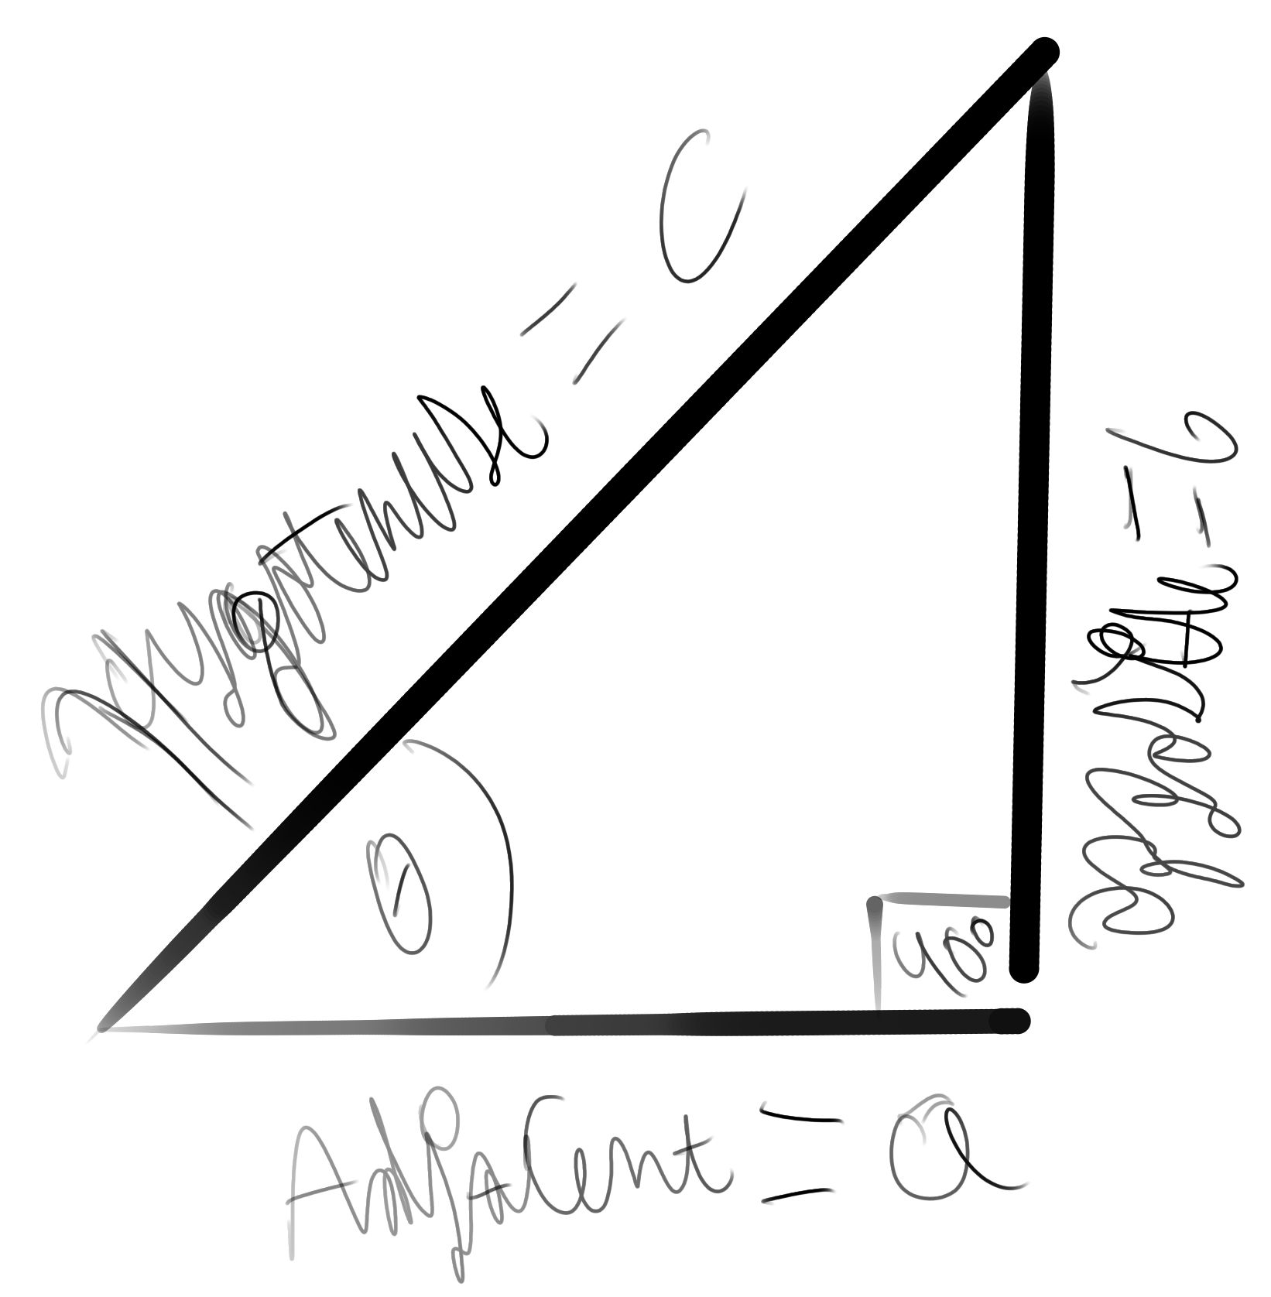
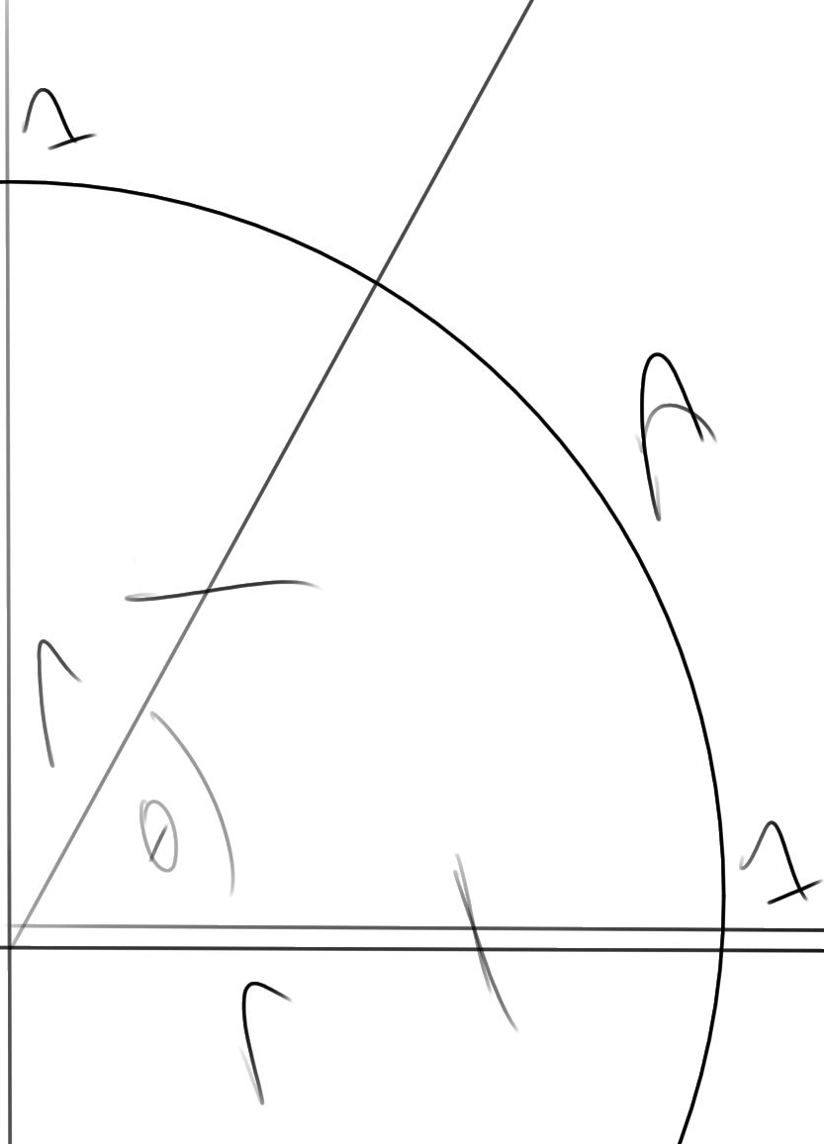
Opposite = O | Adjacent = A | Hypotenuse = H

Sine – O/H | Cosine - A/H
Cosecant – H/O | Secant - H/A
Tangent – O/A | Cotangent – A/O
(Note: it can be useful to think of the secants as both having unchanging hypotenuses on top and the tangents as going on divergent political ramblings at predictable, periodic moments.)
Pythagorean Theorem - or
Special Right Triangle 1 – a right triangle with 2(45 degree angles)
Special Right Triangle 2 – a right triangle with 1(30 degree angle) and 1(60 degree angle)
- the Greek letter theta is a symbol that represents “variable angle measure”.
- “pi is the mathematical constant defined as the ratio of the circumference of a circle to its diameter with value of approximately 3.14159.” - REF 13
The Unit Circle – a circle with radius 1, making any straight line drawn from it’s vertex to its locus have a length of 1unit. (see the next page for a unit circle diagram)
Subtend – to underlay.
Radian - “The radian is [an angle measure] unit defined so that an angle of one radian subtended from the center of a unit circle produces an arc with arc length 1.
A full angle is therefore 2π radians, so there are 360° per 2π radians, equal to 180°/π Similarly, a right angle is π/2 radians and a straight angle is π radians.
Radians are the most useful angular measure in calculus” – REF 14
Radian-Degree Equality -
Sinusoidal Functions – sine and cosine functions (Think sinus-oi-dal for memorization purposes)
Amplitude – The maximum height that a sinusoidal function can diverge from its vertex, also known as the coefficient of the sinusoidal.
Hertz - “the unit of frequency; one hertz has a periodic interval of one second” - REF 20
Periodic – “happening or recurring at regular intervals” – REF 19
Verify Trig Expressions – A sort of light version of a proof where you prove that a statement is true or false through using trig identities to expand and collapse expressions until you prove or disprove your given trig question.

Topnote: if you would like a glimpse into how the unit circle is used in more ‘complex’ math, see what happens if you draw a unit circle where all y values are ‘purely imaginary’, and the x values real.
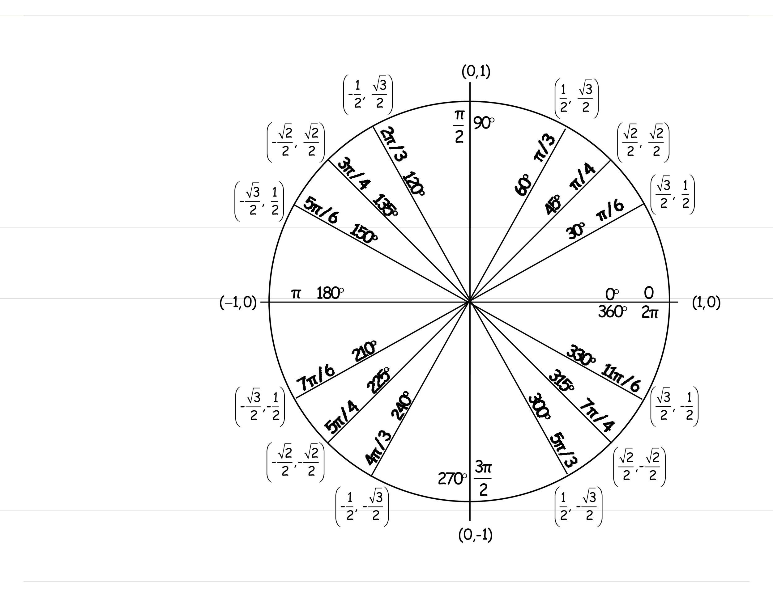
The Unit Circle – REF 42
The numbers on the circle represent coordinate pairs.
The Pi fractions and degree measure represent exact angle measure
Bottomnote: Each noted radian angle has a LCD of 12, where 3*4 and 2*6 = 12

Some Trig Videos I Find Useful
1: Trig Identities Animated Diagram (no arctrig) https://www.youtube.com/watch?v=dUkCgTOOpQ0
2: Double Angle Formulas (Weird notation) https://www.youtube.com/watch?v=2yRAh9gqUw0
Question: what do , , and the Unit Circle have in common?

Light Combinatorics & Probability
Factorial – The product of some expression multiplied by itself take one until you hit 1.
(ex. )
Combinations (Combs) – The number of ways x entities can be combined where order doesn’t matter
Permutations (Perms) – The number of ways x entities can be structured where order does matter
Comb Formula - Perm Formula
Are Perms always* larger than Combs?
Perms are always larger than Combs because they lack the essential k factorial divisor that prevents messiness in their formulas. More specifically, they don’t get rid of reorganizations like combs do because of the absence of k! in the denominator
Notating Combs
nCr or work. Note: ‘r’ was used instead of ‘k’
Notating Perms
nPr where n & r are variable like in ‘Combs’. Note: ‘r’ was used instead of ‘k’
What is a normal distribution?
A normal distribution is a distribution—oftentimes a probability density function—where its mean and median are equivalent to mu.
Another Definition: “a probability distribution that is symmetric about the mean, showing that data near the mean are more frequent in occurrence than data far from the mean.” - Ref 41
What the heck does ‘normal’ mean here?
I don’t quite know! 3B1B has a video on the “Central Limit Theorem” which may help.
What other distributions are out there?
I don’t know! Maybe ‘abnormal’, ‘Overlap’, ‘income’, ‘population density’, etc exist?
Mu - - Typically represents the ‘mean’ of some dataset
Lowercase Sigma - - Represents a standard deviation, though when squared it means “variance”

Logic & Set Builder Notation
- Is an Element of some Set - Is NOT an Element of some Set
- All values of thing in question - There Exists a value - There Exists a !Specific value - There does NOT Exist a value
- Is a Subset of - Is NOT a Subset of
- An ‘if’ statement, usually read as ‘given’. (ex. )
- the union of sets - the disunion of sets
- “setminus” – removes elements that are common between two sets
[ - when defining ranges, is used close to a bound to say this thing/bound is included
( - when defining ranges, is used close to a bound to say this thing/bound is excluded
{ - “Roster notation defines a set by listing its elements between curly brackets, separated by commas” – Ref 9
- Approximately - Similar - 2-way implication - 1-way implication - Proportional
.’. - Therefore (three dots) ‘.’ - Because (three dots)
Notable Sets
Natural Numbers -
Integers -
Rational Numbers/Rationals -
Irrational Numbers/Irrationals – not standardized, can be written as
Real Numbers -
Imaginary Numbers – not standardized
Complex Numbers -
Definitions of the Notable Sets
Natural Numbers – all real positive integers
Integers -all real integers
Rational Numbers – all numbers that can be represented as fractions of integers
Irrational Numbers – all numbers that cannot be represented with integers. (
Real Numbers – The collection of the previous sets.
Complex Numbers – all numbers that can be written in form. This includes all the previous sets of numbers.
What are sets? - Sets are collections of things.
What is ‘Set Builder Notation’ – It is a mostly standardized way of writing, defining, and making collections of things; aka building sets.
DOMAINS AND RANGES can be expressed through sets, alongside the RESTRICTION of such things!
Q1: What set of numbers only includes numbers like ‘e’ ‘pi’ & ‘tau’?
Q2: What sets of numbers have a similar standard form to that of the complex numbers?

Math Tools
Free Online Calculators
desmos.com – Has graphing and geometry tools
geogebra.org – Has a CAS (Computer Algebra System) tool that can graph certain imaginary ‘functions’, and a 3D graphing calculator.
Casio & TI Websites
https://world.casio.com/ - Casio Site https://education.ti.com/en – TI Site
Programing Languages
python.org – a popular and easy to use programming language that you can use with simple text editors. Has libraries you can install that are specifically used for math computations.
Note: A lot of math words are used in comp sci; oftentimes with only slightly altered meanings!
Note2: Other programming languages can also do math; they may just be harder to use.
Note3: Some Ti-Nspire Calculators can run programs written in this language!
rust-lang.org – Another popular programming language that you can do math stuff with.

Math Content
3B1B - https://www.youtube.com/@3blue1brown/courses – A math channel run Grant Sanderson
Khan Academy - https://www.khanacademy.org/math – An educational website; has decent math questions, quizzes, courses, and videos.
FreeCodeCamp - https://www.freecodecamp.org/ - Non-profit with math and comp-sci courses
Quanta Magazine - https://www.quantamagazine.org/ - A STEM magazine publication
Numberphile - https://www.youtube.com/@numberphile/playlists – A lover of numbers
Brilliant – brilliant.org – For profit organization with Really good free STEM wiki pages
Wikipedia – wikipedia.org – Non-profit free encyclopedia
Youtube – youtube.com – Video streaming platform with mixed math content
Wolfram Alpha - https://www.wolframalpha.com/ - a “Computational Search Engine”
Python Math Library - https://docs.python.org/3/library/math.html – a simple math library
Free Calc 1-3 Textbooks - https://www.apexcalculus.com/ - Open Education Resource Calc Txtbooks
SoME (Summer of Math Exposition)
if you don’t know what ‘Exposition’ means, think ‘Exposae’ (an example would be ‘The Jungle’) or ‘Exposure’ (exposing yourself to new knowledge like Merriam-webster's definition of ‘Exposition’).
Link for the SoME Website - https://some.3b1b.co/
Link for the SoME Blog - https://www.3blue1brown.com/blog/some1
SoME#1 youtube playlist - https://www.youtube.com/playlist?list=PLnQX-jgAF5pTkwtUuVpqS5tuWmJ-6ZM-Z
SoME#2 youtube hashtag - https://www.youtube.com/hashtag/some2
SoME#3 youtube hashtag - https://www.youtube.com/hashtag/some3
SoME#1 Results - https://www.youtube.com/watch?v=F3Qixy-r_rQ
SoME#2 Results - https://www.youtube.com/watch?v=cDofhN-RJqg
Sources
2. www.ontrack-media.net
3. mathworld.wolframalpha.com
4. brilliant.org
5.www.wolframalpha.com
6. en.wikipedia.org
7. mometrix.com
8. www.merriam-webster.com
9. https://pixabay.com/
10. https://www.investopedia.com/
11. https://templatelab.com

References
2. https://www.ontrack-media.net/algebra2/algebra2glossary.html
3. https://mathworld.wolfram.com/
4. https://brilliant.org/wiki/complex-numbers/
5.https://brilliant.org/wiki/completing-the-square/
6.https://brilliant.org/wiki/quadratic-equations/#biquadratic-equations
7.https://brilliant.org/wiki/polynomials/
8.https://www.wolframalpha.com/input?i=asymptote
9.https://en.wikipedia.org/wiki/Set_(mathematics)
10. https://en.wikipedia.org/wiki/Rational_function
11. https://www.mometrix.com/academy/factors/
12. https://en.wikipedia.org/wiki/Lowest_common_denominator
13. https://www.wolframalpha.com/input?i=pi&assumption=%7B%22C%22%2C+%22pi%22%7D+-%3E+%7B%22MathWorld%22%7D
14. https://www.wolframalpha.com/input?i=radian&assumption=%7B%22C%22%2C+%22radian%22%7D+-%3E+%7B%22MathWorld%22%7D
15. https://www.merriam-webster.com/dictionary/subtend
16. https://www.wolframalpha.com/input?i=algebra&assumption=%7B%22C%22%2C+%22algebra%22%7D+-%3E+%7B%22Word%22%7D
17. https://www.wolframalpha.com/input?i=arithmetic&assumption=%7B%22C%22%2C+%22arithmetic%22%7D+-%3E+%7B%22MathWorld%22%7D
18. https://en.wikipedia.org/wiki/Logarithm#Product,_quotient,_power,_and_root
19. https://www.wolframalpha.com/input?i=periodic
20. https://www.wolframalpha.com/input?i=hertz&assumption=%7B%22C%22%2C+%22hertz%22%7D+-%3E+%7B%22Word%22%7D
21. https://en.wikipedia.org/wiki/Normal_distribution
22. https://www.wolframalpha.com/input?i=mode&assumption=%7B%22C%22%2C+%22mode%22%7D+-%3E+%7B%22MathWorld%22%7D
23.https://www.wolframalpha.com/input?i=sigma+notation
24. https://www.wordnik.com/words/entity
25. https://www.wolframalpha.com/input?i=sequence&assumption=%7B%22C%22%2C+%22sequence%22%7D+-%3E+%7B%22MathWorld%22%7D
26. https://www.wolframalpha.com/input?i=series&assumption=%7B%22C%22%2C+%22series%22%7D+-%3E+%7B%22MathWorld%22%7D
27. https://www.wolframalpha.com/input?i2d=true&i=recursion
28.https://www.wolframalpha.com/input?i=standard+deviaton&assumption=%7B%22F%22%2C+%22StandardDeviationCalculator%22%2C+%22list%22%7D+-%3E%22%7B1%2C+2%2C+-2%2C+4%2C+-3%7D%22&assumption=%7B%22C%22%2C+%22standard+deviaton%22%7D+-%3E+%7B%22MathWorld%22%7D&assumption=%7B%22FP%22%2C+%22StandardDeviationCalculator%22%2C+%22Form%22%7D+-%3E+%22Pop%22
29.https://www.wolframalpha.com/input?i=variance&assumption=%7B%22C%22%2C+%22variance%22%7D+-%3E+%7B%22MathWorld%22%7D
30. https://www.wolframalpha.com/input?i2d=true&i=variate
31. https://pixabay.com/illustrations/unit-circle-trigonometry-math-6988807/
32. https://en.wikipedia.org/wiki/Synthetic_division
33. https://brilliant.org/wiki/partial-fractions/
34. https://mathworld.wolfram.com/Double-AngleFormulas.html
35. https://en.wikipedia.org/wiki/List_of_trigonometric_identities
36. https://en.wikipedia.org/wiki/Binomial_theorem#Statement
37. https://wikimedia.org/api/rest_v1/media/math/render/svg/23050fcb53d6083d9e42043bebf2863fa9746043
38. https://www.wolframalpha.com/input?i=nomial
39. https://www.wolframalpha.com/input?i=poly
40. https://www.merriam-webster.com/dictionary/poly
41.https://www.investopedia.com/terms/n/normaldistribution.asp
42 https://templatelab.com/unit-circle-charts/
43. https://en.wikipedia.org/wiki/Commutative_property
44. https://brilliant.org/wiki/commutative-property-of-addition-and/
45. https://en.wikipedia.org/wiki/Associative_property
46.https://brilliant.org/wiki/associative-property-of-addition-and/
47. https://www.youtube.com/watch?v=2yRAh9gqUw0
48.https://www.youtube.com/watch?v=dUkCgTOOpQ0

