Accounting App

Group 3 Zhenghao Liang

Idea: this app is able to record the income and expenditure of the user. User could select a date and input the income and expenditure then the app would show total cost and expenditure.

The first page is a login page with a register button. First time user have to click the register button and register a account.
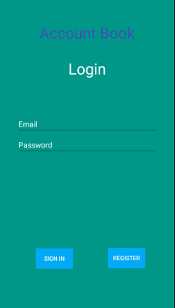
In the register page, user has to set up the email and password.
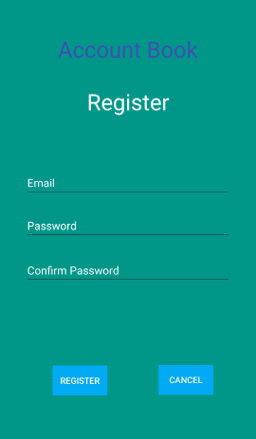
When user login, app would show date to select and then choose income or expenditure and input number. And user clicks the save button, there are two labels to show the total income and expenditure.
