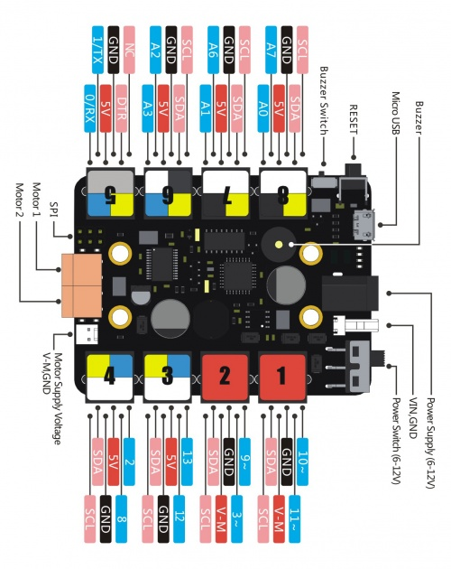

|  |  |  |
| --- | --- | --- |
| **220Ω** 1%  Red, red, black, black, brown.  *Red, red, black, black, brown.* | **2.2kΩ** 1%  Red, red, black, brown, brown.  *Red, red, black, brown, brown.* | **220Ω** 5%  Red, red, brown, gold.  *Red, red, brown, gold.* |
| **20kΩ** 5%  Red, black, orange, gold.  *Red, black, orange, gold.* | **180Ω** 5%  Brown, gray, brown, gold.  *Brown, gray, brown, gold.* | **4.7kΩ** 5%  Yellow, violet, red, gold.  *Yellow, violet, red, gold.* |

|  |  |
| --- | --- |
| What is an LED - The anatomy | http://electropark.pl/img/cms/uklady_scalone/wzmacniacze/TLC274CN-wyprowadzenia.jpg |

