SPL Outdoor Proposal

The purpose of this document is to describe the plans of the SPL towards 'going outdoors' for 2016 and beyond in response to the call proposed by the RoboCup Executive Committee.

Plans for 2016:

The following rule changes are agreed upon:

- The SPL will use a realistic ball (e.g. a FIFA mini ball, see below) in 2016 instead of an orange street hockey ball.
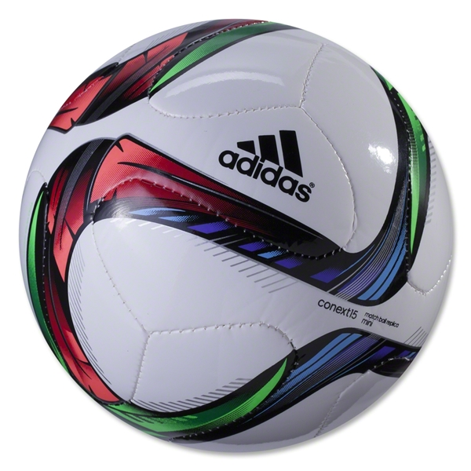
- Custom jersey designs with no (or very few color) restrictions will be allowed.

In 2016, the SPL is committed to hosting a variety of events. Assuming adequate interest from teams, we will host an indoor (previously called 'main') competition, two technical challenges, a drop-in player competition, and an outdoor tournament. It is not expected that every team will participate in every event – in fact, teams only need to commit to participating in two events.

We propose the following two outdoor events:

1.) Outdoor Tournament:

- There will be an outdoor tournament. Hence, we will ask the organisers for two full-size SPL fields (as well as associated equiptment such as a desktop computer and wireless router) in the atrium.
- The outdoor tournament will consist of exactly eight teams. Pre-qualified teams will be given preference. The teams to compete in the outdoor tournament will be decided when the SPL technical committee reviews qualification applications (ie, likely by mid-January).
- Full games will be played. The game rules will be exactly the same as in the main soccer competition (i.e. the SPL rule book will fully apply). There is one exception: the outdoor competition will use artificial grass. A 'many carpets challenge' was held at RoboCup 2015 in which many teams showed they were able to walk on a variety of carpets. The TC will select one of these, or a similar carpet, for use in the outdoor competition.
- There will be two pools (4 teams each) in the outdoor tournament. The teams in these pools will play round robin games, such that each team plays three games. The two best teams from each pool will advance to the semi-finals. A third-place game and final game will also be played, with a trophy being awarded to the winning team.
- The eight outdoor teams will be seeded into the second round robin of the indoor (previously called 'main') competition based on their performance in the outdoor competition. However, it should be noted that no outdoor teams will be eliminated (i.e. All outdoor teams will continue to the second round robin of the indoor competition regardless of their performance in the outdoor competition). Care will be taken to ensure that teams are incentivized to attempt to perform well in the outdoor competition though.
- In parallel to the outdoor competition, the indoor competition will start with 12-16 teams (none of which are participating in the outdoor competition). These 12-16 teams will play an initial round, and 8 will advance to the second indoor competition round. These 8 teams will be joined by the 8 outdoor competition teams for the second indoor competition round. The 16 teams in the second round of the indoor competition will likely be divided into 4 pools of 4 teams each for round robin play. From this point, either with out withou play-in games, 8 teams will advance to the quarter-finals. The semi-finals, championship, and 3rd place games will be subsequently played.
- This mode will ensure that teams who choose to challenge themselves with the outdoor competition will still be given the opprotunity to place well in the indoor competition. Additionally, since it is likely that the teams who take on the outdoor competition will be teams who have performed well in previous indoor competitions, newer and weaker teams will also be able to play more competitive games in the preliminary indoor round (since many of the stronger teams will be instead competiting in the outdoor competition during this round).
- In summary, the outdoor competition will consist of one round. The indoor (previously called 'main') competition will consists of two prelimenary rounds (which may feed into play-in games if time permits), quarter-finals, semi-finals, third place game, and final game.

2.) Outdoor Technical Challenge:

- This technical challenge is open for all the SPL teams participating in RoboCup (even those taking part in the Outdoor Tournament).
- Two penalty shootouts will be carried out at two different days on the SPL outdoor competition fields in the atrium.
- The details of the challenge are still in discussion. However, on a high level we expect that teams will design penalty kickers – the goal will either be empty or manned by a stationary goalie. All other normal SPL penalty kick rules will apply.

Outlook 2017-2019:

We are willing to continue and improve the outdoor competition based on the interest of teams. Since there will be no atrium in Nagoya 2017, we will have to find other solutions if the outdoor competition will be continued and/or expanded since our current standard platform can not be operated in wet or rainy conditions. One preliminary possibility for 2017 and onward would be to use a transparent tent.

Eventually the entire SPL competition could be held outdoors. However, before running the competition and technical challenges at RoboCup 2016, it would be premature to estimate how quickly the league should move completely outdoors.

