**Welcome everyone to Secreatures TCG!**

Secreatures TCG is a game where 2 duelists, 2 SLIMEMANCERS, fight with their decks full of powerful slime creatures and cool ACTION cards, till one player ends with 15 cards in the Sewerz, the discard pile. This is mainly done through battling with these Secreatures, but it can be accomplished through other ways, and victory can be attained through alternative means too! But that’s an advanced course.

First, let’s look at the cards, we have:

**Secreature Cards**

Secreatures are our main fighting force, the stars of the show, and they are comprised of

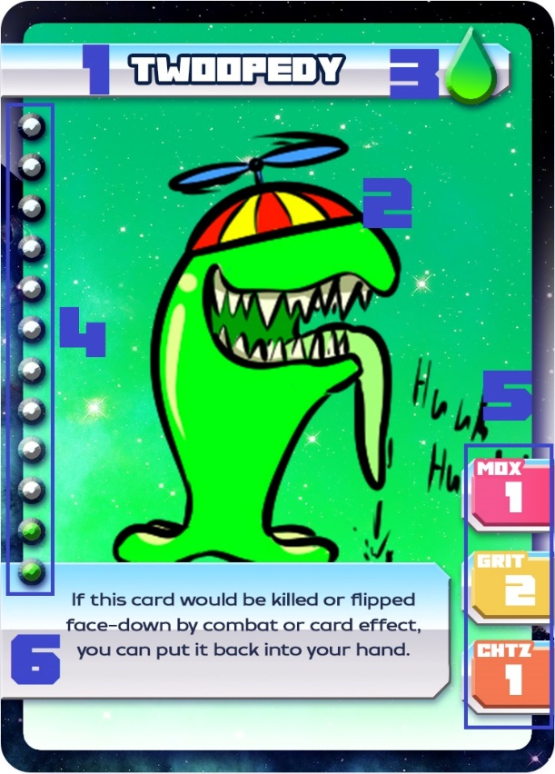1 Name

2 Art

3 Type: The little droplet here indicates which type the creature is with it’s color. The structure decks have only SLIME Secreatures, indicated by the lime green color, but there is also

Poudrin, indicated by the Yellow – Dark green color mix

Mutants, indicated by the Orange - Magenta color mix

Constructs, indicated by the Cyan – Purple color mix

And Nega, indicated by the Black – White color mix

4 S. Level Gauge: It goes from 1 to 12, indicated by the number of spheres filled with green slime. It’s important when it comes to secreting them, secreting being the term for playing these monsters on the field

5 Stats: Moxie, Grit and Chutzpah, used for combat.

6 Text: Be it flavor and/or effects, which come in the form of unique effects, as well as Keywords which are specific effects that can be shared between many different cards. This is also the case for our next category of cards

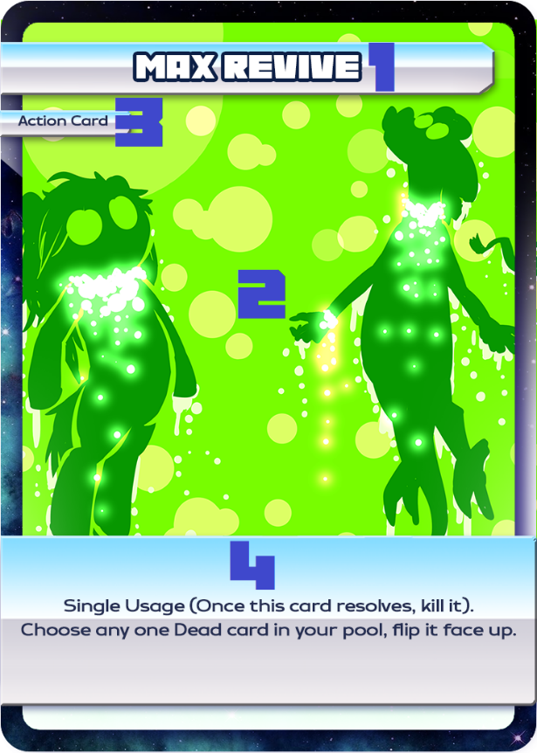**Action Cards**

Action cards are the spells of the game, sorta speak, they come in 5 varieties, as many as types of Secreatures, that act distinctly. Before going over them, let’s see what comprises an Action Card!

1 Name

2 Art

3 Type: Indicated by the small type tag below the name, regular Action Cards have “Action Card” written in here, but there is also the other 4 types; quickie, object, power up and events

4 Text: Pretty much working the same way as Secreatures’ text, here we can find what the Action Card mainly does, as well as some flavor text, and Action Cards specific keywords too

Now, let’s go into more detail on the different types of **Action Cards.**

1. Normal Action Card: Your regular “spells”, which do a myriad of things to help you control the slime-tide of battle.
2. Quickie: Like normal Action Cards, but faster. These can be activated **from your hand** during your opponent’s turn as a response of any action of their part.
3. Object: “Permanent” Action Cards, these can be reused as many times you want
4. Power Up: Equippable Action Cards, when you play these, you equip them to one of your Secreatures, and while equipped gives bonus stats and/or effects to your Secreatures!
5. Event: These are locations or famous events which are played in the specific, neutral, Event Horizon zone. Event Action Cards have effects which both players can access and/or affect them.

--------------------------------------------------------------------------------------------------------------------------------------

With the cards detailed, keep them in mind as we go over the game. Don’t worry, we will go back to all their details.

**The Deck:**

A Standard Deck is comprised of exactly **30 cards**, as well as a **Recipe Book Deck**, that can hold up to 3 Mix Secreature cards (but is not mandatory). A deck can hold up to 2 copies of any singular card.

In this game, **the top 3 cards of your deck are, at all times, your hand, but they are still considered as part of your deck.** This means that A. If your deck gets shuffled, so does your hand, B. If you play a card, you draw a card (Albeit, if you activate an effect from the hand or an effect that makes you discard or play cards from your hand, you draw a card AFTER all the effects are resolved). This could seem confusing, but it will make sense on playing, it’s not that different from having a regular hand, it just adds special caveats. By the way, if an effect tells you that you draw a card, you draw a card, and that card doesn’t count to the 3-card limit, but you don’t get to draw new cards unless your hand goes below 3 cards.

**The Board:**

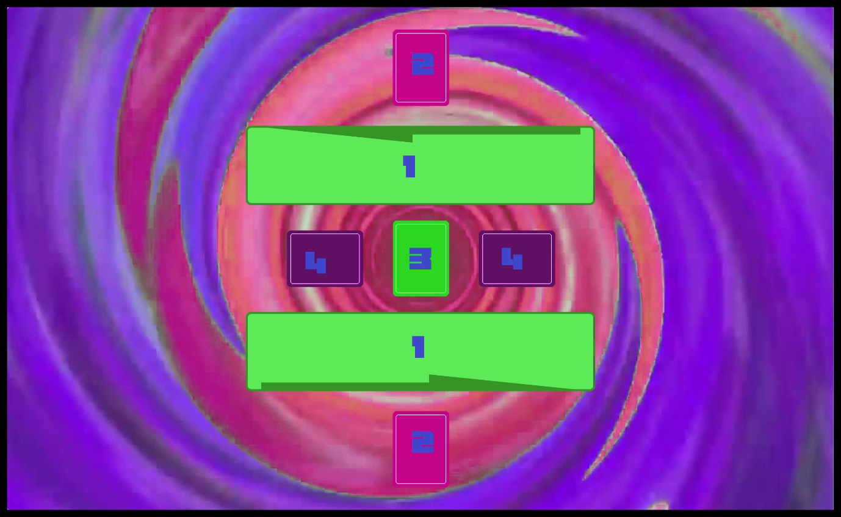

**1 The Pool:** One per player. **Here go all the cards you play directly from your hand** (except for Events, we will get to that soon), be it Secreatures or Action CardsThe Pool is a pile of cards, which means that all cards are organized in an order from top to bottom, to help with this, the pool supposes an ample area where you can either put all your cards in a literal pile, or spread them across the Pool area of the board for better management and visualization.

**2 Action Zones:** One per player. **Here you can opt to place an Action Card face down**, which is called a **SET**. **A Set Action Card in the Action Zone can be activated whenever, as a response to anything, except during the turn is set.** This allows you to transform your regular action cards into powerful INTERACTION.

**3 The Event Horizon:** A one of, here is where Event cards go when played from the hand, replacing any previous Event Card there. **Both players can interact with this zone, as is always neutral.**

**4 Combat Zones:** One per player. **Here is where Secreatures that are going to fight in the combat phase are placed.** When the turn player places a Secreature here, it signifies the turn is moving to its Combat Phase



There is also the **Sewerz**, which doesn’t show up on the board, but can be anywhere you want, it’s your discard pile, where all the cards already spent and killed go. Besides it, the **Recipe Book**, a side deck where you can hold up to 3 Mix Secreature Cards.

It’s also important to point out the **Slime Points**. Slime Points are a resource you can gain and lose for many card effects. You start with 0, and the counter can go both positive or negative if is taken below 0, in which case is considered as that player having that amount of **NegaSlime Points**.

To facilitate the count of Slime Points, since Lackey CCG can’t add more than 100k points at a time, we have the **Megaslime Counter: One point in the Megaslime Counter equals to 1 Million Slime Points.**

--------------------------------------------------------------------------------------------------------------------------------------

**Start of the Game**

Both players roll 2 6-faced dice, the player that gets the higher roll chooses to go first or second. Then both players shuffle their decks, and draw the top 3 cards to their hand.

**During your Turn**

**Main Phase**

During the Main Phase, you can, in any order:

* Once per turn, **Secrete** (play) **a Secreature from your hand** **OR Call a Secreature from your pool** to put it on top of the pool.
* As many times as you want, **play an Action Card from your hand of any type.**
* Once per turn, **activate a single face up** **Action Card from your Pool** (Objects don’t count to this limit) **that hasn’t been played from your hand this turn.**
* Once per turn, **Set an Action Card on the Action Zone.**
* Once per turn, **MIX a Secreature from your Recipe Book** (we will leave this one for way later)
* **Activate the effects of your Secreatures and/or Objects**, once per card of course
* Once per turn, **Shuffle Your Deck** (Which, in change, will give you a new hand). We call this a **Mulligan**.

Then, at the end of the Main Phase you can **EITHER** choose to:

* Go to the **Combat Phase, by placing your Active Secreature on a Combat Zone**
* Go to the **End of the Turn**

Before going to the combat phase, let’s go over these in detail

**Active Secreatures, Secreting a Secreature and Calling a Secreature.**

At all times, **your Active Secreature is the Secreature that is the closest to the top of the Pool.** You can initiate Combat Phase only by placing your Active Secreature on a Combat Zone and, if during your opponent initiates the Combat Phase, you are forced to place your Active Secreature on your Combat Zone.

Secreting Secreatures as part as your Secretion for the turn is simple: **You can play any S. Level 4 or lower Secreature from your hand onto the pool without any cost**, but for **any S. Level 5 or higher, you need to pay their Price:**

Either **tribute creatures whose levels + 4 equal or exceed the level of the Secreature you are trying to Secrete OR pay a specific amount of Slime based on the level:**

**5, 6:** **1000 Slime**

**7, 8, 9: 1 Million Slime**

**10, 11, 12: 1 Billion (1000000000) Slime**

Megaslime is a level 7 Secreature, we can either tribute a level 1 and a level 2 Secreatures to Secrete it (1 + 2 + 4 = 7) or a level 4 one (4 + 4 = 8 > 7).

Or we could pay 1 Million Slime (1000000) Points

Instead of secreting, you can **Call a Secreture.** This simply means you can choose any Secreature face up on the pool and move it to the **top of the Pool**. By a card effect, a Secreature (or card) can be “Out”, this is showed by the card being **FACE DOWN** on the Pool. You can flip face up a creature that is Out by calling it.

Also, once per turn, you can MIX a Secreature: In your Recipe Book you can hold Mix Secreatures, which are powerful combinations of 2 or more Secreatures through specific conditions! You need to possess the materials on your pool and have met the Preparation Conditions described in the first line of text of a Mix Secreature, then Sacrificing all the materials as cost to Secrete the Mix Secreature.

**Playing Action Cards**

As said before, you can play any amount of Action Cards **FROM YOUR HAND** during your turn, that said, there are some details about Action Cards you need to know:

* **After an Action Card of any type that activated from your hand resolves, you leave it face up on the pool**. For Events and Power Ups, this also applies after they leave the Event Horizon and the creature that they are attached to (respectively).
* **Quickies can be activated from YOUR HAND during your opponent’s turn,** as a response to anything they (or you) do**.**
* **Object cards** are activated from your hand, but **their** **effects can be used once per turn every turn as long as they are face-up on the pool.**
* **Power Up cards have to be attachable to a target to be played**, so if you can’t attach it to a Secreature, you can’t play it. Also, **you can only attach ONE Power Up from your hand or Pool to any singular Secreatures per turn.**
* **Event Action Cards have to be played on the Event Horizon, and they replace any Event Card that was previously there.** Events that were played directly from the hand are sent face-up to the pool when replaced by a new Event Card.
* **Any Action Card activated from the pool, except Object Cards, gets Killed after resolving or**, in the case of Power Ups and Events, **when they return to the pool** (By getting detached and leaving the Event Zone, respectively). **Quickies can ONLY be activated during YOUR TURN from the pool as a response to any action any player takes, even your own.**
* **You can Set ANY card on the Action Zone, this will allow you to activate them the same way as quickies do during your opponent’s turn**, that said, their effects and capabilities will resolve according to the card type: An Event will go to the Event Horizon, a Power Up will be equipped to a Secreature, etc. Objects here are rather useless, as activating them will not make their effects go off, so… only do as a funny.

**Activating Effects and Playing Cards**

You can activate as many Secreature effects and/or Object cards’ effects as you want, but only one time per card.

**When a card is played, is placed on top of the pool**, but also, **when a card’s effect is activated, the card is moved to the top of the pool**, so, if you use the effect of a Secreature which is not your active Secreature, that Secreature will go on top of the Pool, and therefore also become your Active Secreature. Consider using your Secretion or Call for the turn and your Secreatures effects to take full advantage of your cards and have the ability to leave a powerful Secreature on top to fight.

On the topic of effects, for an important clarification: There is 3 ways a Secreature on a Pool can go to the Sewerz, those are **A. Getting KILLed**, either by battle or effect (“Kill that Secreature”) B. **DYING**, it is said a card **“dies”** when is sent to the sewerz by an effect that moves them to the Sewerz specifically C. **SACRIFICE**, where is used as a cost for an effect, Secretion or a Sacrifice Phase Penalty.

**Combat Phase**

If the turn player chooses to, they can move their Active Secreature to a Combat Zone to initiate the Combat Phase. That said, **players can’t enter combat during the first turn of the game.** During the Combat Phase, both players look at both Secreatures stats to see which one comes on top. It goes as follows:

First we check both creatures **Types**, if one type is advantageous over the other, **the creature with advantage gains a +1 to all stats, while the creature at disadvantage gets a -1 to all stats.** Here is the advantage wheel: **Mutants beat Constructs, Constructs beat Poudrin Creatures, and Poudrin Creatures beat Mutants.** Slime and Nega Secreatures are neutral, but **Nega Secreatures can’t be killed In battle against a non-Nega Secreature.**

Then, the turn player chooses a single stat on which make a **Stat Check** first. **A Stat Check is**, simply put, **checking which Secreature has a higher value in the chose stat**. The Secreature with the highest value on the chosen stat wins that Stat Check. Then, after that Stat Check, the opponent chooses the 2nd stat on which to make the Stat Check, and after that, the last stat is checked.

**The Secreature that gets 2 Stat Check victories wins the Combat immediately**, without any following Stat Checks. **If none of the 2 Secreatures gets 2 victories, the Secreature that got the first and/or only victory wins the combat**, this is how ties are resolved or when 2 ties happen. **If no creatures get victories, Combat Phase ends immediately as a Tie** and players move to the Sacrifice Phase.

But above all else, during any Stat Check, **if a Secreature has double or more the value of the opponent’s Secreature, that Secreature is Killed and the killer wins the combat automatically.**

Example of Combat:

Slime Knight (Moxie 3 - Grit 2 - Chutpah 3) fights Slime Boi (2-2-2), the turn player chooses Moxie as the first stat check, which SK wins (3 to 2), then the owner of Slime Boi chooses grit, tie (2 to 2), finally, Chutzpah is checked, which SK wins again (3 to 2) so the Combat goes to Slime Knight and it’s trainer I mean owner!

Now if Slime Knight would fight a Questing Slime (2-4-2), Slime Knight could win in a check of Moxie or Chutzpah, but the moment Grit is checked, Slime knight would die to Questing Slime (2 to 4, double the amount of SK) and the owner of SK would lose the combat automatically.

Now if it fought a creature with 3-3-3 for example, SK would lose as this creature would win in Grit and both Moxie and Chutz were ties.

If there is no Secreature on the opponent’s side during a Combat, the opponent loses the combat immideatly. This is referred as **Attacking Directly**

**The loser of the combat moves always to Sacrifice Phase:**

**Sacrifice Phase**

On Sacrifice Phase, the loser of the combat has to decide on a **Sacrifice** from 3 options:

1. **Discard a random card from their hand**
2. **Discard the bottom 2 cards from their deck**
3. **Send their Secreature on the Combat Zone to the Sewerz (Doesn’t count as killing or dying)**

* If a player’s Active Secreature Died during the Combat, they must choose between Sacrifice 1 and 2.
* If a player loses combat because a creature Attacked Directly: They add 1 more card to the Sacrifice they chose.
* If a Combat is a tie, both players take Sacrifice 1.

After Sacrifice Phase, or at the end of Main Phase if a player chooses to skip the Combat Phase, the next player begins their turn.

**Victory Conditions:**

**When a player has 15 cards on the Sewerz OR has no cards left in their deck** (which would include having 0 cards in hand) **that player loses the game. If for any reason the game gets to a stalemate**, where neither player can have creatures attack and therefore neither player can cause the other one to deck out, **then both decks are checked, and the player with more cards in deck wins the game.** If for some reason they possess the same number of cards in deck, **winner can be decided on who possess the most Slime Points**. Negative Points, NegaSlime Points, count as positive for this checkup, so a player with -1 million slime points beats a player with 100k slime points.

**AND THAT’S IT, NOW YOU KNOW EVERYTHING, SO GO BEAT EM ALL UP!**

**Turn**

**Main Phase**

During the Main Phase, you can, in any order:

Once per turn:

* **Secrete** (play) **a Secreature from your hand** **OR Call a Secreature (**put it on top of the pool **) from your pool**. (Levels 4 can be Secreted for free, 5 or higher need Sacrifices which can be payed with Slime. Levels 5 and 6 need 1000 Slime, Levels 7, 8 and 9 need a Million, 10, 11 and 12 need a Billion).
* **Activate a single face up** **Action Card from your Pool** (Objects don’t count to this limit) **that hasn’t been played from your hand this turn.**
* **Set an Action Card on the Action Zone.**
* **MIX a Secreature from your Recipe Book**.
* **Shuffle Your Deck**/ **Mulligan**.

As many times as you want:

* **Activate the effects of your Secreatures and/or Objects**, once per card of course.
* **Play an Action Card from your hand of any type.**

Then, at the end of the Main Phase you can **EITHER** choose to:

* Go to the **Combat Phase, by placing your Active Secreature on a Combat Zone.**
* Go to the **End of the Turn.**

**Combat Phase**

* **Combat Phase is conducted always between both player’s Active Secreatures which are moved to the Combat Zones.**
* **The types of both Secreatures are checked, and if one has advantage over the other, the creature with advantage wins +1 to all its stats, and the other creature loses 1 point on each stat.**
* **Advantage wheel: Poudrin > Mutant > Construct > Poudrin.**
* **Turn player chooses a stat to be compared, then the opponent chooses another, and the 3rd one is compared last.**
* **The Creature with the biggest stat on each check wins a point. The creature with the most points at the end wins the Combat.**
* **If, on a Stat Check, a Secreature has double or more the value of the other creature’s stat, the latter is Killed and the former wins the Combat Phase.**
* **Nega Secreatures can’t be killed in battle by non-Nega Secreatures.**
* **The loser then takes a Penalty in Sacrifice Phase**

**Sacrifice Phase**

* **Only after a successful Combat Phase.**
* **Penalties:**

1. **Sacrifice your Secreature on the Combat Zone.**
2. **Discard 2 cards from your hand at random.**
3. **Discard the bottom 3 cards of your Deck.**

* **You can take Penalty 1 if you don’t have a Secreature on the Combat Zone.**
* **If a Combat ends in a tie, both players take Penalty 2.**
* **If a Direct Attack (A Combat Phase where a player has no Creature on their Pool) happens: The player that loses that Combat Phase shows the opponent their hand, who chooses a card to be sent to the Sewerz, then Sacrifice Phase happens normally.**