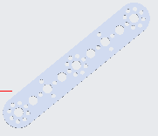When creating the dog legs in CAD, the first thing you should do is to find all the pieces you need. The only pieces that are needed were four flats, and four axles 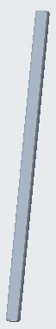. All the axles are the same, however for the flats, two of them has 9 holes, and the other two have 5 holes. You plot down the first piece (easiest if it is 9 holes). All pieces should be put in pin constraint except the first, otherwise it will be difficult to recreate the dog legs. The pin constraint makes the object rotatable, but not movable. One point stays there, but the rest rotate, making the dog move forward.

The next step is adding the axle. When you add an axle, you should always add it to the right most or left most. Connect the right most big hole to the side of the axle, and the bottom of the flat to the bottom of the axle. Doing that would make the two pieces connected to each other. You want to connect the two pieces using coincident.

Then you should add a flat to the axle. When you are connecting the second flat, you should connect the big hole to the side of the axle and put the flat on the other side of the axle. Then you add another axle to the second flat you added. Connect the hole of the flat to the side of the axle.

If you are going to add another flat, you do the same thing, except for the second part of the constraint, switch coincident to distance, and use the distance as -1 or such. Do this for all the other flats, until you have four flats, and three axles. Add the axle to any of the remaining holes, both will work.

In order to connect the last axle to the first flat, you need to add a new set. Click on the axle, go to the placement tab, and click new set. Doing this allows you to be able to connect the last piece to the first piece, connecting it into a circle shape.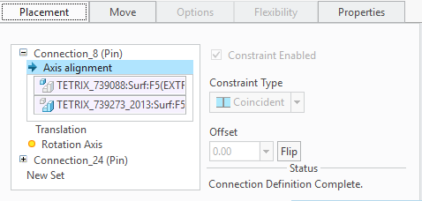 When you finish doing that, you can see how the other three flats can move while the last flat stays still. If you don’t want to move it yourself. You can add a motor. If you go under applications, mechanisms, then add a motor. If you click on the axle where you want to add the motor, a motor will be added.

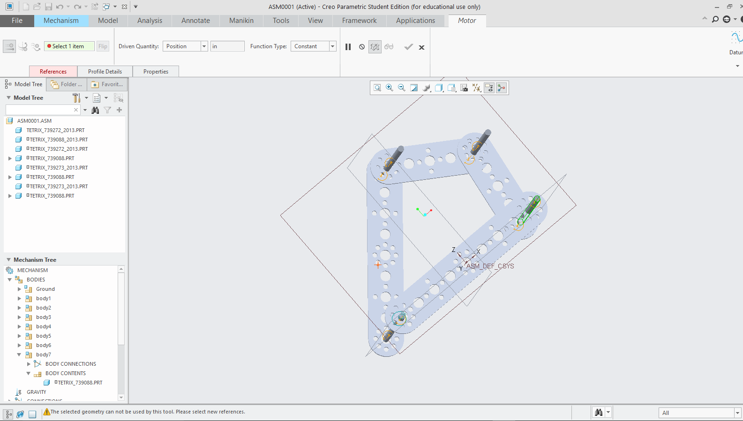 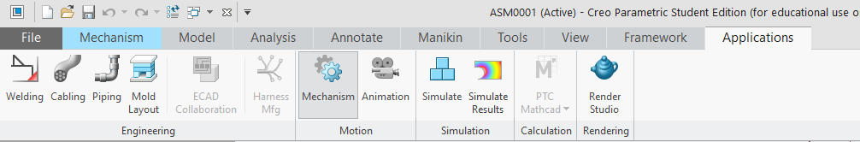 With the motor, you can go to mechanism, and run the motor. It will move the pieces until it can’t move anymore, in that case you want to move the parts back to how they used to be.