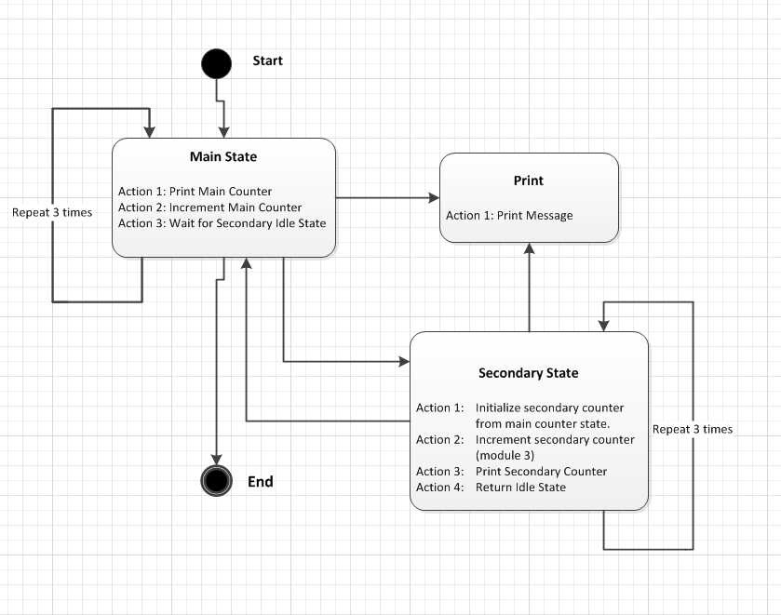

Implement in C or C++ a State Machine as described above.
You may use any C or C++ compiler but executable must run on a windows command shell.
The print out of the program shall be like:
Main: 0
Secondary: 1
Secondary: 2
Secondary: 3
Main: 1
Secondary: 2
Secondary: 3
Secondary: 1
Main: 2
Secondary: 3
Secondary: 1
Secondary: 2
Main: 3
Bye!

