# Programming GPIO on Raspberry Pi 3 using C language and WiringPi library

(by Robin Brämer – <https://github.com/robinbraemer>)

**Steps:**

First open a new “Geany”...



...make a new “main.c” file…

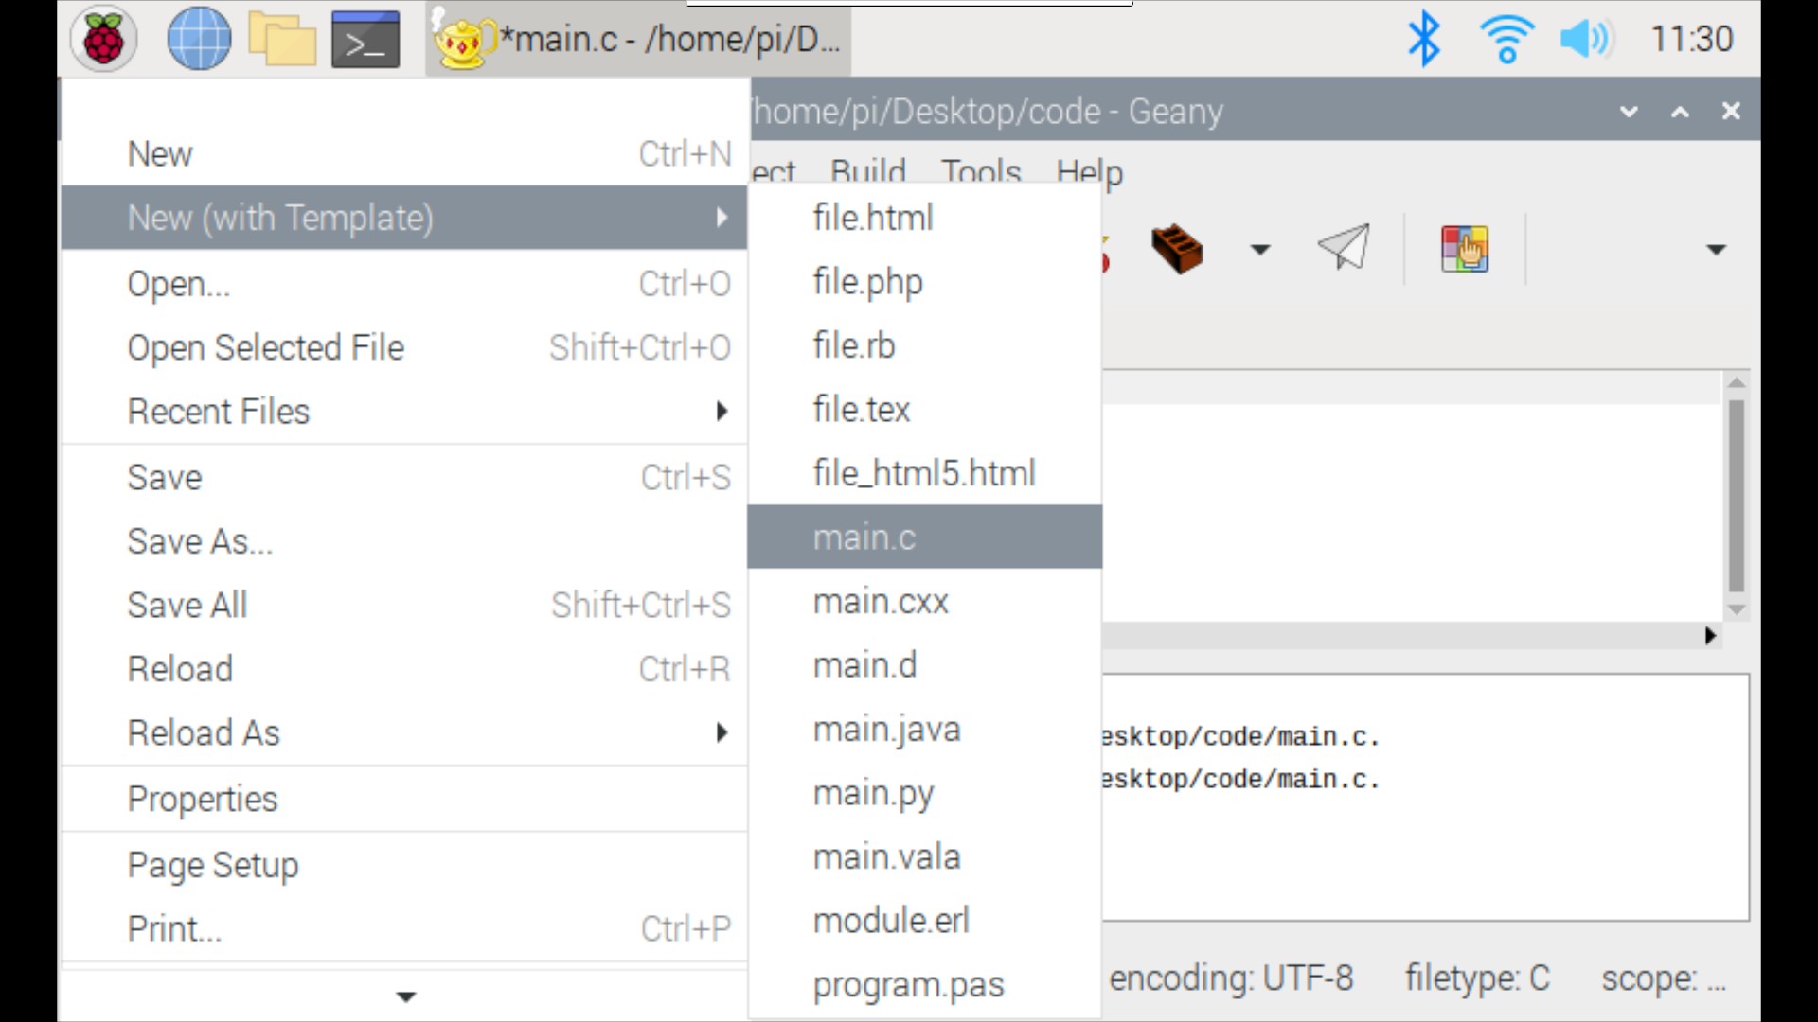

...and copy-paste the following code.

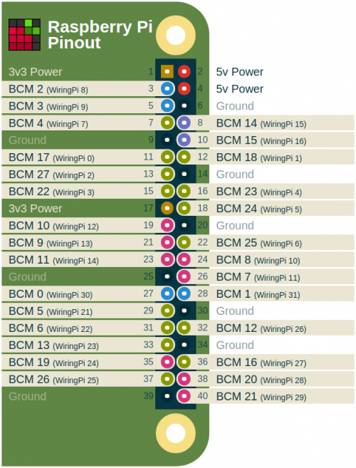**Code sample:**

#include <stdio.h>

#include <wiringPi.h>

#define LED 29

int main(void) {

printf("Raspberry Pi blink\n");

wiringPiSetup();

pinMode(LED, OUTPUT);

for (;;) {

digitalWrite(LED, HIGH); // On

delay(500); // mS

digitalWrite(LED, LOW); // Off

delay(500);

}

return 0;

}

Before you can build & run the program you need to link the included wiringPi library!

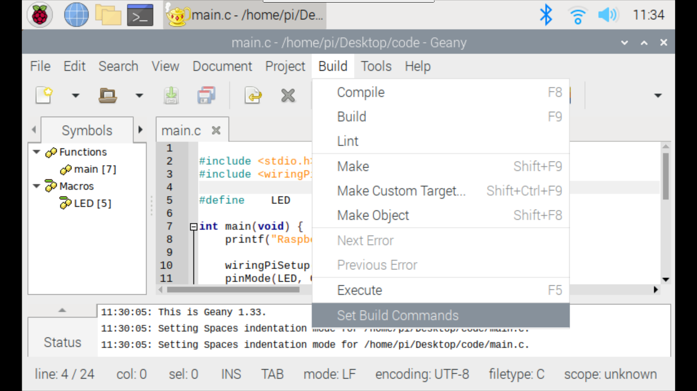

Add the two “-l wiringPi” link flags and save.

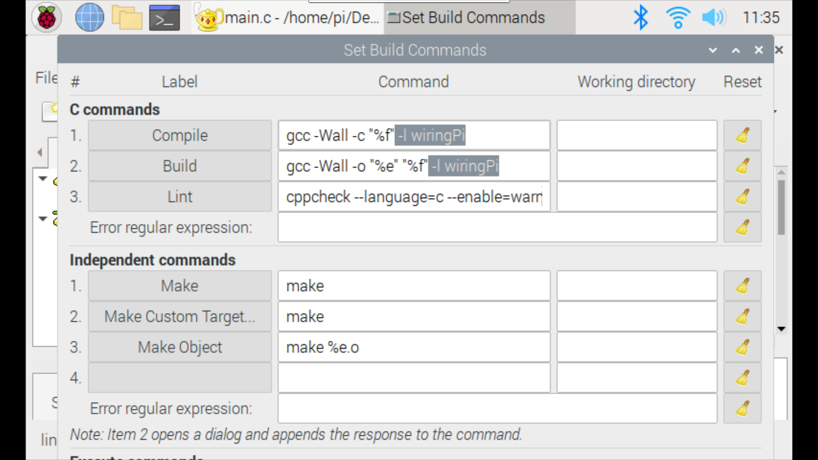

Now you can click **Build** and **Run** the program!

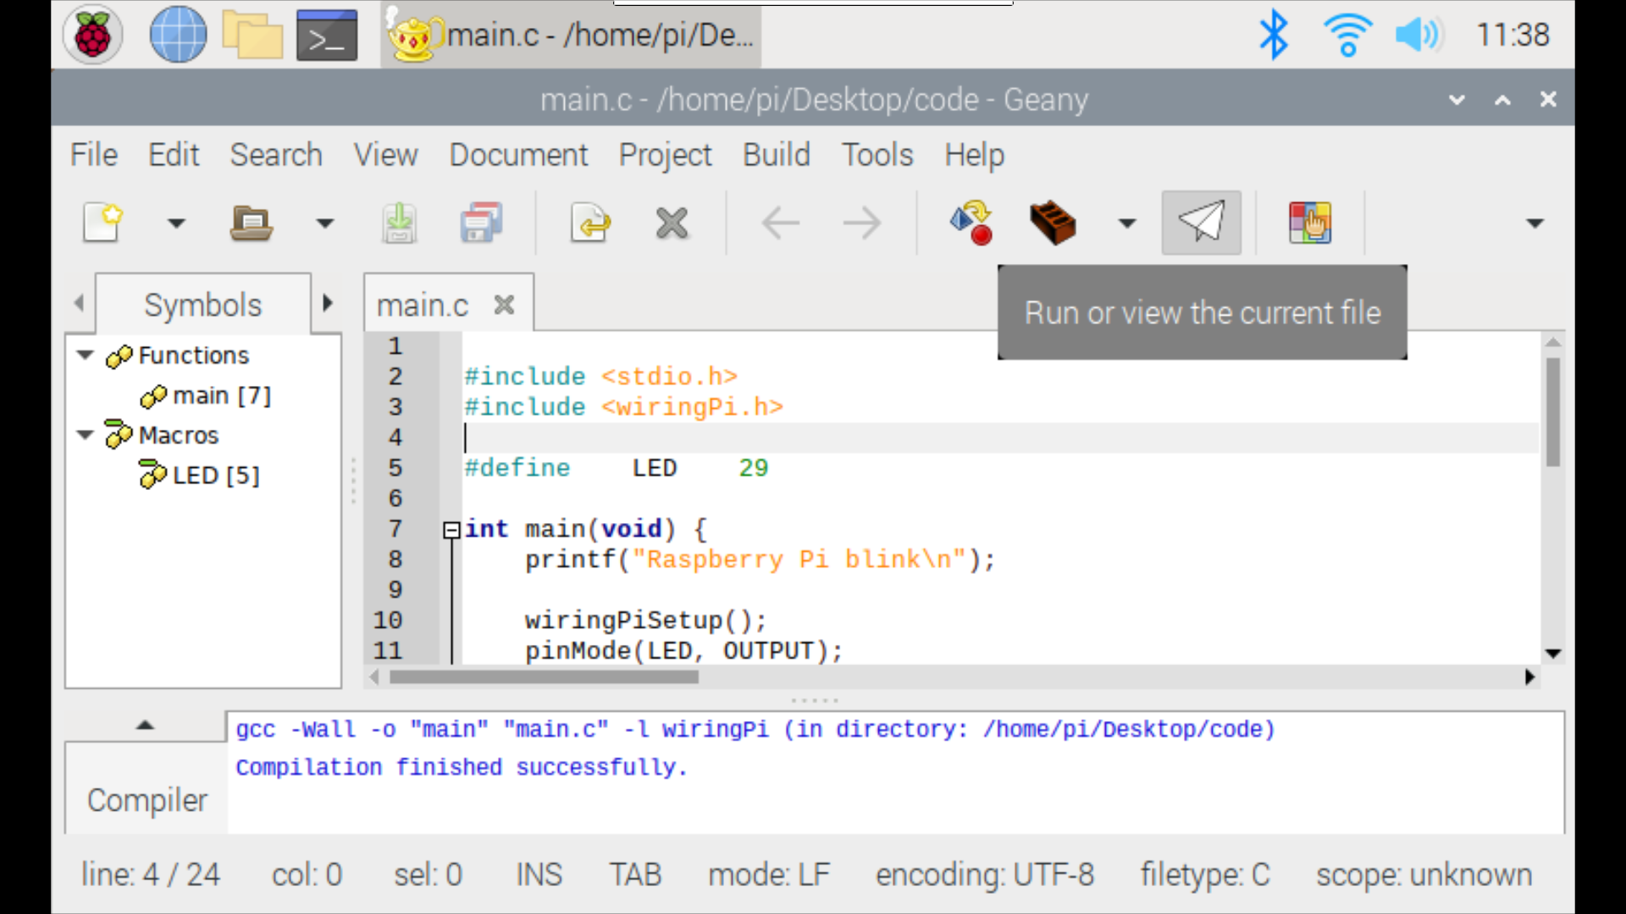

Sources:

* <https://wiki.odroid.com/_media/odroid-xu4/application_note/gpio/screenshot_from_2018-03-29_11-33-26.png?w=500&tok=6ae58c>