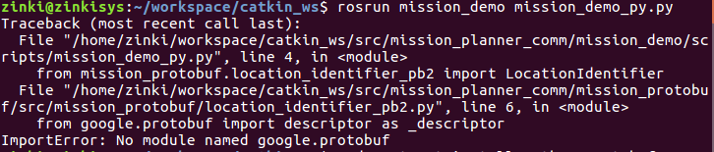
Solution:

sudo apt-get install python-protobuf

