# Redesign of physical E-stop

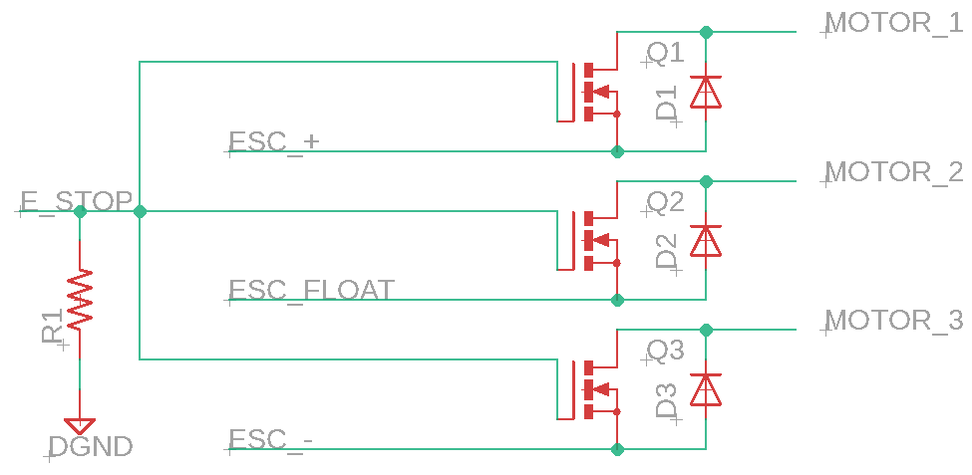

Can get MOSFTS with built-in body diode: <https://www.onsemi.com/pub/Collateral/FDMS1D4N03S-D.pdf>

# Plan for Deadman wireless E-stop

Requirements

* Range of 30m
* Must cut the power within 1 sec of losing contact
* Must cut the power immediately when the Stop button is pressed
* Must not turn off ESC?