# Requirements

* Must have ‘deadman’ logic to stop car if signal is lost
* Must have >30m range
* Must interface with current 6 pin header
* Must be able to handle reconnecting
* Must have a simple control box (in addition to any other controls)
* Must have >3-hour battery life with replaceable battery
* Must have indicator LEDs on remote to show state

# Block diagram

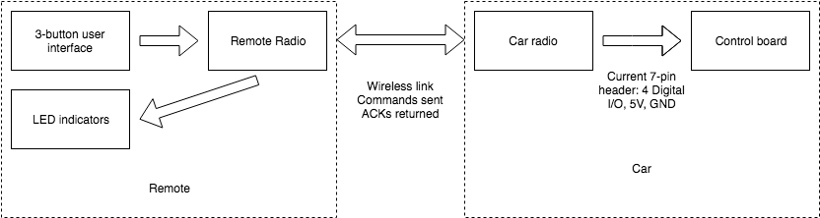

# E-stop state machine

1. GO
   1. Transitions to STOP upon receiving stop signal.
   2. Transitions to DISCONNECTED if no signals for >0.5 sec
2. STOP
   1. Transitions to GO upon receiving go signal
   2. Transitions to DISCONNECTED if no signals for >0.5 sec
3. DISCONNECTED
   1. Transitions to STOP upon receiving stop signal.
   2. Transitions to GO upon receiving go signal.

# Major parts

TI battery bank – Power source for remote. Has built-in USB charging, regulated 5V output, and is easily changeable.

Sparkfun radio RFM69HCW (915 MHz version): radio chips

ATMEGA MCU (3.3 V version): Microcontroller

# Useful references

<https://learn.sparkfun.com/tutorials/how-to-build-a-remote-kill-switch/all> - semi-following this

<https://learn.sparkfun.com/tutorials/rfm69hcw-hookup-guide> - wiring guide for radio