ROBOSAIL

Mentor
Name: ___________________
Email: ___________________

Class Leader
Diane Brancazio,
diane@robosail.org
www.robosail.org

BOARDS
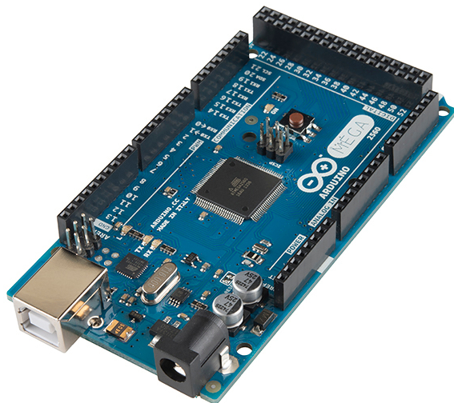
Arduino Mega
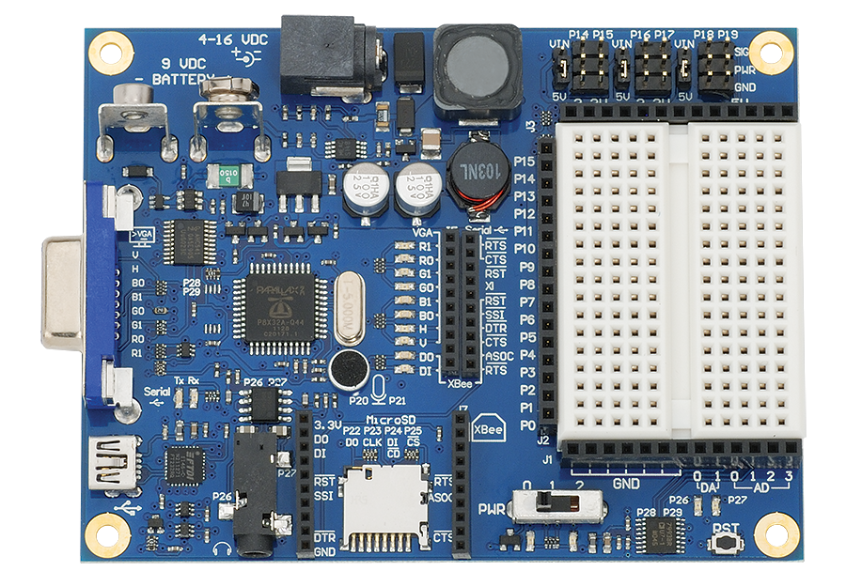
Parallax Propeller
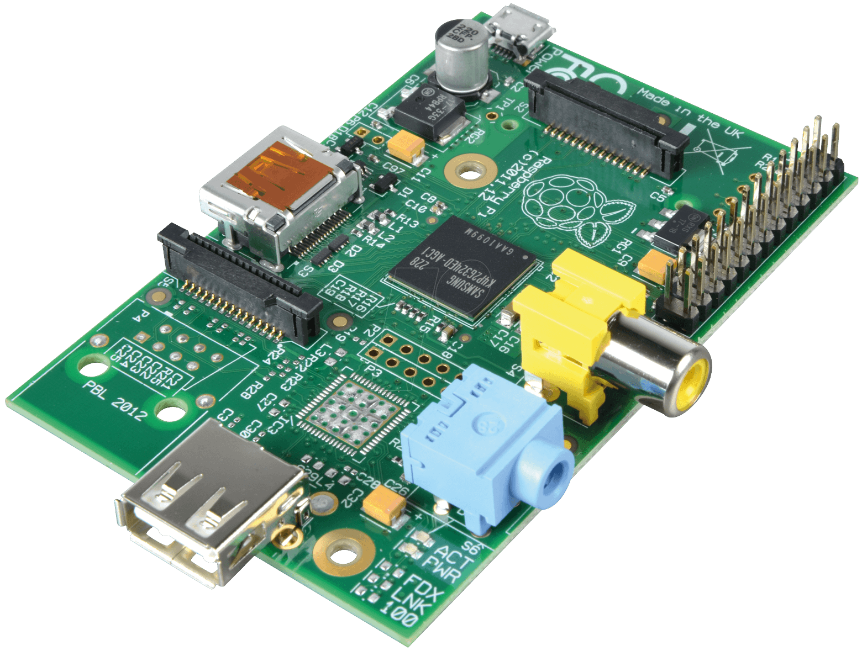
RaspberryPi
LANGUAGES
 | 
 | 
 | 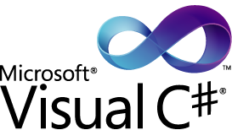

BOOKS
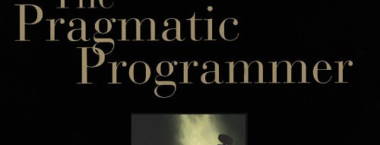
The Pragmatic Programmer, by Andrew Hunt and David Thomas
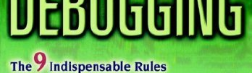
Debuggung, by David Agans
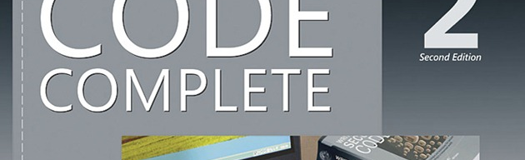
Code Complete by Steve McConnel
MAGAZINES
 | 
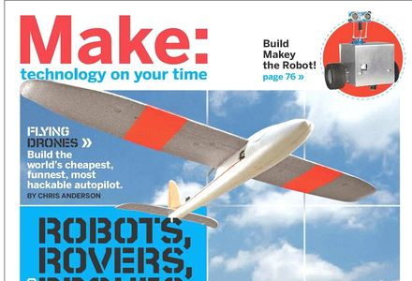 | 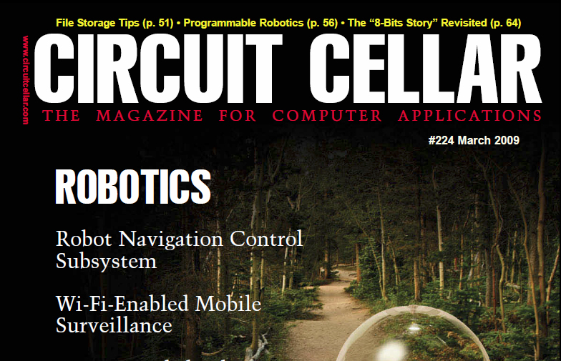
Others: Wired, Elektor, ROBOT Magazine

ASSOCIATIONS
 | 
Electrical Engineering | Computer Science
 | 
Mechanical Engineering | Engineering Outreach

SUPPLIERS
 | 
 | 
 | 

COLLEGE
Computer Science: the scientific and practical approach to computation and its applications. A computer scientist specializes in the theory of computation and the design of computational systems.
Electrical Engineering: the design, development, testing, and supervision of the manufacturing of electrical and electronic equipment, such as motors, radar, navigation, broadcast and communications systems—from portable music players to global positioning systems (GPS).
Computer Engineering: the integration of several fields of electrical engineering and computer science required to develop computer hardware and software, with training in electrical engineering, software design, and hardware-software integration instead of only software engineering or electronic engineering. Computer engineering not only focuses on how computer systems themselves work, but also how they integrate into the larger picture.

