Abstract

The project entitled CAR PARKING SYSTEM, the major motivation of this project is to reduce the traffic congestion in roads, multi-storeyed buildings and malls due to unavailability of parking spaces. The project displays the empty. Our project aims to make efficient use of parking spaces. We track vacant slots in the parking space and assign that to the user. Smart parking system as described above can lead to an error-free, reliable, secure and fast management system. In recent times the concept of smart cities has gained great popularity. Thanks to the evolution of the technology the idea of smart city now seems to be achievable. Consistent efforts are being made in the technology in order to maximize the productivity and reliability of urban infrastructure. Problems such as, traffic congestion, limited car parking facilities and road safety are being addressed by IoT. The proposed Car Parking system consists of an on-site deployment module that is used to monitor and signalize the state of availability of each single parking space. The project also describes a high-level view of the system architecture.

**Introduction**

The development of traffic management system, car parking system was created to hiring people and optimal use of resources. General method of finding a parking space is physical. This method takes time and effort and lead worst case of failing to find parking space. The solution for parking problem, which take in the fuel consumption and pollution ,it minimized by carry out the system. In this project we implement the system with IR sensor, ARDUINO microcontroller, LED and LED Display. This system check the parking availability in using IR sensor the decision may be made by ARDUINO microcontrollers. Aim of project is to automate the car park for allowing the cars into the parking slot. The status of parking slot send to the LCD display . Several automobile research institutes and fabrication are increasing automatic parking system. Two basic modules are required for implementation of this system

1. Parking availability prediction system

2. Automatic car parking

The following software are used in this project

1. Arduino IDE

2. Android Studio IDE 3. Virtual Terminal

The aim of this project is to provide an efficient car parking system with minimal human intervention.

Proposed Work:

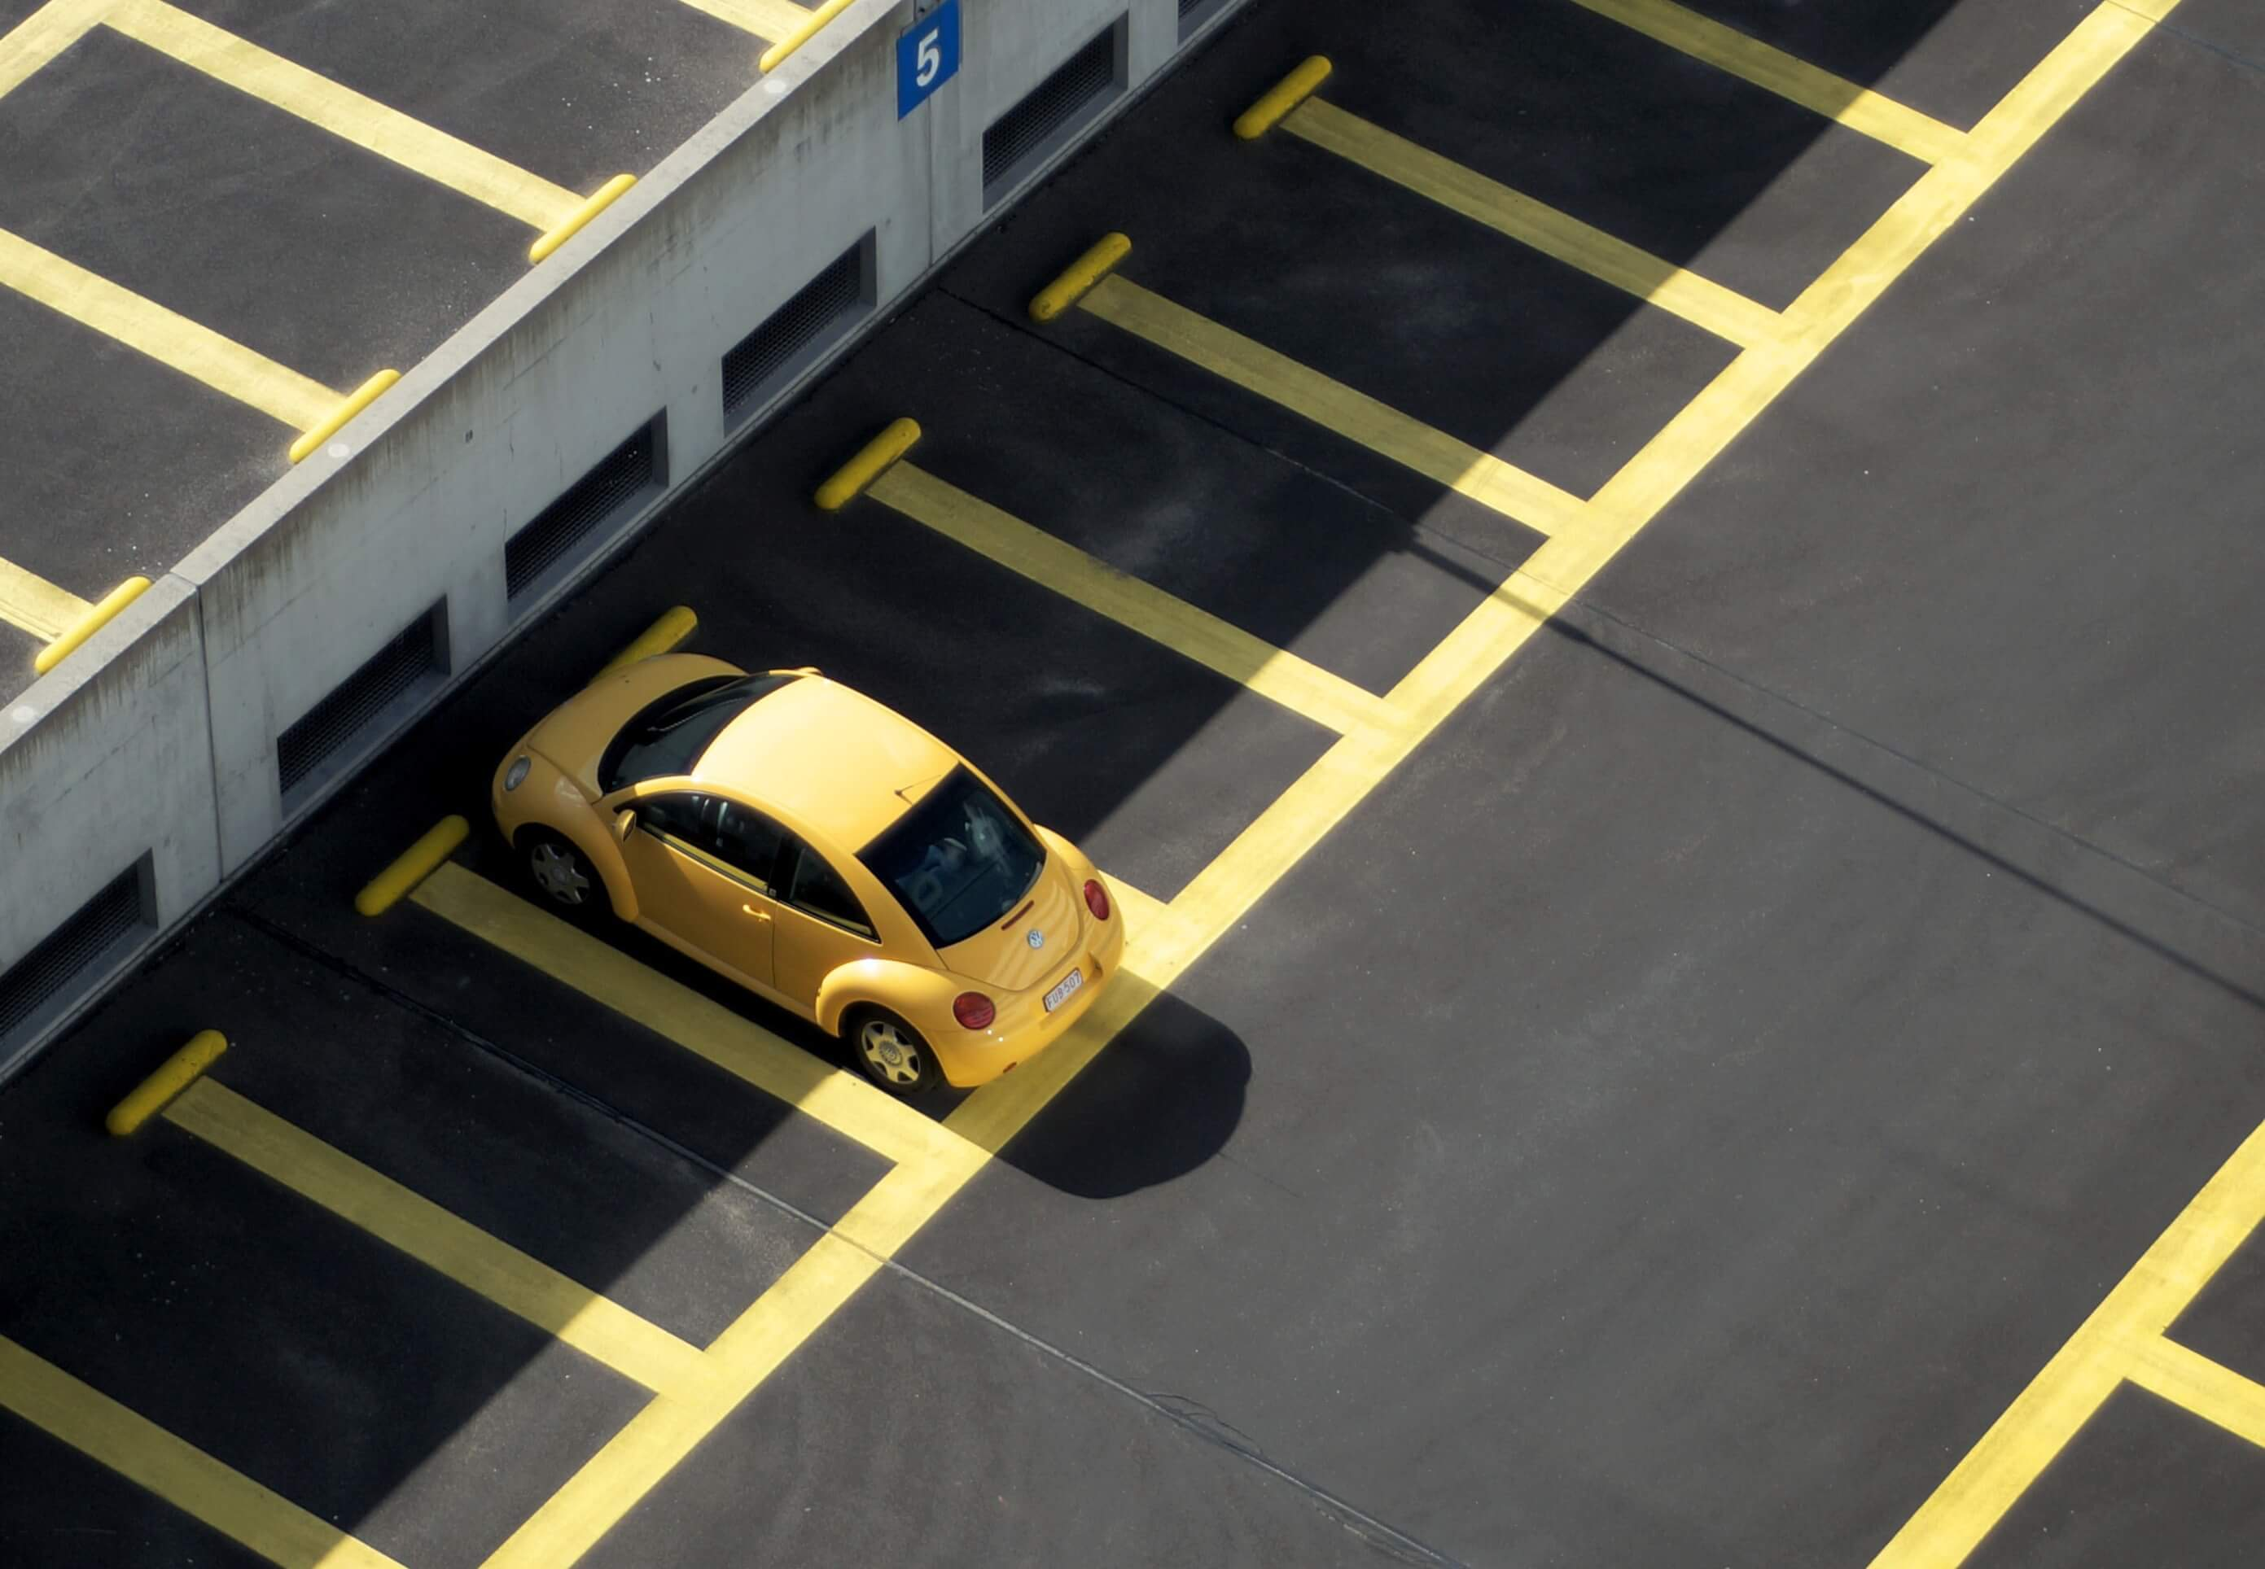

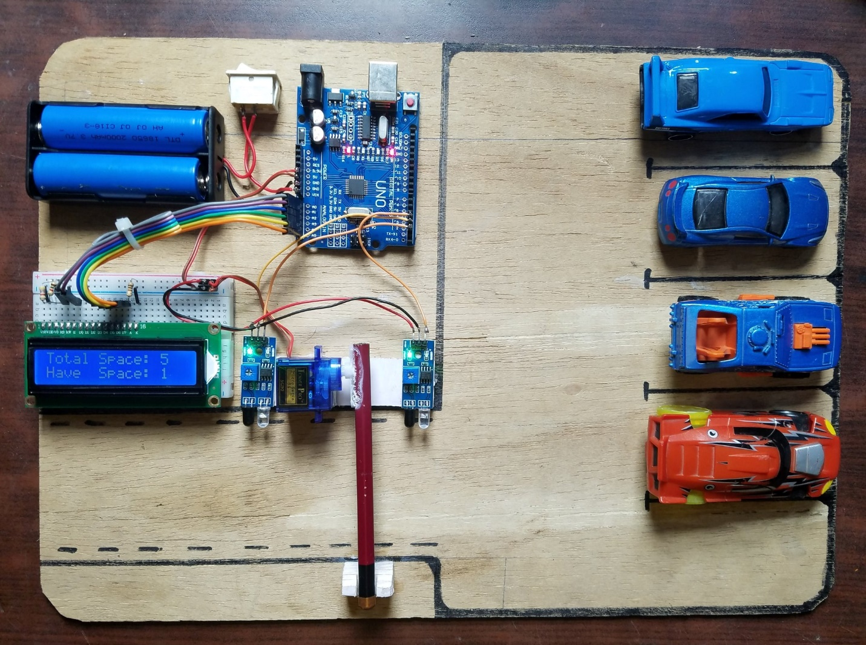

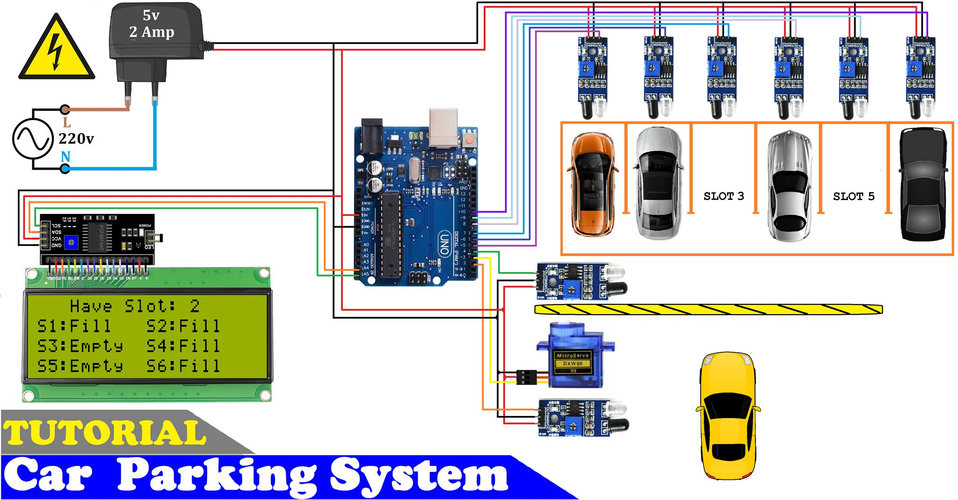

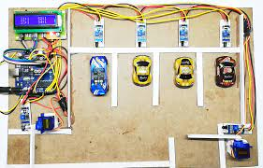

In car parking system, here we are using the IR sensors, which will detect the empty and engaged slots which will displayed on LED so any one got to know the slots availability