**Abstract**

In agriculture, there is a need for a technology that is more easily understood, implemented, and used by the farmers. Equipment that requires less human effort and time with less cost of implementation is much required for success in the agricultural industry. Hence, we designed a Seed sowing robot that can be controlled with the help of IoT and it helps in the sowing of seeds in the desired position hence assisting the farmers in saving time and money. This machine performs the operations like plowing, sowing, and leveling which are used for small-scale farming. Seed sowing is one of the main processes of farming activities. It requires a substantial amount of human effort and also time-consuming. This project aims to design and fabricate a seed sowing robot for the mentioned task. This robot requires less maintenance and is portable.

**INTRODUCTION**

* Agriculture has been the backbone of the Indian economy and it will continue to remain so for a long time.
* It has to support almost 17 percent of the world population from 2.3 percent of the world's geographical area and 4.2 percent of the world’s water resources. The net sown area is 142 Million hectares.
* The basic objective of the sowing operation is to put the seed and fertilizer in rows at desired depth and spacing, cover the seeds with soil and provide proper compaction over the seed.
* The recommended row to row spacing, seed rate, seed to seed spacing, and depth of seed placement vary from crop to crop and for different agricultural and climatic conditions to achieve optimum yields and an efficient sowing machine should attempt to fulfill these requirements.
* Also, saving in cost of the operation time, labor and energy are other advantages to be derived from the use of improved machinery for such operations.
* A traditional method of seed sowing has many disadvantages.
* This project is about a robot which do operations like seed sowing, ploughing and levelling and its was controlled by IoT.

**LITERATURE REVIEWS**

* 2.1 Pankaj Kumar, G. Ashok, [Research paper citing] – 2020 In this journal, they designed and fabricated a smart seed sowing robot. This smart seed sowing robot consists of one robotic arm to sow the seeds from the seed container. The robot arm is controlled through the mobile application to get the desired positions of the arm. This robot arm can able to pick and drop the seeds of Ground Nut, Soya bean without any problem but it faces difficulties while dropping Red Gram Dal, Almond, and same.
* 2.2 Tanmay Nagdeve, Sushobhit Dhara, Hrushikesh Tandulkar, Pranay Jangde, Neema Ukani, Saurabh Chakole, [Research paper citing] – 2020 This paper discusses the design of the chassis of an automated seed sowing Robot for Cotton Seed. They experimented with a small four-wheeled bot connected to a 6V high current battery in fields. They find that due to the battery issues, the bot was unable to get enough power required to cross over the obstacles, because of the small chassis size, the bot was unable to overcome the potholes and due to the low ground clearance of the bot, there were high chances for the wiring beneath the chassis, getting jumbled into the small plants. So, we decided to go for a design, similar to a four-legged table, with wheels at the end of each leg. Thus, providing the Robot body with enough ground clearance and stability.
* 2.3 M. ARUN, R. PRATHIPA, PRIYANKA S, AKSHAYA ANAND, CHANDRIKA N, [Research paper citing] – 2018 Here robots can perform multiple agricultural activities like seed sowing, plowing, obstacle detection, and irrigation, and all these operations of the robot are controlled by a WIFI module. The smart agriculture robot can be directed to various directions like forwarding, reverse, left, and right. These directions are commanded by the user by clicking on the respective options on the webpage. The robot is not autonomous and it requires human operations.
* 2.4 Prof. P. V. Bute, Shailesh Deshmukh, Govind Rai, Chetan Patil, Vishal Deshmukh, [Research paper citing] – 2018 In this paper, they designed a Multipurpose agriculture robot that functions operations like plowing and seed sowing. It is a wireless robot. Here RF module is used as a transmitter and receiver for controlling the robot. It is used in home gardening, sports ground and in fruit gardens and it is not suitable for agriculture fields.

Objectives of the study

* 1. Automate seed sowing with great efficiency and accuracy
* 2. To reduce the sowing time.
* 3. To reduce the sowing cost.
* 4. To resolve the problem of uncertainty in availability of manual labor.

Advantages

* 1. Improved efficiency in planting.
* 2. Increased yields and reliability in the crop. Increased cropping frequency.
* 3. Increased speed of seed planting.
* 4. With a limited number of agricultural labor the seed sowing process can be completed in a short time.

Limitations

* 1. If any disturbance in the electrical set up it difficult for the farmer to handle.
* 2. Few farmers may feel difficult in using mobile app to control the robot.

COMPONENT DETAILS

* DC MOTOR

A DC motor is defined as the electrical machine which converts the direct electrical current energy into mechanical energy. Its works on the principle of “Fleming’s left-hand rule”. The speed of dc motor has a wide range of control can be done by varying supply voltage. 40rpm, 12V Dc motor used in this Seed sowing robot.

* BATTERY

In order to provide supply to the controller unit battery is used. A 12V, 7AH Lead acid battery is used in this project. The lead-acid battery is a rechargeable battery. Despite having a very low energy-to-weight ratio and a low energy to volume ratio, their ability to supply high surge currents means that the cells maintain a relatively large power-to weight ratio. These features, along with their low cost, make them attractive for use in motor vehicles to provide the high current required by automobile starter motors.

* CHAIN DRIVE

Mechanical power from one place to another. It is often used to convey power to the wheels of a vehicle, particularly bicycles and motorcycles. It is also used in a wide variety of machines besides vehicles. The power is conveyed by a roller chain, known as the drive chain, passing over a sprocket gear, with the teeth of the gear meshing with the holes in the links of the chain. The gear is turned, and this pulls the chain putting mechanical force.

HOPPER

It is used to store the seeds and their delivery for the further use. The capacity of the Hopper is 1 to 1.5 kg. Here, in our design the hopper is semi-circular in shape in order to prevent the wastage of the seeds.

SEED SHOWER

The mechanism of a seed drill distributor which delivers seeds from the hopper at selected rates is called seed metering mechanism.

IoT

The Internet of things (IoT) is a system of interrelated computing devices, mechanical and digital machines are provided with unique identifiers (UIDs) and the ability to transfer data over a network without requiring human-to human or human-to-computer interaction.

**Proposed Model:**

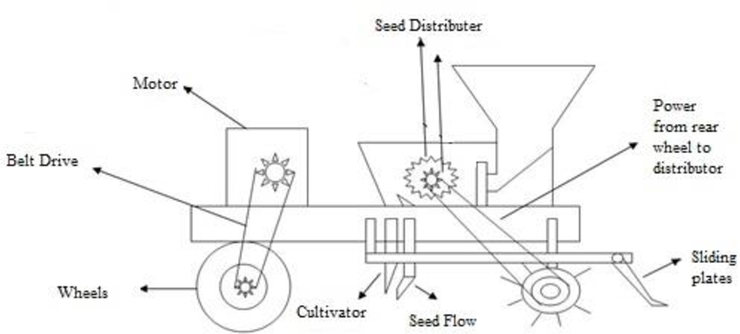

Figure Proposed Model

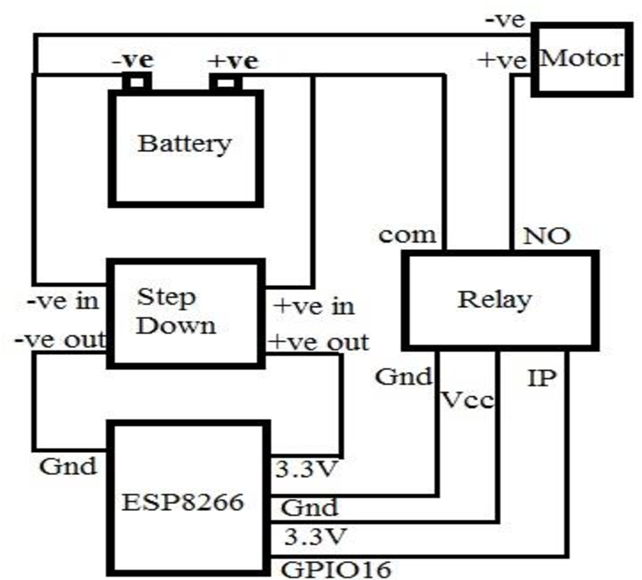

Figure Wiring Connections

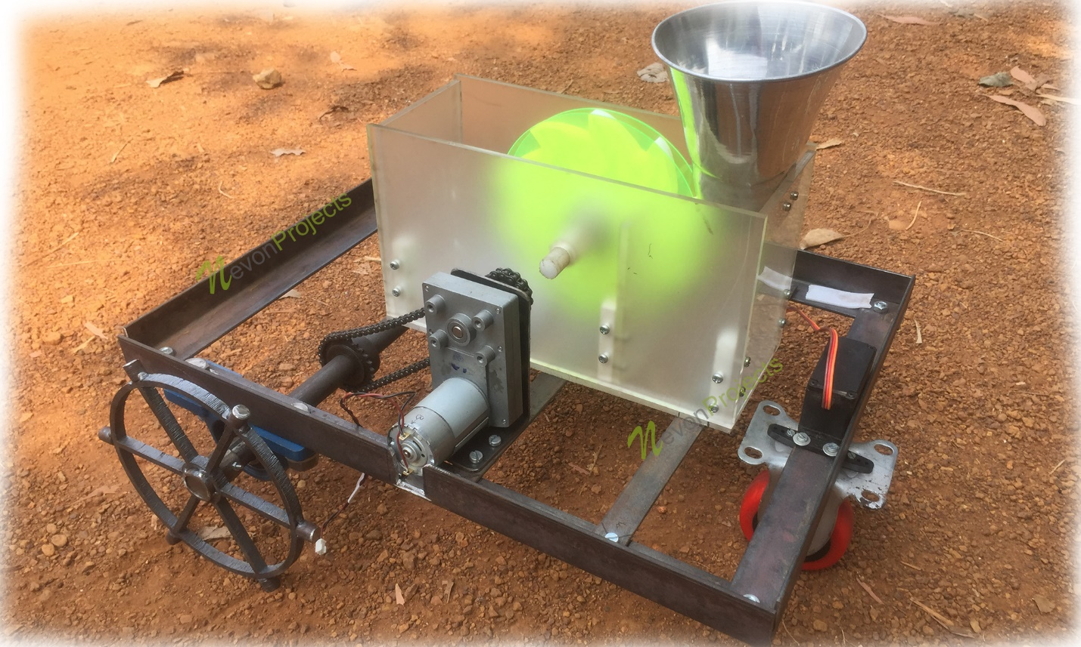

Figure Model Design

**Expenditure**:

|  |  |  |  |
| --- | --- | --- | --- |
| **Sr No** | **Quantity** | **Description** | **Total Price** |
| 1 | 1 | Motor 12v 50 RPM | 2200 |
| 2 | 1 | Motor 12v 150 RPM | 1600 |
| 3 | 1 | Chain Sproket | 2100 |
| 4 | 1 | Chain | 1200 |
| 5 | 1 | Ball Bearing | 900 |
| 6 | 2 | Wheels | 1600 |
| 7 | 1 | Battery 12v | 1200 |
| 8 | 1 | Rods Iron | 3000 |
| 9 | 1 | IoT Kit | 1600 |
| 10 | 1 | Wires | 200 |
| 11 | 1 | Jumpers | 100 |
| 12 | 1 | Gears | 900 |
| 13 | 1 | SEED SHOWER | 700 |
| 14 | 1 | Hopper | 900 |
| 15 | 1 | Caster wheels | 250 |
| 16 | 1 | 12v Charger | 450 |
| 17 | 1 | 5v Cherger | 200 |
| 18 | 1 | Step down | 5500 |
| 19 | 1 | Relay | 700 |
| **Total** | | | 25300 |

CONCLUSIONS

* IoT-based Seed sowing robot was designed and fabricated to perform ploughing, seed sowing, and levelling operations. The advantages of the seed sowing robot are reducing human intervention, reduces the sowing, ploughing, and levelling time, improves efficiency in sowing and Uniformity will be maintained while placing the seeds in a row with specified distance. This robot is majorly used for the sowing of seeds. In the future, we try to improve the robot and will design a completely autonomous robot without the requirement of human interaction.

REFERENCES

* [1] Vijaykumar N Chalwa, Shilpa S Gundagi (2014), "Mechatronics Based Remote Controlled Agricultural Robot" International Journal of Emerging Trends in Engineering Research.
* [2] Prof. P. V. Bute, Shailesh Deshmukh, Govind Rai, Chetan Patil, Vishal Deshmukh (2018), “Design and Fabrication of Multipurpose Agro System” International Journal of Emerging Trends in Engineering Research.
* [3] Timo Blender, Thiemo Buchner, Benjamin Fernandez, Benno Pichlmaier and Christian Schlegel (2016), “Managing a Mobile Agricultural Robot Swarm for a Seeding Task” IEEE.
* [4] Pankaj Kumar, G. Ashok (2020), “Design and fabrication of smart seed sowing robot”, Elsevier.
* [5] M.ARUN, R. PRATHIPA, PRIYANKA S, AKSHAYA ANAND, CHANDRIKA N (2018), “SMART AGRICULTURE ROBOT”, International Journal of Pure and Applied Mathematics, Volume 119 No. 15 2018, 1901-1906. [6] T. Blender, T. Buchner, B. Fernandez, B. Pichlmaier and C. Schlegel, "Managing a Mobile Agricultural Robot Swarm for a seeding task, "IECON 2016 - 42nd Annual Conference of the IEEE Industrial Electronics Society, Florence, 2016, pp. 6879-6886.
* [7] V. Santhi, Kapileswar, Venkata Siva Prasad. CH, Vijay K. R, “Sensor and Vision based Autonomous AGRIBOT for Sowing seeds”, IEEE, 2017, Page No. 242-245
* [8] Tanmay Nagdeve, Sushobhit Dhara, Hrushikesh Tandulkar, Pranay Jangde, Neema Ukani, Saurabh Chakole “Design and Synthesis of Chassis of Automated Seed Sowing Robot for BT Cotton Seed.” IEEE, 2020, Page No. 1-4.