ACKNOWLEDGEMENT

I would like to express my gratitude, sincere thanks and deep sense of appreciation to my project guide Prof. P. H. Parkale, Assistant Professor, Department of Mechanical Engineering, SVPM’s College of Engineering, Malegaon (Bk.) for continuously assessing my work, providing great and valuable guidance throughout the academic year by timely suggestions and discussions at every stage of this work making my seminar work in reality.
I would like to express my heartedly sincere thanks and deep sense of gratitude to Dr. S. S. Patil, Head, Department of Mechanical Engineering, SVPM’s College of Engineering, Malegaon (Bk.) for his valuable support and kind cooperation. I also glad to express my gratitude and thanks to Dr. S. M. Mukane, Principal, SVPM’s College of Engineering, Malegaon (Bk.) for their valuable suggestions and comments, ideas related to project work.
Finally, I would like to wish special thanks to Management of SVPM’s College of Engineering, Malegaon (Bk.), my family members and friends, without whose patience, encouragement, and support this seminar work might never have been completed.

Jadhav Nikhil Anant | 141/12/ME
Kangude Akash Prakash | 151/12/ME
Jagdale Saurabh Vitthal | 144/12/ME
Jadhav Navnath Madhukar | 140/12/ME

ABSTRACT

Agriculture is the major sector in the world that plays a vital role in developing the economy of a nation. Agro technology is the process of implementing the recent technologies to develop the crops that are being produced. The use of agro technology not only helps in improving the efficiency of the crop that are being produced but also helps in developing devices that are suitable for doing mechanical works in the fields. This results in minimization of the total cost of production, saving of time and reduction in the effort involved in the process.
The new technology should also be economically feasible and hence the behavior of the technology and its role in the society is an important consideration before developing a new product or process. In this work a seed sowing machine has been developed that help the farmers in harvesting the best crop with least efforts. A mechanical device that helps in sowing operation and controlled using IoT (Internet of Things) has been developed.

Keywords: Agriculture, Agro-Machinery, Internet of Things, Efficiency, Seed Sowing Machine

LIST OF FIGURES

Fig. No. | Description of Figure | Page No.
1.1 | Experimental techniques for high strain rate testing of materials | 3
2.1 | Shear test clamps | 6
2.2 | Porcine PDL test setup | 6
2.3 | A schematic of Kolsky bar modified for soft tissue testing | 7
2.4 | Instron type tensile test setup | 8
2.5 | Tensile device for dynamic tests on planar soft tissues | 9
2.6 | Setup of split Hopkinson pressure bar | 10
2.7 | Experimental setup for unconfined compression of brain tissue | 11
2.8 | Experimental setup for tension of brain tissue | 12
2.9 | Modified Kolsky tension bar technique | 12
2.10 | Split Hopkinson pressure bar apparatus | 14

LIST OF TABLES

Table No. | Description of Table | Page No.
1.1 | Spectrum / Protocol of experimental strain rate testing | 2
2.1 | Summary of literature review for strain rate | 20
2.2 | Summary of major developments in SHPB for modified setup | 21
A.1 | Instruments and their specification required for testing | 49

NOMENCLATURE
IoT | Internet of Things
Ref. | Reference

Chapter – 01
INTRODUCTION

India record of progress in agriculture over the past four decades has been quite impressive. The agriculture sector has been successful in keeping pace with rising demand for food. The contribution of increased land area under agricultural production has declined over time and increases in production in the past two decades have been almost entirely due to increased productivity. Contribution of agricultural growth to overall progress has been widespread. Increased productivity has helped to feed the poor, enhanced farm income and provided opportunities for both direct and indirect employment. The success of India’s agriculture is attributed to a series of steps. The major sources of agricultural growth during this period were the spread of modern crop varieties, intensification of input use and investments leading to expansion in the irrigated area. In areas where ‘Green Revolution’ technologies had major impact, growth has now slowed. New technologies are needed to push out yield frontiers, utilize inputs more efficiently and diversify to more sustainable and higher value cropping patterns”. At the same time there is urgency to better exploit potential of rain fed and other less endowed areas. Given the wide range of agro ecological setting and producers, Indian agriculture is faced with a great diversity of needs, opportunities and prospects. Future growth needs to be more rapid, more widely distributed and better targeted. These challenges have profound implications for the way farmers’ problems are conceived, researched and transferred to the farmers. “On the one hand agricultural research will increasingly be required to address location specific problems facing the communities on the other the systems will have to position themselves in an increasingly competitive environment to generate and adopt cutting edge technologies to bear upon the solutions facing a vast majority of resource poor farmers”. The robotic systems play an immense role in all sections of societies, organization and industrial units.
The objective of the project is to develop a microcontroller-based system at helps in on-farm operations like seeding and fertilizing at pre-designated distance and depths with all applicable. Agriculture comes from two Latin words: Ager which means a field. Culturia which means cultivation, Due to traditional methods of agricultural process the Indian farmer faces many problems about productivity of agricultural product than others. It is due to unbalance feeding of fertilizer without knowing the actual requirement of nutrient to a particular crop. Digital models of biological objects have proven to deliver new facilities for the analysis of structural and functional interrelationships as well as developmental processes in a spatial or spatio-temporal context .We are working towards the generation of a generalized 3-D anatomical atlas of developing barley (Hordeum vulgare) grains at different developmental stages. Serving as reference framework for the integration, visualization, and exploration of various data modalities, such inter-individual atlases significantly promote the analysis of developmental gradients and dynamics. Traditional methods include broadcasting manually, opening furrows by a country plough and dropping seeds by hand, and dropping seeds in the furrow through a bamboo/meta funnel attached to a country plough (Pora). For sowing in small areas dibbling i.e., making holes or slits by a stick or tool and dropping seeds by hand is practiced. Multi row traditional seeding devices with manual metering of seeds are quite popular with experienced farmers. In the current generation most of the countries do not have sufficient skilled man power specifically in agricultural sector and it affects the growth of developing countries. So, it’s a time to automate the sector to overcome this problem. In India there are 70% people dependent on agriculture. So, we need to study agriculture. Innovative idea of our project is to automate the process of sowing crops such as sunflower, baby corn, groundnut and vegetables like beans, lady’s finger, pumpkin and pulses like black gram, green gram etc & to reduce the human effort and increase the yield. The plantation of seeds is automatically done by using DC motor. The distance between the two seeds is controlled and varied by using Microcontroller. It is also possible to cultivate different kinds of seeds with different distance. When the Robot reaches the end of the field, we can change the direction with the help of remote switches. The whole process is controlled by Microcontroller. Seed plantation is our day-to-day life is done by tractor in farms. The conventional method for seeding is the manual one. But it requires more time & the man power shortage is faced continuously. India is agrarian economies and most of rural populations depend on agriculture to earn their livelihood. Agriculture is the largest livelihood provided in India mostly in the rural areas. The farmers are in need of seeds for ploughing & cultivation. The seeds are available in packets & many industries deal in manufacture of such seed packets.
In Modern world, Automation robot is used in many of the fields such as Defence, surveillance, medical field, industries and so on. In this project, the robot system is used to develop the process of cultivating agricultural land without the use of man power. The aim of the paper is to reduce the man power, time and increase the productivity rate. All the basic automation robot works like weeding, harvesting and so on. In current generation most of the countries do not have sufficient human factor in agricultural sector and it affects the growth of developing countries so it’s time to automate the sector to overcome this problem. In India, there are 70% people dependent on agriculture. So, we need to study the agriculture. Innovative idea of our project is to automate the process of sowing crops such as groundnut, sunflower, and baby corn and so on. The farming system like ploughing, cultivating, weeding, harvesting, etc is the different process. All the processes are advance to modifying the mechanism in farming which works automatically without the man power requirement. The small machine would be assembled from existing mass-produced components without the need of specialized design and tooling. Also, energy require to this machine is less as compared with tractors or any agricultural instrument. Seeding preparation is our day-to-day life we use tractor in farms. But it requires more time and the man shortage is faced continuously. Now a day soil is tested in laboratory and proper analysis of soil is done and amount of various contains and their ratio are measured but laboratories are normally in district places and it is little bit time consuming process. This proposed system contributes to give contain of NPK in soil within some minutes’ (Nitrogen) – for growth of leaves and vegetation. P (Phosphorus)-for root and growth. K (Potassium) regulation of water. Nutrient in plant cell, flowering, fruiting. Seeding is one of the main processes of farming activity. It also takes more power that can be reduced with this system, seeding is automated which, helps linear way of seeding and time consumption is reduced. The NPK value is measured and compared with the standard value for particular crop is known so the difference amount of fertilizer is dispensed by robot [1].
In the recent days due to shortage of skilled laborers and modernization in technology and to consume less time and increase productivity came the automation. At the same time automation should also be cost effective and reduce the time. The influence of environment changes effects the production with the food industry demands is increasing [2]. Considering all those a technological Agribot is designed. The prerequisite for proper yielding is soil preparation. In traditional system soil is first cleaned taking out unwanted roots. And then rows are done accordingly in the plot. these rows are 2-3 inch in deep because after sowing the seeds it has to be closed.
The distance between seeding depends upon the type of seeding crop. It varies for different crops. This method used to take lot of time and the Laborers had to put more energy either using some animals or equipped tools or Tractors or some other vehicles which used to give a lot of sound. In some cases, there are also making holes and sowing the seeds in hand. Most of the time the animal used was a pair of bullock carts. So there came the need to automate the problem with the technology applying in Agricultural field [3]. By this automation almost 80 to 90 percent of the human work is reduced and it also consumes less time. Sound pollution is also less compared to tractors or vehicles. In the recent era Robotic technology plays a very important role in agricultural field, medical field and industries. The main use of robots in agriculture is during seed sowing and harvesting time [4]. The robotic Vehicle developed in this project performs sowing the seeds which is all controlled by Android application from the former side through the help of controlling circuit in the Robot [5]. Mainly in the controlling circuit microcontroller is operated with network/ WiFi.
  - Objectives:
The principal target of this venture is to outline and build up a machine/connection to sow the seeds in soil naturally by running a machine over the field which will contain every one of the seeds that are to be sown in a basin that will be mounted over the machine. This kind of computerization in a machine will push the ranchers to –
- Stepping towards the digitalization in the field of agriculture.
- To make this machine which operates based on the android phone through internet.
- Decrease the measure of work required to sow the seeds.
- To produce seed sowing machine which can be worked by the single administrator.
  - Problem Statement:
In the present scenario most of the countries do not have sufficient skilled man power in agricultural sector and that affects the growth of developing countries. Therefore, farmers have to use upgraded technology for cultivation activity (digging, seed sowing, fertilizing, spraying etc.). So, it’s a time to automate the sector to overcome this problem which in turn will also eliminate the requirement of Labors and also avoid the wastage of seeds.
  - Problem Motivation:
As we are interested in Embedded Electronics based projects and there are many advantages of the embedded system as well in spite of the electronics-based projects. We can control the speed of the DC motor which is an electrical component by using a delay in the source coding. We are motivated for doing this project because it is an autonomous agriculturally based project and here, we get to deal with the controller, its interfacing with the dc motors, interfacing with the ultrasonic sensor, a linear actuator which is used for opening and closing of the valve required for the dis-pension of seeds and so on.

Chapter – 02
LITERATURE REVIEW

Simon Blackmore and colleagues investigated the potential mechanization of agricultural output. Although the study is ongoing, the overall concept requires a paradigm shift in how we think about agricultural mechanization, with a focus on plant demands and innovative ways to address them rather than modifying existing procedures [6].
Albert et al. described the design and construction of a distributed wireless sensor network prototype system for tracking mobile search and rescue robots. The robotic gadget can travel autonomously over rubble and seek for living human body heat using its thermal array sensor [7].
Domagoj and colleagues have developed a sophisticated localization system that can be used by both autonomous tractors and humans. This strategy enhanced localization accuracy and might be used in challenging conditions when the Global Navigation Satellite System (GNSS) signal is muted by dense vegetation [8].
Shrinivas et al. created a model based on a robotic platform that may be used to do activities like ploughing on ploughed ground. Without the need of humans, ploughed ground is cultivated mechanically. The inclusion of a microcontroller enables the vehicle's system movements to be continuously controlled and monitored. Objects are detected and guided to their destination using infrared sensors [9].
Hui Liua et al. have provided an infrared radio navigation module, multi-robot board control centers (PCs), a remote server control center (PC), a wireless communication network, and an infrared radio navigation module [10].
Gerard Rudolph Mendez and colleagues developed an automated system that uses three stations: a sensor node, a router, and a server to monitor agricultural conditions in a pre-programmed way. In an agricultural environment such as a field or greenhouse, the sensor station is equipped with a variety of sensor components such as temperature, humidity, light, air pressure, soil moisture, and water level [11].
Kulkarni et al. have created a novel system that uses autonomous vehicles to enhance speed, accuracy, and life in several agricultural chores including as weed management, cultivation, harvesting, and spraying. A robot with a dc motor and an IR sensor setup was built for steering and commanding. The robot also detects obstacles in the vehicle's route and suppresses weeds in the farm by considering rows per column at a predetermined distance depending on the crop. The robot also detects obstacles in the vehicle's route and suppresses weeds in the farm by considering rows per column at a predetermined distance depending on the crop [12].
Peng Jian-sheng demonstrated an intelligent pesticide spraying robot operated by Wi-Fi. For monitoring, a microcontroller core is employed, and a wireless router is used as the network connection point. The robot performed well in spraying activities over a variety of terrains and crops of varied heights. Because of its low cost, simplicity of handling, and low maintenance, it is ideal for agricultural productivity [13]. Many technologists are attempting to develop more dependable, effective, and faster automation-based technologies.
Shiva Prasad and his colleagues developed a remotely operated farm robot. The internet connects the robot with the remote-control system. Six DC motors control the robot's navigation. The actuator regulates the seeding and fertilization operations [14].
Mahesh et al. investigated the various seed sowing devices available for plantations. Seeding depth, which can be assessed with seed measuring equipment, has been shown to have a significant influence on seeding vigour and crop output. There are many different types of crops, and for high precision pneumatic planters, a wide variety of seed sizes have been devised, resulting in uniform seed distribution throughout the travel route and seed spacing [15].
Andrew et colleagues addressed Automatic Ground Vehicles with the goal of mapping and managing the high amount of variety found in pastoral paddocks. They've developed low-cost, easy-to-use precision agricultural technology that has obvious pastoral farming benefits and the ability to minimize farmer labor [16].
Amol et al. compared the standard sowing method to the newly suggested machine, which can do many activities simultaneously. Reduced sowing time, human effort, and labor cost are just a few of the benefits of these methods. Variables such as row to row spacing, seed rate, seed to seed spacing, and fertilizer distribution vary with crop [17]. Similarly, mobile robot control system development has achieved new heights in the previous two decades.
Arturo Gil-Pinto et al. explain how they used an Extended Kalman Filter (EKF) to combine wireless network measurements and vehicle sensor outputs to estimate the relative distance and angle between robots, concluding that the Wi-Fi network can also be used as a positioning tool in cooperative robotic applications [18].
Saliyah Kahar et al. investigated how Bluetooth, Wi-Fi or Wireless LAN, and 3G may be utilized to operate mobile robots. The type of wireless technology to be utilized is defined by the type of app to be created, but it must also consider the following factors: data rate, range, and frequency [19].
Sudarshan and colleagues have developed a rover that can navigate using remote orders from an operator. Realtime communication was established with as low lag as feasible. An algorithm is developed that allows the automobile to be securely operated from a distance. Communication between the client and the rover is established using the connection parameters provided by the operator [20].
Shashank was able to communicate with two computers utilizing Wi-Fi as the communication medium. These computers are linked by Wi-Fi, which sends serial data, and a link is established between one computer near the robot and a microcontroller, which controls the robot's trajectory [21]. Wireless communication is essential when controlling from a great distance. A robust robot that can communicate wirelessly via a Wi-Fi network or the internet has been created. There are multiple buttons on the web page that signify various duties, making robot control simple. A rapid and high-quality image transfer is also possible while using an Android device [22].
Yuxiang Sun et al. developed a system for indoor Wi-Fi signal strength-based localization that compares the standard K - Nearest Neighbors (KNN) algorithm to an upgraded KNN algorithm, with the probabilistic technique offering around 2m localization accuracy in the test setting [23].
Won-Shik Na and Seok- Hoon Kim designed an Efficient Data Forwarding Scheme (EDFS) to assist efficient data transfer of IoT devices because Wi-Fi technology is not suited to manage this data [24].
Muthiah and colleagues proposed the creation of a cleaning robot controlled by RF signals and an Induino (microcontroller). They also include features like a wireless camera that make human interaction with the robot simple and straightforward. To control a mobile robot remotely [25],
Gonca Ersahina et al. employed an android interface application. The Android operating system was created with the goal of making it more user- friendly, and it can be used by multiple users on their own devices [26].
Mohammed Saquib Khan and colleagues have developed a Wi-Fi controlled robot composed of three modules: a Wi-Fi module, a router, and a microprocessor that performs all of a robot's fundamental operations. To connect the Microcontroller to the Wi-Fi module, a webpage was constructed [27].
Pankaj Kumar, G. Ashok In this journal, they designed and fabricated a smart seed sowing robot. This smart seed sowing robot consists of one robotic arm to sow the seeds from the seed container. The robot arm is controlled through the mobile application to get the desired positions of the arm. This robot arm can able to pick and drop the seeds of Ground Nut, Soya bean without any problem but it faces difficulties while dropping Red Gram Dal, Almond, and same [30].
Tanmay Nagdeve, Sushobhit Dhara, Hrushikesh Tandulkar, Pranay Jangde, Neema Ukani, Saurabh Chakole, This paper discusses the design of the chassis of an automated seed sowing Robot for Cotton Seed. They experimented with a small four-wheeled bot connected to a 6V high current battery in fields. They find that due to the battery issues, the bot was unable to get enough power required to cross over the obstacles, because of the small chassis size, the bot was unable to overcome the potholes and due to the low ground clearance of the bot, there were high chances for the wiring beneath the chassis, getting jumbled into the small plants. So, we decided to go for a design, similar to a four-legged table, with wheels at the end of each leg. Thus, providing the Robot body with enough ground clearance and stability [31].
M. ARUN, R. PRATHIPA, PRIYANKA S, AKSHAYA ANAND, CHANDRIKA N, Here, robots can perform multiple agricultural activities like seed sowing, plowing, obstacle detection, and irrigation, and all these operations of the robot are controlled by a WIFI module. The smart agriculture robot can be directed to various directions like forwarding, reverse, left, and right. These directions are commanded by the user by clicking on the respective options on the webpage. The robot is not autonomous and it requires human operations [32].
Prof. P. V. Bute, Shailesh Deshmukh, Govind Rai, Chetan Patil, Vishal Deshmukh, In this paper, they designed a Multipurpose agriculture robot that functions operations like plowing and seed sowing. It is a wireless robot. Here RF module is used as a transmitter and receiver for controlling the robot. It is used in home gardening, sports ground and in fruit gardens and it is not suitable for agriculture fields [33].

As the preceding literature study shown, current seeding procedures are either complex or time consuming. Seed waste, a staff scarcity, and a number of other issues all have an influence on crop output. Agricultural automation is required to compensate for these problems. A simple flap and servomotor mechanism was used to replace existing complicated seeding systems in this study, which enhanced seeding accuracy and precision. Similarly, most robot control literatures employ accelerometers; flex sensors, RF modules, and Wi-Fi technologies to control the robot, all of which have disadvantages. These can only operate robots within a certain radius, but the Internet of Things allows you to control the robot from a distance [28]. There are certain real-world difficulties, such as a lack of control choices in agricultural applications. The usage of IoT as a communication channel may be able to assist solve these problems [29].

Chapter – 03
MATERIALS AND COMPONENTS USED

- DC Gearmotor:
Most sorts produce rotational movement; a direct engine straightforwardly creates power and movement in an orderly fashion.
- Battery:
In order to provide supply to the controller unit battery is used. A 12V, 7AH Lead acid battery is used in this project. The lead-acid battery is a rechargeable battery. Despite having a very low energy-to-weight ratio and a low energyto volume ratio, their ability to supply high surge currents means that the cells maintain a relatively large power-to weight ratio. These features, along with their low cost, make them attractive for use in motor vehicles to provide the high current required by automobile starter motors.
- Arduino Board:
It incorporates a few little applications, or control boards, that can be utilized to view and change equipment or programming settings for the programmed seed planting machine with speed varieties, watering and bearings.
- Relay Driven Circuit:
A relay is an electrical switch that opens and closes under the control of another electrical circuit.
- Chain Drive:
Mechanical power from one place to another. It is often used to convey power to the wheels of a vehicle, particularly bicycles and motorcycles. It is also used in a wide variety of machines besides vehicles. The power is conveyed by a roller chain, known as the drive chain, passing over a sprocket gear, with the teeth of the gear meshing with the holes in the links of the chain. The gear is turned, and this pulls the chain putting mechanical force.
- Shaft:
Shaft is comprised of a 120cm since a long time ago strung pole of 10mm breadth, two spike wheels on one or the other side of the hardware and all the seed metering and compost metering circles are mounted upon the shaft.
- Seed Meter Mechanism:
Utilitarian necessities of seed metering gadgets; Metering of the seed ought to be done at a rate, precise, and not harm
- IoT
The Internet of things (IoT) is a system of interrelated computing devices, mechanical and digital machines are provided with unique identifiers (UIDs) and the ability to transfer data over a network without requiring human-tohuman or human-to-computer interaction.

Chapter – 04
METHODOLOGY
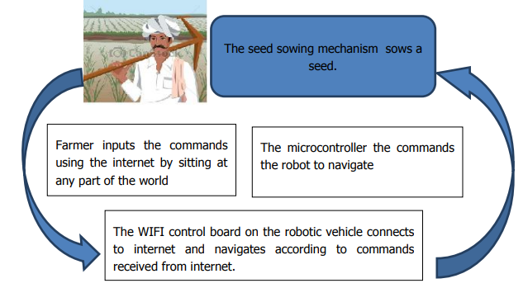

The figure above shows the principle of operation of IOT based seed sowing robotic vehicle. The farmer is provided with a web-based portal for controlling the robot which permits him to control the robot from any part of the world. The robotic vehicle is also equipped with seed sowing mechanism which will help the robotic vehicle to drop the seeds after it navigates by receiving the commands. Thus, this forms an intelligent seed sowing mechanism over the conventional methods of seed sowing.
The entire approach to the project can be divided into the following modules:
1) The Wi-Fi controller module: This is the heart of the project this responsible for taking the input from farmer and processing the input and then taking the decision for robot to travel according to the command received. This is also responsible for stopping the robot and taking turns The Wi-Fi controller used is Node MCU
2) The robotic vehicle: The robotic vehicle forms the integral part of this project. This consists of chassis on which all the parts are incorporated and the drive train which is responsible for sowing of seeds. The drive train consists of D.C geared motors which are driven using electrical energy stored in the battery of the robot.
3) The power unit: The power unit consists of a rechargeable battery which supplies the power for all components of the robotic vehicle. There is also a provision for charging the battery when the battery is discharged.
4) The seed sowing mechanism: The seed sowing mechanism is responsible for sowing the seeds at a particular pitch. It consists of a hopper in which seeds are added and a small plough which digs the field. When the robot stops at particular pitch the seed from the hopper is sowed into the field.
5) The Web application: The internet portal is developed which can help the farmers to command the robot using the internet.

Chapter – 05
DESIGN CALCULATIONS

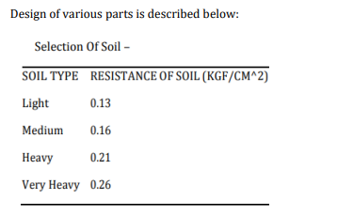

10.1 Design of Plough
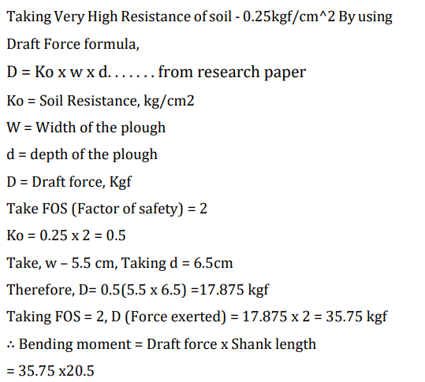
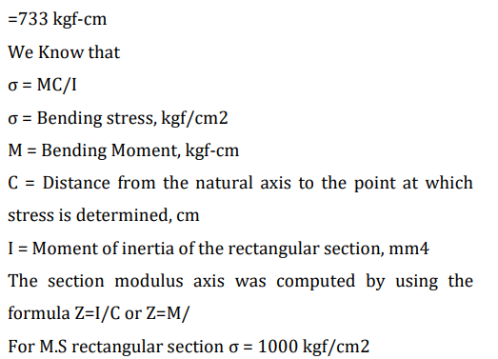
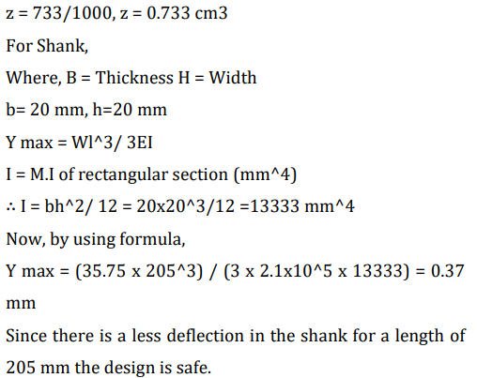

10.2 Design of Shaft:
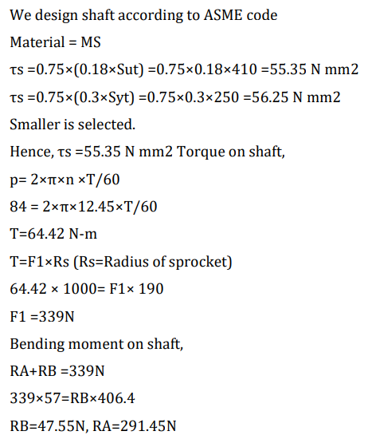
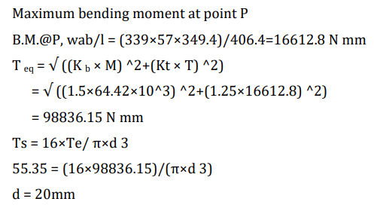
10.3 Bending Stress Calculation of the Rectangular Beam
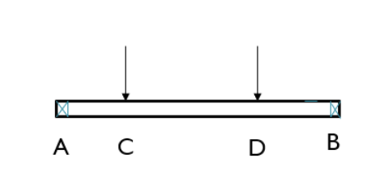
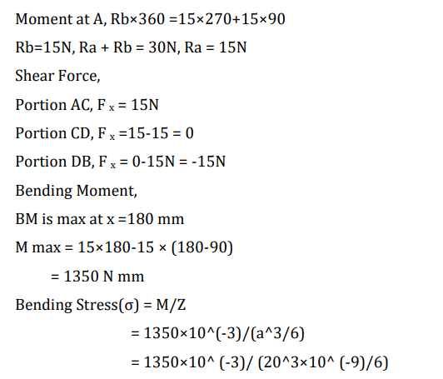
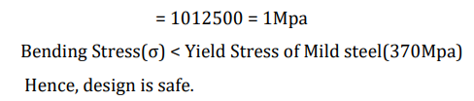
10.4 Design of Chain drive
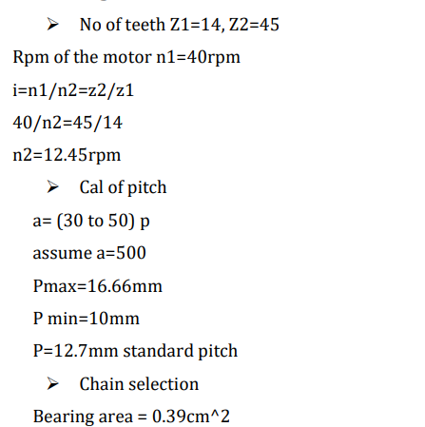
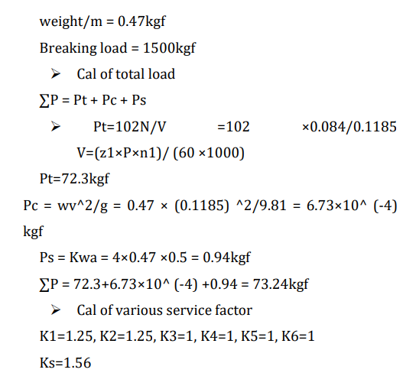
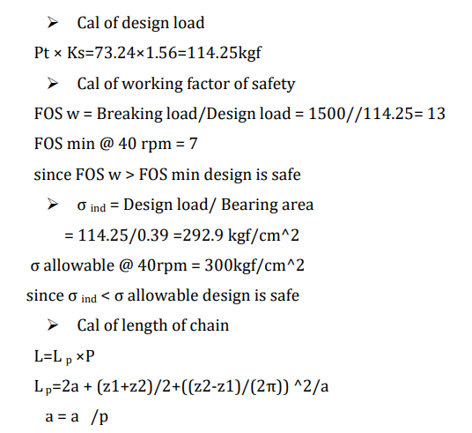
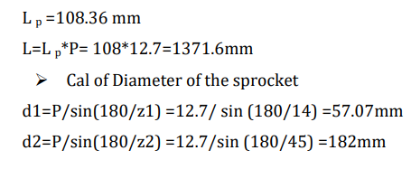

SCOPE AND FUTURE WORKS

1. Further development can be possible using IOT in agricultural sector. Use of electronic control with IOT in agricultural field going to push the limits of engineering streams beyond the conventional methods.
2. Further development can be possible for fertilizer spraying machine, grass cutting machine and other multi-purpose machines.

Chapter – 06
CONCLUSION
IoT-based Seed sowing robot was designed and fabricated to perform ploughing, seed sowing, and levelling operations. The advantages of the seed sowing robot are reducing human intervention, reduces the sowing, ploughing, and levelling time, improves efficiency in sowing and Uniformity will be maintained while placing the seeds in a row with specified distance. This robot is majorly used for the sowing of seeds. In the future, we try to improve the robot and will design a completely autonomous robot without the requirement of human interaction.

REFERENCES
Journal / Conference Papers:
- Abdulrahman, Mangesh Koli, Umesh Kori, Ahmadakbar, “Seed Sowing Robot”, International Journal of Computer Science Trends and Technology (IJCST) – Volume 5 Issue 2, Mar – Apr 2017, ISSN: 2347-8578.
- Vishnu Prakash K, Sathish Kumar, Venkatesh P, Chand ran A,” Design and Fabrication of Multipurpose Agricultural Robot,” International journal of Advanced Science and Engineering Research Volume:1, Issue:1, June 2016, ISSN: 24 55-9288.
- M.Arun, R. Prathipa,Pritanka S, Akshaya Anand, Chandr ika N,” Smart Agricultural Robot”, International Journal of Pure and Applied Mathematics Volume 119 No. 15 2018, 1901-1906, ISSN: 1314-3395.
- Dan Wang, Maofeng Yang, Wu Cheng XUguang Guan, Zhan gming Zhu, Yintang Yang “Novel Low Power Full Adder Cells in 180nm CMOS Technology”, 4th IEEE conference on Industrial Electronics and Applications, pp. 430-433,2009.
- Avula Likitha, B. Mamatha, Agamanthi Sai kiran, Dondeti Pranitha,” IoT Based Smart Agriculture and Automatic Seed Sowing Robot”, International Journal of Resource Manag ement and Technology, ISSN No:0745-6999.
- Blackmore B S, Stout W, Wang M, Runov B. “Robotic agriculture – the future of agricultural mechanisation?” 5th European Conference on Precision Agriculture. The Netherlands, Wageningen Academic Publishers. (2005); 621-628.
- Ko, Albert, Henry YK Lau. “Robot assisted emergency search and rescue system with a wireless sensor network.” International Journal of Advanced Science and Technology. 3, (2009),69-78.
- Drenjanac, Domagoj, Slobodanka Tomic, Juan Agüera, Manuel Perez-Ruiz. “Wi-Fi and SatelliteBased Location Techniques for Intelligent Agricultural Machinery Controlled by a Human Operator.” Sensors. 14(10),( 2014)19767-19784.
- Zanwar, Shrinivas R, Kokate R D. Advanced Agriculture system. IAES International Journal of Robotics and Automation. 1(2), (2012)107-112.
- Liu, Hui, Norbert Stoll, Steffen Junginger, Kerstin Thurow. “A common wireless remote-control system for mobile robots in laboratory.” In IEEE International Instrumentation and Measurement Technology Conference (I2MTC). (2012); pp. 688- 693.
- Mendez, Gerard Rudolph, Subhas Chandra Mukhopadhyay. “A Wi-Fi Based Smart Wireless Sensor Network for an Agricultural Environment”. In Wireless Sensor Networks and Ecological Monitoring. (2013); 247-268.
- Kulkarni V A, Ajit G Deshmukh. “Advanced Agriculture Robotic Weed Control System.” International Journal of Advanced Research in Electrical, Electronics and Instrumentation Engineering. 2 (10), (2013) 5073-5081.
- Jian-sheng, Peng. “An Intelligent Robot System for Spraying Pesticides.” The Open Electrical & Electronic Engineering Journal. 8, (2014), 435-444.
- Shivaprasad B S, Ravishankara M N, Shoba B N. “Design and implementation of seeding and fertilizing agriculture robot.” International journal of application or innovation engineering & management (IJAIEM), 3 (6), (2014).
- Mahesh R, Pundkar A. “Seed sowing machine: A review.” International journal of engineering and social science. 3 (3), (2014) 1-5.
- Manderson, Andrew, Chris hunt. “Introducing the agri- rover: an autonomous on-the-go sensing rover for science and farming e-book”. 1-14, (2013).
- Amol B Rohokale, Pavan D Shewale, Sumit B Pokharkar, Keshav K Sanap, “A review on MultiSeed Sowing Machine.” International Journal of Mechanical Engineering and Technology. 5(2), (2014)180-186.
- Gil-Pinto, Arturo, Philippe Fraisse, Rene Zapata. “Wireless reception signal strength for relative positioning in a vehicle robot formation.” IEEE 3rd Latin American Robotics Symposium LARS' 06, (2006), 100-105.
- Kahar, Saliyah, Riza Sulaiman, Anton Satria Prabuwono, Nahdatul Akma Ahmad, Ashri Abu Hassan M. “A Review of Wireless Technology Usage for Mobile Robot Controller.” In 2012 International Conference on System Engineering and Modeling. 34, (2012), 7-12.
- Sudarshan B T, Namradha, Pradeep, “Wi-Rover: A Wi-Fi Controlled Remotely Operated Video Enhanced Receiver.” International Journal of Computer Applications. 56(7), (2012), 1-9.
- Moro, Shashank U. “WIFI Enabled Smart robot.” Conference: Science, Engineering and Technology. (2013), 1-5.
- Gaikwad, Kunal Borker-Rohan. “Wireless Controlled Surveillance Robot”. International Journal of Advance Research in Computer Science and ManagementStudies. (2014), 2321-7782.
- Sun, Yuxiang, Ming Liu, Max Q-H Meng. “WiFi signal strength-based robot indoor localization.” In IEEE International Conference on Information and Automation (ICIA). (2014), 250-256.
- Won-Shik Na, Seok-Hoon Kim. “An efficient data forwarding scheme for internet of things in Wi-Fi networks.” Indian Journal of Science and Technology. 8(1), (2015), 112-117.
- Muthiah M, Nirmal K, Sathiendran RK. “Low-cost radio frequency-controlled robot for environmental cleaning.” In International Conference on Circuit, Power and Computing Technologies (ICCPCT). (2015), 1-5.
- Ersahin, Gonca, Herman Sedef. “Wireless Mobile Robot Control with Tablet Computer.” Procedia Social and Behavioral Sciences. 195, (2015), 2874- 2882.
- Mohammed Saquib Khan, Ataur Rehman Khan, Altamash Khan, Akmal Kalia, Lochan Bisne. “WI-FI Based Robot Controlling by Webpage Interface and Video Monitoring.” International Journal of Emerging Technology and Advanced Engineering. 5(4), (2015), 2250-2459.
- Dnyanesh Jalamkar, Arockia Selvakumar A. “Use of Internet of Things in a Humanoid Robot”
- Skansholm, Jan (2000). Vägen till C [The road to C] (in Swedish). Studentlitteratur. pp. 237–774. ISBN 91- 44-01468-6.
- Pankaj Kumar, G. Ashok (2020), “Design and fabrication of smart seed sowing robot”, Elsevier.
- M.ARUN, R. PRATHIPA, PRIYANKA S, AKSHAYA ANAND, CHANDRIKA N (2018), “SMART AGRICULTURE ROBOT”, International Journal of Pure and Applied Mathematics, Volume 119 No. 15 2018, 1901-1906.
- T. Blender, T. Buchner, B. Fernandez, B. Pichlmaier and C. Schlegel, "Managing a Mobile Agricultural Robot Swarm for a seeding task, "IECON 2016 - 42nd Annual Conference of the IEEE Industrial Electronics Society, Florence, 2016, pp. 6879-6886.
- V. Santhi, Kapileswar, Venkata Siva Prasad. CH, Vijay K. R, “Sensor and Vision based Autonomous AGRIBOT for Sowing seeds”, IEEE, 2017, Page No. 242-245

