1. First download the sample input file and configuration file in [this folder](https://drive.google.com/drive/folders/1l-WOLd1KW7yYFUMW3VShpUxd8I9w0uTC), to understand their specific format.

* DQGen will generate a question for every sentence or paragraph between two blank line, so make sure to add a blank line after a sentence or a paragraph in the input file.
* There are many parameters in the configuration file:

1. context_lines: the maximum number of lines in the context to generate the question.
2. min_context_words: the minimum number of words in the context.
3. ungram_kid_words: the maximum number of words in ungrammatical distractor candidate list, which is generated from noun list, verb list, adj list, etc. in the resource directory. And filter out some unqualified words.
4. input_ungram_distractors: the number of ungrammatical distractor candidates as input per filter.
5. output_ungram_distractor: the number of ungrammatical candidate passed through per filter.
6. ungram_num: the maximum number of ungrammatical distractors in a question.
7. nonsen_kid_words: the maximum number of words in nonsensical distractor candidate list.
8. input_nonsensical_distractors: the number of nonsensical distractor candidates as input per filter.
9. output_nonsensical_distractor: the number of nonsensical candidate passed through per filter.
10. nonsen_num: the maximum number of nonsensical distractors in a question.
11. plau_kid_words: the maximum number of words in plausible distractor candidate list.
12. input_plau_distractors: the number of plausible distractor candidates as input per filter.
13. output_plau_distractor: the number of plausible candidate passed through per filter.
14. output_plau_distractor: the number of plausible candidate passed through per filter.
15. plau_num: the maximum number of plausible distractors in a question.
16. Submit DQGen request from DQGen website:

* Upload an input file: make sure that there is a blank line after every sentence or paragraph, so that DQGen can generate question for every sentence or paragraph in the input file.
* Upload a configuration file: change parameters in the default configuration file if you want, so that you can make your own setting for DQGen.
* Enter your own email address and submit the DQGen request.

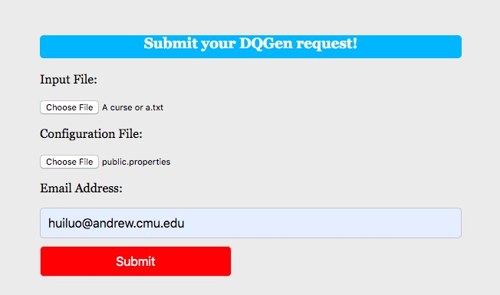

1. After submitting the request, you should wait for a few minutes for DQGen to process the request. After DQGen finish processing a request, it will send an email with the output file as an attachment to the corresponding email address.



A generated question will occupy five lines in an output file:

* + 1. The first line is the question (file name, sentence, question)
    2. The second line is the correct answer
    3. The third line are ungrammatical distractors
    4. The fourth line are nonsensical distractors
    5. The fifth line are plausible distractors

Note that for a question, DQGen may not be able to generate any distractor of a certain type, and that line will be a blank line.

You can refer to the sample output file to see its format for question and distractors.