**rqt_plot**

rqt_plot provides a GUI plugin visualizing numeric values in a 2D plot using different plotting backend .

**Installation**

$ sudo apt-get install ros-kinetic-rqt

$ sudo apt-get install ros-kinetic-rqt-common-plugins

**OR**

$ rosdep install rqt_plot

**How to RUN**

$ rqt_plot

To specify topic(s) to plot, you need full path name of the topics published. You can find them easily for instance by the command below:

$ rostopic list

/rosout # these are only example topics.

/rosout_agg

/turtle1/cmd_vel

/turtle1/color_sensor

/turtle1/pose

There are two ways to give the topic names to rqt_plot as explained in following sections. In both ways, topics that are set in previous run is resumed (as far as the program was shut down without error).

Both of the following lines plot the same topics.

$ rqt_plot /turtle1/pose/x:y:z

$ rqt_plot /turtle1/pose/x /turtle1/pose/y /turtle1/pose/z

Reference : <http://wiki.ros.org/rqt_plot>

**In this example**, we are interfacing Accelerometer ADXL 335 to Arduino Mega through ADC pins and plotting the values using the ROS tool called rqt_plot.

The preceding code will publish the ADC values of X, Y, and Z axes in a topic called

/adc. The code uses the rosserial_arduino::Adc message to handle the ADC value. We can plot the values using the rqt_plot tool.

Following is the command to plot the three axes values in a single plot:

$ rqt_plot adc/adc0 adc/adc1 adc/adc2

Next is a screenshot of the plot of the three channels of ADC:

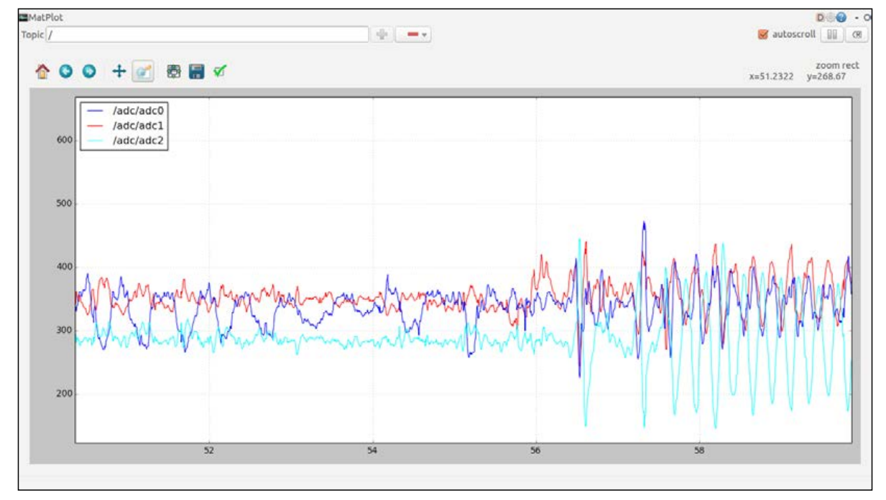

Reference : Mastering ROS for robotics programming "BOOK"