ROBOCUP YOLO AI MODEL

INTRODUCTION
This document is going to describe the path of creating an own AI model for object detection.

The main source is this video, which describes precise way of creating a model: https://youtu.be/r0RspiLG260?si=lUBlRGLYkdQrThXx

DEVELOPMENT

PREPARATION
First of all it is necessary to download Anaconda Command Prompt or Anaconda Manager and then start Anaconda Command Prompt. The second thing is Label Studio. It is open source software for marking boxes of an object on the photos.
The further work will be done in an environment. The one that I have, I called yolo-env1 (as in the video). In this environment we’ll be working. Than installing all libraries that are needed. Starting Label Studio localy and start the work

THE ACTUAL WORK
The most important part of training is the good quality images. For a normal working Model it is almost necessary to have at least 200 pictures. Those are obviously have to be taken in different states, where all possibilities will be pictured.
There are some examples:
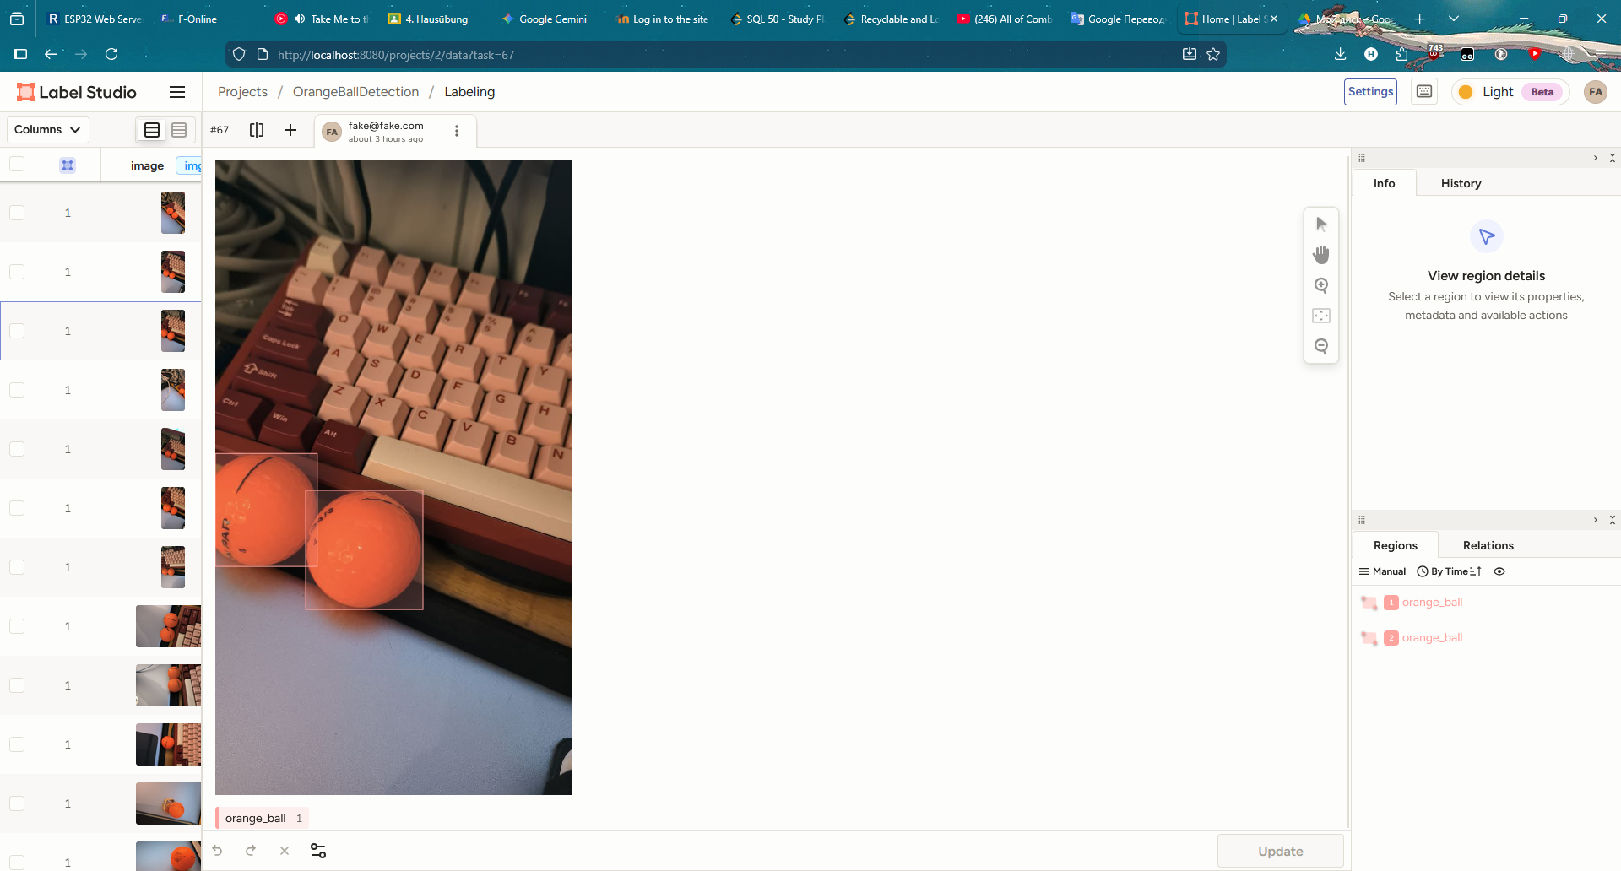

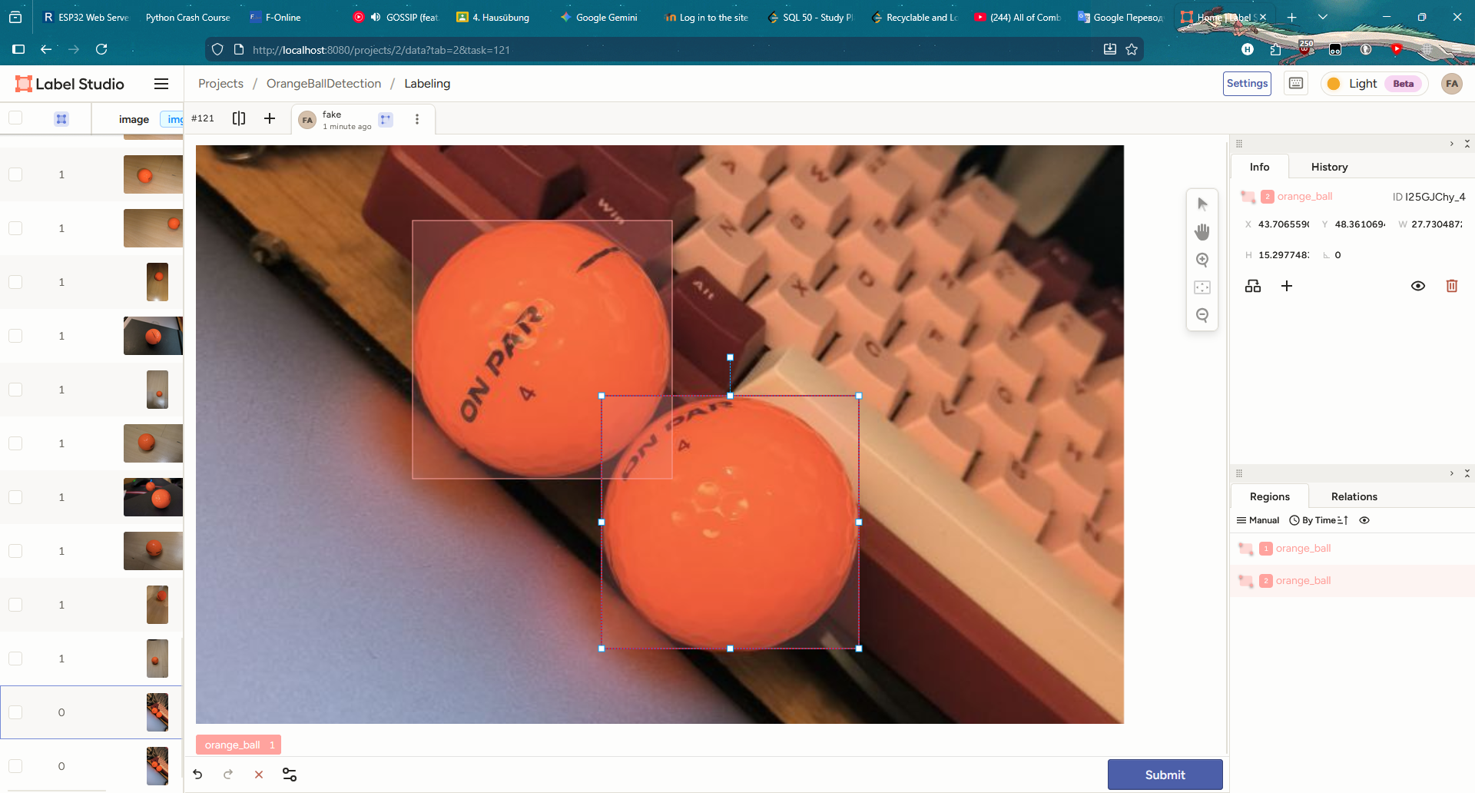

After marking everything it is important to import it with YOLO with images:
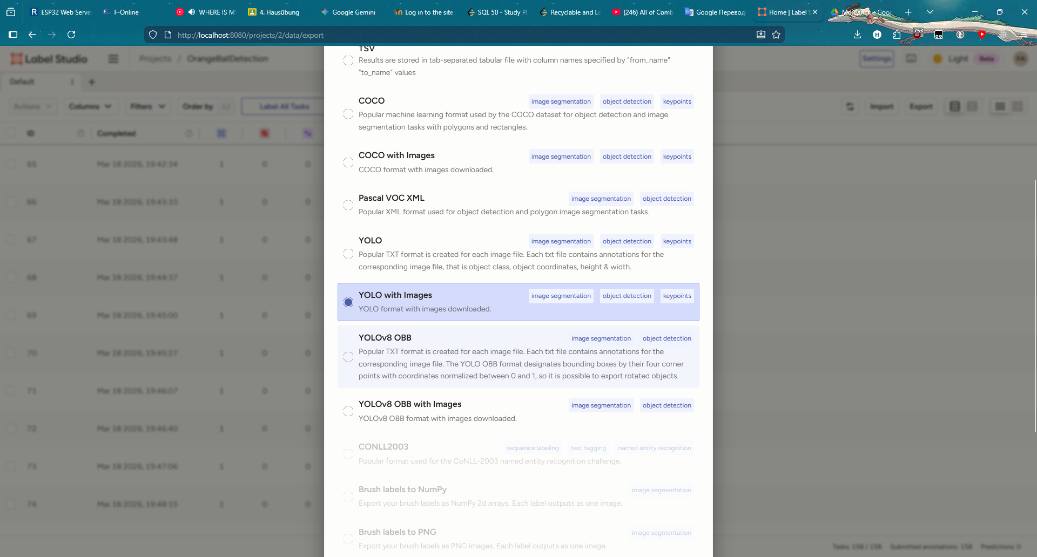

The steps after that are very straight forward. There is Google Colab link in the video description for training your AI model with external tools from Google.
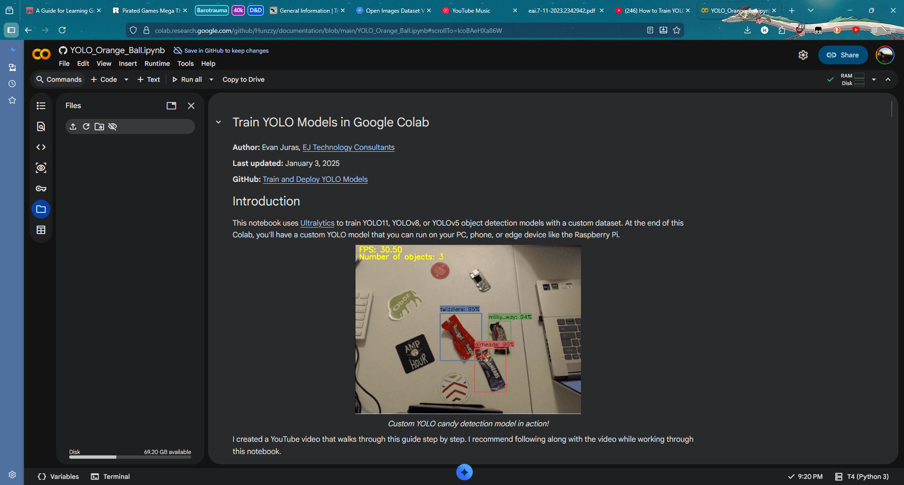

After that you download your finished model and run as written on your computer. In the guide there is only description for Nvidia Graphic Cards and nothing about AMD. So with help of AI a program was created that bypasses it. The program is called “yolo_directml_AMD_type.py”

The command for running:
python yolo_directml_AMD_type.py --model my_model.pt --source usb0 --resolution 640x480

The data set be also provided as well

And Observe
