

Biweekly Report (Week 2): MEPS Panel 18 Non-Cancer Adult Cohort (2013-2014)
ALY 6980: Capstone, Northeastern University
Professor Ajit Appari
From Khanh Huynh

Abstract
This biweekly discussion deliverable extends the XN capstone project by completing cohort construction and exploratory analysis using the Medical Expenditure Panel Survey (MEPS) Panel 18 longitudinal file (2013-2014) and associated medical conditions files. I restricted the sample to adult (AGE1X >=18) and excluded individuals with any cancel diagnosis identified through Clinical Classification Codes (CCCODEX 11-45). I cleaned MEPS missing-value codes by converting negative values to missing, applied simple imputation, and adjusted expenditures to 2018 constant dollars using the CPI-U Medical Care Index. Descriptive results showed a right-skewed Year 2 expenditure distribution with a small high-spending segment, motivating a log-transformed target and a top 20% high-expenditure flag for downstream risk stratification. This report documents the finalized analytic dataset, key cohort characteristics, and initial visual summaries will support subsequent clustering and predictive modeling.

Introduction
This project evaluates healthcare utilization and expenditures among US adults without cancer using MEPS Panel 18 (2013-2014). The analytic goal is to support rick classification and patient segmentation by predicting Year 2 total expenditures (TOTEXPY2) from baseline demographic, insurance, and health status indicators.

Research Methods
I used the MEPS Panel longitudinal full-year consolidated file (HC 172) and linked the 2013 and 2014 medical conditions files (HC-162 and HC-170) via DUPERSID. I restricted the cohort to adults (AGEY1X >= 18). I excluded cancer cases using CCCODEX values 11-45 from either conditions file. I converted negative MEPS codes to missing values, imputed numeric variables with medians and categorical variables with modes, and normalized expenditures to 2018 constant dollars using CPI-U Medical Care annual averages. I created a log-transformed target ln (TOTEXPY2 +1) and a binary high-expenditure indicator defined as the top 20% of Year 2 spending.

Analysis Results
Table 1 summarizes cohort construction. After applying the adult restriction and cancer exclusion, the final analytic cohort includes one record per individual. Figure 1 shows the log-transformed Year 2 spending distribution. Figure 2 shows the expenditure spread using a boxplot with outliers hidden for readability. Figure 3 summarizes baseline insurance coverage categories and provides context for downstream segmentation.
Table 1. Cohort construction summary
Step | N
Original Panel 18 Sample (HC-172) | 16714
Adult Filter (AGEY1X >= 18) | 11691
Exclude cancer (CCCODEX 11-45) | 855
Final analytic cohort | 10836

Figure 1. Distribution of Year 2 Healthcare Expenditures (Log Scale)
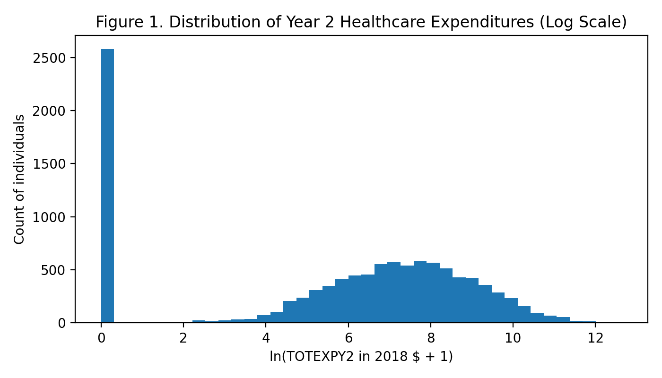

Figure 2. Year Expenditure Distribution (Boxplot, Outliers Hidden)
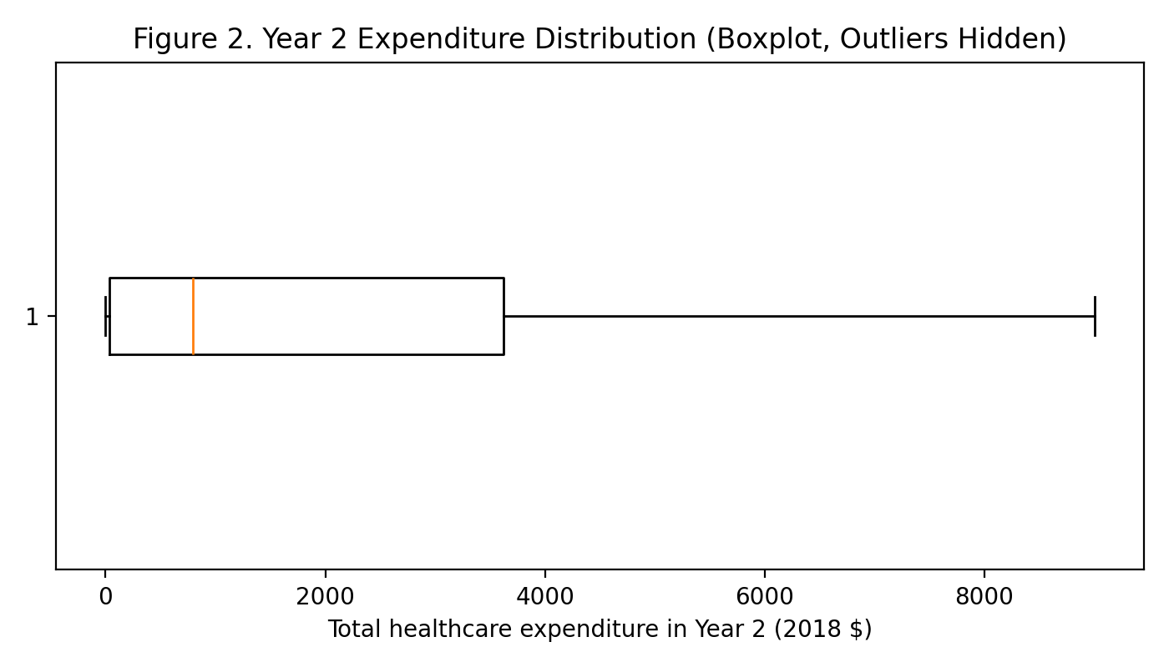

Figure 3. Baseline Insurance Coverage Distribution (Year 1)
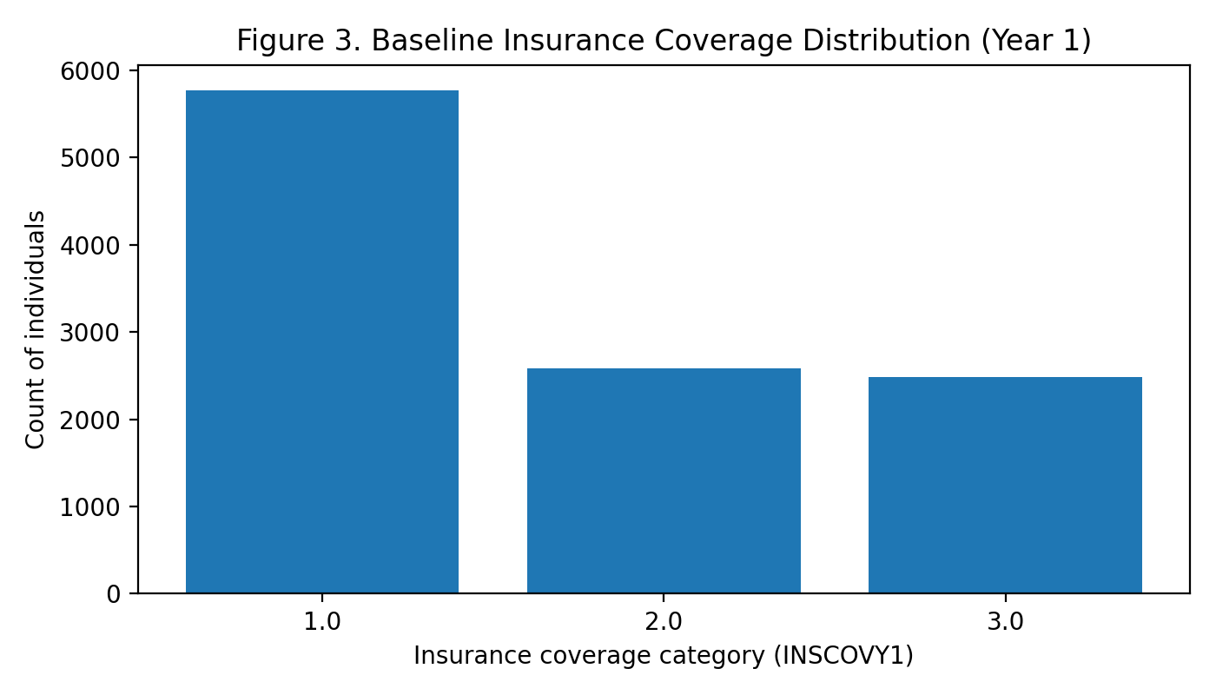

Conclusion
This Bi-weekly discussion completed a reproducible cohort built for adult, non-cancer MEPS Panel 18 respondents and produced initial descriptive outputs. The prepared analytic dataset includes Year 2 total expenditure in 2018 dollars and baseline predictors needed for subsequent clustering and predictive modeling. Next steps will compare candidate modeling approaches and evaluate segment-level differences in utilization and spending.

References
Wang, J., & Shi, L. (2020). Prediction of medical expenditures of diagnosed diabetics and the assessment of its related factors using a random forest model, MEPS 2000–2015. International Journal for Quality in Health Care, 32(2), 99–112. https://doi.org/10.1093/intqhc/mzz135
Federal Reserve Bank of St. Louis. (n.d.). Consumer Price Index for All Urban Consumers: Medical care in U.S. city average (CPIMEDNS) [Data set]. FRED. https://fred.stlouisfed.org/series/CPIMEDNS

