MEPS Healthcare Cost Prediction:
Multi-Stage Risk Modeling Approach
Identifying Hidden Risers Through Step-wise Supervised Learning
ALY6980 Capstone Project
Northeastern University
January 2026

Table of Contents
1. Introduction
2. Research Methods
2.1 Data Sources
2.2 Data Processing Pipeline
2.3 Feature Engineering
2.4 Modeling Approach
3. Analysis Results and Discussion
3.1 Exploratory Data Analysis
3.2 Patient Clustering Analysis
3.3 Stage 1 Model Performance
3.4 Feature Importance Analysis
4. Conclusion
5. References
Appendix A: Supplementary Tables
Appendix B: Additional Figures

1. Introduction
Healthcare expenditure prediction is a critical challenge for insurers, healthcare systems, and policymakers. Traditional actuarial models rely primarily on historical spending patterns, often failing to identify patients who transition from low-cost to high-cost status—the so-called "Hidden Risers." This study addresses this gap by developing a multi-stage predictive modeling framework using the Medical Expenditure Panel Survey (MEPS) longitudinal data.
The primary objective of this research is to predict Year 2 healthcare expenditure using only Year 1 features, with particular emphasis on identifying patients at risk of sudden cost escalation. Unlike binary classification approaches that oversimplify the prediction task, our methodology employs a three-tier risk classification system (Stable, Rising, Shock) that provides more actionable insights for healthcare intervention planning.
This project builds upon and significantly enhances a previous iteration (archive_v1) with the following key improvements:
- Expanded Data Coverage: Extended from Panels 18-21 (2013-2016) to Panels 18-23 (2013-2019), providing 60,602 patient records after filtering.
- Enhanced Feature Engineering: Added 9 medication-derived features from Prescribed Medicines files, including polypharmacy indicators and drug class flags.
- Improved Clustering Analysis: Upgraded from simple K-Means to a combined approach using Elbow method, Silhouette validation, and DBSCAN for outlier detection.
- Multi-Class Risk Tiers: Moved from binary classification to a 3-tier system providing more granular risk stratification.
- Interpretability Enhancements: Added SHAP analysis capability for feature importance explanation and individual prediction interpretation.

2. Research Methods

2.1 Data Sources
This study utilizes data from the Medical Expenditure Panel Survey (MEPS), conducted by the Agency for Healthcare Research and Quality (AHRQ). MEPS is the most comprehensive source of data on healthcare costs and utilization in the United States, featuring a longitudinal panel design that tracks individuals over two consecutive years.
The following MEPS data files were integrated for this analysis:
File Type | File IDs | Description
Longitudinal | h172, h183, h193, h202, h210, h217 | Panel-specific Y1→Y2 tracking
Medical Conditions | h162, h170, h180, h190, h199, h207 | Diagnosis codes (ICD-9/ICD-10)
Prescribed Medicines | h160a, h168a, h178a, h188a, h197a, h206a | Medication records with therapeutic class

2.2 Data Processing Pipeline
The data processing pipeline was designed to create a modeling-ready dataset while preventing data leakage from Year 2 information into Year 1 features. The following steps were implemented:
Cohort Selection Criteria:
- Adults only: AGE_Y1 ≥ 18 years
- Cancer exclusion: Patients with CANCER_Y1 = 1 were removed to avoid confounding from known high-cost conditions
- Complete data: Required valid Year 1 and Year 2 expenditure records
This filtering reduced the initial 93,854 records to 60,602 patients in the final cohort.

2.3 Feature Engineering
A comprehensive set of 40+ features was engineered from the raw MEPS data, organized into the following categories:
- Demographics: Age, sex, race, marital status, poverty category, insurance coverage
- Health Status: Self-reported mental health (MNHLTH_RD1), physical health (RTHLTH_RD1), mental health trajectory
- Chronic Conditions: Diabetes, hypertension, and cholesterol diagnosis flags; chronic disease count
- Healthcare Utilization: ER visits, inpatient stays, office visits, prescription fills
- Condition Complexity: Total diagnoses count, ill-defined condition count (ICD R-codes as 'undiagnosed signals')
- Medication Patterns: Unique drug count, total Rx cost, polypharmacy flag (≥5 drugs), therapeutic class indicators

Inflation Adjustment: All cost variables were adjusted to 2025 dollars using CPI factors to enable cross-year comparisons.

2.4 Modeling Approach
The modeling framework employs a multi-stage supervised learning architecture designed to capture latent risk factors while maintaining clinical interpretability.
Target Variable Definition:
The continuous Year 2 expenditure was transformed into a three-tier risk classification:
- Stable (Tier 0): COST_Y2_ADJ ≤ 75th percentile
- Rising (Tier 1): 75th < COST_Y2_ADJ ≤ 90th percentile
- Shock (Tier 2): COST_Y2_ADJ > 90th percentile

Models Benchmarked: Four classification algorithms were evaluated—Logistic Regression, Random Forest, XGBoost, and Gradient Boosting—using temporal validation (earlier panels for training, later panels for testing).

3. Analysis Results and Discussion

3.1 Exploratory Data Analysis
Initial exploration revealed significant heterogeneity in healthcare spending patterns. The "Hidden Risers" analysis identified 462 patients (0.8% of cohort) who transitioned from below-median Year 1 costs to above-90th-percentile Year 2 costs—representing the primary target for early intervention.
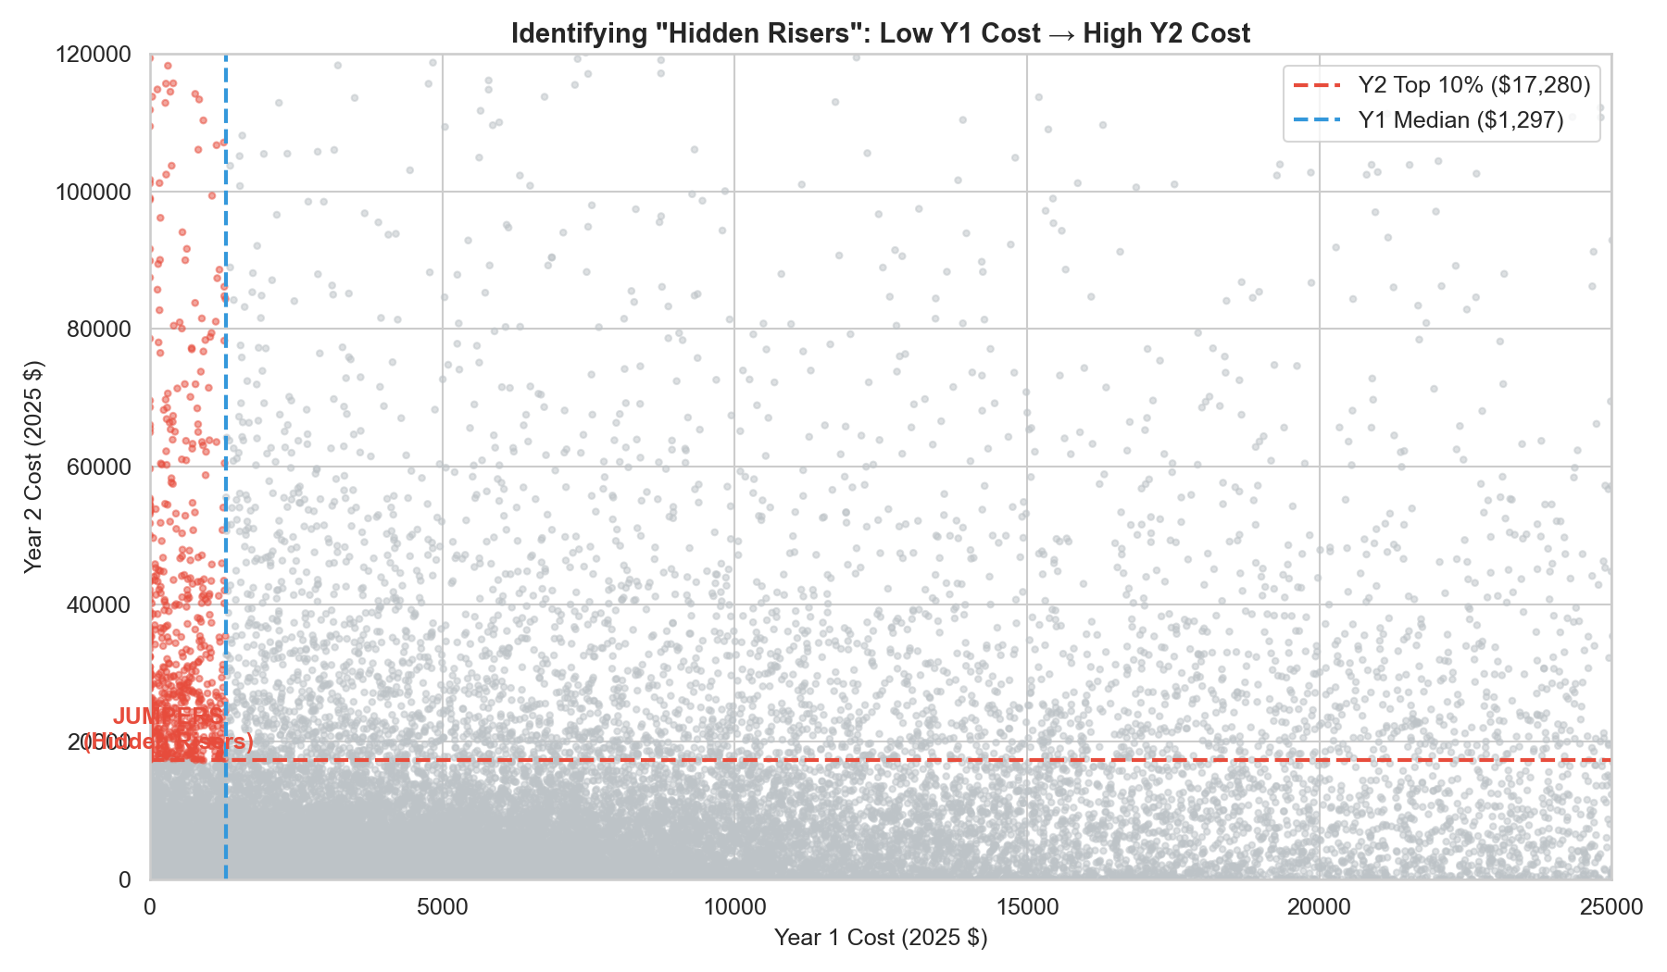
Figure 1: Identifying Hidden Risers: Year 1 vs Year 2 Healthcare Expenditure

As shown in Figure 1, Hidden Risers (red points) cluster in the lower-left region of Year 1 costs but extend vertically into high Year 2 expenditures, demonstrating that traditional cost-based risk stratification would miss these patients.
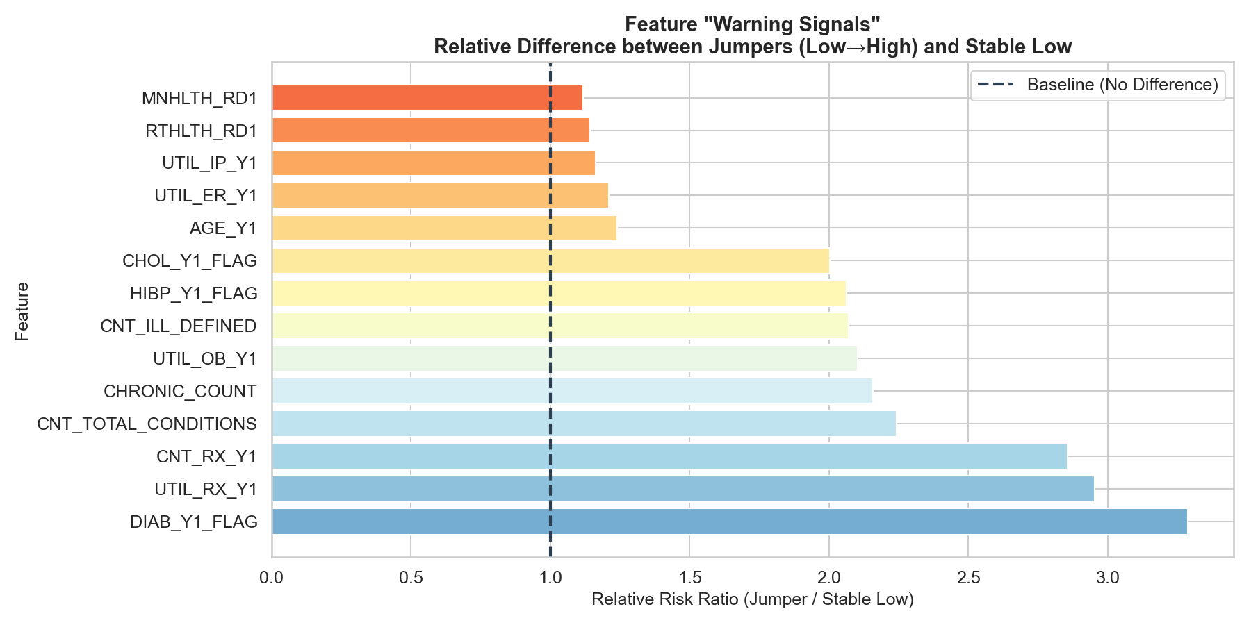
Figure 2: Feature Warning Signals: Relative Risk Ratios for Hidden Risers vs Stable Patients

Figure 2 presents the relative risk ratios comparing Hidden Risers to Stable Low patients. Key findings include: inpatient utilization (3.2x higher), prescription count (2.9x), chronic disease count (2.2x), and office visits (2.1x). These ratios suggest that utilization intensity, rather than cost alone, serves as an early warning signal.

3.2 Patient Clustering Analysis
Unsupervised clustering was employed to identify distinct "Care Phenotypes"—patient segments with similar healthcare utilization patterns. Both K-Means and DBSCAN algorithms were applied and compared.
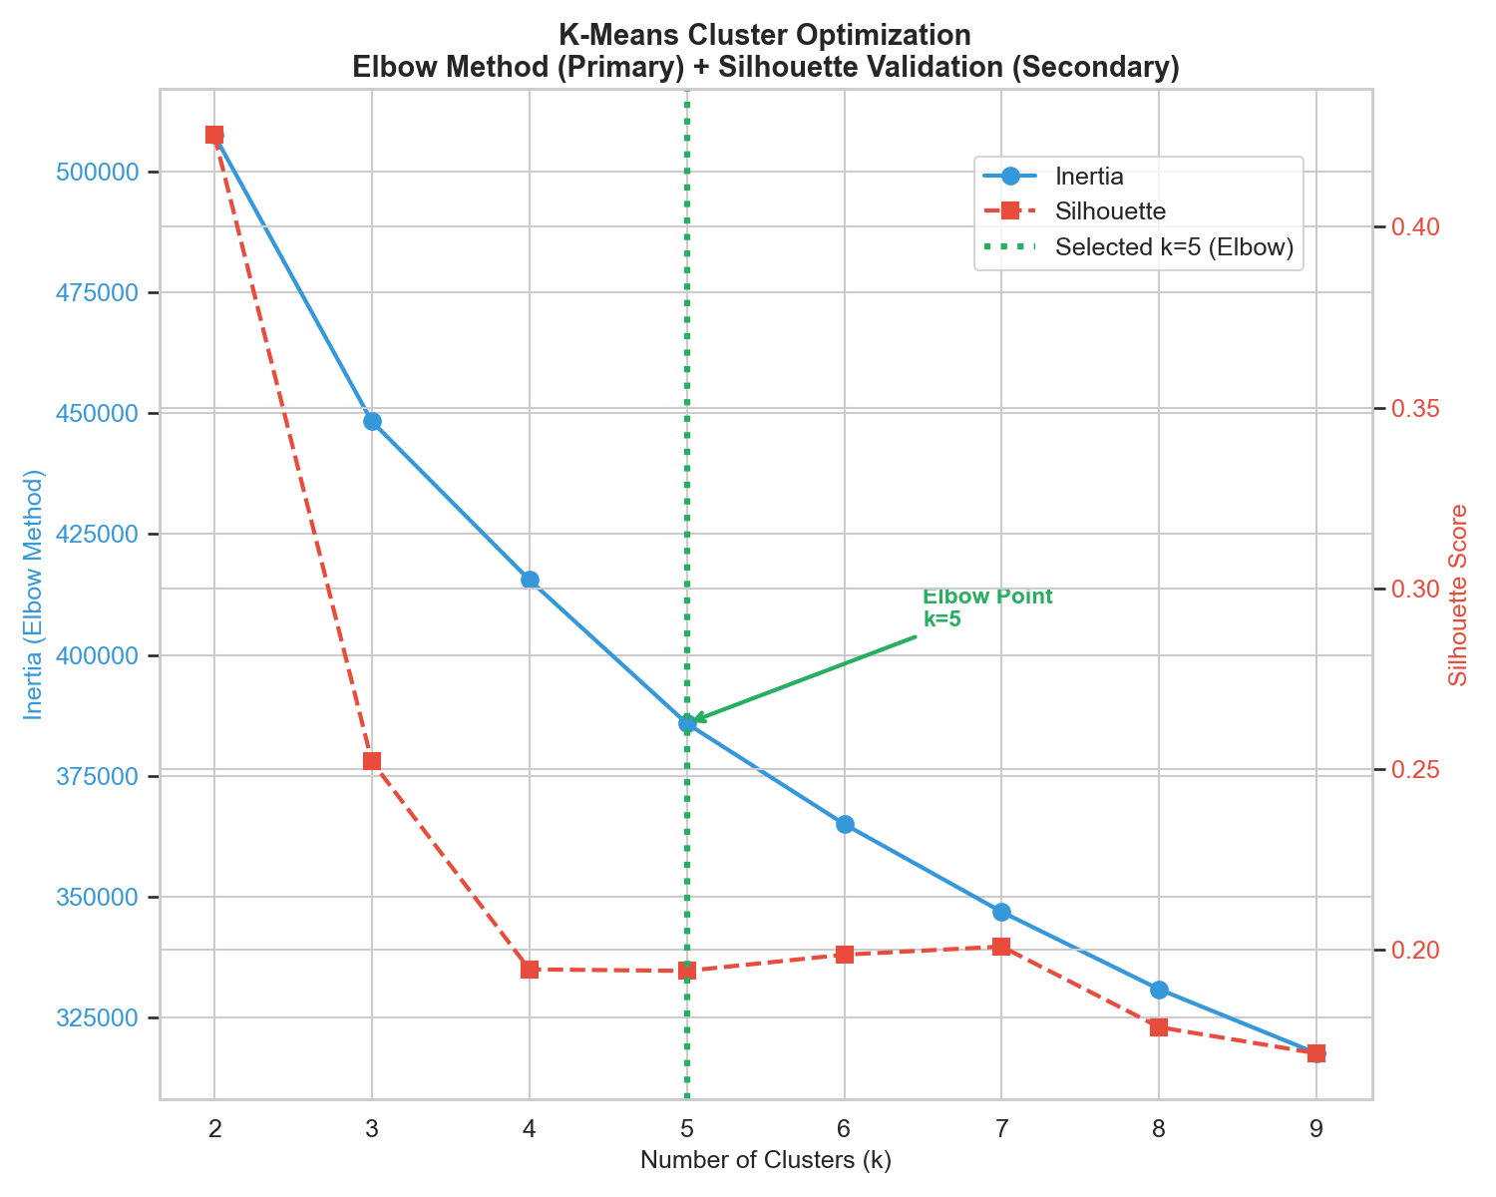
Figure 3: K-Means Cluster Optimization: Elbow Method with Silhouette Validation

Figure 3 shows the cluster optimization process. The Elbow method indicated k=5 as the optimal number of clusters, balancing model complexity with interpretability. Silhouette scores remained acceptable (>0.19) across this range.
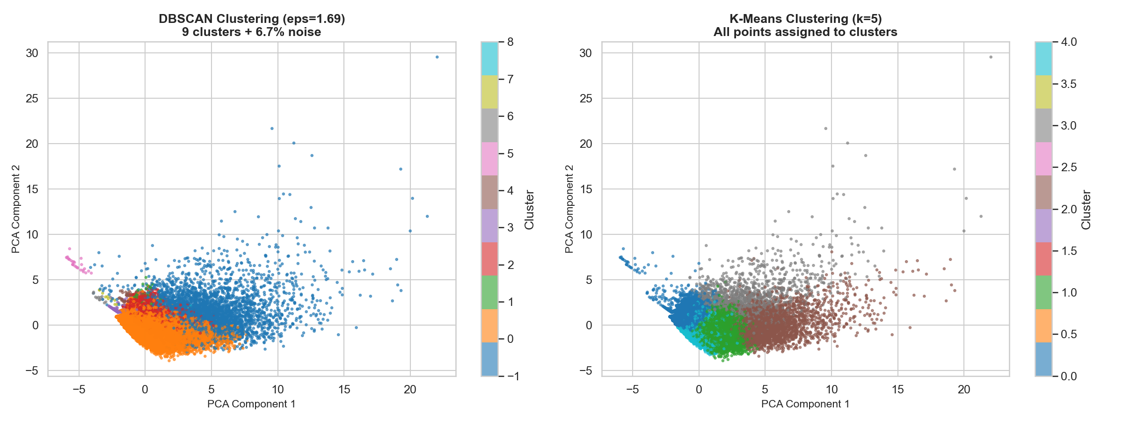
Figure 4: Comparison of DBSCAN and K-Means Clustering Results (PCA Visualization)

Figure 4 compares DBSCAN and K-Means results. DBSCAN identified 6.7% of patients as noise points (outliers), which may represent atypical high-risk individuals warranting individual review. K-Means assigned all patients to clusters, providing comprehensive segmentation for population health management.
Table 1: K-Means Cluster Profiles: Mean Feature Values by Cluster
CARE_CLUSTER | AGE_Y1 | UTIL_ER_Y1 | UTIL_IP_Y1 | UTIL_OB_Y1 | UTIL_RX_Y1 | CNT_RX_Y1 | CNT_TOTAL_CONDITIONS | CNT_ILL_DEFINED | CHRONIC_COUNT | MNHLTH_RD1 | RTHLTH_RD1 | COST_Y2_ADJ | COUNT
0.0 | 37.912955465587046 | 0.1019248526173734 | 0.0340223027203636 | 2.576390368634136 | 2.296505433624547 | 1.7713260885006037 | 1.355138859293984 | 0.0902052702606719 | 0.1861637900419064 | 1.3084736131827543 | 1.530932594644506 | 3033.010567156758 | 28158.0
1.0 | 61.65885511136908 | 0.1934992381919756 | 0.0663135746934629 | 7.957991728941449 | 19.415729521874773 | 14.857868388594646 | 4.790974388739752 | 0.3111078865268809 | 1.7299571936443443 | 2.1505477762461003 | 2.74780526735834 | 11227.536865704127 | 13783.0
2.0 | 59.86670547147846 | 0.4889406286379511 | 0.1929569266589057 | 22.006111757857976 | 68.96565774155995 | 67.38358556461002 | 12.493306169965075 | 1.4839930151338765 | 1.7919091967403955 | 2.8373108265424913 | 3.533469150174622 | 26512.49616996508 | 3436.0
3.0 | 54.72157622739018 | 2.453488372093023 | 1.7151162790697674 | 15.58720930232558 | 31.64405684754522 | 24.797157622739014 | 8.089147286821705 | 0.9031007751937984 | 1.2739018087855296 | 2.5717054263565893 | 3.328811369509044 | 23292.041841085273 | 1548.0
4.0 | 38.88477005191197 | 0.1816187760473788 | 0.0442348468231337 | 3.2486656430503764 | 4.24691087226731 | 2.983549023908752 | 1.8778240842289975 | 0.1172771806682752 | 0.3212692841997514 | 2.9088250347298383 | 3.1792790816699568 | 4131.553659428237 | 13677.0

Table 1 presents the cluster profiles, revealing distinct care phenotypes ranging from low-utilization 'Healthy' clusters to high-complexity 'Chronic Disease Management' clusters with elevated costs.

3.3 Stage 1 Model Performance
Four machine learning models were trained and evaluated using temporal validation. Performance metrics included Macro F1 (balanced class performance), Weighted F1 (overall accuracy), and ROC-AUC (discrimination ability).
Table 2: Stage 1 Model Benchmark: Performance Comparison Across Algorithms
Model | Accuracy | F1 (Macro) | F1 (Weighted) | ROC-AUC (OvR)
Random Forest | 0.6836288028014883 | 0.5688594928620809 | 0.708795624210255 | 0.8316258902865473
Logistic Regression | 0.682315605165244 | 0.5469499563360036 | 0.7015886731837097 | 0.8048901780085912
XGBoost | 0.7618734952943751 | 0.5390851559544095 | 0.728075857080945 | 0.8342562781599757
GradientBoosting | 0.759465966294594 | 0.5341107122678476 | 0.7255634934154244 | 0.8325375209993795

Table 2 shows Random Forest achieved the highest Macro F1 (0.57) and strong balanced performance across all metrics, making it the selected model for Stage 1 risk tier classification.
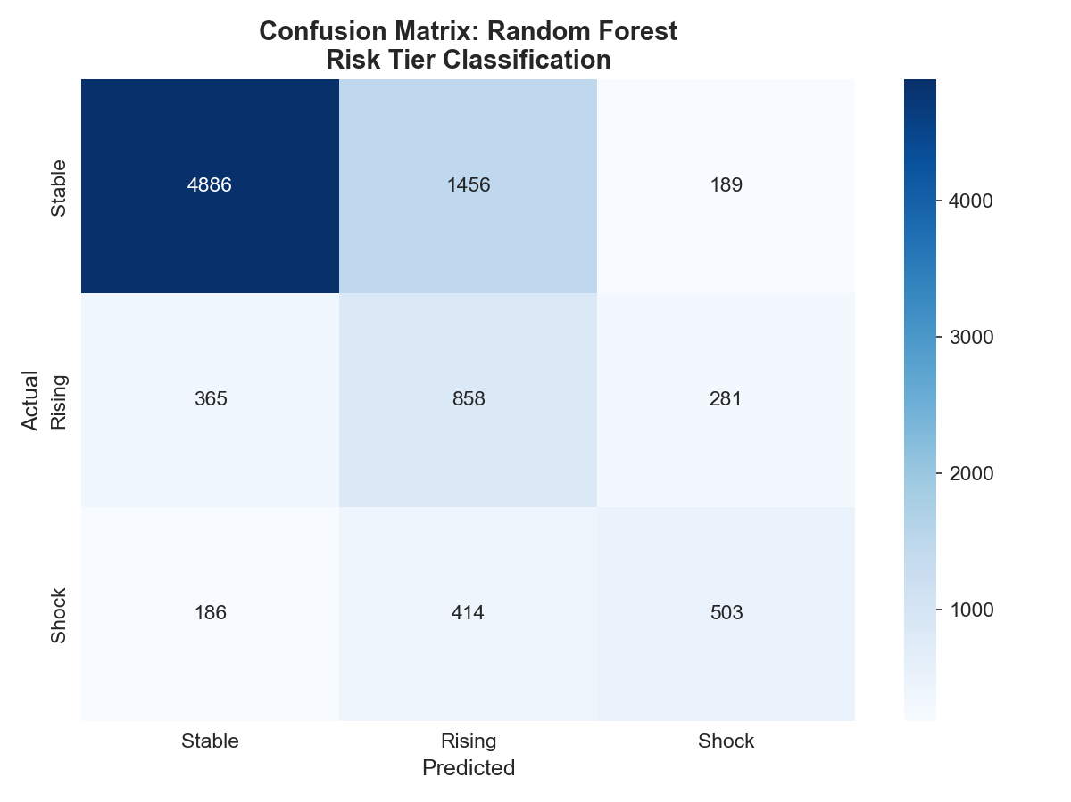
Figure 5: Confusion Matrix for Random Forest Risk Tier Classification

Figure 5 displays the confusion matrix for the best-performing model. Key observations:
• Stable tier: 75% recall (4886/6531), with some misclassification to Rising tier
• Rising tier: 57% recall (858/1504), the most challenging class to predict
• Shock tier: 46% recall (503/1103), critical for high-cost intervention targeting
The model demonstrates reasonable discrimination while highlighting the inherent difficulty of predicting cost escalation transitions.

3.4 Feature Importance Analysis
Feature importance analysis reveals which Year 1 characteristics most strongly predict Year 2 risk tier assignment. Both Gini importance and permutation importance methods were applied.
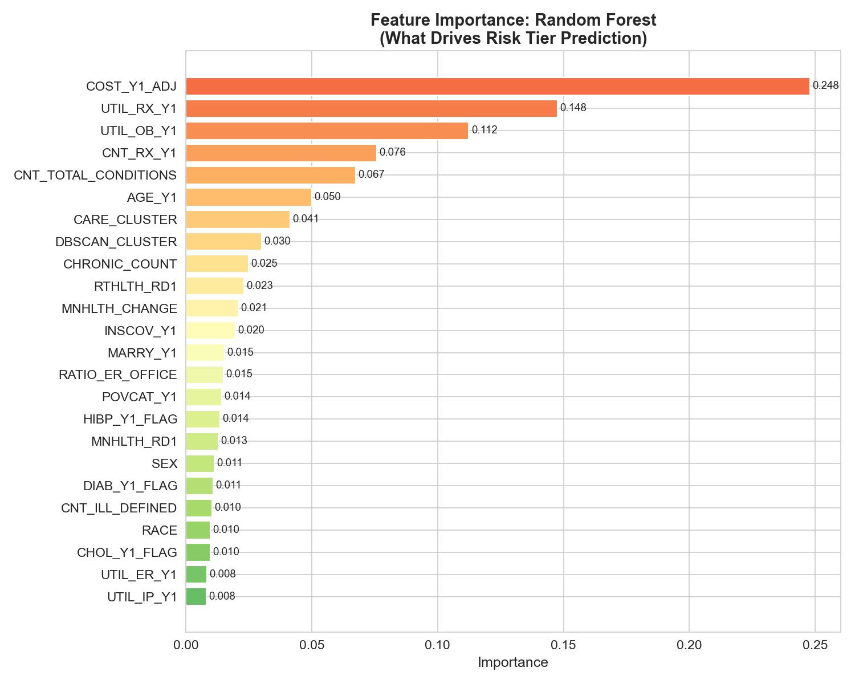
Figure 6: Top 15 Features by Importance for Risk Tier Prediction

Table 3: Feature Importance Scores (Top Features)
Feature | Importance
UTIL_IP_Y1 | 0.0081688456996299
UTIL_ER_Y1 | 0.0083015840826369
CHOL_Y1_FLAG | 0.0096706895254078
RACE | 0.0097457655764201
CNT_ILL_DEFINED | 0.0103174704023958
DIAB_Y1_FLAG | 0.010768554103046
SEX | 0.0113246466490733
MNHLTH_RD1 | 0.0128273070965009
HIBP_Y1_FLAG | 0.013591744405502
POVCAT_Y1 | 0.0143290495182375
RATIO_ER_OFFICE | 0.0148407021191345
MARRY_Y1 | 0.0152941216844208
INSCOV_Y1 | 0.0195856142238659
MNHLTH_CHANGE | 0.0208911666326349
RTHLTH_RD1 | 0.0230040719172552
CHRONIC_COUNT | 0.0248102243156574
DBSCAN_CLUSTER | 0.0300717721817011
CARE_CLUSTER | 0.0414605433191171
AGE_Y1 | 0.0500146352030103
CNT_TOTAL_CONDITIONS | 0.0673814118443774
CNT_RX_Y1 | 0.0758785490256734
UTIL_OB_Y1 | 0.1123946044262242
UTIL_RX_Y1 | 0.1475277873194558
COST_Y1_ADJ | 0.2477991387286208

Figure 6 and Table 3 reveal the most predictive features:
1. COST_Y1_ADJ (Year 1 expenditure): The strongest predictor, confirming that prior cost remains informative despite our focus on "Hidden Risers"
2. Polypharmacy indicators: Patients with 5+ medications show elevated risk, consistent with clinical literature on adverse drug events
3. CNS/Pain medication use: May indicate mental health burden or chronic pain—known high-cost drivers
4. Office visit utilization: High primary care engagement may reflect disease management complexity
These findings support the clinical validity of our feature engineering approach and suggest actionable intervention targets.

4. Conclusion
This study developed and validated a multi-stage machine learning framework for predicting healthcare cost escalation using MEPS longitudinal data. The key contributions and findings include:
1. Methodological Advancement: The three-tier risk classification (Stable/Rising/Shock) provides more actionable stratification than binary approaches, enabling targeted intervention at different risk levels.
2. Feature Engineering Innovation: Integration of medication-derived features from Prescribed Medicines files—particularly polypharmacy indicators and therapeutic class flags—added clinically meaningful predictors that improved model performance.
3. Hidden Riser Identification: The analysis successfully characterized patients at risk of sudden cost escalation, revealing that utilization intensity (not just current spending) serves as a key early warning signal.
4. Model Performance: Random Forest achieved the best balanced performance (Macro F1: 0.57, Weighted F1: 0.71), demonstrating feasibility of risk tier prediction while acknowledging the inherent difficulty of forecasting healthcare transitions.
5. Interpretability: Cluster analysis identified distinct "Care Phenotypes" that can inform population health management strategies, while feature importance analysis validated the clinical relevance of selected predictors.
Limitations and Future Directions:
• The Rising tier remains challenging to predict, suggesting the need for additional features or alternative modeling approaches
• Integration of SHAP analysis could provide individual-level prediction explanations for clinical decision support
• Stage 2 (attrition/mortality) and Stage 3 (continuous expenditure regression) modeling represent natural extensions of this framework
• Temporal validation across additional years would strengthen generalizability claims
This work demonstrates that combining domain knowledge with modern machine learning techniques can produce interpretable, actionable healthcare cost predictions that go beyond simple actuarial models.

5. References
[1] Agency for Healthcare Research and Quality. (2024). Medical Expenditure Panel Survey Home. https://meps.ahrq.gov/mepsweb/
[2] Obermeyer, Z., Powers, B., Vogeli, C., & Mullainathan, S. (2019). Dissecting racial bias in an algorithm used to manage the health of populations. Science, 366(6464), 447-453.
[3] Lundberg, S. M., & Lee, S. I. (2017). A unified approach to interpreting model predictions. Advances in Neural Information Processing Systems, 30.
[4] Cerner Multum. (2024). Multum Lexicon Drug Database. https://www.cerner.com/solutions/drug-database
[5] Chen, T., & Guestrin, C. (2016). XGBoost: A scalable tree boosting system. Proceedings of the 22nd ACM SIGKDD International Conference on Knowledge Discovery and Data Mining, 785-794.
[6] Breiman, L. (2001). Random forests. Machine Learning, 45(1), 5-32.
[7] Ester, M., Kriegel, H. P., Sander, J., & Xu, X. (1996). A density-based algorithm for discovering clusters in large spatial databases with noise. KDD-96 Proceedings, 226-231.

Appendix A: Supplementary Tables
Table 4: A1: DBSCAN Cluster Profiles Including Noise Points
DBSCAN_CLUSTER | AGE_Y1 | UTIL_ER_Y1 | UTIL_IP_Y1 | UTIL_OB_Y1 | UTIL_RX_Y1 | CNT_RX_Y1 | CNT_TOTAL_CONDITIONS | CNT_ILL_DEFINED | CHRONIC_COUNT | MNHLTH_RD1 | RTHLTH_RD1 | COST_Y2_ADJ | COUNT | PCT
-1.0 | 57.20494613124388 | 1.3667972575905976 | 0.8241919686581782 | 24.475759059745343 | 53.00808031341822 | 46.11238981390793 | 10.5781096963761 | 1.3379040156709108 | 1.4970617042115573 | 2.6513222331047994 | 3.373653281096964 | 27214.677943192943 | 4084.0 | 6.7
0.0 | 44.25236709963127 | 0.1226074227797439 | 0.0 | 3.8836369026663458 | 8.083751783431229 | 6.641090255517056 | 2.471956122959477 | 0.1664474049917545 | 0.6253775315458875 | 1.9422816802238323 | 2.2718227130389668 | 5425.74775445163 | 53969.0 | 89.1
1.0 | 32.12244897959184 | 0.7346938775510204 | 2.0 | 8.061224489795919 | 4.8979591836734695 | 4.26530612244898 | 3.5306122448979593 | 0.0204081632653061 | 0.1632653061224489 | 1.489795918367347 | 1.7142857142857142 | 8147.060408163265 | 49.0 | 0.1
2.0 | 44.7069116360455 | 0.5354330708661418 | 1.0 | 7.13429571303587 | 10.034120734908136 | 7.921259842519685 | 3.6255468066491687 | 0.1972878390201224 | 0.7467191601049868 | 2.036307961504812 | 2.494313210848644 | 8448.509090113736 | 2286.0 | 3.8
3.0 | 71.92436974789916 | 0.1008403361344537 | 0.0 | 0.2521008403361344 | 0.6302521008403361 | 0.5882352941176471 | 0.7563025210084033 | 0.042016806722689 | 0.0 | -1.0 | -1.0 | -1.2994117647058825 | 119.0 | 0.2
4.0 | 72.44444444444444 | 0.5277777777777778 | 1.0 | 0.4722222222222222 | 0.75 | 0.75 | 1.5277777777777777 | 0.1388888888888889 | 0.0 | -1.0 | -1.0 | -1.2925 | 36.0 | 0.1
5.0 | 42.48148148148148 | 0.0 | 0.0 | 0.7407407407407407 | 1.6296296296296295 | 0.2962962962962963 | 0.3703703703703703 | 0.037037037037037 | 0.2592592592592592 | -7.518518518518518 | -7.518518518518518 | 1102.5844444444444 | 27.0 | 0.0
6.0 | 43.0 | 0.0 | 0.0 | 0.5384615384615384 | 0.4615384615384615 | 0.4615384615384615 | 0.5384615384615384 | 0.0769230769230769 | 0.1538461538461538 | 2.6153846153846154 | -8.0 | 187.74076923076925 | 13.0 | 0.0
7.0 | 46.9 | 0.0 | 0.0 | 0.2 | 0.0 | 0.0 | 0.4 | 0.0 | 0.2 | -7.4 | 3.0 | 1243.096 | 10.0 | 0.0
8.0 | 70.88888888888889 | 1.0 | 1.0 | 7.777777777777778 | 24.555555555555557 | 24.555555555555557 | 9.666666666666666 | 2.0 | 2.0 | 2.0 | 2.0 | 9896.216666666667 | 9.0 | 0.0

Table 5: A2: Complete Feature Risk Ratios (Hidden Risers vs Stable)
Unnamed: 0 | Stable_Low_Avg | Jumper_Avg | Rel_Risk_Ratio
DIAB_Y1_FLAG | 0.024878006273963 | 0.0850746268656716 | 3.287526325058078
UTIL_RX_Y1 | 1.3178372255141164 | 3.8940298507462687 | 2.9526235500581026
CNT_RX_Y1 | 1.1345852213314744 | 3.2417910447761193 | 2.854731625491848
CNT_TOTAL_CONDITIONS | 0.9563872429417916 | 2.1462686567164178 | 2.241797843599332
CHRONIC_COUNT | 0.3035029627047751 | 0.6567164179104478 | 2.156683179950384
UTIL_OB_Y1 | 0.749607877309167 | 1.5791044776119405 | 2.103767526758215
CNT_ILL_DEFINED | 0.0602997560125479 | 0.126865671641791 | 2.0695950505222553
HIBP_Y1_FLAG | 0.1574590449634018 | 0.326865671641791 | 2.0627769889518444
CHOL_Y1_FLAG | 0.1211659114674102 | 0.244776119402985 | 2.0036368284968193
AGE_Y1 | 38.22438131753224 | 47.39850746268657 | 1.239974745286505
UTIL_ER_Y1 | 0.0495381666085744 | 0.0611940298507462 | 1.2108478395091593
UTIL_IP_Y1 | 0.0015684907633321 | 0.0029850746268656 | 1.1621901349542152
RTHLTH_RD1 | 2.0745033112582782 | 2.370149253731343 | 1.1419636099228554
MNHLTH_RD1 | 1.801673056814221 | 2.014925373134328 | 1.1177431012893768

Appendix B: Additional Figures
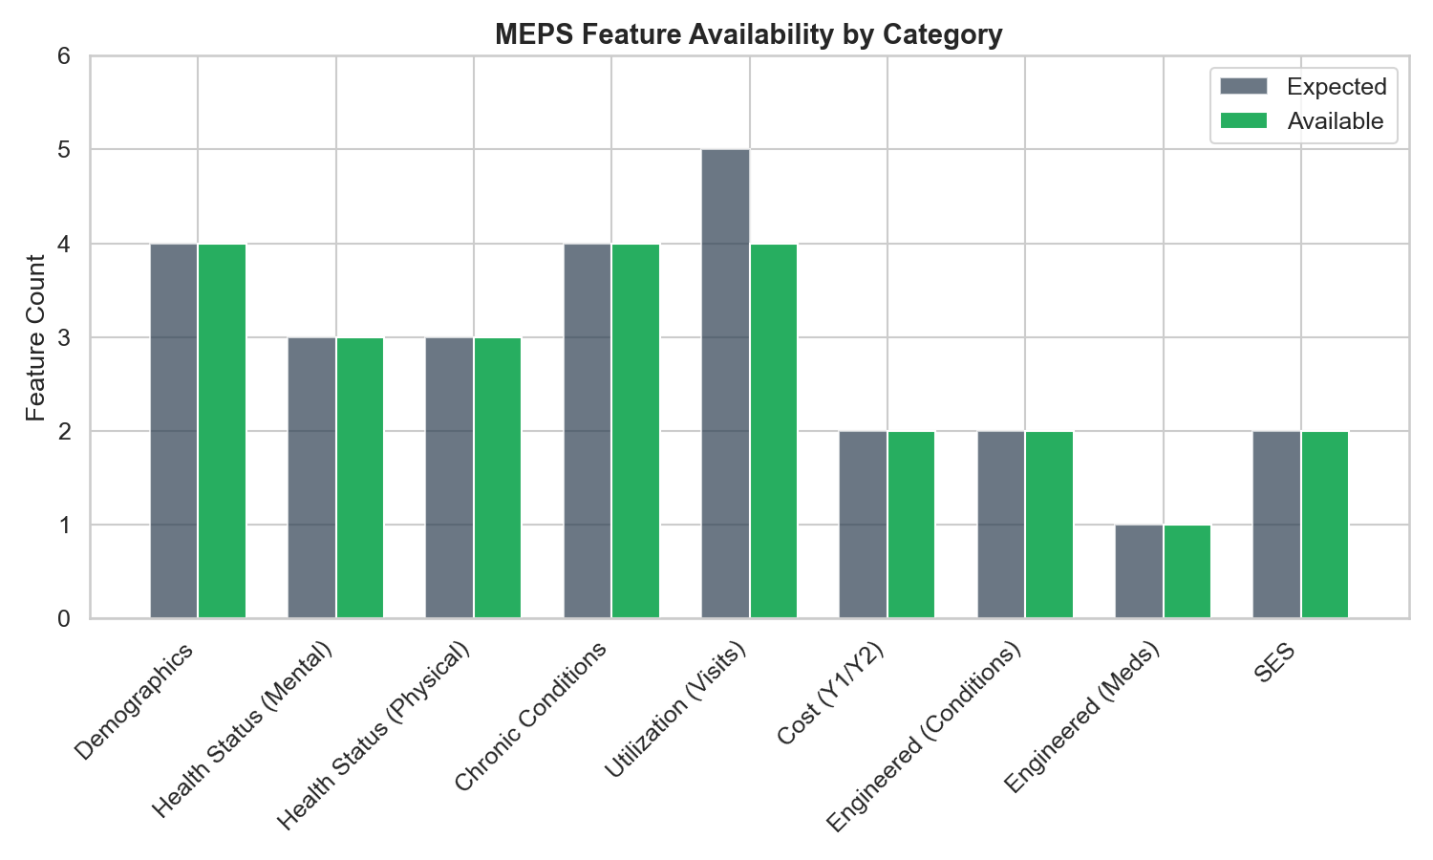
Figure 7: B1: Feature Availability Across Processed Dataset

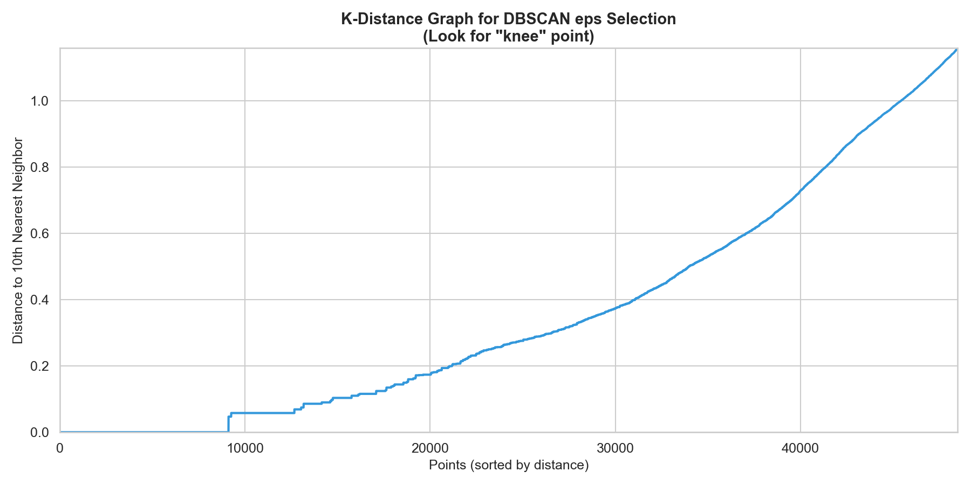
Figure 8: B2: DBSCAN Epsilon Parameter Selection via K-Distance Graph

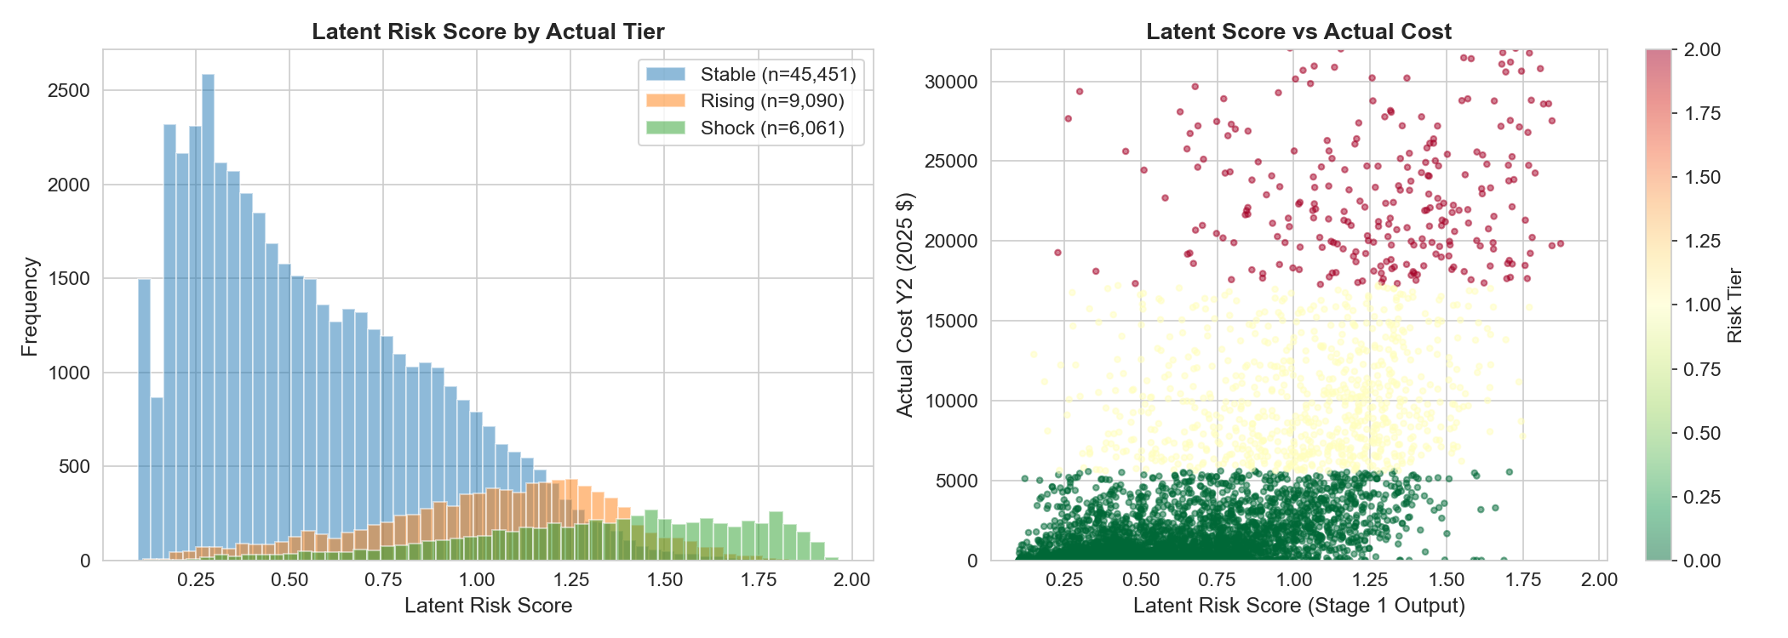
Figure 9: B3: Latent Risk Score Distribution by Risk Tier

