Multi-Stage Healthcare Cost Prediction
Using Longitudinal MEPS Data (2013–2018)
Module 7 — Midterm Report
ALY 6980 Capstone Project
Northeastern University
February 2026

Executive Summary
This report presents a multi-stage machine learning pipeline for predicting individual-level healthcare expenditure using the Medical Expenditure Panel Survey (MEPS) longitudinal data from 2013 to 2018. The study addresses a core challenge in health economics: healthcare costs are extremely right-skewed, with the top 10% of patients accounting for a disproportionate share of total spending (Stanton & Rutherford, 2006). Traditional single-model approaches struggle with this heterogeneity.
Our pipeline consists of four stages: (1) feature engineering from raw MEPS ASCII files, yielding 31 Year-1 predictors for 60,602 patients; (2) risk tier classification into Stable, Rising, and Shock categories using Random Forest (ROC-AUC = 0.833); (3) intermediate latent factor extraction capturing engagement patterns, escalation risk, and medication adherence; and (4) tier-specific XGBoost regression on log-transformed costs. The tier-specific approach achieved R² = 0.600 on the log scale and R² = 0.480 on the dollar scale, substantially outperforming the global single-model baseline (R² = 0.509 log, R² = 0.228 dollar). All models use Year-1 data exclusively, with cross-validated predictions at each stage to prevent data leakage. The ablation study reveals that the tier-specific modeling strategy is the primary driver of improvement, while Stage 1.5 latent factors show limited marginal gain, suggesting opportunities for further optimization.

Table of Contents
Executive Summary
Table of Contents
1. Introduction
2. Literature Review
2.1 Traditional Econometric Approaches
2.2 Machine Learning Approaches
2.3 Risk Stratification and Multi-Stage Models
2.4 Longitudinal Analysis and Feature Engineering
2.5 Evaluation Metrics for Cost Prediction
3. Research Methods
3.1 Data Source and Feature Engineering
3.2 Multi-Stage Pipeline Architecture
3.3 Data Leakage Prevention
4. Analysis Results and Discussion
4.1 Stage 1: Risk Tier Classification
4.2 Stage 1.5: Intermediate Latent Factors
4.3 Stage 2: Tier-Specific Cost Prediction
4.4 Ablation Study
5. Conclusion
References
Appendix

1. Introduction
Healthcare expenditure prediction is a fundamental problem in health economics and actuarial science. In the United States, healthcare spending reached $4.5 trillion in 2022, representing 17.3% of GDP (Centers for Medicare & Medicaid Services [CMS], 2023). The distribution of this spending is highly concentrated: approximately 5% of the population accounts for over 50% of total expenditures (Stanton & Rutherford, 2006; Mitchell & Machlin, 2014). Accurate prediction of individual-level costs enables insurers, healthcare systems, and policymakers to allocate resources efficiently, design targeted interventions, and manage financial risk.
However, healthcare cost prediction presents unique statistical challenges. The distribution of costs is severely right-skewed, with a large mass at zero and extreme right-tail values exceeding $500,000 annually (Manning & Mullahy, 2001). Traditional linear models and even standard machine learning approaches often fail to capture this heterogeneity. Two-part models (Duan et al., 1983), generalized linear models with Tweedie distributions (Jørgensen, 1987), and more recently, tree-based ensemble methods (Bertsimas et al., 2008) have been proposed, each with trade-offs between interpretability and predictive accuracy.
This study leverages the Medical Expenditure Panel Survey (MEPS), a nationally representative longitudinal survey conducted by the Agency for Healthcare Research and Quality (AHRQ). MEPS follows individuals over two-year overlapping panels, collecting detailed information on demographics, health status, chronic conditions, healthcare utilization, and expenditures (Cohen et al., 2009). We use six panels (18–23) covering 2013–2018, yielding 60,602 patient records with 31 Year-1 features.
Our contribution is a multi-stage pipeline that decomposes the prediction problem into sequential sub-tasks: (1) risk tier classification, (2) latent clinical factor extraction, and (3) tier-specific cost regression. This approach is motivated by the observation that a single global model spends most of its capacity learning the gross differences between low-cost and high-cost patients—a distinction that can be made more efficiently through classification—while tier-specific models can focus on the more nuanced within-tier cost variation. All features are restricted to Year-1 data, and cross-validated predictions are used at each intermediate stage to prevent data leakage (Kaufman et al., 2012).

2. Literature Review

2.1 Traditional Econometric Approaches
The foundational work of Duan et al. (1983) introduced the two-part model for healthcare costs: a logistic regression for the probability of any expenditure, followed by a log-linear regression for the conditional cost given positive spending. Manning and Mullahy (2001) extended this framework by comparing log-scale OLS with generalized linear models (GLMs), finding that the choice of retransformation method significantly affects prediction accuracy. Jørgensen (1987) introduced the Tweedie distribution family, which naturally handles the zero-inflated continuous distribution of healthcare costs through a compound Poisson-Gamma formulation.

2.2 Machine Learning Approaches
Bertsimas et al. (2008) demonstrated that classification and regression trees (CART) and ensemble methods could outperform traditional econometric models for healthcare cost prediction, particularly for capturing nonlinear relationships and interactions. Rose (2016) compared multiple machine learning algorithms on MEPS data and found that Super Learner ensembles achieved superior performance. More recently, gradient boosting methods such as XGBoost (Chen & Guestrin, 2016) and LightGBM (Ke et al., 2017) have become the state of the art for tabular prediction tasks, including healthcare cost modeling.
Morid et al. (2017) provided a comprehensive review of supervised machine learning methods for predicting healthcare costs, finding that ensemble methods consistently outperformed individual algorithms. Tamang et al. (2017) demonstrated the value of incorporating medication-level features for cost prediction, a finding that informs our feature engineering approach.

2.3 Risk Stratification and Multi-Stage Models
The concept of patient risk stratification has been widely adopted in population health management. The Johns Hopkins ACG system (Weiner et al., 1991) and the CMS-HCC model (Pope et al., 2004) use diagnosis-based risk scores to predict future costs. Ash et al. (2000) introduced the DxCG model using hierarchical condition categories for risk adjustment. Our approach differs by learning risk strata directly from the data rather than using pre-defined clinical groupings, and by explicitly modeling the transition between stages.

2.4 Longitudinal Analysis and Feature Engineering
MEPS longitudinal structure has been exploited in several studies. Zuvekas and Olin (2009) examined persistence in healthcare expenditures across years, finding substantial autocorrelation (r ≈ 0.5 between consecutive years). This motivates the inclusion of Year-1 cost as a predictor. Medication adherence—measured through prescription fill patterns—has been shown to predict cost escalation in chronic disease populations (Roebuck et al., 2011; Sokol et al., 2005). Our Stage 1.5 medication adherence model draws on survival analysis concepts to quantify discontinuation risk from Year-1 prescription timelines.

2.5 Evaluation Metrics for Cost Prediction
The choice of evaluation metric is critical for healthcare cost models. R² on raw dollar amounts is dominated by extreme outliers, leading Bertsimas et al. (2008) and Rose (2016) to recommend evaluation on the log-transformed scale. Mean absolute error (MAE) provides a more interpretable measure of average prediction quality. Basu and Manning (2009) argued for evaluating models on multiple scales. Following this guidance, we report R² on both log and dollar scales, along with MAE.

3. Research Methods

3.1 Data Source and Feature Engineering
The data source is the MEPS Household Component, panels 18–23, spanning 2013–2018. Raw data was obtained as fixed-width ASCII files from the AHRQ MEPS data repository and parsed into structured Parquet format. The final analytic dataset contains 60,602 patient records with 39 variables, of which 31 are used as predictive features.
Feature categories include:
• Demographics (6): age, sex, race, marital status, poverty category, insurance coverage
• Health Status (2): self-rated mental health (MNHLTH_RD1), self-rated physical health (RTHLTH_RD1)
• Chronic Conditions (4): diabetes, hypertension, high cholesterol flags, comorbidity count
• Utilization (4): ER visits, inpatient stays, office visits, prescription fills
• Engineered Features (3): total conditions, ill-defined symptom count, ER-to-office ratio
• Medication (9): Rx count, unique drugs, Rx cost, polypharmacy flag, therapeutic class flags
• Clusters (2): K-Means and DBSCAN patient clusters from utilization patterns
• Cost (1): inflation-adjusted Year-1 total expenditure (COST_Y1_ADJ)
All costs are inflation-adjusted to 2025 dollars using CPI medical care factors. The target variable is COST_Y2_ADJ (Year-2 inflation-adjusted expenditure). An intermediate target, RISK_TIER, is defined based on COST_Y2_ADJ percentiles: Stable (≤75th percentile, ~75%), Rising (75th–90th, ~15%), and Shock (>90th, ~10%).

3.2 Multi-Stage Pipeline Architecture
Stage 1 (Risk Tier Classification): Predicts RISK_TIER from Year-1 features using Random Forest. Outputs tier probabilities (PROB_STABLE, PROB_RISING, PROB_SHOCK) and a continuous LATENT_RISK_SCORE = 0×P(Stable) + 1×P(Rising) + 2×P(Shock).
Stage 1.5 (Latent Factor Extraction): Constructs four intermediate clinical variables—ENGAGEMENT_SCORE, PROB_UNDIAGNOSED, ESCALATION_SCORE, and HAZARD_DISCONTINUE—each capturing a specific dimension of risk not directly expressed by the original features.
Stage 2 (Tier-Specific Cost Prediction): Trains separate XGBoost regressors for each risk tier on log(1 + COST_Y2_ADJ), using original features, interaction terms, Stage 1 risk score, and Stage 1.5 latent factors as inputs.

3.3 Data Leakage Prevention
Strict protocols prevent information leakage (Kaufman et al., 2012): (a) all features use Year-1 data exclusively; (b) Stage 1 tier probabilities are generated via out-of-fold prediction; (c) Stage 1.5 latent factors use 5-fold cross_val_predict; (d) the train/validation/test split (70/20/10) is stratified by MEPS panel to maintain temporal representativeness.

4. Analysis Results and Discussion

4.1 Stage 1: Risk Tier Classification
Four classifiers were benchmarked on the risk tier classification task. Table 1 presents the results.
Model | Accuracy | F1 (Macro) | ROC-AUC
Random Forest | 0.695 | 0.579 | 0.833
XGBoost | 0.768 | 0.553 | 0.836
GradientBoosting | 0.762 | 0.542 | 0.833
Logistic Regression | 0.684 | 0.550 | 0.815
Table 1. Stage 1 Model Benchmark Results (Test Set, n = 9,138)
Random Forest was selected based on the highest F1 Macro score (0.579), which weights all three classes equally. This is appropriate because the Shock class (10%) is the primary intervention target. The raw accuracy of 69.5% is below the naive majority-class baseline of 75%; this trade-off is intentional, sacrificing majority-class precision for improved minority-class detection (He & Garcia, 2009). Per-class analysis reveals: Stable (precision = 0.90, recall = 0.76), Rising (precision = 0.33, recall = 0.59), and Shock (precision = 0.56, recall = 0.44). The Shock recall of 44% indicates that more than half of true high-cost patients are missed.
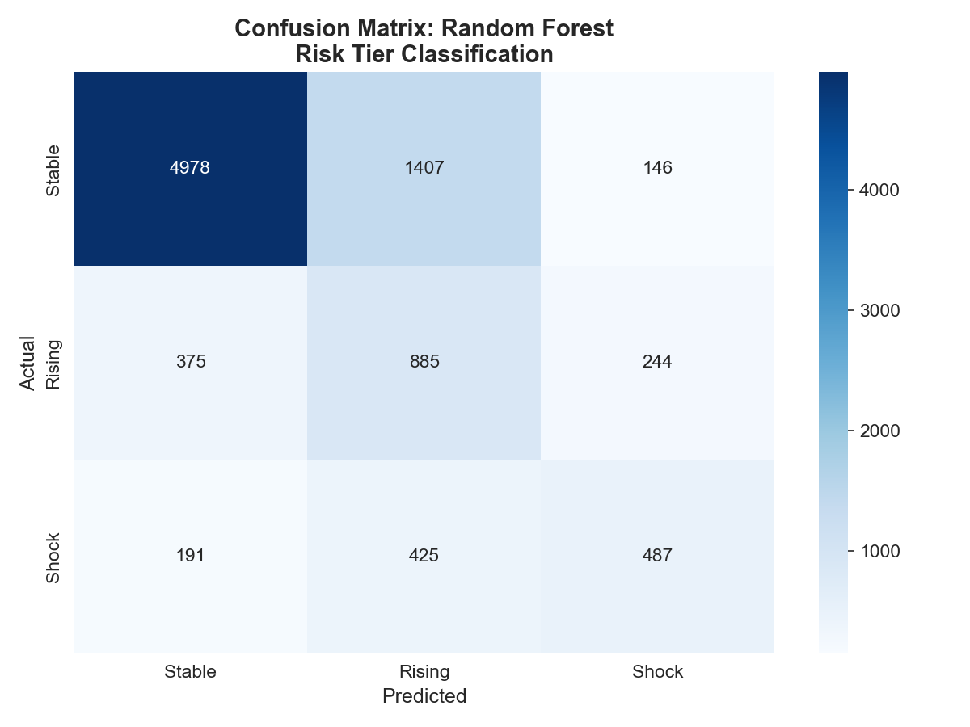
Figure 1. Confusion Matrix — Random Forest Risk Tier Classification
SHAP analysis (Lundberg & Lee, 2017) identified the top predictive features for Shock classification. Prior-year cost (COST_Y1_ADJ, mean |SHAP| = 0.061) dominates, consistent with the cost persistence effect (Zuvekas & Olin, 2009). Prescription volume (UTIL_RX_Y1 = 0.032), office visits (UTIL_OB_Y1 = 0.023), and medication cost (TOTAL_RX_COST_Y1 = 0.021) follow, reflecting chronic disease treatment intensity.
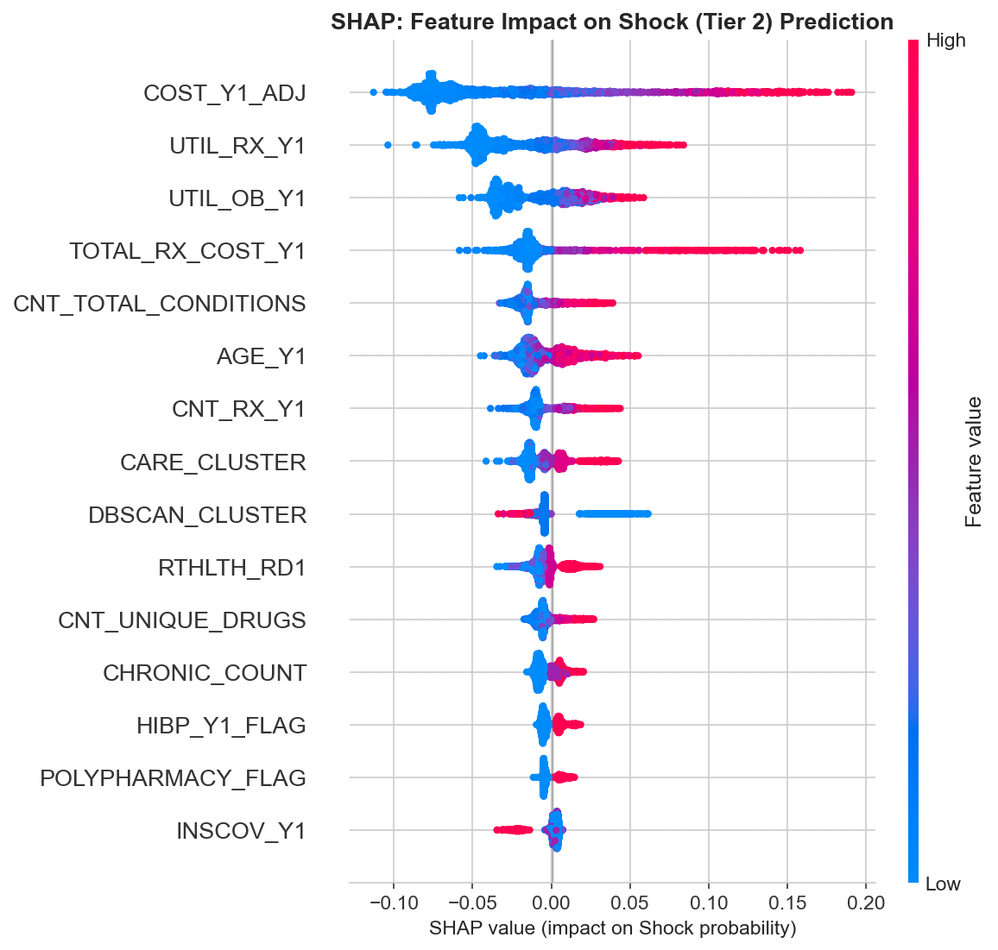
Figure 2. SHAP Feature Importance for Shock (Tier 2) Prediction
The LATENT_RISK_SCORE (mean = 0.712, SD = 0.420) was validated by examining mean Year-2 cost across score deciles (Figure 3). The monotonically increasing pattern confirms correct rank-ordering.
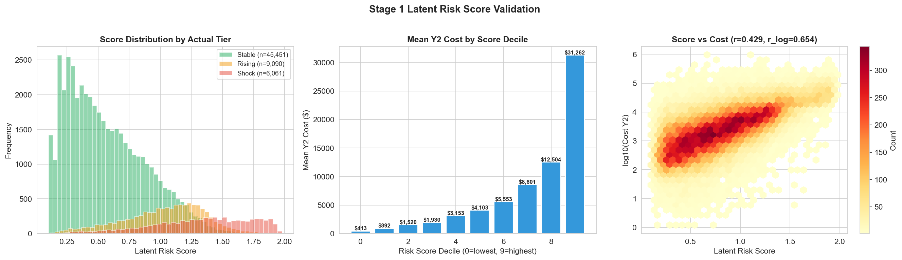
Figure 3. Latent Risk Score Validation: Distribution, Decile Means, and Hexbin

4.2 Stage 1.5: Intermediate Latent Factors
Stage 1.5 constructs four intermediate variables, each capturing a clinical dimension not directly expressed by the original features. A fifth factor (PROB_MH_DECLINE) was removed after evaluation showed negligible correlation with cost (r = 0.01).
Latent Factor | Method | Key Inputs | r with Cost
ENGAGEMENT_SCORE | Direct formula | ER, Office, IP ratios | 0.235
PROB_UNDIAGNOSED | RF + 5-fold CV | Ill-defined Dx, utilization | −0.207
ESCALATION_SCORE | Composite index | Chronic count, IP, polypharmacy | 0.289
HAZARD_DISCONTINUE | GB + 5-fold CV | Rx fill density, gap ratio | 0.384
Table 2. Stage 1.5 Latent Factors Summary
The HAZARD_DISCONTINUE variable, inspired by survival analysis methodology (Cox, 1972; Roebuck et al., 2011), shows the strongest correlation with Year-2 cost among Stage 1.5 factors (r = 0.384). It quantifies medication adherence risk by analyzing Year-1 prescription fill timelines: fill density (proportion of months with fills), gap ratio (fraction of time between fills that are gaps), and trailing gap (months since last fill at year-end). Figure 4 demonstrates that patients in the worst adherence quintile (Q5) have a median Year-2 cost of $9,790 compared to near-zero for the best adherence quintile (Q1)—a ratio of approximately 9,790:1.
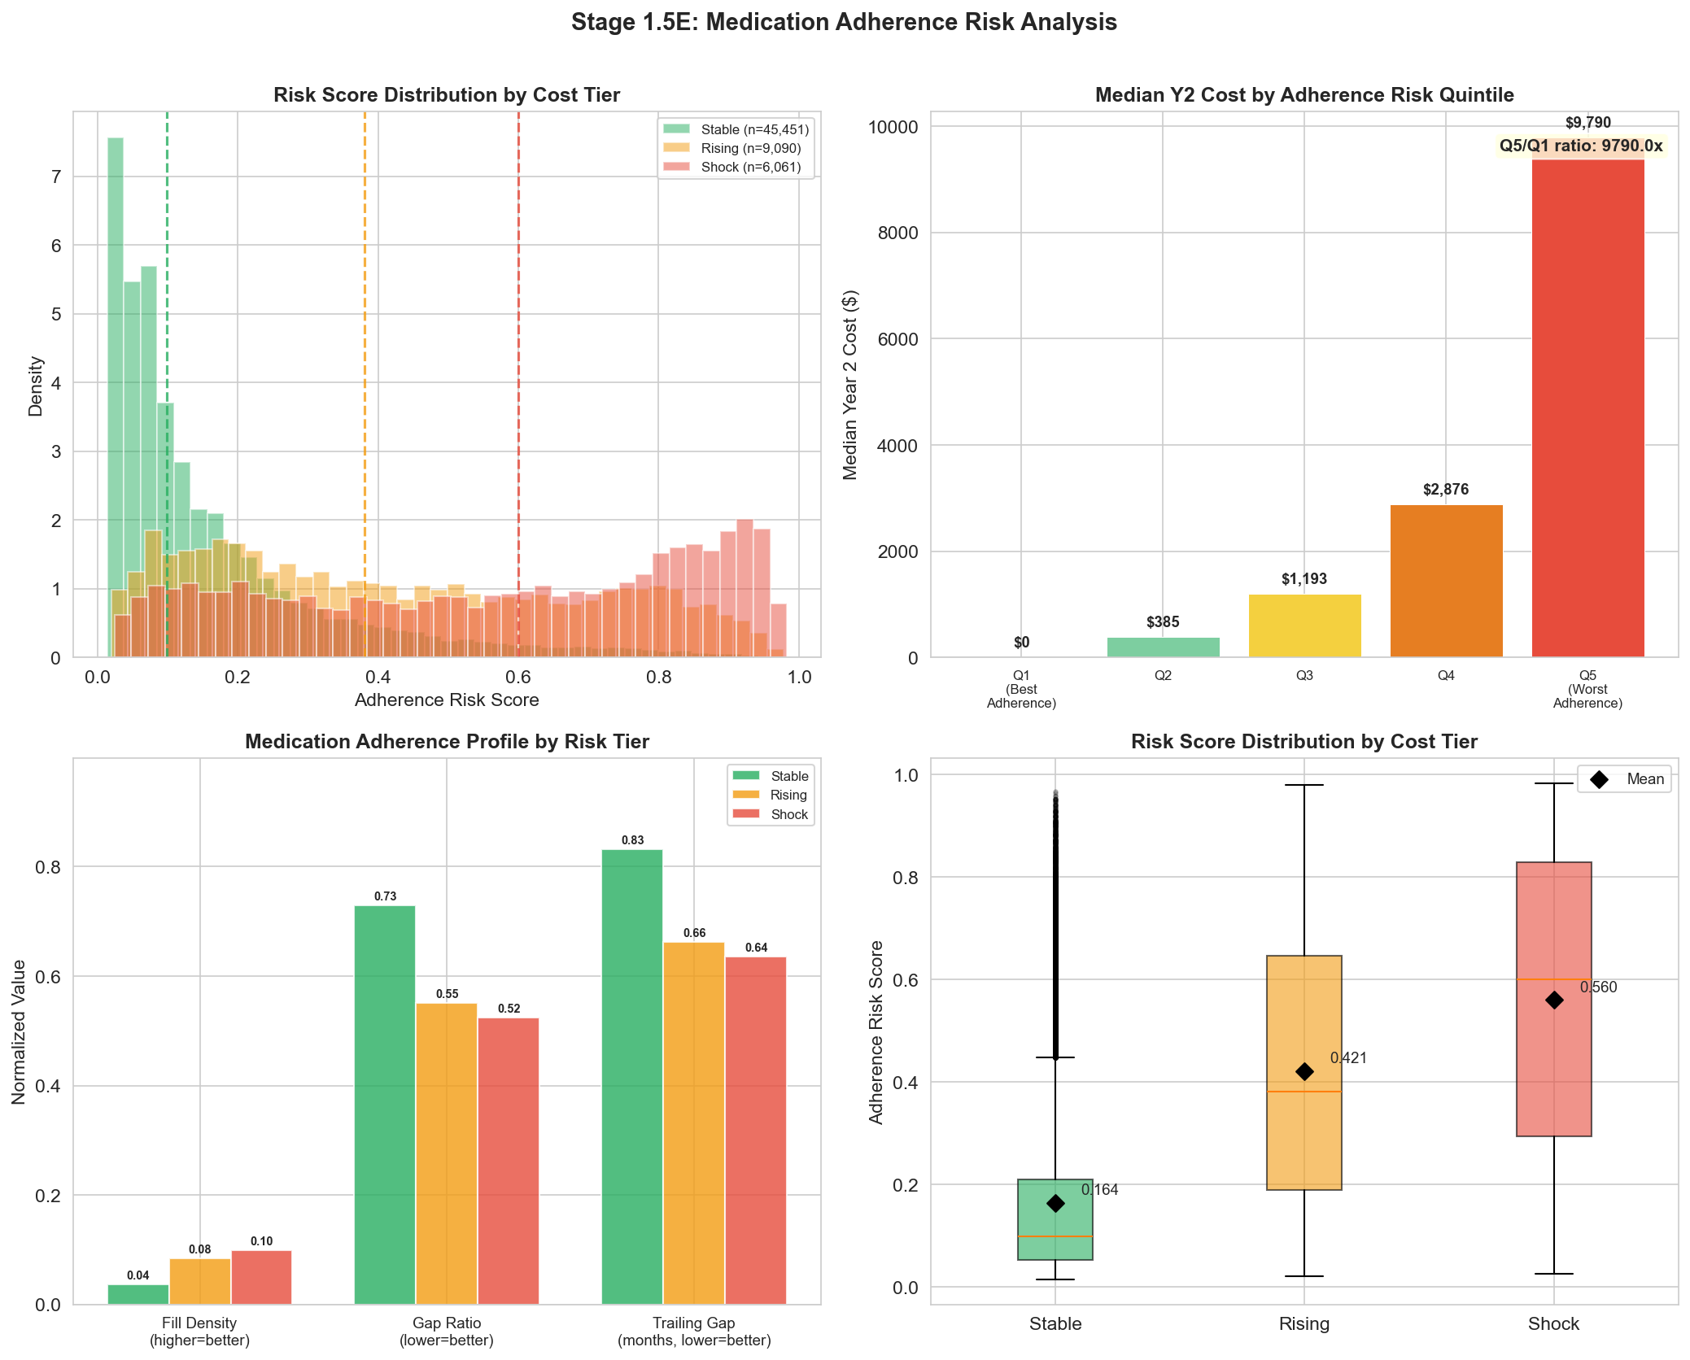
Figure 4. Medication Adherence Risk Analysis (Stage 1.5E)
The correlation matrix (Figure 5) reveals important structural relationships. PROB_CRISIS_MODE and ENGAGEMENT_SCORE are almost perfectly inversely correlated (r = −0.99), indicating redundancy. HAZARD_DISCONTINUE correlates strongly with LATENT_RISK_SCORE (r = 0.91), suggesting substantial overlap with Stage 1 outputs. These findings indicate opportunities for factor refinement.
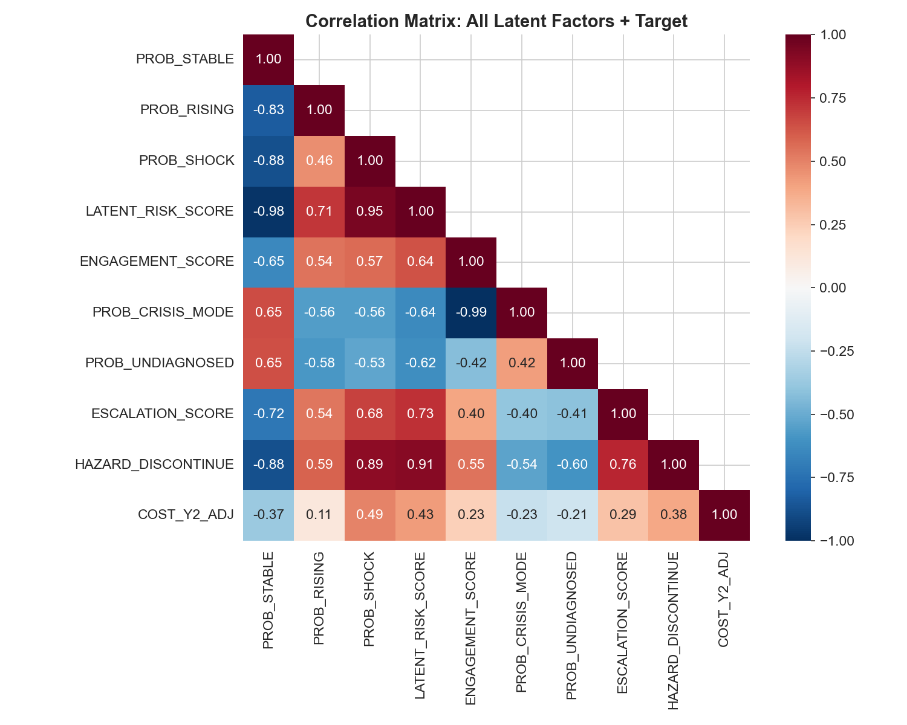
Figure 5. Correlation Matrix: All Latent Factors and Target Variable

4.3 Stage 2: Tier-Specific Cost Prediction
Stage 2 trains XGBoost regressors on log(1 + COST_Y2_ADJ) using 33 features: 21 original, 6 interaction terms, LATENT_RISK_SCORE, and 5 Stage 1.5 latent factors. Two approaches are compared.
Model | R² (log) | R² (dollar) | MAE
Global XGBoost | 0.509 | 0.228 | $5,046
Tier-Specific XGBoost | 0.600 | 0.480 | $3,440
Table 3. Stage 2 Overall Model Comparison (Test Set, n = 6,066)
The tier-specific approach achieves R² = 0.600 on the log scale, a substantial improvement over the global baseline (R² = 0.509). The dollar-scale R² improves from 0.228 to 0.480, and MAE decreases from $5,046 to $3,440.
Tier | n (test) | R² (log) | R² (dollar) | MAE
Stable | 4,552 | 0.372 | 0.095 | $808
Rising | 906 | 0.046 | 0.023 | $2,719
Shock | 608 | 0.136 | 0.030 | $24,213
Table 4. Within-Tier Performance of Tier-Specific XGBoost
Within-tier analysis reveals heterogeneous performance. The Stable tier achieves R² = 0.372 (log) with MAE of only $808. The Shock tier R² = 0.136 (log) with MAE = $24,213 operates on a cost range of $10K–$900K. The Rising tier shows the weakest performance (R² = 0.046), consistent with its nature as a transitional category.
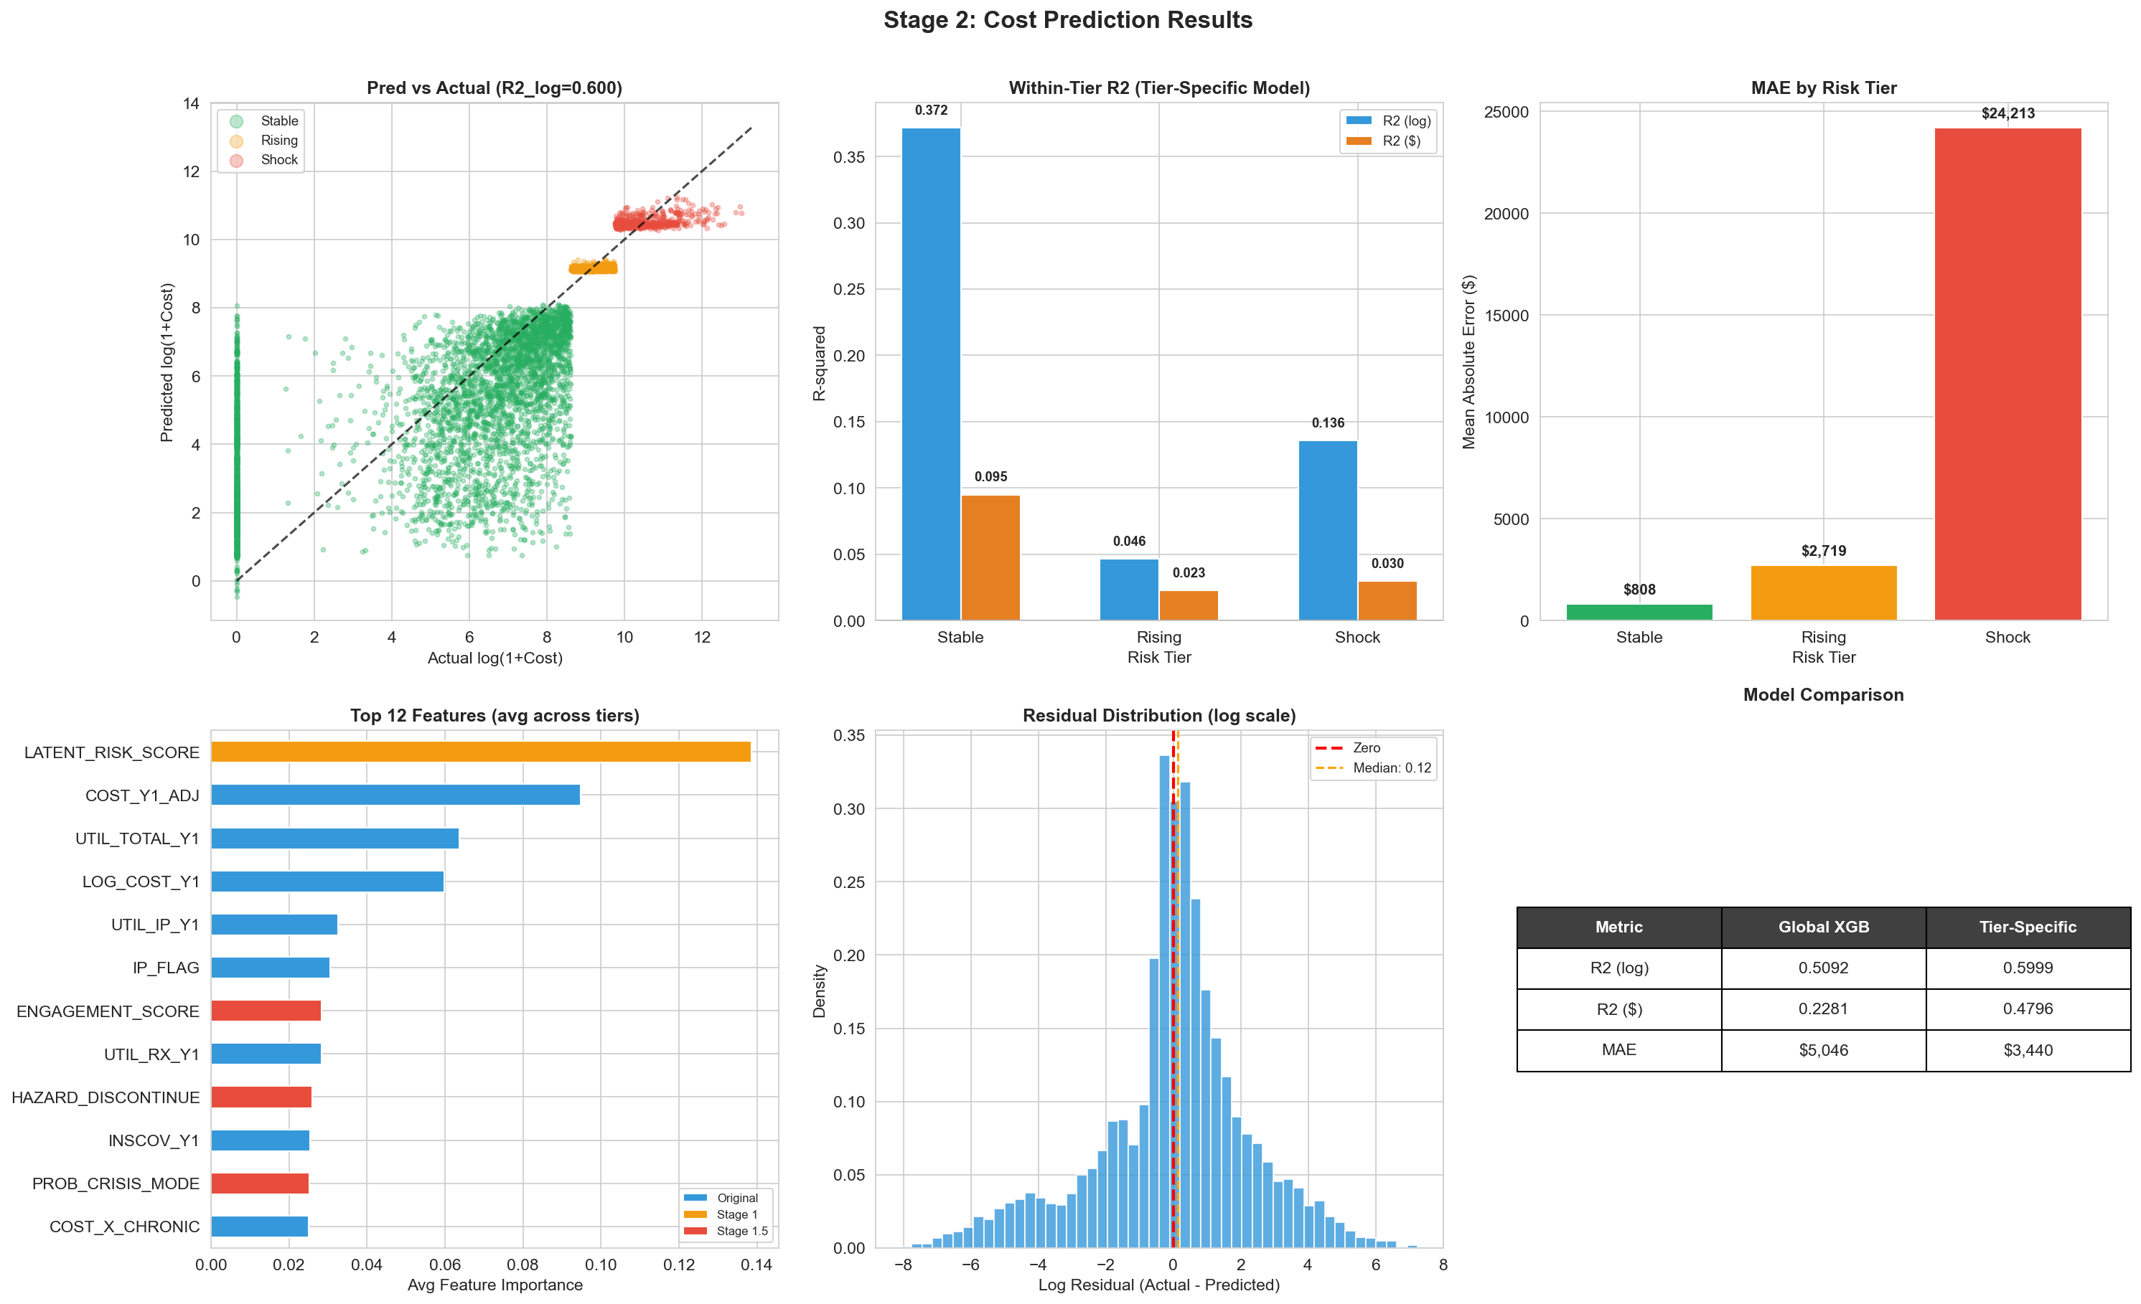
Figure 6. Stage 2 Tier-Specific Model Results (6-Panel Summary)

4.4 Ablation Study
Feature Set | R² (log) | R² (dollar) | MAE
Original Only (21) | 0.601 | 0.480 | $3,444
+ Interactions (27) | 0.600 | 0.481 | $3,441
+ LATENT_RISK_SCORE (28) | 0.600 | 0.475 | $3,447
+ Stage 1.5 Full (33) | 0.600 | 0.480 | $3,433
Table 5. Ablation Study: Feature Set Impact on Tier-Specific Model Performance
A critical finding emerges: within the tier-specific framework, adding Stage 1.5 latent factors provides minimal marginal improvement over original features alone (R² log: 0.601 → 0.600). The primary performance gain comes from the tier-specific modeling strategy itself (Global R² = 0.509 vs. Tier-Specific R² = 0.600), not from the intermediate latent variables. This suggests that once patients are stratified by tier, the original Year-1 features—particularly COST_Y1_ADJ—already capture most of the predictable within-tier variation. The Stage 1.5 factors, while clinically interpretable, are either redundant with the tier-stratification signal (HAZARD_DISCONTINUE, r = 0.91 with LATENT_RISK_SCORE) or too weak to add incremental value (PROB_UNDIAGNOSED, r = −0.207).
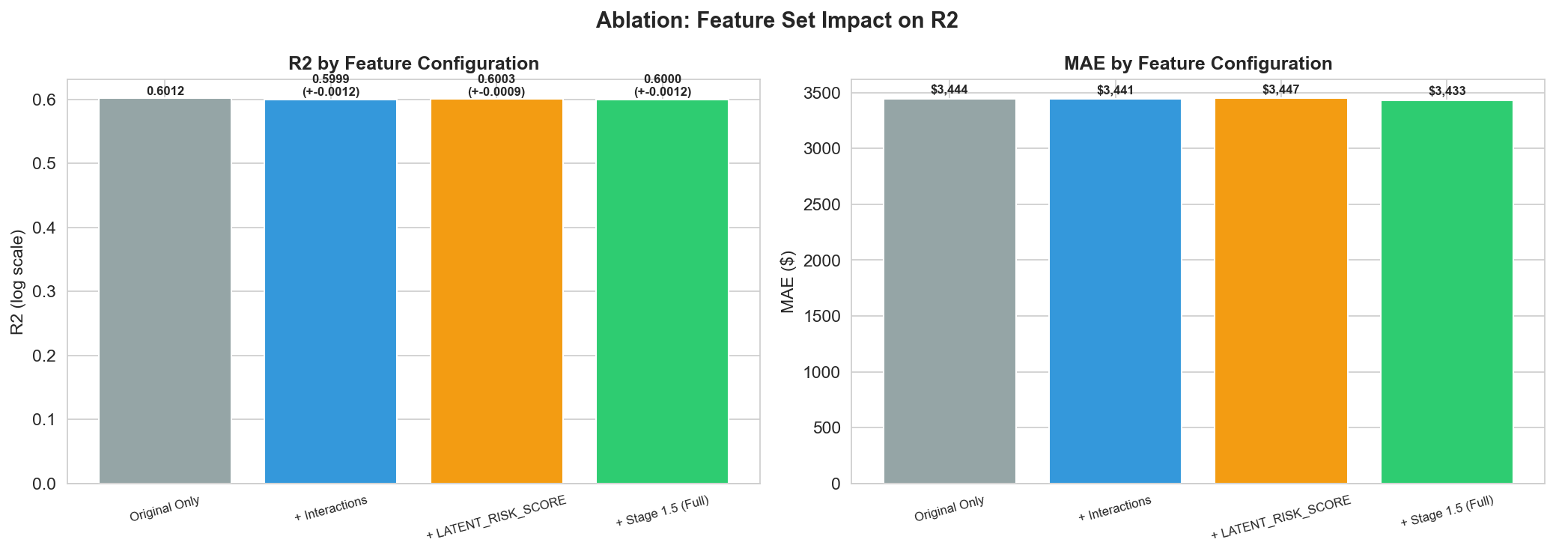
Figure 7. Ablation Study: R² and MAE by Feature Configuration
This finding has important implications for pipeline refinement. Rather than wrapping clinical signals into intermediate classifiers, future work should consider feeding the raw sub-features (e.g., Rx fill density, gap ratio, trailing gap) directly into Stage 2 models, allowing XGBoost to learn the optimal nonlinear transformations itself.

5. Conclusion
This study demonstrates that a multi-stage pipeline—specifically the tier-specific modeling strategy—substantially improves healthcare cost prediction compared to a single global model. The tier-specific XGBoost achieves R² = 0.600 (log scale) and R² = 0.480 (dollar scale) on individual-level MEPS data, compared to 0.509 and 0.228 for the global baseline. The ablation study reveals that the tier-stratification architecture, rather than the Stage 1.5 latent factors, is the primary driver of improvement. Key limitations include low Shock recall (44%) in Stage 1, weak Rising-tier prediction (within-tier R² = 0.046), and redundancy among latent factors. Future work will focus on pruning redundant variables, incorporating raw sub-features directly, Bayesian hyperparameter optimization, and external validation on held-out panels.

References
Ash, A. S., Ellis, R. P., Pope, G. C., Ayanian, J. Z., Bates, D. W., Burstin, H., ... & Yu, W. (2000). Using diagnoses to describe populations and predict costs. Health Care Financing Review, 21(3), 7–28.
Basu, A., & Manning, W. G. (2009). Issues for the next generation of health care cost analyses. Medical Care, 47(7 Suppl 1), S109–S114.
Bertsimas, D., Bjarnadóttir, M. V., Kane, M. A., Kryder, J. C., Pandey, R., Vber, S., & Wang, G. (2008). Algorithmic prediction of health-care costs. Operations Research, 56(6), 1382–1392.
Centers for Medicare & Medicaid Services. (2023). National Health Expenditure Data. CMS.gov.
Chen, T., & Guestrin, C. (2016). XGBoost: A scalable tree boosting system. Proceedings of the 22nd ACM SIGKDD International Conference on Knowledge Discovery and Data Mining, 785–794.
Cohen, S. B., DiGaetano, R., & Goksel, H. (2009). Estimation procedures in the 1996 Medical Expenditure Panel Survey Household Component. AHRQ Methodology Report No. 2009-03.
Cox, D. R. (1972). Regression models and life-tables. Journal of the Royal Statistical Society: Series B, 34(2), 187–202.
Duan, N., Manning, W. G., Morris, C. N., & Newhouse, J. P. (1983). A comparison of alternative models for the demand for medical care. Journal of Business & Economic Statistics, 1(2), 115–126.
He, H., & Garcia, E. A. (2009). Learning from imbalanced data. IEEE Transactions on Knowledge and Data Engineering, 21(9), 1263–1284.
Jørgensen, B. (1987). Exponential dispersion models. Journal of the Royal Statistical Society: Series B, 49(2), 127–162.
Kaufman, S., Rosset, S., Perlich, C., & Stitelman, O. (2012). Leakage in data mining: Formulation, detection, and avoidance. ACM Transactions on Knowledge Discovery from Data, 6(4), 1–21.
Ke, G., Meng, Q., Finley, T., Wang, T., Chen, W., Ma, W., ... & Liu, T. Y. (2017). LightGBM: A highly efficient gradient boosting decision tree. Advances in Neural Information Processing Systems, 30, 3146–3154.
Lundberg, S. M., & Lee, S. I. (2017). A unified approach to interpreting model predictions. Advances in Neural Information Processing Systems, 30, 4765–4774.
Manning, W. G., & Mullahy, J. (2001). Estimating log models: To transform or not to transform? Journal of Health Economics, 20(4), 461–494.
Mitchell, E. M., & Machlin, S. R. (2014). Concentration of health expenditures and selected characteristics of high spenders, U.S. civilian noninstitutionalized population, 2014. AHRQ Statistical Brief #497.
Morid, M. A., Kawamoto, K., Ault, T., Dorius, J., & Abdelrahman, S. (2017). Supervised learning methods for predicting healthcare costs: Systematic literature review and empirical evaluation. AMIA Annual Symposium Proceedings, 1312–1321.
Pope, G. C., Kautter, J., Ellis, R. P., Ash, A. S., Ayanian, J. Z., Iezzoni, L. I., ... & Robst, J. (2004). Risk adjustment of Medicare capitation payments using the CMS-HCC model. Health Care Financing Review, 25(4), 119–141.
Roebuck, M. C., Liberman, J. N., Gemmill-Toyama, M., & Brennan, T. A. (2011). Medication adherence leads to lower health care use and costs despite increased drug spending. Health Affairs, 30(1), 91–99.
Rose, S. (2016). A machine learning framework for plan payment risk adjustment. Health Services Research, 51(6), 2358–2374.
Sokol, M. C., McGuigan, K. A., Verbrugge, R. R., & Epstein, R. S. (2005). Impact of medication adherence on hospitalization risk and healthcare cost. Medical Care, 43(6), 521–530.
Stanton, M. W., & Rutherford, M. K. (2006). The high concentration of U.S. health care expenditures. AHRQ Research in Action, Issue 19.
Tamang, S., Milstein, A., Sørensen, H. T., Pedersen, L., Mackey, L., Betterton, J. R., ... & Hernandez-Boussard, T. (2017). Predicting patient "cost blooms" in Denmark: A longitudinal population-based study. BMJ Open, 7(1), e011580.
Weiner, J. P., Starfield, B. H., Steinwachs, D. M., & Mumford, L. M. (1991). Development and application of a population-oriented measure of ambulatory care case-mix. Medical Care, 29(5), 452–472.
Zuvekas, S. H., & Olin, G. L. (2009). Validating household reports of health care use in the Medical Expenditure Panel Survey. Health Services Research, 44(5 Pt 1), 1679–1700.

Appendix

A. Feature Importance — Stage 1
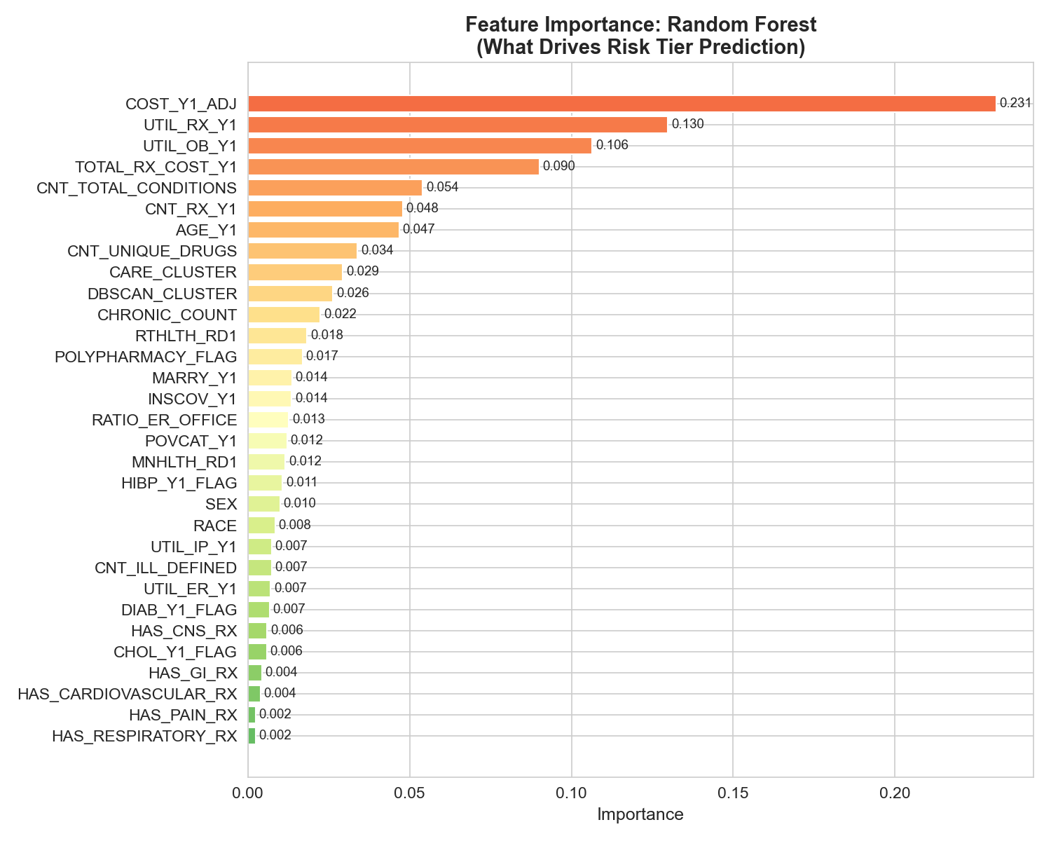
Figure A1. Gini Feature Importance — Random Forest Stage 1 Model

B. Clustering Analysis
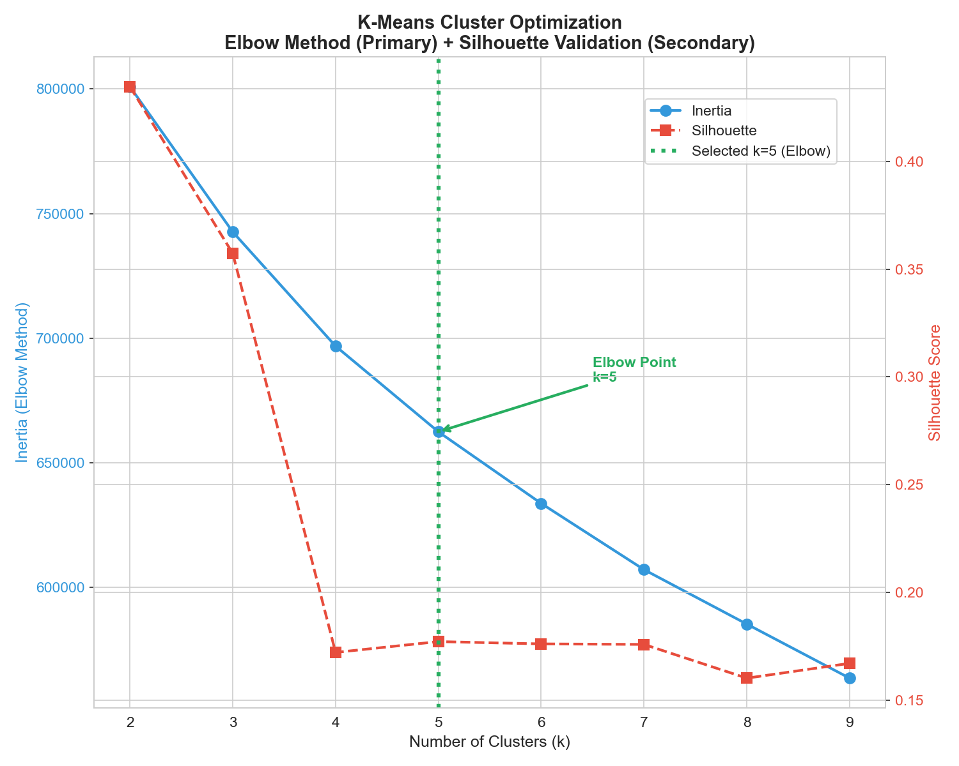
Figure A2. K-Means Elbow Method for Optimal Cluster Selection
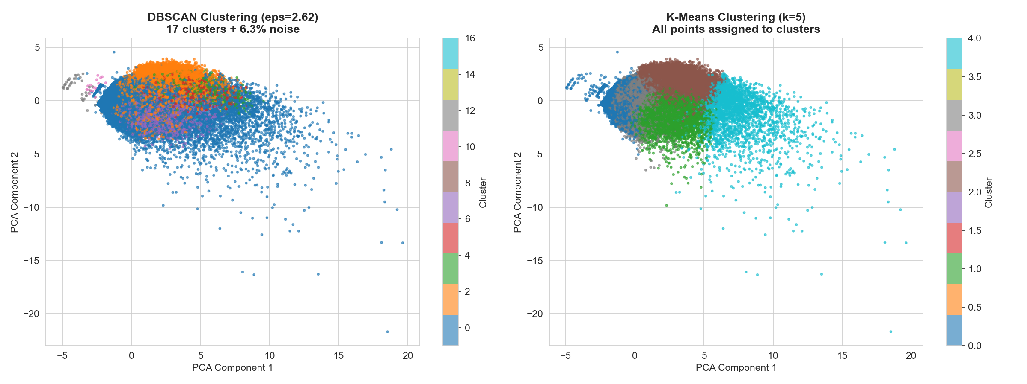
Figure A3. DBSCAN vs K-Means Cluster Comparison

C. Hidden Riser Analysis
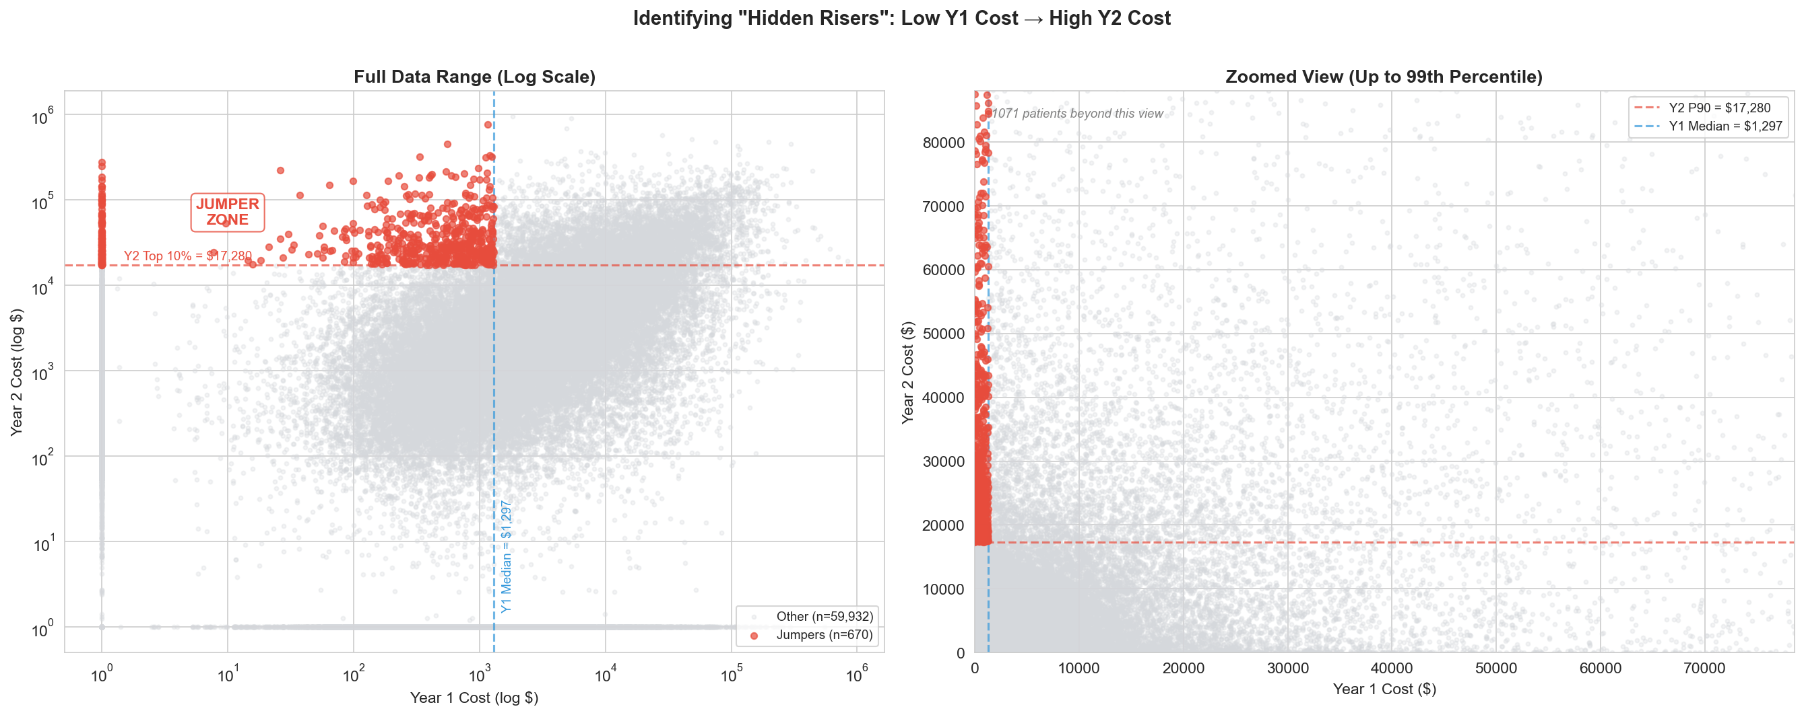
Figure A4. Hidden Riser (Jumper) Scatter Analysis — Year-1 vs Year-2 Cost
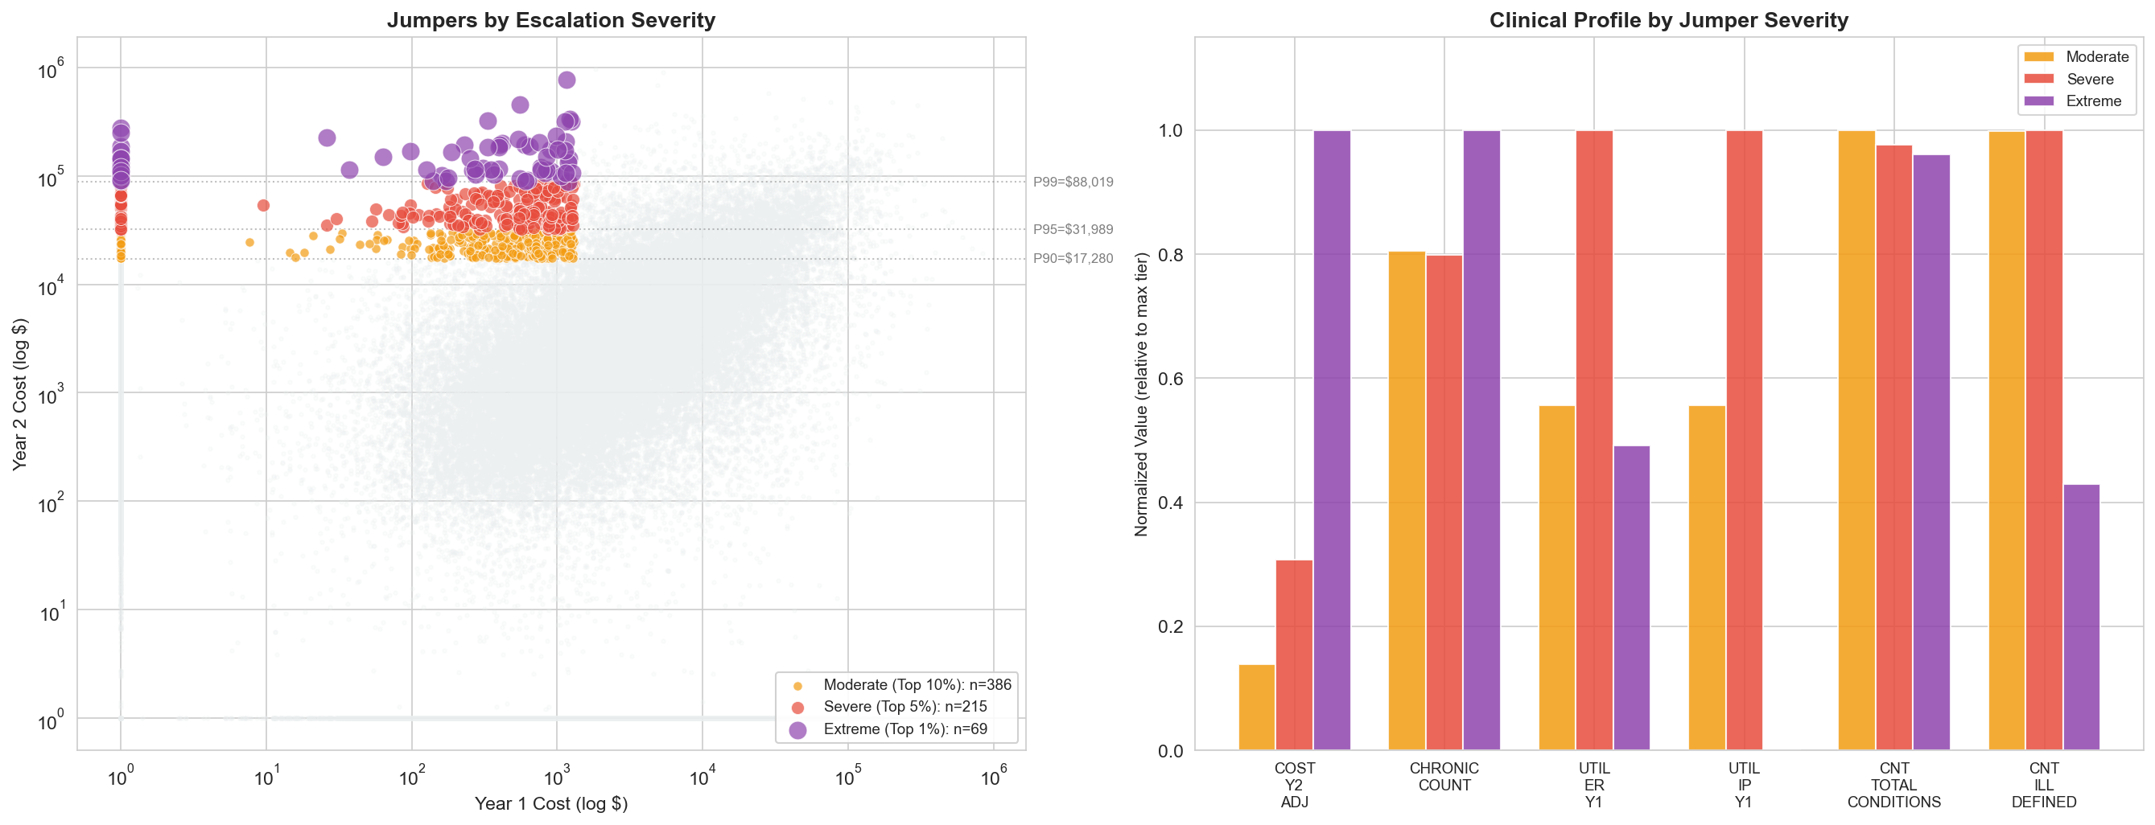
Figure A5. Jumper Tier Distribution Analysis

D. Exploratory Risk Ratios
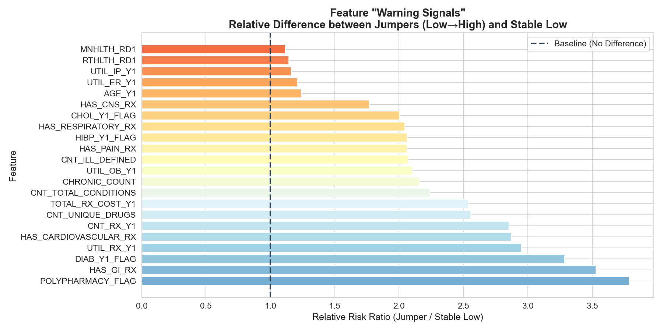
Figure A6. Feature-Level Risk Ratios for Shock Tier

