# Diagnosis

### What

* The heat block (“hotend”) and nozzle are jammed and damaged.
* The hotend wires are bare.
* Several parts are melted.
* Some parts are missing, which are related to the filament sensor.
* The print sheet is damaged on one side.

### Why

My guess is that there was a very bad blockage which caused melted plastic to leak out of the heat block into the wires, and onto the printed parts that shouldn’t get hot.

### Impact

* Bare wires next to a metal heat block is dangerous, this is a fire-hazard in its current state.
* The filament sensor can’t work due to missing parts, which means the heat won’t disconnect if there is no filament or if the filament is jammed. This is also a fire-hazard.
* The missing parts prevent the fan from working correctly. This means filament can’t cool properly so you won’t get correct prints. Also this may be a fire-hazard risk.

# Examination: Parts

**Extruder body**

One corner is broken off, and the putty fix prevents the bed sensor from being adjusted.

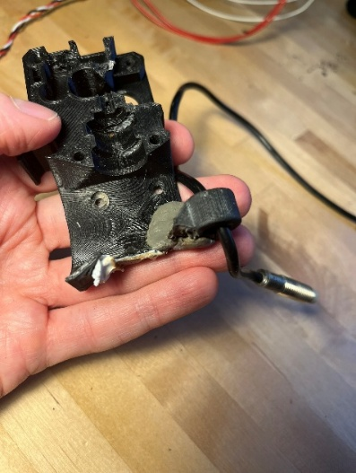 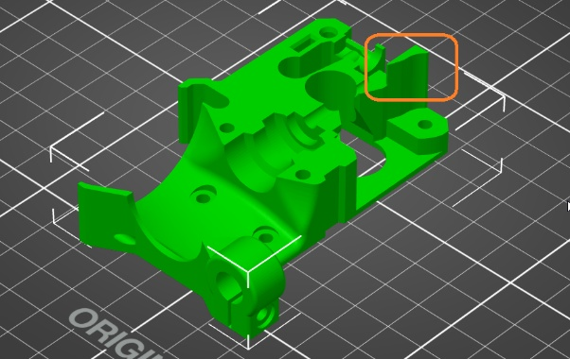

Solution: print a new part in PETG or ASA

**Extruder Missing Parts**

* 2x magnets are missing
* A steel ball bearing is missing

Filament sensor will not work properly without these.

Solution: order + replace the magnets + bearing.

**Extruder motor plate**

The extruder motor plate is worn (or melted?) and needs to be replaced.

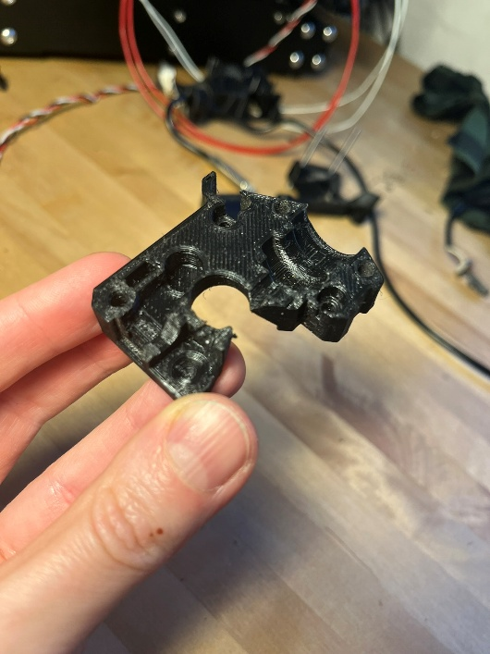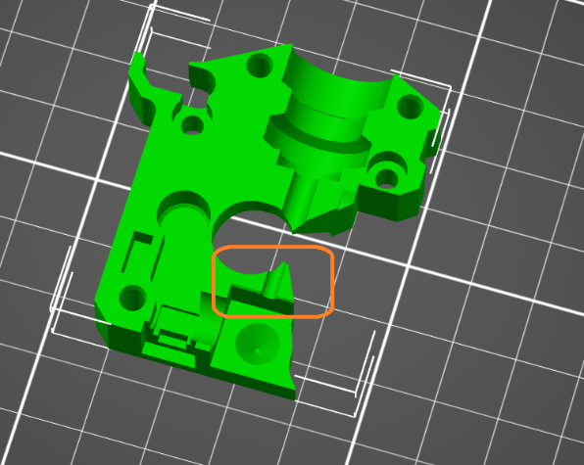

**Part: Hotend Fan**

3x 14mm screws were missing. 20mm screws are used. This is ok but not ideal as it can’t align quite right.

**Part: FS Cover**

Missing.

**Part: Fan Shroud**

Partially melted. If this isn’t complete, fan air is not properly guided to the hot end.

Should be reprinted in something heat-resistant, like ABS or ASA.

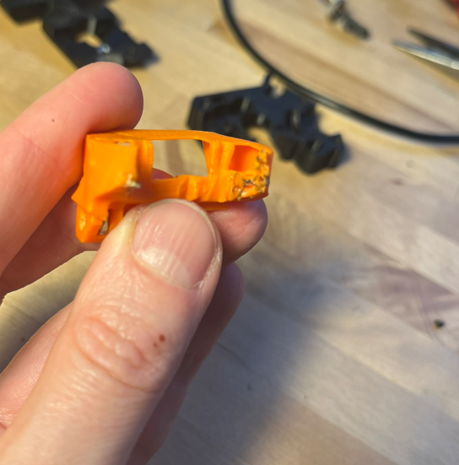 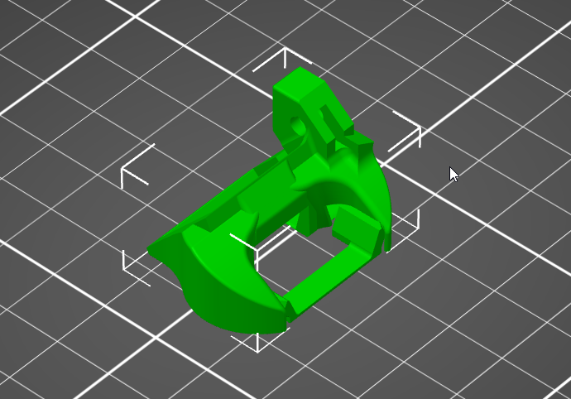

# Option 1: I fix it

Bill of materials – Essential

|  |  |  |  |
| --- | --- | --- | --- |
| **Part** | **Cost (Eur)** | **URL** | **Note** |
| Prusa Nozzle brass – 0.4mm | 21,99 | <https://www.prusa3d.com/en/product/prusa-nozzle-brass-0-4-mm/> |  |
| Assembled Hotend | 79,99 | <https://www.prusa3d.com/product/assembled-hotend-mk3s/> |  |
| Lubricant + applicator | 4,63 | <https://www.prusa3d.com/product/prusa-lubricant-applicator-set-5g/> | Another option is “Super Lube” from 123-3d.nl, 7,50 Eur |
| Set of Magnets | 1,69 | <https://www.prusa3d.com/product/set-of-magnets-mk2-5s-mk3-s/> |  |
| Spare parts | 9,99 | <https://www.prusa3d.com/product/mk3s-fasteners-spare-bag-2/> | Contains the missing steel ball, plus some 18mm screws which would be good because there are a few 20mm where there should be 18mm. |
| ASA Filament | 25,90 | <https://www.prusa3d.com/product/buddy3d-abs-matt-black-750g/> | To print the replacement parts. Prusa don’t sell the printed parts separately, but they do publish the models so they can be reprinted  Alternative: 18 Eur from 3DJake  https://www.3djake.nl/elegoo/asa-black-6 |
| Smooth PEI print sheet | 34,99 | <https://www.prusa3d.com/product/smooth-pei-print-sheet/> | Enables better PLA prints. Your existing textured sheet is OK on the non-damaged side for PETG. |
|  | **179.18** |  |  |

Optional Extras

FYI. Quality-of-life improvements that you don’t need, but it makes printing easier and more enjoyable.

|  |  |  |  |
| --- | --- | --- | --- |
| **Part** | **Cost (Eur)** | **URL** | **Note** |
| Spool Holder | 3,85 | <https://www.prusa3d.com/product/spool-holder/> | A double-holder is very handy when doing 2-colored prints, makes it easier to change filaments. |
| Textile Sleeve 30cm | 1,91 | <https://www.prusa3d.com/product/textile-sleeve-30-cm/> | The sleeve is damaged, may prevent future damage to wires. |
| Hairspray | 5,00 |  | If you want to print PLA, use the smooth print plate, and spray on a layer of hairspray before printing. The cheapest from ETOS works fine. |
| Glassex &/or Isopropyl Alchohol | 3,29 |  | To degrease the textured sheet, for PETG prints. PETG needs a very clean plate.  I use Glassex in a small travel-sized spray bottle, and some microfiber cloths. |
| Small pliers | 5,90 | <https://www.prusa3d.com/product/mini-pliers-with-side-cutter/> | Any small pliers from a hardware store are fine, doesn’t have to be from Prusa. Useful to grab blobs of filament when the print starts |
| A deburrer | 13,50 | <https://www.prusa3d.com/product/noga-teddy-burr-tb1000-deburring-tool/> | Many stores sells these, doesn’t have to be from Prusa. For cleaning up prints. If you print PETG, you may print with a brim and this helps a lot. |
| Brass brush | 3,99 | <https://www.prusa3d.com/product/prusa-brass-nozzle-brush/> | You can also buy this from any hardware store. They’re used for cleaning car spark plugs but also can be used to clean away blobs of filament from your nozzle. May prevent a blockage. |
| A soft-bristled paint brush | 5 |  | To brush away dust. |
| Nozzle-cleaning needle | 1,99 | <https://www.prusa3d.com/product/nozzle-cleaning-needle-5pcs/> | Optional. If the nozzle is hot and nothing comes out, then this can help. Any acupuncture needle works. |
|  | **39.43** |  |  |

There are also several parts that could be printed, to improve the machine’s useability. Because it’s an older model, several things were fixed in later models:

* Cable clips to tidy cables at the back and underneath
* A larger fan shroud that makes cooling more efficient
* A filament guide to keep filament tidy on top
* Dust covers to prevent dust and objects from falling into the aluminium extrusions
* A cleaner tool for the rods
* A tool to help switch nozzles

Also FYI other optional improvements:

1. Sit your printer on a heavy paving stone, to significantly reduce noise and vibrations.
2. Use an air purifier from IKEA, to significantly reduce dust and particles.

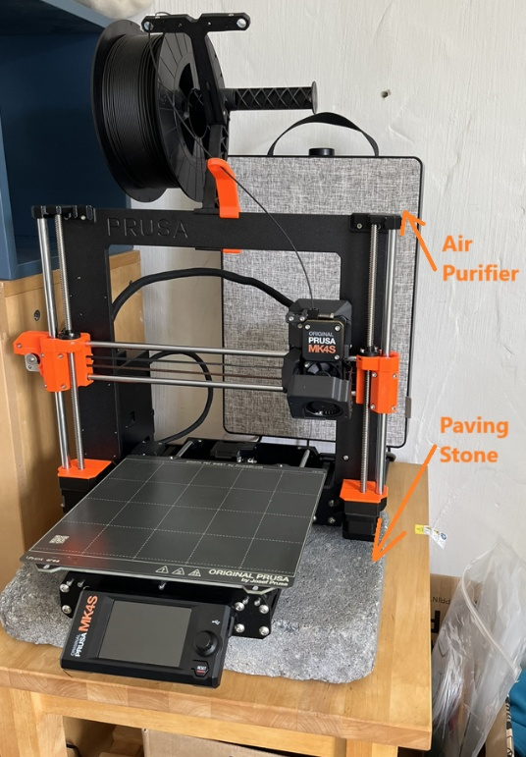

# Option 2: Alternative Machine

If you decide this is a lot of time/effort/cost for an old machine, then you have a good alternative.

The Bambu Lab PIP costs 399 Eur, and it’s reliable. Two of my colleagues have this model: one is an engineer like me, and one is not. Both of them enjoy using it.

This model is a lot more “plug-and-play”. It comes with an enclosure so you don’t need air filter or paving stone, and prints are generally more reliable in an enclosure due to constant temperature of the chamber.

Bambu Lab P-Series: <https://eu.store.bambulab.com/collections/p1-series>

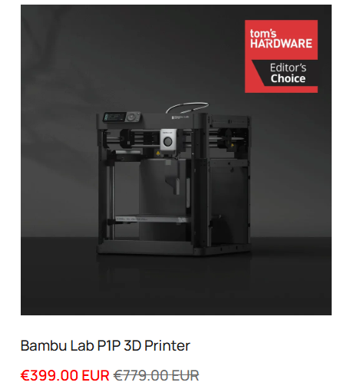

Bambu Lab has a community of users who share models on MakerWorld. <https://makerworld.com/en> , so it’s similar to Prusa’s online community at printables.com. Both sites are good.

# Afterwards

If you are considering switching to an alternative machine, then I would offer to buy your printer from you. This is because I enjoy tinkering and fixing old machines and tools.

If you’re interested in this option, we can look at Marktplaats and other sites to figure out what is a fair price. Here’s what I just found today:

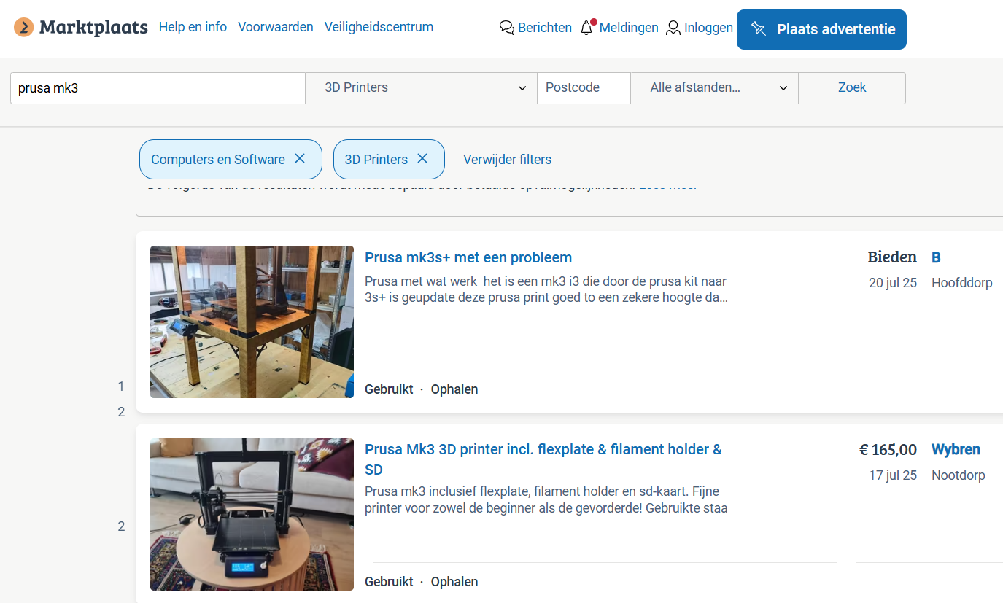

If you take this price and put it towards a new Bambu printer, you would be comparing:

180 Eur for a repair of an old model printer

against (399 – 165) = 234 Eur for the cost of a new printer with enclosure