

Department of Mechanical Engineering

Engr 466 Design Report 1

|  |  |
| --- | --- |
| Authors: | Anderson Li  Andrew Bornstein |
|  |  |
| Filename: |  |
| Date: |  |
| Total Pages: | 32 |

Table of Contents

1 Introduction 1

1.1 Background 1

1.2 Objectives 1

2 Manufacturing Method 1

3 Film Gate Concept Designs 2

3.1 Design Concept #1: Rail and Pressure Plate 3

3.2 Design Concept #2: Side Adjusting Plate Design 4

3.3 Design Concept #3: Flexible Side Plate Design 5

3.4 Comparison and recommendation 6

4 Film Transport Drive Mechanism Design Concepts 6

4.1 Design Concept #1: Stepper Motor – Direct Drive 7

4.2 Design Concept #2: The Geneva Drive 8

4.3 Design Concept #3: Servo Motor – Direct Drive 10

4.4 Comparison and recommendation 10

5 Sprocket for Transport 10

5.1 Inherent System parameters 11

5.2 Design of the sprocket pair 13

5.3 Choosing a proper set 15

6 Passive Film Rollers 16

6.1 Design #1: Simple Fixed Pin 16

6.2 Design #2: Chicago Bolt and Plastic Sleeve Bearing 17

6.3 Design Concept #3: Custom Made Sleeve Bearing 18

6.4 Recommendations 18

7 Reel Up-Take and Out-Take Drive System 18

7.1 Design Concept #1: Spring Loaded Potentiometer 18

7.2 Design Concept #2: Infrared Range Finder 19

7.3 Recommendations 20

8 Tensioning Device 20

8.1 Design Concept #1: Allow the reel to Slip 20

8.2 Design Concept #2: Feedback With a Professional Tension Sensor 21

8.3 Design Concept #3: Optical Encoder Film Detection Method 22

8.4 Recommendations 22

9 Preliminary frame layout concepts 23

9.1 Upright Frame Layout 23

9.2 Perpendicular Camera mounted Layout 24

10 Figure 5 - Perpendicular Camera Mount LayoutControl System 24

11 Choosing Illumination Source 25

12 Conclusions 25

References 27

Table of Figures

Figure 1 – Film gate concept design #1 3

Figure 2 - Film gate concept design #2 4

Figure 3 - Film gate concept design #3 5

Figure 1 - Stepper Motor Coupled to a Sprocket Pair 7

Figure 2 - Frame Position Feedback Device Concept 8

Figure 3 - Geneva Drive System Coupled to a Film Sprocket 9

Figure 4 - Five Slotted Geneva Drive 9

Figure 5 - Telecine System Layout Concept Sketch 11

Figure 6 - 28mm Film Segment 12

Figure 7- Coarse Sprocket 13

Figure 8 - Fine Sprocket 13

Figure 9 - Exploded Sprocket Roller: Radius = 11.94mm 16

Figure 10 - Aluminum pins used to guide 8mm film [2] 17

Figure 11 - Chicago Bolt 17

Figure 12 - Roller Design 17

Figure 13 - Measuring Film Reel Radius with a Roller on a Spring Loaded pendulum 19

Figure 14 - Measuring Film Reel Radius with an Infrared Range Finder 19

Figure 15 - Ratcheting Freewheel Sprocket from a Bicycle 20

Figure 16 - Ratcheting Film Feeder Concept Sketch 21

Figure 17 - Professional Tension Sensor 22

Figure 4 – Upright Frame Layout 23

10 Figure 5 - Perpendicular Camera Mount LayoutControl System 24

Figure 21 - Arduino Uno Microcontroller 24

List of Tables

Table 1 - Manual machining and 3D printing comparison 2

Table 2 – Scoring table for the film gate design concepts. 6

Table 3 – Drive mechanism comparison 10

Table 4 - Sprocket Analysis: varied number of teeth 14

Table 5 – Sprocket comparison table 16

Table 6 – Film roller comparison table 18

Table 7 – Tension device comparison table 23

Table 8 – Light sources comparison 25

Table 5 - Table of Design Decisions 25

# Introduction

* 1. Background

Recently a large collection of old 28 mm movie films that were made between 1915-1918 has been found in Victoria. These films were used for instruction and entertainment in schools during this period. The projectors for these films have not been made for the past 90 years and now the films are beginning to decompose at a very rapid pace. The films represent a cultural heritage valuable to scholars of social science and history and it would be a great loss to future generations if the films were to be disintegrated before they could be rescued.

* 1. Objectives

The objective of the project is to construct a film transport mechanism that will capture each image from the film and recombine the stills in a computer to recreate the entire movie. The core components of this project would include: transport mechanism to advance the frames, film gate to flatten and align the film, drive system to rotate the outtake and intake of the film, source of illumination for project images, and create a mounting point for the camera.

# Manufacturing Method

The parts to be made in this project can be manufactured by machining the parts in the machine shop or printing them using a 3D printer. If the part is to be machined then the material will most likely be made out of aluminum. If the 3D printing method is used then the part would be made out of ABS plastic. Both methods of manufacturing methods have its strengths and weaknesses as shown in Table 1. Depending on the application, one method may be preferred over the other.

Table 1 - Manual machining and 3D printing comparison

|  |  |
| --- | --- |
| **Cost** | Although the price of ABS plastic is more expensive per kilogram than aluminum ($40/kg for plastic as opposed to $2 per Kg for aluminum), it can actually be less expensive to print parts using the 3D printer because less material is wasted in the process of making the part. |
| **Weight** | ABS plastic has a very light density of 1.03 g/cm3 compared to aluminum which has a density of 2.70 g/ cm3. |
| **Durability** | The durability of aluminum is much greater than ABS plastic. Aluminum has a tensile strength of up to 69 GPa compared to ABS Plastic which only has 30 MPa. Therefore parts can be thinner with aluminum and still provide lots of strength. |
| **Application** | One of the limitations of the 3D printer is the size of the part. Typical commercial 3D printers offer a space no more than 10 cm by 10 cm by 10 cm. Larger parts must be done with machining. However, many complex geometric shapes can be achieved with 3D printing that would normally be impossible using machining techniques. |
| **Precision/Reliability** | The precision and reliability of the 3D printer also falls a bit short. The error of the desired part can be as great as ± 0.5 mm. Higher accuracy components should definitely be machined. |
| **Speed** | With the 3D printer, the speed at which a part is prototyped is very fast. Since the process is automated, a 3D model drawing can be directly transferred from the computer without going through a machinist. Machining the part would take more man hours which also contributes to the cost. |

# Film Gate Concept Designs

The film gate is necessary part in any movie projectors or telecine machines to center and align the film while the frame is being exposed and projected. Three different design concepts were developed to satisfy the requirements from the client. Due to the precision necessary to position the film, this device will be machined out of aluminum in the machine shop. However, the mounts attached to the film gate for the LEDs and camera can be made using the 3D printer to save weight and cost, but this will be discussed further along in the design process. The main criteria for the film gate are as follows:

* Allows film to pass through without moving too much from side to side
* Keeps the film reasonably flat
* Has an opening to allow light to pass through and illuminate the film
* Must advance the film without any significant stress, drag or damage.
  1. Design Concept #1: Rail and Pressure Plate

The first design concept for a film gate is to align the film using a set of fixed rails and a pressure plate on top. The pressure plate utilizes springs with screws for adjustment to keep the film resting on the gate while the rails on each side prevent the film from moving side to side. The advantages of this design is that it is easier to machine and has less parts to assemble compared to the other concepts. The problem with this design is that there is no flexibility in the adjustment of the film from side to side due to the rails being fixed. This could cause issues if the film gets caught between the rails which could damage the film.

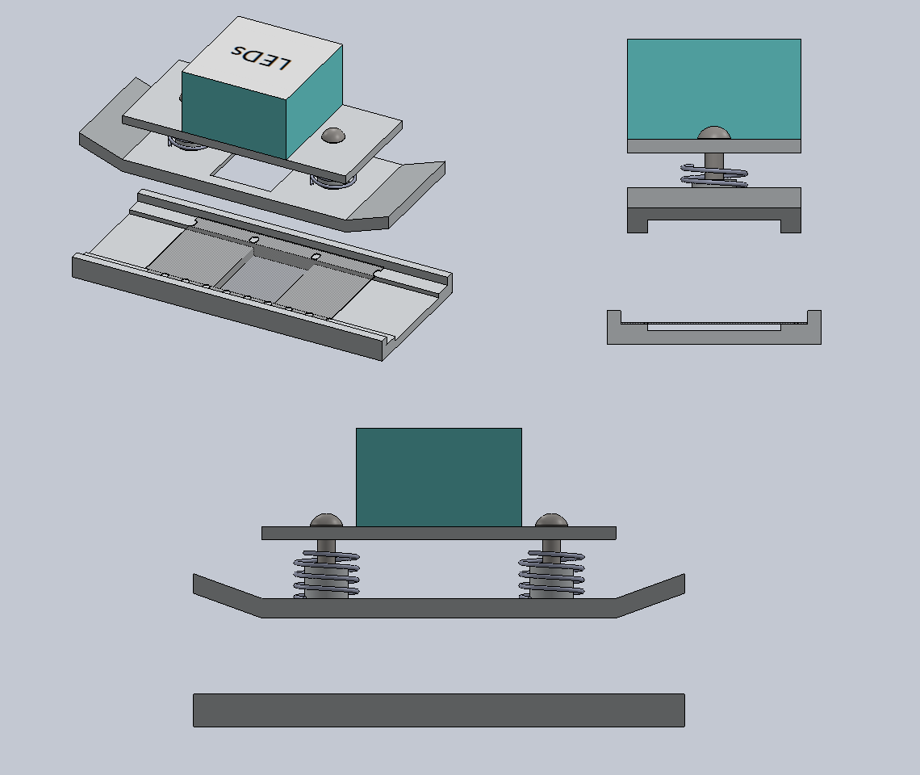

Figure – Film gate concept design #1

* 1. Design Concept #2: Side Adjusting Plate Design

The second design concept is based on the first design but a side plate is also implemented to allow more adjustment and flexibility regarding the side to side movement of the film. Similar to the pressure plate, the amount of pressure the side plate acts on the film can be adjusted using the two screws and if the film begins to exert forces against the walls, the spring mechanism will displace to relive the stress on the film. The major issue with this design is that the side plate is in one whole piece and it also rests directly against the base plate. Having the side plate as a single piece would mean displacements on one end of the film gate will directly affect the other. The side plate also rests directly on the base plate and if it is not properly machined, the plate movement could either cause too much friction or leave a gap for the film slide through.

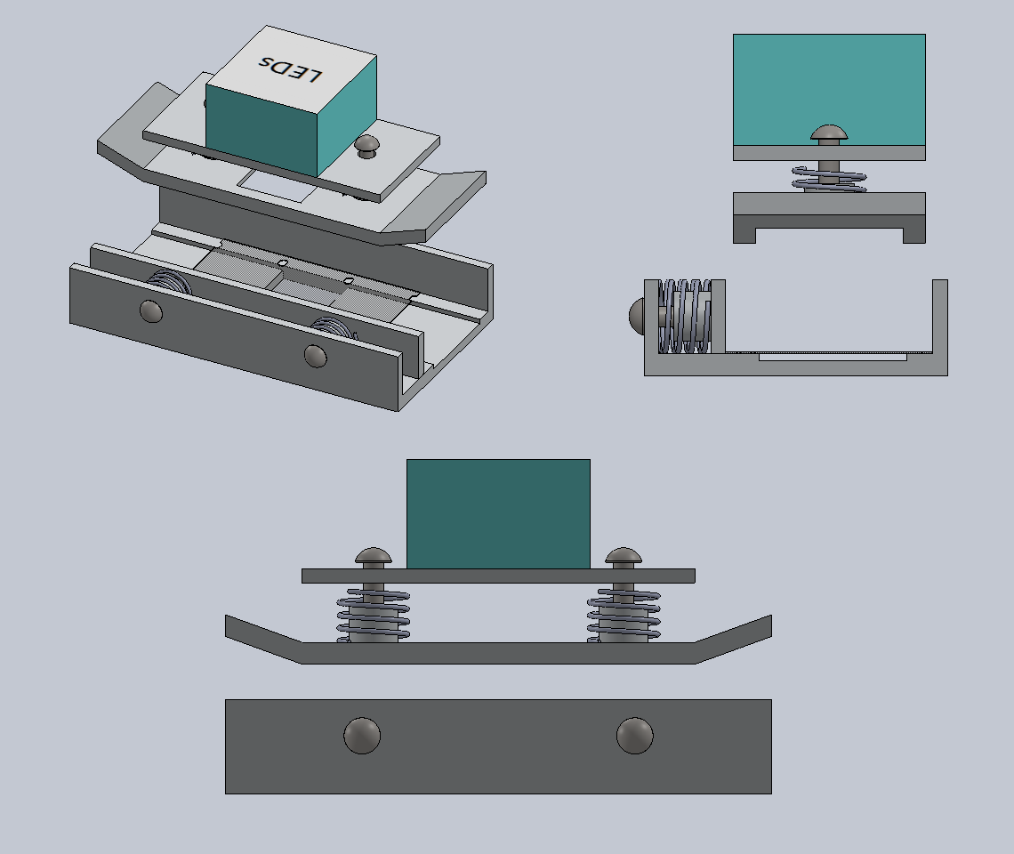

Figure - Film gate concept design #2

* 1. Design Concept #3: Flexible Side Plate Design

This design is based on the second design but attempts to fix some of the flaws that are associated with it. Instead of having the side plate as a single piece, it is cut into two pieces so that the adjustments of the plate are independent of one another. Channels were also cut into the base plate so that the side plate has room to overlap. This allows for a higher tolerance when machining the parts since the side plate is not flush on the base plate and it also reduces the amount friction on the side plate during movement. The disadvantage with this concept is that there is more complexity in machining and assembly of the parts, but it offers the best alignment quality.

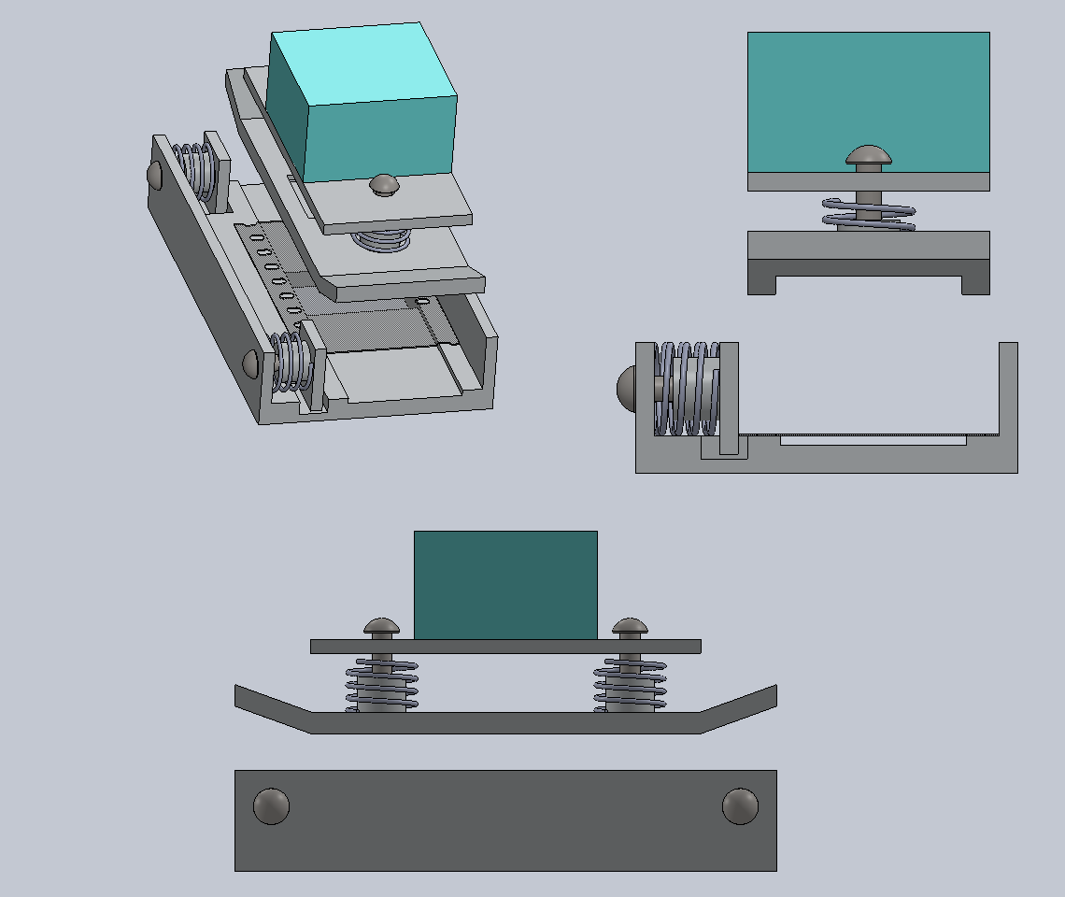

Figure - Film gate concept design #3

* 1. Comparison and recommendation

After reviewing the three concept ideas a comparison table was created. The categories in this table are based on the client’s requirements and our ability to make the components for the concept.

Table – Scoring table for the film gate design concepts.

|  |  |  |  |  |  |  |
| --- | --- | --- | --- | --- | --- | --- |
|  | Ease of Manufacture | Ease of Assembly | Keeps Film Flat on Plate | Resistance to side to side movement. | Reliability, Minimize Damage to Film | Total Score |
| Concept #1 | 2 | 3 | 3 | 2 | 1 | 11 |
| Concept #2 | 2 | 2 | 3 | 6 | 3 | 16 |
| Concept #3 | 1 | 1 | 3 | 10 | 8 | 23 |
| Max Score | 3 | 3 | 3 | 10 | 10 |  |

As shown from Table 2 concept #3 scored the highest because it best satisfies the client’s criteria for the project. Concept #1 and #2 is more simplistic would have scored higher in reliability if the film were perfectly flat and is in good condition. However, due to the extensive age, the film itself is falling apart so extra mechanisms is required to keep better alignment. Concept #3 is recommended because it would be the most reliable in terms of minimizing the possibility of damaging the already deteriorating film and spring mechanism will ensure proper alignment of the frame.

# Film Transport Drive Mechanism Design Concepts

The primary function of this device is to move 28mm film, one frame at a time, with great accuracy, through a film gate where each frame can be illuminated and digitally captured. The following sections will outline three methods of transporting the film, the pros and cons of each method, and justification for the final recommended design.

The important criteria in developing the drive method are as follows:

* High precision rotational positioning
* Must advance the film without any significant stress, drag or damage.
* Ease of Manufacture and assembly (Limited time constraint)
* Durable and long-lasting

Cost is a factor, but certainly not of great concern. More than adequate funding and materials are provided. Weight and size are also of little concern; the device does not have to be portable.

The speed of frame movement does not need to be very high. It is likely that the device will be limited by the capture rate of the camera as opposed to the speed of the drive system. This rate is on the order of 1-3 frames per second. Care should be taken so that, at this speed, the film is subjected to little stress.

* 1. Design Concept #1: Stepper Motor – Direct Drive

A Vexta EM569H-NA 5-phase stepper motor was provided by the client. This motor has a step size of 0.72 Degrees per step. As this stepper motor has more than enough resolution and torque to fulfill the design requirements, no other stepper motors were considered.

The stepper motor is interfaced directly with a sprocket as seen in the figure below. The radius and number of teeth of the sprocket should be chosen so that the angle between the teeth correspond to an integer multiple of the step size of the stepper motor.

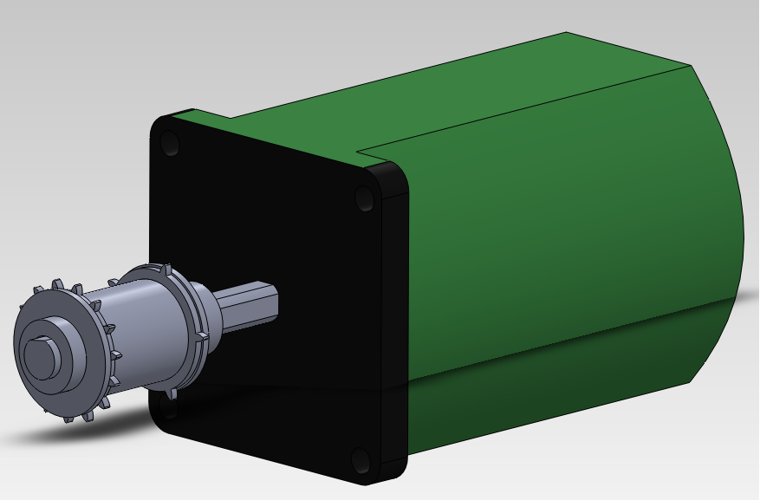

Figure 4 - Stepper Motor Coupled to a Sprocket Pair

To eliminate errors from the motor skipping steps, or slipping on torn sprocket holes, a frame position feedback loop is recommended. The system is simple; an optical encoder placed on the edge of the film, counts the number of sprocket holes that have passed. The motor will stop stepping once the encoder has counted three sprocket holes indicating that the film has progressed by one frame.

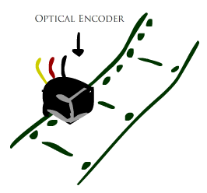

Figure - Frame Position Feedback Device Concept

This design is closed-loop. The error in film position will result from the step error of the stepper motor, and the tolerance when machining the sprockets. It is unknown whether this resulting error will be acceptable for this application.

The design is simple to implement with the help of an appropriate microcontroller to handle the logic of the feedback loop. The low number of parts also means that it will be simple to assemble and maintain. As both the stepper motor and optical encoder are already possessed by the group, further implementation costs are minimal.

* 1. Design Concept #2: The Geneva Drive

The Geneva mechanism is used in many film projection applications. It is a proven and logical design choice for this application. The angle between the slots of the Maltese cross should correspond to the angular length of one frame as it passes over the sprocket coupled to it. In the figure below, a Maltese cross with four slots will move the sprocket through 90 degrees for every full rotation of the input crank. In the second image, a five slotted Maltese cross will move the sprocket through 72 degrees for the same full rotation of the input crank.

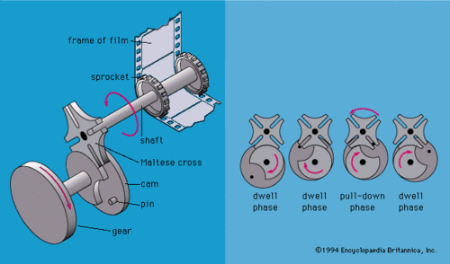

Figure - Geneva Drive System Coupled to a Film Sprocket

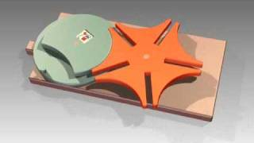

Figure 7 - Five Slotted Geneva Drive

This design is open loop. The error in the frame position depends entirely on the accuracy when machining the mechanical components. This design is more complicated to design initially, but once it is machined its implementation is simple. It has no feedback loop so there is no requirement for sensors to control its position. Another advantage is that during the dwell phase, the frame is stationary and can be captured without stopping and starting the driving motor.

A major disadvantage to this system is the uncontrolled accelerations inherent to the mechanism. This will apply unnecessary stress to the already delicate film.

* 1. Design Concept #3: Servo Motor – Direct Drive

A third design option is to replace the stepper motor with a continuous rotation servo motor with no finite angular position resolution. This system is loop and relies entirely on sensors detecting position of the film to control the actuation of the drive motor. The use of a continuous rotation servo also allows for a greater range of sprocket radii that can be used because it is not a requirement that the angle between the teeth on the sprocket is divisible by the step size.

The use of this concept would require that an appropriate motor be speed for the application. In addition, it is questionable whether this motor can be stopped and started with enough rotational precision to show noticeable improvement in frame position error when compared to the use of a stepper motor.

* 1. Comparison and recommendation

The stepper motor based drive system is recommended for this system. Because of the step resolution of the stepper motor, it is nearly equivalent to using a servo motor. The servo motor is an unnecessary cost. Sensors can be used to ensure that skipping a step will not result in position error. We believe that the level of error in a single step is acceptable and will not noticeably affect the results of the film.

Table – Drive mechanism comparison

|  |  |  |  |  |  |  |
| --- | --- | --- | --- | --- | --- | --- |
|  | Frame Transport Accuracy | Low Cost | Ease of Machining and Assembly | Available Feedback | Minimize stress applied to film | Total Score |
| Stepper Motor | 8 | 9 | 9 | 4 | 5 | 35 |
| Geneva Mechanism | 3 | 3 | 8 | 0 | 2 | 16 |
| Servo Motor | 3 | 4 | 3 | 10 | 5 | 25 |
| Max Score | 10 | 10 | 10 | 10 | 10 |  |

# Sprocket for Transport

Instead of being driven through the film gate with a claw like a typical film projector, the film will be moved with a single sprocket. This sprocket is driven externally, via one of the drive systems mentioned above, and it is offset from the film gate (to the right as seen in the sketch below). A second sprocket is also offset from the film (to the left as seen in the sketch below). This second sprocket is passive and merely acts as a guide as the film enters the film gate.



Figure 8 - Telecine System Layout Concept Sketch

The design requirements of this component are as follows:

* Sprocket teeth are of appropriate size to allow the film to move without slippage or damage
* Tooth spacing on the sprocket match the hole spacing on the film
* High number of teeth interfacing with film holes at any time while maintaining a small angle through which the film must bend.

Due to the application, this part must be custom made. It is assumed that such a detailed, custom part will be fabricated on a CNC device. The difficulty in producing this part is high.

* 1. Inherent System parameters

The film is what all major components of this telecine device should be based around. A sketch of a short segment of 28mm film is shown below. As the name suggests, the film is 28mm wide. Each frame is 15mm in length. On the lower side of the frame one can see 3 sprocket holes per frame. On the upper side there is only 1 sprocket hole per frame.

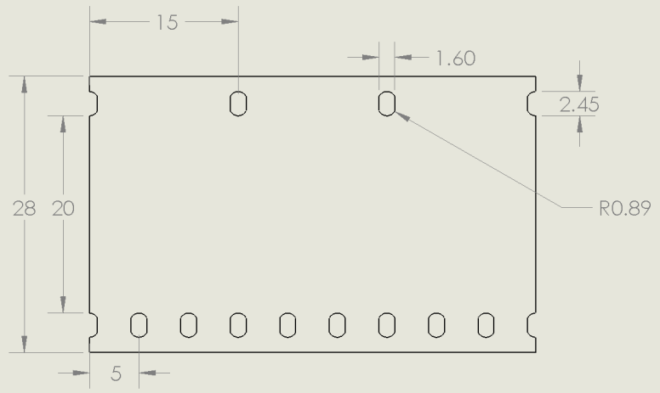

Figure 9 - 28mm Film Segment

The above sketch defines some initial parameters of a sprocket set suited for the system. Two different sprockets are required to propel this film. A coarse sprocket, with a 15mm arc length between each tooth will drive the upper portion. A fine sprocket, with a 5mm arc length between each tooth will drive the lower portion. The fine sprocket must have exactly three times the number of teeth as the coarse sprocket for the teeth to line up on both sides of the film.

The images below are of a set of sprockets designed according to parameters discussed later in this section. At this point they serve as an example of a theoretical set of sprockets with the appropriate tooth spacing and tooth ratio to drive 28mm film. Sprocket radii or the number of teeth can be changed and still drive the film so long as the arc lengths and tooth ratios mentioned above are maintained.

|  |  |
| --- | --- |
| G:\flim-transport-project\Models\CoarseSprocketFront.png  Figure 10- Coarse Sprocket | G:\flim-transport-project\Models\CoarseSprocketIso.png |
| G:\flim-transport-project\Models\FineSprocketFront.png  Figure 11 - Fine Sprocket | G:\flim-transport-project\Models\FineSprocketIso.png |

* 1. Design of the sprocket pair

Of the three drive mechanisms mentioned above, the design concept which is most heavily influenced by the sprocket dimensions is the stepper motor drive. Thus, a set of sprockets are designed using the step size of 0.72 degrees.

The following table compares the parameters of a number of sprockets. The number of teeth of the coarse sprocket (N/3 – the sprocket with fewer teeth) is varied from 4 to 12 and the remaining parameters are calculated based on an arc length between teeth on the fine gear of 5mm. The resulting minor arc length should be as close to the ideal 5mm as possible and the frame arc should be close to 15mm. The number of angular steps between each tooth on the sprockets should be an integer value to minimize angular position error. In the sample calculation of the sprocket radius below, the number of teeth on the coarse sprocket is 5, and an ideal arc length of 15mm is used.

In the following calculation for the steps per tooth (SPT) of the coarse sprocket, the angle between each tooth on the sprocket with 5 teeth is divided by the step size of the stepper motor of 0.72 degrees.

=100 Steps per tooth

This value corresponds to the number of steps required to progress by one frame.

Table 4 - Sprocket Analysis: varied number of teeth

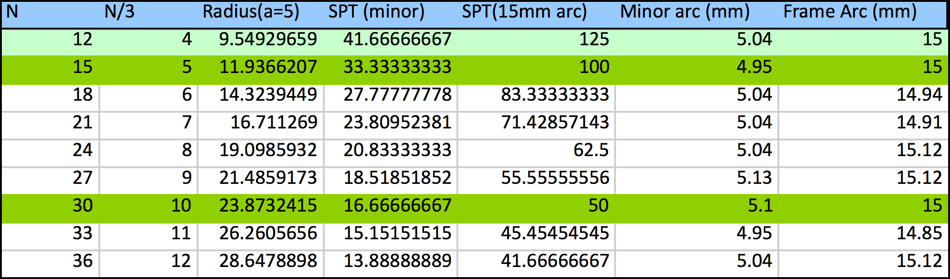The most important column in the above table for deciding on the parameters of the sprockets is the “SPT(15mm arc)” column. This lists the number of steps that the stepper motor must execute to move a tooth through an arc of 15mm length (the length of one frame). This number should be an integer value to minimize the amount of error.

A radius of 9.55mm, 11.94mm, and 23.87mm all result in integer values in the “SPT(15mm arc)” column. In addition, these radii with their corresponding number of teeth all have a tooth-to-tooth arc length of exactly 15mm on the coarse sprocket.

* 1. Choosing a proper set

Deciding between the three sprockets mentioned above (again assuming that they will be used for the stepper motor drive system) can be done by reviewing the design criteria. It is desirable to have a sprocket which is:

* Precise
* Relatively easy to machine
* A manageable size
* High sprocket tooth to film contact ratio
* Puts minimal stress on the film

The sprocket with a 23.9 mm radius is slightly too large to be practical in this application; given the size of the film, a sprocket with a 48 mm diameter is a waste of space on the apparatus. Moreover, the relatively large number of teeth on this sprocket makes machining more complicated. The advantage of a sprocket this size is the relatively large number of teeth in contact with the sprocket holes of the film at any time; this reduces the likelihood that the film will slip due to torn sprocket holes. A larger sprocket also means that the angle that the film has to bend through is less than on a relatively smaller sprocket; minimizing the bending of the film results in less stress on the film.

As the sprocket radius shrinks, the resolution of the steps between each tooth increases. A higher resolution implies that the positioning of a frame can be done more precisely. For the sprocket with a radius of 11.94 mm and a coarse tooth count of 5, the steps-per-tooth is 100. This means that for each step, the film advances by 0.15 mm. Adjusting the frame position by increments of this size gives the system a great deal of control over frame adjustments.

The sprockets with radii of 9.55 mm, and 11.94 mm have a similar steps-per-tooth count; the resolution difference is minimal between these two sizes. The sprocket with a radius of 11.94 mm is recommended for use in the design. This sprocket is considered to be a compromise between the 23.9 mm sprocket and the 9.55 mm sprocket.

This sprocket design can be easily used with the other two drive system concepts mentioned above. If the coarse sprocket shown in Figure 10 is used, the five slotted Geneva mechanism below is appropriate for this application. Each movement of the Maltese cross corresponds to the progression of one frame and a sprocket rotation of 72 degrees and an arc length movement of 15 mm.

A continuous rotation servo can stop at any angle; therefore, the dimensions of the sprockets are irrelevant, only the relation between sprocket radius and the number of teeth matters in order to achieve the desired arc length between teeth of 15 mm.

An exploded view of the recommended sprocket set can be seen below. A cylindrical spacer is placed between the sprockets and has a width of 21 mm. The radius to the base of the sprocket teeth is slightly less than 11.94 mm (11.5 mm); a washer with an outer radius of 11.94 mm is placed next to the sprocket. This design feature is meant to prevent the film from getting caught at the base of the teeth on the sprocket. In order to achieve the high precision requirements of the sprockets these parts will be machined out of aluminum.

Table – Sprocket comparison table

|  |  |  |  |  |  |  |
| --- | --- | --- | --- | --- | --- | --- |
|  | Frame Precision | Ease of Manufacture | Size | Tooth/film contact ratio | Minimize stress applied to film | Total Score |
| Small Sproket | 9 | 2 | 9 | 2 | 2 | 24 |
| Medium Sproket | 7 | 3 | 7 | 7 | 6 | 30 |
| Large Sproket | 3 | 4 | 3 | 9 | 9 | 28 |
| Max Score | 10 | 10 | 10 | 10 | 10 |  |

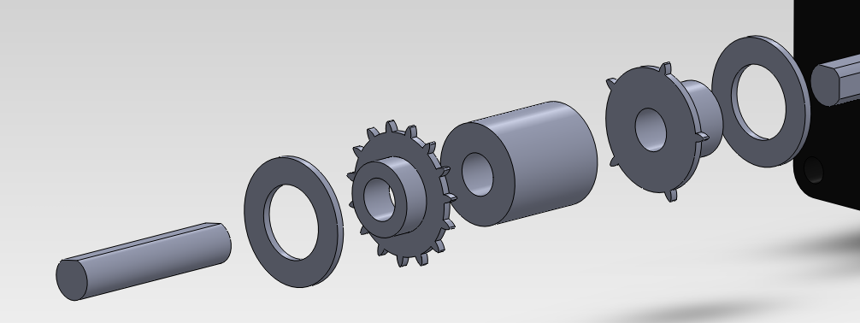

Figure 12 - Exploded Sprocket Roller: Radius = 11.94mm

# Passive Film Rollers

Next to the sprockets and along the film’s path are a set of passive rollers which guide the film.

* 1. Design #1: Simple Fixed Pin

These rollers can be as simple as a few pins with no ability to rotate. This concept can be seen implemented below by Richard J. Kinch in his own telecine device.[2]

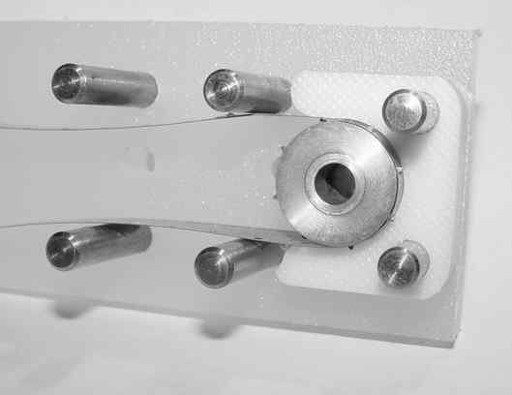

Figure 13 - Aluminum pins used to guide 8mm film [2]

This design is simple, easy to produce, and, as seen above, proven to function in an existing telecine device. However, the current project does not deal with relatively new 8mm film. The 28mm film is beginning to decompose. Care should be taken to apply as little stress to the film as possible. This system of fixed pins subjects the film to unnecessary friction.

* 1. Design #2: Chicago Bolt and Plastic Sleeve Bearing

A simple bearing design is proposed using a Chicago bolt with a 28mm shank placed inside a plastic tube. The plastic has a low coefficient of friction so that it may rotate smoothly on the Chicago bolt.

|  |  |
| --- | --- |
| http://www.yandcdisplay.com/wp-content/uploads/wpsc/product_images/chicago-screws.jpg  Figure 14 - Chicago Bolt | G:\flim-transport-project\Models\Rollerdesign.png  Figure 15 - Roller Design |

Both Delrin® and Teflon have extremely low dynamic coefficients of friction of 0.25 and 0.7 respectively. [3] A less expensive plastic such as abs has a coefficient of friction of 0.5, [4] which is still acceptable for this application.

This option is much more expensive and time consuming than the previous design. Chicago bolts and plastic rods are relatively expensive. An initial cost estimate placed a single 1-1/4" aluminum Chicago bolt at $13.95. This can be compared to 6 feet of 1/8” aluminum rod stock costing only $2.11 from McMaster-Carr.

* 1. Design Concept #3: Custom Made Sleeve Bearing

With a bit more time in the machine shop, the Chicago bolts become unnecessary. Custom sleeve bearings can be made by machining and threading some aluminum rod so that a plastic sleeve can be slid on and the assembly can be screwed onto the system frame.

* 1. Recommendations

Because only a small number of these rollers are required, it is recommended that custom made sleeve bearings be machined. This will save on material costs. The added time required for machining is minimal.

Table – Film roller comparison table

|  |  |  |  |  |
| --- | --- | --- | --- | --- |
|  | Low Cost | Time it takes to make parts | Minimize friction applied to film | Total Score |
| Pins | 10 | 8 | 2 | 20 |
| Purchased Sleeve Bearings | 2 | 10 | 15 | 27 |
| Machined Sleeve Bearings | 10 | 4 | 17 | 31 |
| Max Score | 10 | 10 | 20 |  |

# Reel Up-Take and Out-Take Drive System

The angular speed of the up-take and out-take film reels are different from each other and change constantly based on the amount of film on the reel. The reels will be rotated by a DC motor from an old cassette tape device. The angular speed of each motor will be controlled independently with a control signal running a PWM circuit. To develop the logic needed to control the PWM signal a relation must be developed between the angular speed and the amount of film on the reel. The major design challenge in this case is reliably monitoring the continuously changing film radius. Two initial design concepts to handle this problem are described below.

* 1. Design Concept #1: Spring Loaded Potentiometer

A pendulum with a roller on one end can be spring-loaded to rest against the film on the reel. The pendulum is pivoted about a potentiometer. As the film is removed from the reel, the radius shrinks and the pendulum moves towards the center of the reel, changing the resistance of the potentiometer. This change in resistance can be translated to an increase in motor speed, ensuring that the film continues to be fed at the proper rate. A concept sketch of this design can be seen below.

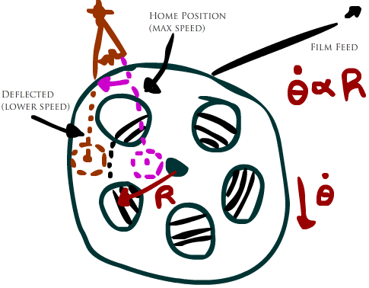

Figure - Measuring Film Reel Radius with a Roller on a Spring Loaded pendulum

* 1. Design Concept #2: Infrared Range Finder

Another option is to measure the radius of the film reel indirectly with an infrared range finder. As the reading from the range finder changes, the control signal to the PWM circuit is augmented. An increasing range value indicates that the film is being removed from the reel and the motor should be increasing in angular velocity. A concept sketch of this design can be seen below.

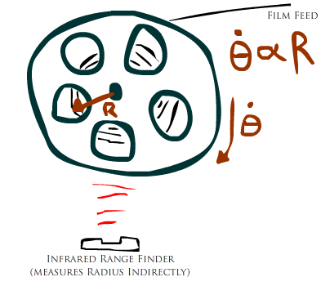

Figure - Measuring Film Reel Radius with an Infrared Range Finder

* 1. Recommendations

More testing is required to know if the infrared sensor will work in this application. The beam characteristics and the resolution of the reading may be inadequate. However, implementing the infrared range finder is far easier and preferable to fabricating a custom, spring-loaded potentiometer.

The particulars of this design are not yet complete. A relation between the linear speed of the film through the film gate, the radius of the film on the reel, and the rotational velocity of the film reel needs to be developed.

# Tensioning Device

In order to prevent damage, a closed-loop system to maintain appropriate film tension is required. This system should augment the rotation of the up-take and out-take film reels to minimize the tension in the event that the film becomes too tight. The system should also act as an emergency stop if the film breaks.

* 1. Design Concept #1: Allow the reel to Slip

The use of a ratchet mechanism in the drive turning the film reels will prevent the film from becoming tensioned to the point that it is opposing the torque exerted by the DC motor on the film reel. If the film becomes tensioned to the point that it opposes forward rotation, the ratchet will slip. This will greatly reduce the maximum tension force that the film may be subjected to.

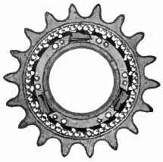

Figure - Ratcheting Freewheel Sprocket from a Bicycle

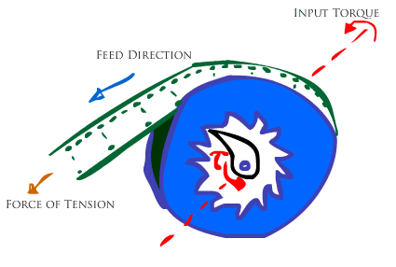

Figure - Ratcheting Film Feeder Concept Sketch

* 1. Design Concept #2: Feedback With a Professional Tension Sensor

A professional tension sensor will give precise readings of the current state of the film. From these readings, a control system can be developed with maximum and minimum threshold values for tension to control the amount of power delivered to the drive system of the device. If the tension is too high, motor speeds can be adjusted to reduce this value. If the tension is too low (potential broken film), the motors can all be shut down to prevent further damage.

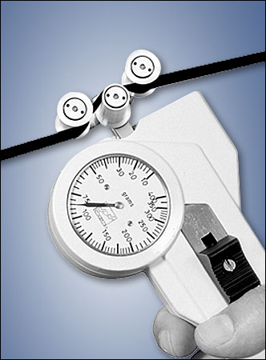

Figure - Professional Tension Sensor

* 1. Design Concept #3: Optical Encoder Film Detection Method

A much simpler solution to this problem is to position an optical encoder over the film. If the encoder does not sense the film, it assumes that the film is broken and all the motors driving the system shut down. This solution is not preventative, it would not detect the tension in the film as it increases and adjust the motor speeds to reduce it. This design can only detect if a failure has occurred and shut down the system to prevent further damage.

* 1. Recommendations

The ratchet bearing on the film reel mounts would be useful in ensuring that the tension in the film is never opposing the torque of the motor. The design and plan for implementation of this system have not yet been considered. The cost of such a device may be too high to be worth it for this system.

The two designs meant to measure the tension of the film are wildly different. The Professional tension sensor requires a very complicated control system and is extremely expensive; however, the device could potentially detect unreasonable stress in the film and prevent a breakage before it happens. The optical sensor based design is extremely simple, cheap, and easy to implement and control; however, the device can only detect a film breakage and prevent further damage by shutting down the system.

Table – Tension device comparison table

|  |  |  |  |  |  |
| --- | --- | --- | --- | --- | --- |
|  | Low Cost | Easy Control System | Damage prevention | Minimize Friction applied to film | Total Score |
| Tension Sensor | 1 | 3 | 20 | 2 | 26 |
| Optical Encoder | 10 | 8 | 6 | 10 | 34 |
| Max Score | 10 | 10 | 20 | 10 |  |

# Preliminary frame layout concepts

The frame is where all the components will be mounted on to. At this point in the design the specific details of the frame is uncertain because it depends on the components that are design and how they need to be mounted. However different frame layouts were still considered, but they are subject to change depending on our final component designs.

* 1. Upright Frame Layout

The upright frame as shown in Figure 21 was specified by our client. The problem with this design is that the camera is mounted on top which makes it more difficult to adjust the camera to match the frame to be captured. It is also very heavy and bulky to carry around, but the design is very simple to build and assemble.

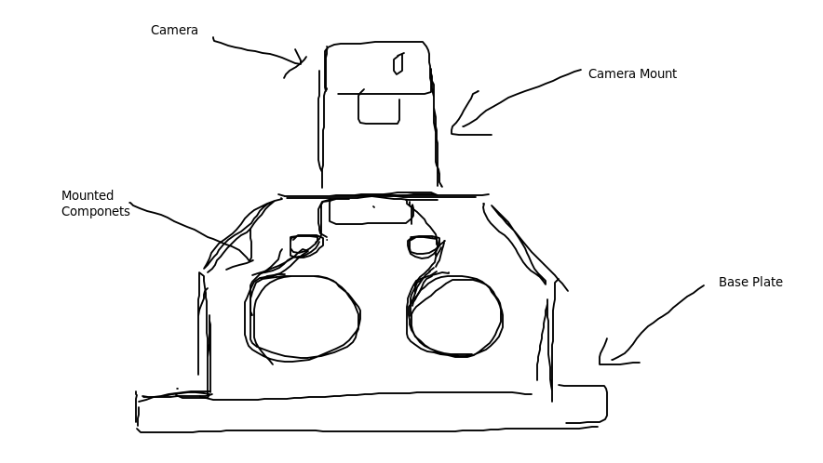

Figure – Upright Frame Layout

* 1. Perpendicular Camera mounted Layout

This type of frame layout as shown in Figure 22 is common to many Telecine machines that were retrofitted from old projectors. The advantage of this design is that the camera is mounted separately from the frame which allows better camera adjustments with the frame. However this design is more complex to manufacture and it is not very modular.

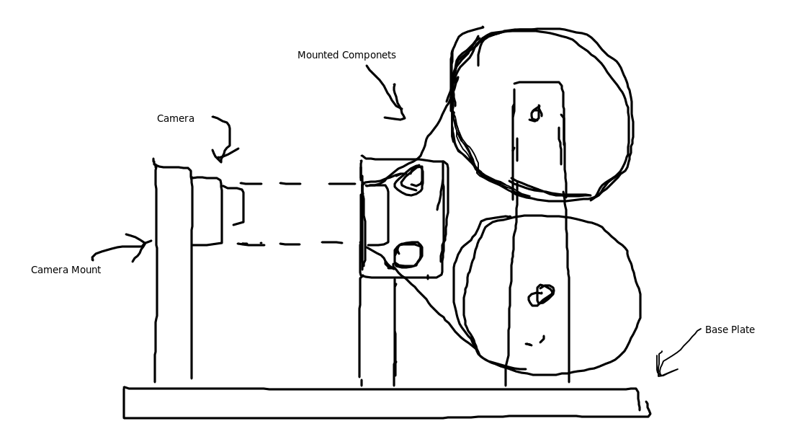

Figure – Perpendicular camera mount layout

# Control System

The control system will be implemented using the Arduino Uno microcontroller. Although many other options exist, the Arduino Uno is preferred due to its good community support, open source libraries, low cost, easy implementation, and lots of past experience with the device.

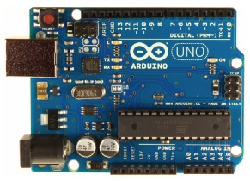

Figure - Arduino Uno Microcontroller

# Choosing Illumination Source

In order to capture the images on the film, a bright light source is required to project the image. Although many different types of illumination methods do exist, LEDs with a light filter would be the best option for this project due to its low heat output, reliable lifespan, and high lumen per watt values. LED illumination cost more, but the low heat output and low power consumption is necessary if the machine is to run for a long periods of time. Table 8 shows the comparison between 3 common light sources.

Table 8 – Light sources comparison

|  |  |  |  |
| --- | --- | --- | --- |
|  | **LEDs** | **CFLs** | **Incadescents** |
| **Lifespan** | 50,000 hours | 10,000 hours | 1,200 hours |
| **Cost** | $35.95 | $3.95 | $1.25 |
| **450 Lumens** | 4-5 Watts | 8-12 Watts | 40 Watts |
| **Turns on Instantly** | Yes | Slight Delay | Yes |
| **Heat Emitted** | 3 btu/hr | 30 btu/hr | 85 btu/hr |

# Conclusions

This report outlines the major design modules for a 28mm telecine device. The major components and the recommended design for each are listed in the table below.

Table - Table of Design Decisions

|  |  |
| --- | --- |
| Film Gate | Flexible Side Plate Design |
| Transport Mechanism Drive | Stepper Motor Drive |
| Sprocket Parameters | R = 11.94mm, Ncoarse = 5, NFine = 15 |
| Passive Film Rollers | Custom Made Sleeve Bearing |
| Reel Up-Take and Out-Take Drive | Infrared Range Finder: Angular Speed as a Function of Film Radius |
| Film Tension Monitor | Optical Encoder Sensing |
| System Frame Layout | Upright Layout |
| Microcontroller | Arduino Uno |
| Illumination Source | LEDs |

At this stage of the project there are a number of design modules, each with a distinct contribution to the function of the overall system. Determining how each component interfaces and interacts with the remaining components is the next step in this project. After this, each of the components needs to be combined and mounted onto a final frame.

# References

1. EarthEasy. [Online] [Cited: May 24, 2012.] http://eartheasy.com/live_led_bulbs_comparison.html.

2. Flatbed Scanner Digital Telecine (FSDT) Project. [Online] [Cited: May 25, 2012.]

http://www.truetex.com/telecine.htm.

3.Machinist-Materials, Plastics Comparison Table [Online] [Cited: May 25, 2012] http://www.machinist-materials.com/comparison_table_for_plastics.htm.

4. Omnia Plastica ABS Acrylonitrile-butadiene-styrene. [Online][Cited: May 25, 2012] http://www.matweb.com/search/datasheet.aspx?matguid=f6c2155e247b427d8bedaad7620b4c37&ckck=1.

5. 1 -1/4” Chigaco Screws. [Online][Cited: May 25, 2012] <http://www.screwpost.com/product_info.php?cPath=1&products_id=10>

6. 1/8” Aluminum Rod Stock. [Online][Cited: May 25, 2012]

<http://www.mcmaster.com/#standard-aluminum-rods/=hoo0rc>