

Department of Mechanical Engineering

Engr 466 Design Report 2

|  |  |
| --- | --- |
| Authors: | Anderson Li  Andrew Bornstein |
|  |  |
| Filename: |  |
| Date: |  |
| Total Pages: | 32 |

Table of Contents

1 Introduction 1

1.1 Current State of the Project 1

1.2 Objectives of this Report 1

2 Final Design Description 1

3 Detailed Mechanical Overview 4

3.1 Film Gate 4

3.1.1 Specifications 5

3.1.2 Failure Modes 6

3.1.3 Comments 8

3.2 Film Transport Mechanism 9

3.2.1 Specifications 10

3.2.2 Failure Modes 11

3.2.3 Comments 11

3.3 Film Reel Up-take and Out-take 11

3.3.1 Specifications 13

3.3.2 Failure Modes 14

3.3.3 Comments 14

3.4 Roller Array 14

3.4.1 Specifications 15

3.4.2 Failure Modes 16

3.4.3 Comments 16

3.5 Film Tension Monitor 16

3.5.1 Specifications 17

3.5.2 Failure Modes 18

3.6 LED and Camera Mounts 18

3.6.1 Specifications 18

3.6.2 Drawings 19

4 Design Component Interfacing and Assembly Overview 19

5 Electrical Design 20

6 Preliminary Software Design 22

7 Conclusions 24

References 25

8 Appendices 26

Apendix A: Insert Title 26

Apendix B: Insert Title 27

Apendix C: Insert Title 28

Table of Figures

Figure 1 - 28mm Film Segment 1

Figure 2: Transport Sprocket 9

Figure 3: Transport Sprocket - Side View 9

Figure 4: Film Transport Mechanism - Top View 10

Figure 5: Film Transport Sprocket - Exploded View 10

Figure 6: Reel Drive System (rubber belts for pulleys not shown) 12

Figure 7: Reel Drive System - Side View 12

Figure 8: Reel Drive System (supporting system frame not shown) 13

Figure 9: Keyed Shaft for Reel Drive 13

Figure 10: Small Pulley 13

Figure 11: Film Roller Array 14

Figure 12: Delrin Film Roller 14

Figure 13: Film Roller Profile 15

Figure 14: Film Roller Assembly - Exploded View 15

Figure 15: Film Tension Device 17

Figure 16: Tensioner Arm 17

Figure 18: Film Tensioner Assembly - Exploded View 17

Figure 1 – Software design flowchart 20

List of Tables

Table 5: Film gate assembly – Bill of Materials 5

Table 1: Film Transport Mechanism - Bill of Materials 11

Table 2: Film Reel Drive System - Bill of Materials 13

Table 3: Film Roller Array - Bill of Materials 15

Table 4: Tensioner Device - Bill of Materials 18

# Introduction

* 1. Current State of the Project
  2. Objectives of this Report

KEEP THINGS CONCISE. GO THROUGH THE DESIGN IN DETAIL BUT ONLY SAY WHAT YOU HAVE TO. SAY IT DIRECTLY AND SIMPLY.

# Final Design Description

The following section outlines the design of a Telecine machine for converting analog 28 mm film to a digital format. The device is made up of a number of design modules which interface with one another to perform the task of cycling through the individual frames on a film reel.

The subsystems of this device are as follows:

* **Film gate**: This device flattens and aligns the film as it passes in front of a digital camera. The component itself is made of two aluminum plates which sandwich the film, forcing it flat. The aluminum plates have a narrow channel for the film to follow, lined with spring-loaded guides to align the film horizontally (preventing sideways drifting of the frames).
* **Film transport mechanism**: The film transport mechanism is what propells the film, pulling it through the film gate. A set of custom-made sprockets were machined to fit the dimensions of the 28 mm film. One of the sprockets is actuated by a stepper motor while the other is free-spinning. The sprockets pull the film by the sprocket holes in the film.

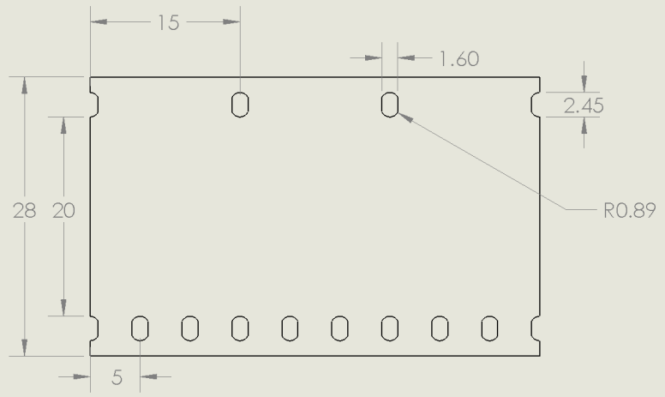

Figure - 28mm Film Segment

The sprockets are fabricated from aluminium and are sandwiched by two aluminium disks for the film to rest on. The sprockets are spaced apart with a delrin spacer of much smaller diameter than the sprockets so the frame of the film is not resting on its surface. The coupler between the sprockets and the stepper motor is also fabricated from delrin.

* **Film Reel Actuation**: The reels of film need to rotate, both feeding film to the sprockets (avoiding unnecessary tension in the film), and spooling up film that has already been imaged on a take-up reel (avoiding a pile of tangled film at the end of the system).

A set of custom-made steel shafts are designed to fit a 28 mm standard film reel. Each of the two shafts (one for out-take, one for up-take) are coupled to a DC motor via a set of aluminum pulleys. The pulley system serves two purposes. One, the ratio of the pulley diameters reduce the speed of rotation from the DC motors; a relatively fast-spinning DC motor can turn the film reels at a slower rate. The ratio of the pulley diameters is approximately 2:1. The other important role that the belted pulley system plays is to allow for slippage. If, for some reason, the film transport sprockets are not moving the film at the same rate as the film reels are rotating, the film will not be providing tension to stall the shaft of the DC motor driving the reel shaft, the belt driving the pulley will slip and provide relief.

As mentioned above, the reel shafts are stainless steel and the pulleys are aluminium. The DC motors are mounted to a piece of 1/8” angle aluminium.

* **Passive Roller Array**: The film is guided from the reels to the sprockets by a set of four delrin rollers. The rollers are free spinning and machined to only contact the film on the edges, in order to prevent unnecessary friction forces on the film. The rollers spin on stainless steel shafts and are sandwiched by two delrin washers.
* **Film Tension Monitor**: Should the tension in the film become too high, a monitoring system will alert the actuators moving the film and act to remedy the problem. One of the passive rollers mentioned above is fixed to the end of an aluminum lever-arm which pivots about the knob of a potentiometer. As the tension in the film increases, the roller will deflect and rotate the knob of the potentiometer, creating an analog output which can be measured and translated into a digital quantity of the tension of the film. The lever-arm is attached to a spring so that, as the tension is reduced, the arm rotates back to the zero-displacement position.
* **LED Frame Illumination Device**: This provides the light source for the film. The array of LEDs was originally from a flashlight. The round shape of the aluminum casing makes it perfect for mounting using a cylindrical interference fit.
* **Camera Mount**: This holds the camera in place as it takes pictures. At this moment, the client has not yet provided the camera he wishes to use. Therefore general mounting plates were modeled but it is subject to change once the camera arrives.

In summary, the combined action of the above-described subsystems is as follows: The DC motor driving the out-take film reel feeds film through an array of passive rollers which guide the film to a set of sprockets, which rigidly fix and actuate the film through the film gate (positioned between the two sprockets). The film then passes through another set of rollers and is rolled onto an up-take reel driven by another DC motor. As each frame passes through the film gate, it is framed and illuminated by a light source and then captured by a digital camera mounted above the film gate. The tension in the line is monitored by a spring-loaded roller which deflects as the tension increases.

# Detailed Mechanical Overview

* 1. Film Gate

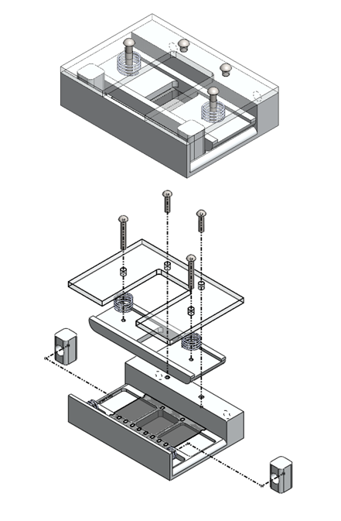

Figure : Film gate assembly exploded views

* + 1. Specifications

The purpose of the film gate is to align and straighten the film as each frame passes by for capture by the camera. The main criteria of concern are to pass the film through this device with a margin of error less than 1/64 inches without causing damage the film.

* + - 1. Components and Materials

This device will be mainly constructed out of aluminum. To prevent wear on the film it will be anodized by the client. Aluminum was chosen because the client requested this as his material of choice and that it would be more durable than using plastics. The springs used in this assembly are commercially available through capital iron and are chosen because they are cheap and abundant. Two types of screws were used, both of them are standard ANSI Inch sized which makes it easier for the machine shop to make threading and holes. The mounting frame for the pressure plate is made out of transparent plexi-glass so that the pressure plate can be exposed. This makes it easier to assemble the film gate and it acts as a visual verification of how well the film is passing through the device. The bill of materials is listed in the table below.

Table : Film gate assembly – Bill of Materials

|  |  |  |  |  |
| --- | --- | --- | --- | --- |
| ITEM NO. | PART NUMBER | MATERIAL | DESCRIPTION | QTY. |
| 1 | A002-B003_base | Aluminum | Base plate | 1 |
| 2 | virtualFilmModel^A002-003_assem | Aluminum | Film Representation | 1 |
| 3 | A002-B003_topTensioner | Aluminum | Pressure Plate | 1 |
| 4 | A002-B003_TensionMount | Plexi-glass | Pressure plate Mount | 1 |
| 5 | A002-B003_screw | Steel | #4-40 Screw Short | 2 |
| 6 | A002-B003_screw | Steel | #4-40 Screw Long | 2 |
| 7 | A002-B003_spring | Steel | Pressure Plate Springs | 2 |
| 8 | A002-B003_tensioner | Aluminum | Tension Blocks | 2 |
| 9 | A002-B003_spring-2 | Steel | Tension Block Springs | 2 |
| 10 | A002-B003_Post | Aluminum | TBD | 2 |

* + - 1. Drawings and Machined components

Besides minor modifications and adjustments, all the components of this film gate device have been machined and made. The drawings that were used to create these parts in the machine shop can be found in APPENDIX. The assembled film gate can be seen in the figure below.

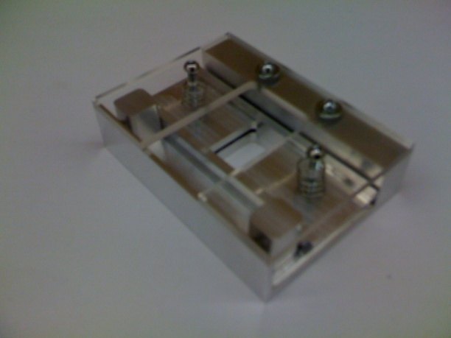

Figure : Actual film gate workpiece

* + 1. Failure Modes

Since this component is not under any type of major strain or stress it is unlikely for the part to break especially since it is made out of aluminum. This device can align the film with an error of less than 1/64 of an inch thanks to the spring loaded mechanisms. However there is still major concern on the integrity of the film, especially on the pressure plate where pressure is added to straighten the incoming film. Several features were incorporated in the film gate to minimize this potential wearing on the film.

* + - 1. Filleted Film Entry and Exit

The entry and exit for the film gate are designed to be rounded so that the film can slip into and out of the film gate with ease. The cross section figure shown below illustrates this design.

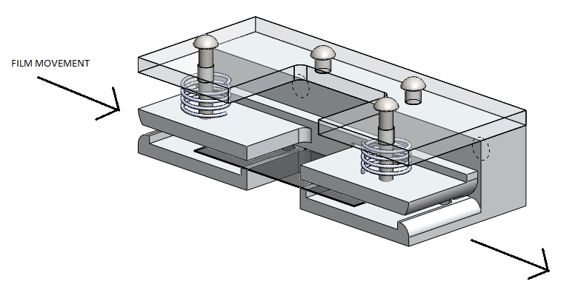

Figure : Film movement through the film gate

* + - 1. Spring Force and Spring Length

The amount of force the pressure plate adds to the film is important in terms of keeping the film in shape and aligned. However if too much force is added, the friction that results can tear the film apart during film advancement from the stepper motor. To simplify this problem, the forces acting on the film are analyzed as shown in the figure below.

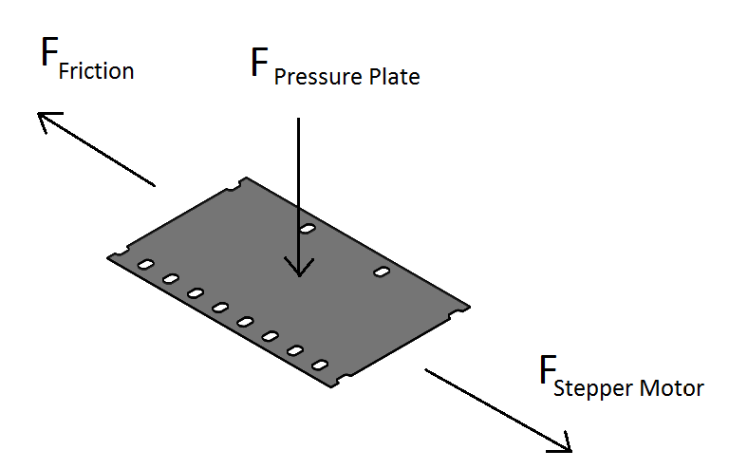

Figure : Simplified force analysis acting on the film

The force that caused friction will be equal to the amount of force the stepper motor will have to pull in order to advance the film. The force from the springs on the pressure plate will provide the normal force for the friction. The formulas for the calculations are shown below.

Equation

Using the equation above, the maximum amount of spring compression can be calculated. The spring constant was found by compressing the spring using a known amount of weight. The apparatus is shown below.

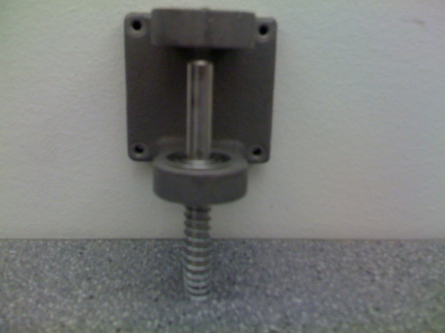

The spring constant was found by measuring the deflection of the spring that was caused by the 108g of weight. The equation used to calculate the spring constant is shown below. The deflection was measured to be 5mm. Therefore the spring constant for one spring is approximately 211.68 N/m. Keep in mind there are two springs so the total spring constant is double this value.

Equation

Unfortunately, the coefficient of friction µ is not known. These values have to be found experimentally which is difficult to do. The closest estimate would be to take the coefficient of friction to be aluminum against aluminum which is 1.4[1]. From the force following calculations on the sprockets, the maximum amount of force that can be applied to the film before the holes tear was found to be 21 N. Using a safety factor of 3, the maximum amount of force should be no more that 7 N. Therefore the maximum amount of allowed spring deflection is approximately 11 mm. In the actual film gate device, the springs were cut so that the maximum deflection is 5 mm which is below the safety limit. However it not known if this is enough pressure to keep the film from bending too much. It will be up to experimentation and troubleshooting the film gate to find out.

* + 1. Comments

The assembly and making of the film gate device was done very well and as expected. There are a few minor improvements that could be made to make the device more accessible to the user. For example, the two screws that secure the top mounting plate require screw drivers to remove. Every time a new roll of film is replaced, these screws will need to be undone. It would be better if they were thumb screws instead so the user can quickly setup the telecine system.

* 1. Film Transport Mechanism

|  |  |
| --- | --- |
| Figure : Transport Sprocket | Figure : Transport Sprocket - Side View |

The overall film transport mechanism is composed of two sprockets with sprocket teeth dimensions and spacing to mate with the sprocket holes of the 28 mm film (see Figure 1). One of these sprockets is fixed directly to the shaft of a stepper motor as seen in Figure 3. The sprocket actuated by the stepper motor is responsible for pulling the film frame-by-frame through the device. Accuracy in frame-to-frame movements is achieved by actuating the stepper motor through a number of steps that will progress the film by a length equal to a single frame (15mm). The radius of the film sprocket -23.87 mm- results in system dimensions where 50 steps taken by the stepper motor –each step is 0.72 degrees- corresponds to the advancement of one frame in the film. The second sprocket composing this mechanism is free-spinning and is fixed to the frame through a Delrin bushing. The sprockets guide the film through the film gate where each frame is digitally captured. Figure 4 below shows the layout of the two sprockets; the gap between them is the designated location of the film gate.

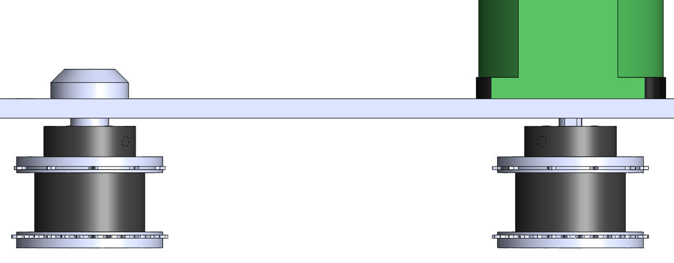

Figure : Film Transport Mechanism - Top View

* + 1. Specifications

The sprocket is composed of a series of independently machined layers. The layers are held together by two 1/8” steel pins, which are press fit into holes perpendicular to the layers of the sprocket. Figure 5 below, is an exploded view with the major components of a film sprocket.

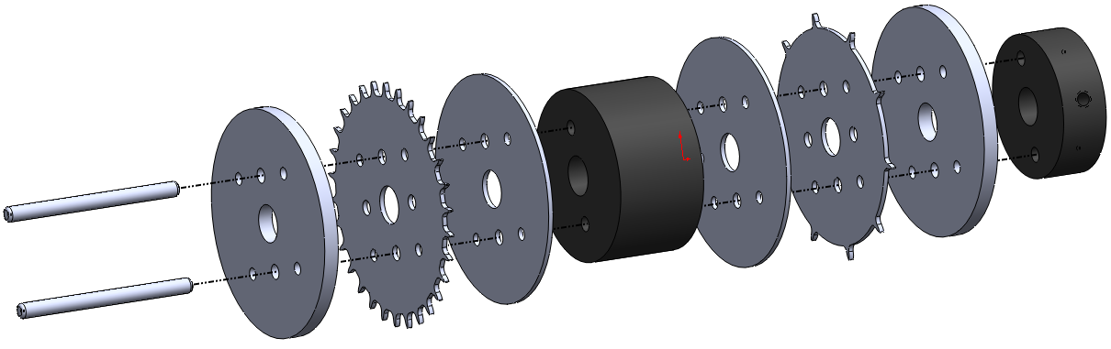

Figure : Film Transport Sprocket - Exploded View

Corresponding with the dimensions of the 28 mm film, there is a distinct sprocket positioned to engage with either side of the frame. One side of the film has three holes per frame while the other side has one. As seen in the figure above, these two distinct sprockets can be seen sandwiched between two aluminium disks. The sprockets themselves are fabricated from aluminum on a CNC mill. The aluminium sandwiches on either side act as a large and continuous surface for the film to rest on as it passes over the teeth of the sprocket. The aluminum sandwiches and the sprockets are only wide enough to support the edges of the film where there are only sprocket holes and no frame. Between these two sprockets is a Delrin spacer. This spacer has a smaller diameter than the aluminum sandwich disks; this eliminates contact of the frame of the film with the sprocket, preventing friction damage to the film. A Delrin coupler is attached to the sprocket set so that the assembly can be coupled to the stepper motor shaft, for the active sprocket, or a roller shaft, for the free-spinning sprocket. A 6-32 set screw is used to fix the coupler onto a shaft.

Table 1 is a bill of materials for the entire film transport device. The part numbers in this table correspond to a single drawing found in Appendix A. For more detailed dimensions of the device described in this section, please reference these drawings. The stepper motor and its controller which are used to actuate the device, are not listed in this table.

Table : Film Transport Mechanism - Bill of Materials

|  |  |  |  |
| --- | --- | --- | --- |
| ITEM NO. | PART NUMBER | DESCRIPTION | QTY. |
| 1 | Coupler | Coupler between the stepper  motor and the sprocket | 2 |
| 2 | OuterSandwich | Thick shoulder for film to rest on | 4 |
| 3 | SprocketCoarse | Sprocket with 10 teeth | 2 |
| 4 | OuterSandwich_THIN | Thin shoulder for film to rest on | 4 |
| 5 | LongInnerSpacer |  | 2 |
| 6 | SprocketFine | Sprocket with 30 teeth | 2 |
| 7 | Sprocket_Pin | Pins to align components | 4 |
| 8 | 6-32_Set_Screw |  | 2 |
| 9 | Delrin_Bushing |  | 1 |
| 10 | RollerPin |  | 1 |

* + 1. Failure Modes

-periodic shaft loading

-static shaft loading from its own weight

* + 1. Comments

The diameter of the sprockets is relatively large. A larger sprocket is preferred because of the increased number of sprocket teeth and a higher sprocket hole to tooth contact ratio. Because the film is old and damaged in parts, more sprocket teeth are required to minimize possible slippage of the film.

The sprocket component is proving to be a challenge to design. The current dimensions of the sprocket, although carefully chosen, do not give ideal tooth engagement with the film. As this is the most critical component of the telecine device, another iteration of fabrication is required.

* 1. Film Reel Up-take and Out-take

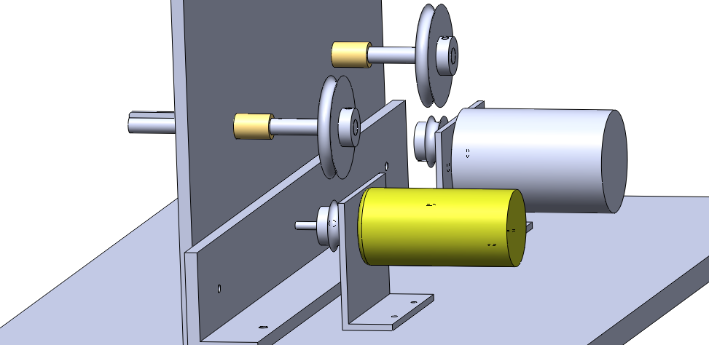

Figure : Reel Drive System (rubber belts for pulleys not shown)

The film reel drive system has two, keyed, stainless steel shafts that are driven through a set of aluminum pulleys by two DC motors. The shafts rotate inside brass bushings. Pulleys are used to drive the reels, as opposed to directly driving the shafts, to allow the film reels to slip if the film is put in excessive tension. The DC motors are supported by motor mounts made from 1/8” aluminum angle.

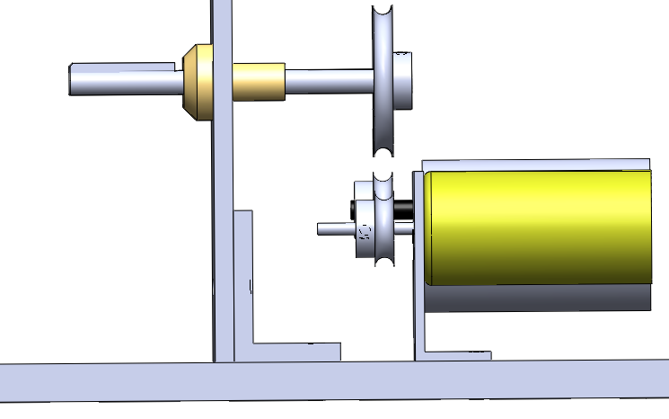

Figure : Reel Drive System - Side View

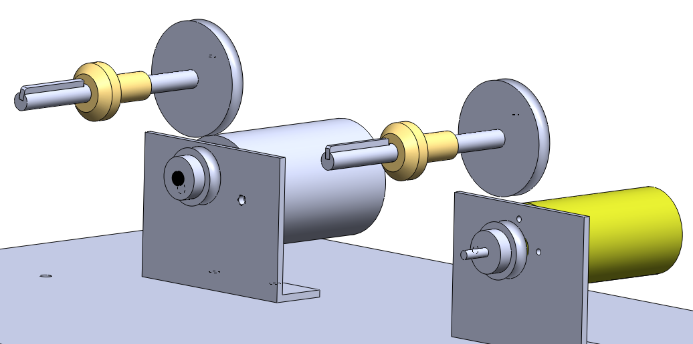

Figure : Reel Drive System (supporting system frame not shown)

* + 1. Specifications

The pulleys are fixed to both the steel reel shafts and the DC motor shafts by 6-32 set screws. The key on the reel shaft is laser welded into the keyway.

|  |  |
| --- | --- |
| Figure : Keyed Shaft for Reel Drive | Figure : Small Pulley |

Table 2 is a bill of materials for the film reel drive system. The part numbers in this table correspond to a single drawing found in Appendix A. For more detailed dimensions of the device described in this section, please reference these drawings. The DC motors and associated circuitry, which are used to actuate the reels, are not listed in this table.

Table : Film Reel Drive System - Bill of Materials

|  |  |  |  |
| --- | --- | --- | --- |
| ITEM NO. | PART NUMBER | DESCRIPTION | QTY. |
| 1 | ReelRod |  | 2 |
| 2 | ReelKey |  | 2 |
| 3 | LargePulleyRoller |  | 2 |
| 4 | 6-32_Set_Screw |  | 4 |
| 5 | SmallPulleyRoller | Pulley for larger motor | 1 |
| 6 | SmallPulleyRoller_4mm | Pulley for smaller motor | 1 |
| 7 | Brass_Bushing |  | 2 |
| 8 | GE_restricted | Mount for larger motor | 1 |
| 9 | Wimpy_Faithful | Mount for smaller motor | 1 |

The DC motors used to drive the reels have different sized shafts –both 8 mm diameter and 4 mm diameter. As a result, two different pulleys are to be coupled with each respective motor. Items 5 and 6 in the bill of materials, list the two pulleys with differing bore sizes. As the shafts driving the reels are identical, only one pulley design is required as seen in Figure 9.

* + 1. Failure Modes

-periodic shaft loading

-static shaft loading from its own weight

-steel was chosen cause its good for shafts… aluminum would ave been strong enouh for long time…

* + 1. Comments

The 28 mm film reels do not have consistent shapes at the center of the film reel. The size and shape of the key and shaft are chosen as an average of the sizes and shapes seen on the film reels available through the client.

* 1. Roller Array

|  |  |
| --- | --- |
| Figure : Film Roller Array | Figure : Delrin Film Roller |

An array of Delrin rollers are used to guide the film between the reels and the sprockets. The rollers all spin freely on a stainless steel shaft which is fixed to the frame of the device.

* + 1. Specifications

The roller itself is a single piece of Delrin. The profile of the roller, as seen in Figure 13, is shaped to minimize contact with the film and maintain alignment. The sloped sides (where the diameter drops from 1” to 0.8”) provide a valley for the film to rest in. The grove in the center with the flat shoulders on either side (where the diameter drops from 0.8” to 0.6”) give the film support on the edges while preventing the frames from contacting the surface.

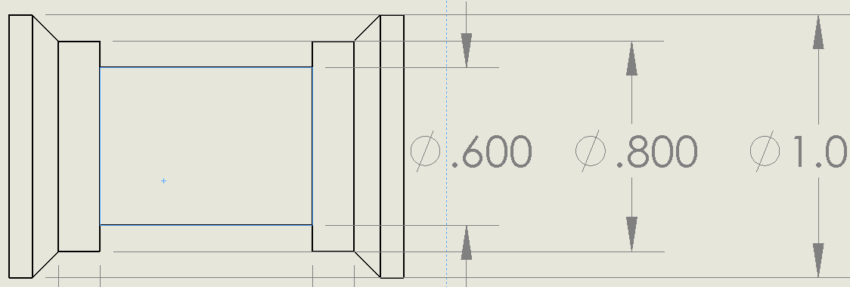

Figure : Film Roller Profile

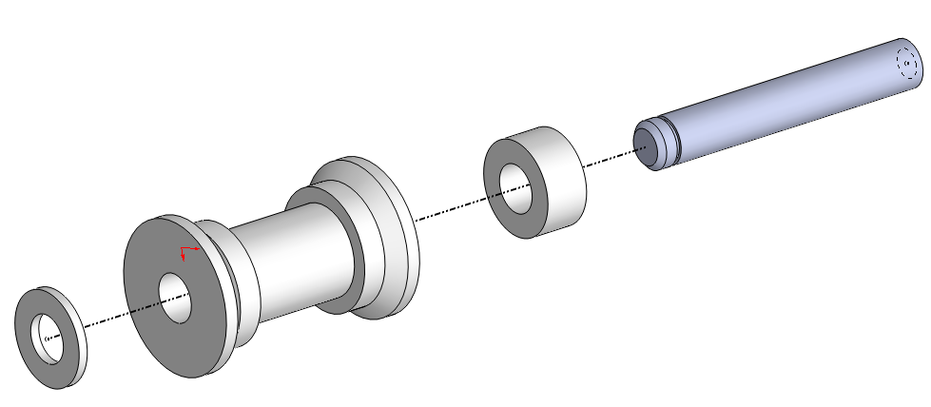

Figure : Film Roller Assembly - Exploded View

As seen in Figure 14, the film roller assembly is composed of the plastic roller itself, sandwiched between two Delrin spacers all of which spin freely on a stainless steel shaft. The shaft is fixed to the frame of the device with 10-32 screws. The roller and the washers are fixed axially with a 5/16” c-clip.

Table 3 is a bill of materials for all of the film rollers. The part numbers in this table correspond to a single drawing found in Appendix A (with the exception of the fasteners). For more detailed dimensions of the device described in this section, please reference these drawings.

Table : Film Roller Array - Bill of Materials

|  |  |  |  |
| --- | --- | --- | --- |
| ITEM NO. | PART NUMBER | DESCRIPTION | QTY. |
| 1 | RollerPin |  | 4 |
| 2 | DelrinSpacer |  | 4 |
| 3 | RollerPLASTICSECTION |  | 4 |
| 4 | DelrinWasher |  | 4 |
| 5 | 5/16" C-Clip |  | 4 |
| 6 | 10-32 Screw |  | 4 |
| 7 | 10-32 Washer |  | 4 |

* + 1. Failure Modes

-periodic shaft loading

-static shaft loading from its own weight

* + 1. Comments

One of the film rollers, instead of being fixed to the stationary system frame, is mounted on the film tensioner device. This device is discussed in more detail in the following section.

* 1. Film Tension Monitor

The film tension monitoring device for the system translates a rotational deflection of a spring-loaded potentiometer into a digital value for the tension of the system. As seen in Figure 15, one of the film rollers described above, is mounted to the end of a 5” aluminum bar as seen in Figure 16. The center of this bar is fixed to the rotation axis of a potentiometer. At the other end of the aluminum bar is a hole to attach a spring. The spring is fixed at the other end to a 6-32 screw on the system frame. This spring resists the rotation of the aluminum rod as the tension in the film pulls on the roller. As the tension changes in the film and the bar rotates, the value of the potentiometer changes and can be translated to a relative tension value.

|  |  |
| --- | --- |
| Figure : Film Tension Device | Figure : Tensioner Arm |

* + 1. Specifications

The tensioner arm is press fit onto the end of the potentiometer. The film roller assembly is fixed to the tension arm with a 10-32 screw. The linear spring used to provide rotational resistance is harvested from an old printer.

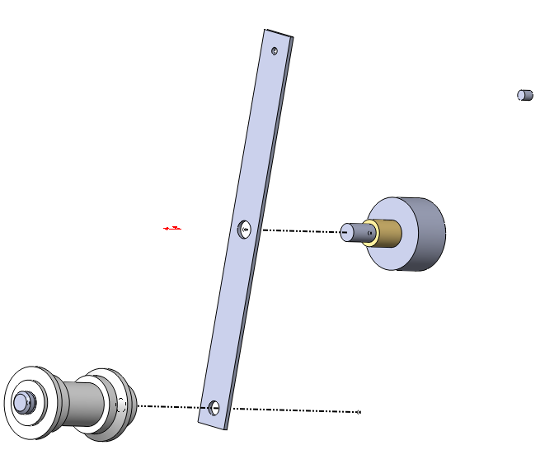

Figure : Film Tensioner Assembly - Exploded View

Table 4 is a bill of materials for all of the film tensioner. The part numbers in this table correspond to a single drawing found in Appendix A (with the exception of the fasteners). For more detailed dimensions of the device described in this section, please reference these drawings.

Table : Tensioner Device - Bill of Materials

|  |  |  |  |
| --- | --- | --- | --- |
| ITEM NO. | PART NUMBER | DESCRIPTION | QTY. |
| 1 | Potentiometer |  | 1 |
| 2 | TensionArm |  | 1 |
| 3 | RollerAssembly | An Instance of the Delrin Film Roller | 1 |
| 4 | 6-32_Screw |  | 2 |
| 5 | Linear Spring |  | 1 |

* + 1. Failure Modes

-periodic shaft loading

-static shaft loading from its own weight

* 1. LED and Camera Mounts

|  |  |
| --- | --- |
| Figure : LED mount plate | Figure : Camera Mount Plate |

* + 1. Specifications

The function of both these devices is to hold the electronic components. For the LEDs, the mounting plate is stationary and illuminates the film gate directly above it. The Camera mounting plate on the other hand is a bit different. In addition to keeping the camera stationary, the mounting plate must also have an adjustable XY stage so that the camera can aligned manually with the film gate.

* + - 1. Components and materials

In order to increase the durability, the mounts will be machined out of aluminum. The bill of materials for the two components is shown in the table below.

|  |  |  |  |  |
| --- | --- | --- | --- | --- |
| ITEM NO. | PART NUMBER | MATERIAL | DESCRIPTION | QTY. |
| 1 | A004_LEDMounts | Aluminum | LED mount | 1 |
| 2 | A004_FrameLBracket | Aluminum | Camera bracket attached to the frame | 1 |
| 3 | A002-CameraLBracket | Aluminum | Camera bracket attached to the camera | 1 |

* + - 1. Exploded view

The camera mount provides XY stage alignment using two bracket parts. The first bracket slides along the frame, giving it the X alignment. The Y alignment is achieved by using the second camera bracket to slide in the perpendicular direction on the first bracket. The exploded view shown in the figure below illustrates the mechanism in action.

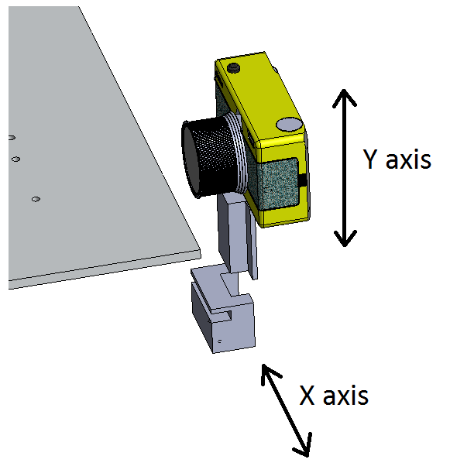

Figure : Exploded view for the camera mount

* + 1. Drawings

The drawings for the LED mount can be found in APPENDIX. The models for the camera mounts are complete, but since the camera is not given, the drawings for the parts are not complete

# Design Component Interfacing and Assembly Overview

The interfacing between the mechanical parts is very important in order to keep the film aligned. Misalignment of the film can cause severe damage to the film and surrounding components. The holes and spacing of the frame that holds the parts together were determined in order to prevent the parts from interfering with each other and to keep parts aligned with one another. The full assembly overview of all the parts is shown in Figure 25. The detailed drawings for the frame, L bracket and base plate can be found in APPENDIX.

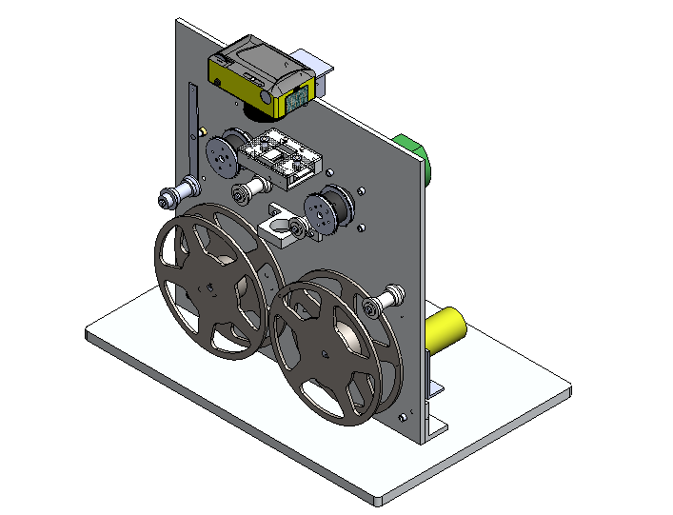

Figure : Full assembly of all the parts

The distance the film is away from the frame is very important in terms of film alignment. All the components are designed to be 0.5 inches away from the frame as illustrated by the side view of the assembly shown in Figure 26.

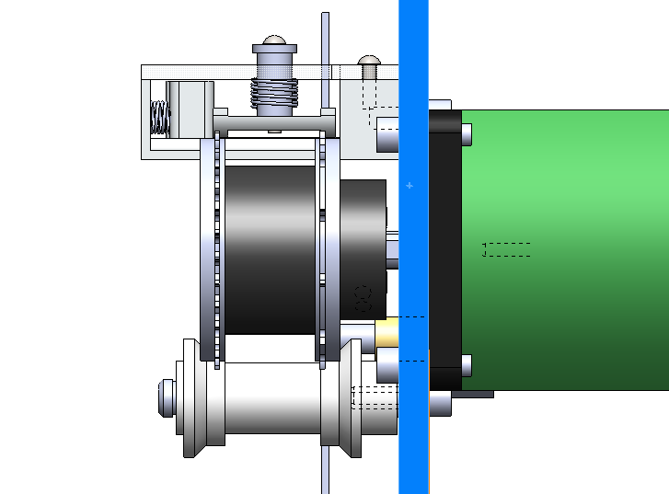

Figure : All components located 0.5 inches away from frame (highlighted in blue)

# Electrical Design

The control system for the telecine machine will be controlled by an Adruino microcontroller as shown in the figure below. The client requests an interface system that will allow the user to reverse the film as well as adjusting the speed of film advancement.

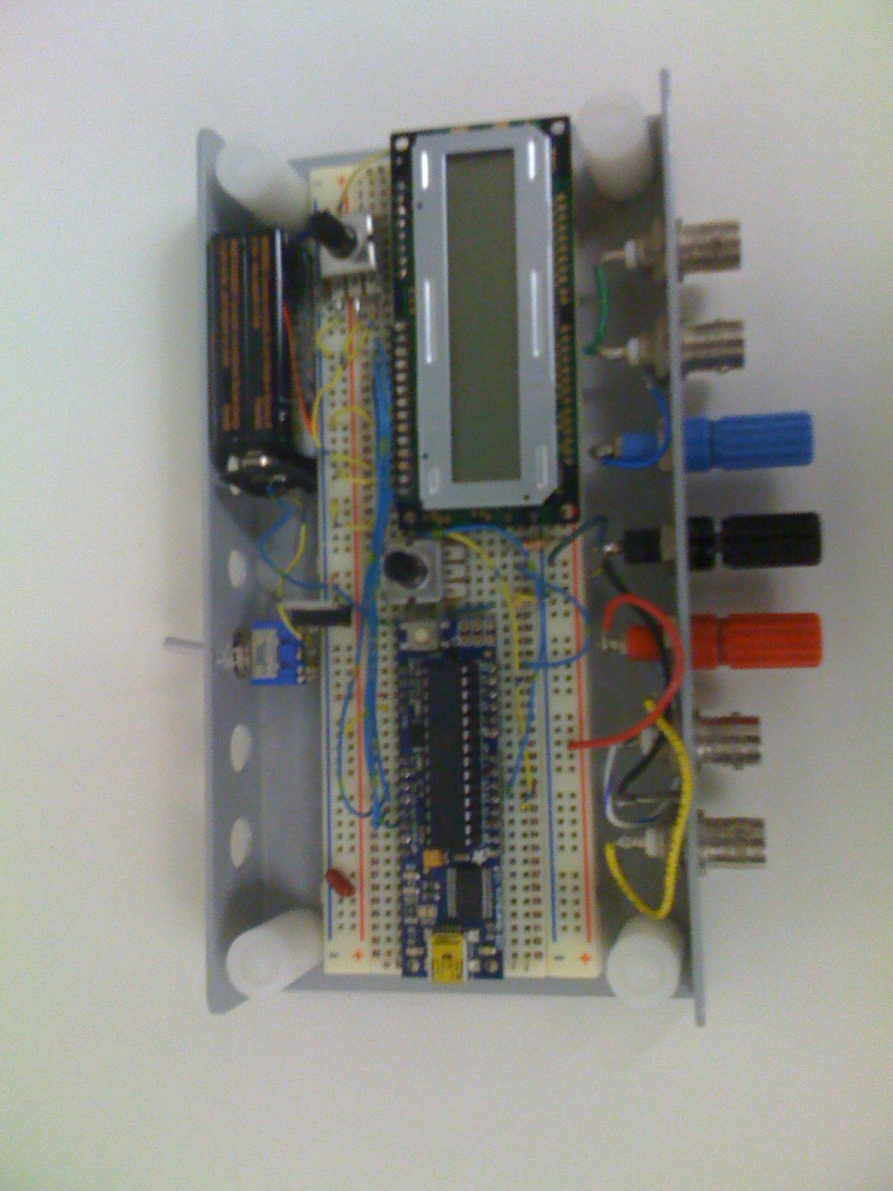

Figure : Adruino microcontroller with LCD screen

The electrical componets and its functionality is shown in Table 6. The full electronic schematic diagram can be found in APPENDIX.

Table : Electronic Components

|  |  |
| --- | --- |
| **Component** | **Description** |
| Adruino Microcontroller | Microcontroller used to control the motors, camera capture, sensor information, and user interface for the telecine setup. |
| LCD Screen | Displays information to the user. For example, frame counts, motor speed and motor direction. |
| Tension Sensor | The tension senor is a potentiometer attached to a lever so that a change in tension can be measured as a change in voltage. |
| DC motors (2 qty) | The DC motors uptake or releases the film for the stepper motor to advance. The speed of these motors is based on the values obtained from the Tension sensor. |
| IRFZ40 (2 qty) | MOSFET that allows the Adruino MC to control the DC motor speed and to turn on or stop the motor. |
| 955 Power supply | 5VDC power supply that is powered by a power outlet. This power source will supply 5VDC to the microcontroller, LCD and the DC motors. |
| VEXTA 5 phase Stepper Motor | Stepper motor to drive the film sprockets. |
| VEXTA Motor Controller | The motor controller for the 5 phase stepper motor. It is powered by an electric outlet. |

# Preliminary Software Design

The implementation of the software control system is aimed for simplicity and robustness. Since the main project objective is only focused on capturing film, most of the microcontroller’s resources will execute the operations one at a time. The preliminary software design for this project is displayed in Figure 27 and Table 7.

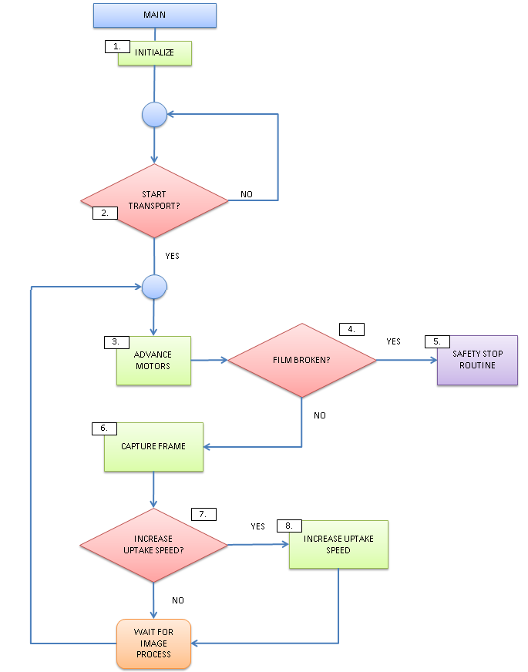

Figure : Software design flowchart

Table : Software design description

|  |  |
| --- | --- |
| **Ref** | **Description** |
| 1 | Initialization for the control system. This is where the rotational speeds for the motors are first set, along with the manual adjustments so that the frame matches with the film gate hole. |
| 2 | This is a confirmation for the user to start the film transport operation. The trigger for this event will be a push button input of some sort. Otherwise, the program will wait until the user is ready. |
| 3 | The motors advance the film forward by one frame. This means the stepper motor and the driving film motors will all move. |
| 4 | This is where the optical sensors will try to detect a discontinuation in the film. |
| 5 | This routine is accessed if there is a discontinuation in the film. It could mean that the film has been broken or the film wheel has reached the end of the movie. Either way, the whole system must stop. The micro-controller will power down everything to conserve power. |
| 6 | If everything goes well in the film advancement, a signal will be sent to the camera to capture the frame on the film. |
| 7 | Optical sensors will check the thickness left in the film wheel and decide if the motors require a change in speed. |
| 8 | Changes in motor speed are requested so it will be adjusted accordingly. Afterwards it will wait for the camera to finish processing the image before repeating the entire film capturing process. |

# Conclusions

Even though the design of the telecine machine have been refined and drawn, there are still many challenges that still need to be resolved. Most of the issues so far are due to the amount of time it takes to produce the parts. This is caused by the lack of experience in the machine shop and the need to remake failed parts.

The next major steps in the project are to setup the electronics and programming. Although the components have been tested individually, interfacing all the components will still remain a tough challenge. The goal is to begin assembly of parts next week and troubleshooting the issues early before the prototype presentation.

# References

1. Coeffient of Friction. [Online] [Cited: June 30, 2012.]

http://www.engineershandbook.com/Tables/frictioncoefficients.htm

# Appendices

### Insert Title

### Insert Title

### Insert Title