

Department of Mechanical Engineering

Engr 466 Design Report 2

|  |  |
| --- | --- |
| Authors: | Anderson Li  Andrew Bornstein |
|  |  |
| Filename: |  |
| Date: |  |
| Total Pages: | 32 |

Table of Contents

1 Introduction 1

1.1 Background 1

1.2 Objectives 1

2 Manufacturing Method 1

3 Film Gate Concept Designs 2

3.1 Design Concept #1: Rail and Pressure Plate 3

3.2 Design Concept #2: Side Adjusting Plate Design 4

3.3 Design Concept #3: Flexible Side Plate Design 5

3.4 Comparison and recommendation 6

4 Film Transport Drive Mechanism Design Concepts 6

4.1 Design Concept #1: Stepper Motor – Direct Drive 7

4.2 Design Concept #2: The Geneva Drive 8

4.3 Design Concept #3: Servo Motor – Direct Drive 10

4.4 Comparison and recommendation 10

5 Sprocket for Transport 10

5.1 Inherent System parameters 11

5.2 Design of the sprocket pair 13

5.3 Choosing a proper set 15

6 Passive Film Rollers 16

6.1 Design #1: Simple Fixed Pin 16

6.2 Design #2: Chicago Bolt and Plastic Sleeve Bearing 17

6.3 Design Concept #3: Custom Made Sleeve Bearing 18

6.4 Recommendations 18

7 Reel Up-Take and Out-Take Drive System 18

7.1 Design Concept #1: Spring Loaded Potentiometer 18

7.2 Design Concept #2: Infrared Range Finder 19

7.3 Recommendations 20

8 Tensioning Device 20

8.1 Design Concept #1: Allow the reel to Slip 20

8.2 Design Concept #2: Feedback With a Professional Tension Sensor 21

8.3 Design Concept #3: Optical Encoder Film Detection Method 22

8.4 Recommendations 22

9 Preliminary frame layout concepts 23

9.1 Upright Frame Layout 23

9.2 Perpendicular Camera mounted Layout 24

10 Figure 5 - Perpendicular Camera Mount LayoutControl System 24

11 Choosing Illumination Source 25

12 Conclusions 25

References 27

Table of Figures

Figure 1 – Film gate concept design #1 3

Figure 2 - Film gate concept design #2 4

Figure 3 - Film gate concept design #3 5

Figure 1 - Stepper Motor Coupled to a Sprocket Pair 7

Figure 2 - Frame Position Feedback Device Concept 8

Figure 3 - Geneva Drive System Coupled to a Film Sprocket 9

Figure 4 - Five Slotted Geneva Drive 9

Figure 5 - Telecine System Layout Concept Sketch 11

Figure 6 - 28mm Film Segment 12

Figure 7- Coarse Sprocket 13

Figure 8 - Fine Sprocket 13

Figure 9 - Exploded Sprocket Roller: Radius = 11.94mm 16

Figure 10 - Aluminum pins used to guide 8mm film [2] 17

Figure 11 - Chicago Bolt 17

Figure 12 - Roller Design 17

Figure 13 - Measuring Film Reel Radius with a Roller on a Spring Loaded pendulum 19

Figure 14 - Measuring Film Reel Radius with an Infrared Range Finder 19

Figure 15 - Ratcheting Freewheel Sprocket from a Bicycle 20

Figure 16 - Ratcheting Film Feeder Concept Sketch 21

Figure 17 - Professional Tension Sensor 22

Figure 4 – Upright Frame Layout 23

10 Figure 5 - Perpendicular Camera Mount LayoutControl System 24

Figure 21 - Arduino Uno Microcontroller 24

List of Tables

Table 1 - Manual machining and 3D printing comparison 2

Table 2 – Scoring table for the film gate design concepts. 6

Table 3 – Drive mechanism comparison 10

Table 4 - Sprocket Analysis: varied number of teeth 14

Table 5 – Sprocket comparison table 16

Table 6 – Film roller comparison table 18

Table 7 – Tension device comparison table 23

Table 8 – Light sources comparison 25

Table 5 - Table of Design Decisions 25

# Introduction

* 1. Current State of the Project
  2. Objectives of this Report

KEEP THINGS CONCISE. GO THROUGH THE DESIGN IN DETAIL BUT ONLY SAY WHAT YOU HAVE TO. SAY IT DIRECTLY AND SIMPLY.

# Final Design Description

The following section outlines the design of a Telecine machine for converting analog 28 mm film to a digital format. The device is made up of a number of design modules which interface with one another to perform the task of cycling through the individual frames on a film reel.

The subsystems of this device are as follows:

* **Film gate**: This device flattens and aligns the film as it passes in front of a digital camera. The component itself is made of two aluminum plates which sandwich the film, forcing it flat. The aluminium plates have a narrow chanel for the film to follow, lined with spring-loaded guides to align the film horizontally (preventing sideways drifting of the frames).
* **Film transport mechanism**: The film transport mechanism is what propells the film, pulling it through the film gate. A set of custom-made sprockets were machined to fit the dimensions of the 28 mm film. One of the sprockets is actuated by a stepper motor while the other is free-spinning. The sprockets pull the film by the sprocket holes in the film.

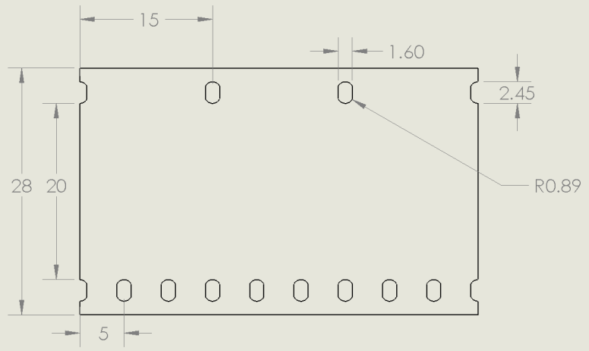

Figure - 28mm Film Segment

The sprockets are fabricated from aluminium and are sandwiched by two aluminium disks for the film to rest on. The sprockets are spaced apart with a delrin spacer of much smaller diameter than the sprockets so the frame of the film is not resting on its surface. The coupler between the sprockets and the stepper motor is also fabricated from delrin.

* **Film Reel Actuation**: The reels of film need to rotate, both feeding film to the sprockets (avoiding unnecessary tension in the film), and spooling up film that has already been imaged on a take-up reel (avoiding a pile of tangled film at the end of the system).

A set of custom-made steel shafts are designed to fit a 28 mm standard film reel. Each of the two shafts (one for out-take, one for up-take) are coupled to a DC motor via a set of aluminum pulleys. The pulley system serves two purposes. One, the ratio of the pulley diameters reduce the speed of rotation from the DC motors; a relatively fast-spinning DC motor can turn the film reels at a slower rate. The ratio of the pulley diameters is approximately 2:1. The other important role that the belted pulley system plays is to allow for slippage. If, for some reason, the film transport sprockets are not moving the film at the same rate as the film reels are rotating, the film will not be providing tension to stall the shaft of the DC motor driving the reel shaft, the belt driving the pulley will slip and provide relief.

As mentioned above, the reel shafts are stainless steel and the pulleys are aluminium. The DC motors are mounted to a piece of 1/8” angle aluminium.

* **Passive Roller Array**: The film is guided from the reels to the sprockets by a set of four delrin rollers. The rollers are free spinning and machined to only contact the film on the edges, in order to prevent unnecessary friction forces on the film. The rollers spin on stainless steel shafts and are sandwiched by two delrin washers.
* **Film Tension Monitor**: Should the tension in the film become too high, a monitoring system will alert the actuators moving the film and act to remedy the problem. One of the passive rollers mentioned above is fixed to the end of an aluminum lever-arm which pivots about the knob of a potentiometer. As the tension in the film increases, the roller will deflect and rotate the knob of the potentiometer, creating an analog output which can be measured and translated into a digital quantity of the tension of the film. The lever-arm is attached to a spring so that, as the tension is reduced, the arm rotates back to the zero-displacement position.
* **LED Frame Illumination Device**:
* **Camera Mount**:

In summary, the combined action of the above-described subsystems is as follows: The DC motor driving the out-take film reel feeds film through an array of passive rollers which guide the film to a set of sprockets, which rigidly fix and actuate the film through the film gate (positioned between the two sprockets). The film then passes through another set of rollers and is rolled onto an up-take reel driven by another DC motor. As each frame passes through the film gate, it is framed and illuminated by a light source and then captured by a digital camera mounted above the film gate. The tension in the line is monitored by a spring-loaded roller which deflects as the tension increases.

# Detailed Mechanical Overview

* 1. Film Transport Mechanism

|  |  |
| --- | --- |
|  |  |

* + 1. Specifications

-description and function

-exploded drawuing

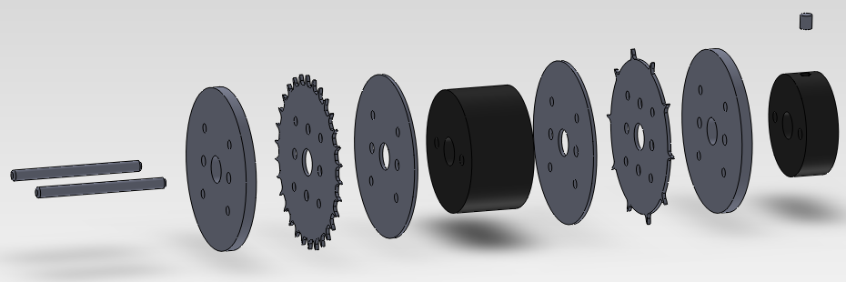

-components, material, interfacing actuators

-fasteners

-drawings

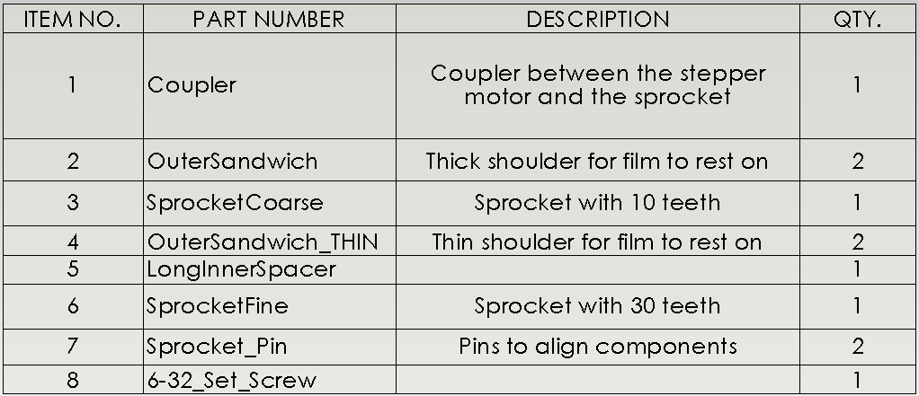

* + 1. Failure Modes

-periodic shaft loading

-static shaft loading from its own weight

* + 1. Comments

How coould it be better? Why it might be overdone?

* 1. Film Reel Up-take and Out-take

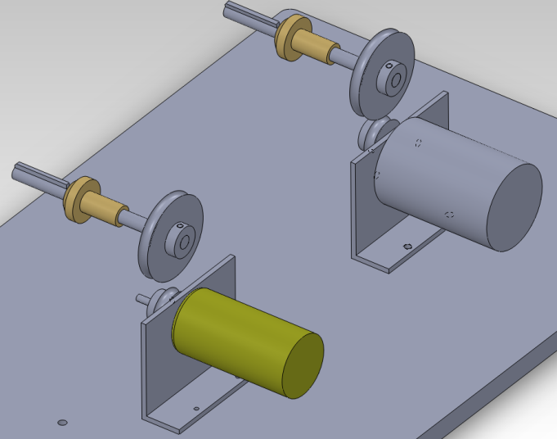

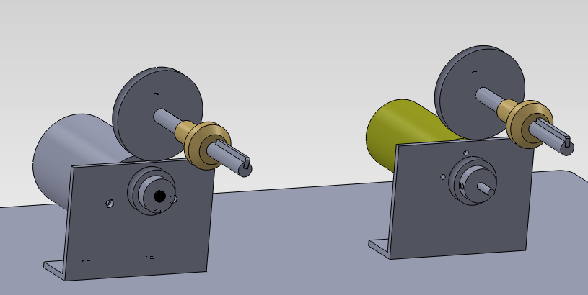

* + 1. Specifications

-description and function

-components, material, interfacing actuators

-fasteners

|  |  |
| --- | --- |
|  |  |

-drawings

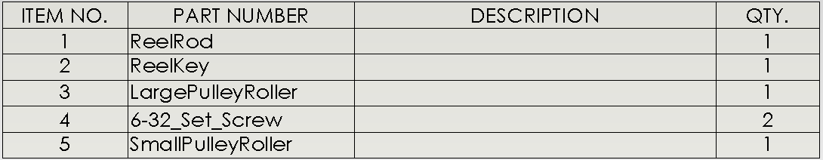

* + 1. Failure Modes

-periodic shaft loading

-static shaft loading from its own weight

* + 1. Comments
  1. Roller Array

|  |  |
| --- | --- |
|  |  |

* + 1. Specifications

-description and function

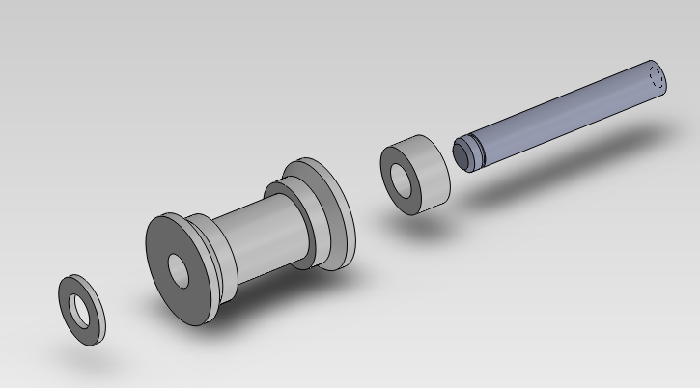

-components, material, interfacing actuators

-fasteners

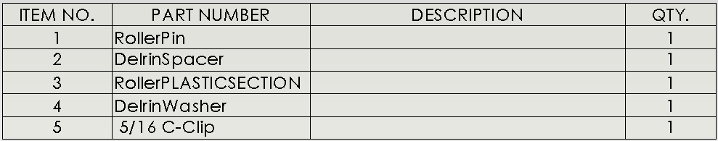

-drawings

* + 1. Failure Modes

-periodic shaft loading

-static shaft loading from its own weight

* + 1. Comments
  1. Film Tension Monitor

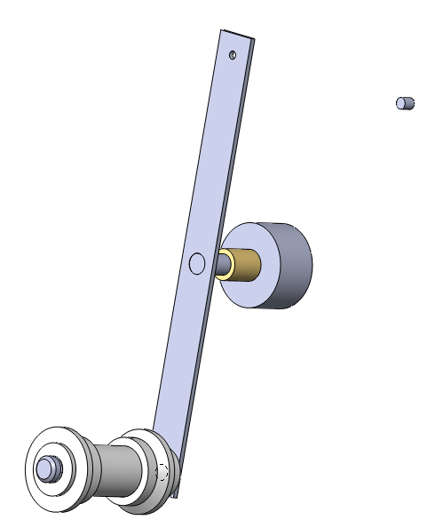

* + 1. Specifications

-description and function

-components, material, interfacing actuators

-fasteners

-drawings

* + 1. Failure Modes

-periodic shaft loading

-static shaft loading from its own weight

* 1. System Frame

The system frame supports and aligns the mechanical components of this telecine device.

* + 1. Specifications

-description and function

-components, material, interfacing actuators

-fasteners

-drawings

* + 1. Failure Modes

-periodic shaft loading

-static shaft loading from its own weight

* + 1. Comments

# Design Component Interfacing

…the mechanical interfacing.. spacing between film gate and sprockets.. how things are layed out on the frame ex, so the tensioner will fit and operate. (basically a detailed discussion of the frame)

Identify all the interface circuits

Identify the software relationships between

# System Assembly Overview

# Electrical Design

-individual circuits and the power requirements, operating parameters for our actuators/sensors

-giant system circuit

# Preliminary Software Design

-system flow chart

-flow chart for the components (like in that 230 assignment)

# Conclusions

-current challenges we are facing and how we are attacking it.

-our next steps

# References

1. EarthEasy. [Online] [Cited: May 24, 2012.] http://eartheasy.com/live_led_bulbs_comparison.html.

2. Flatbed Scanner Digital Telecine (FSDT) Project. [Online] [Cited: May 25, 2012.]

http://www.truetex.com/telecine.htm.

3.Machinist-Materials, Plastics Comparison Table [Online] [Cited: May 25, 2012] http://www.machinist-materials.com/comparison_table_for_plastics.htm.

4. Omnia Plastica ABS Acrylonitrile-butadiene-styrene. [Online][Cited: May 25, 2012] http://www.matweb.com/search/datasheet.aspx?matguid=f6c2155e247b427d8bedaad7620b4c37&ckck=1.

5. 1 -1/4” Chigaco Screws. [Online][Cited: May 25, 2012] <http://www.screwpost.com/product_info.php?cPath=1&products_id=10>

6. 1/8” Aluminum Rod Stock. [Online][Cited: May 25, 2012]

<http://www.mcmaster.com/#standard-aluminum-rods/=hoo0rc>