|  |
| --- |
| The University Of Victoria |
| Film Transport Project |
| Weekly Project Report #2 |
|  |
|  |

|  |  |
| --- | --- |
| **Team Manager for the Week:**  **Team Recorder:**  **Week:**  **Instructor:**  **Supervisor/Client:** | **Andrew Bornstein**  **Anderson Li**  **6/13/2012 - 12/19/2012**  **Dr. D Constantinescu**  **Mr A.Makosinski** |

# Progress Report

In this week the following tasks have been completed:

* Initial concept idea for a film gate was developed. This is used to center the roll of film before capturing the frame. The idea is to use springs to align the film:

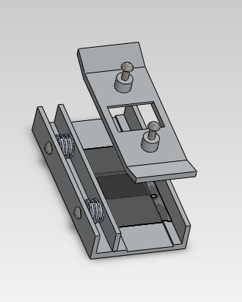

* Initial concept idea for a frame was developed.

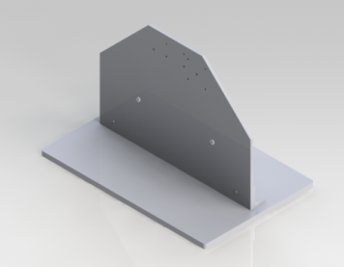

* Film Reel Sketching
* Clarified some design concepts with the client. Design components, control system, budget, and additional features were discussed.
* Did background research on Telecine projects including one that Mr. Makosinski had made.
* Sprocket designs

# Issues

# Next Week Agenda

|  |  |
| --- | --- |
| Task | Task Lead |
| * Create additional film gate designs * Create additional frame design concepts * LED and cameral mounting designs * Start writing the report and presentations | Anderson Li |
|  | Andrew Bornstein |

# Gantt Chart

