|  |
| --- |
| The University Of Victoria |
| Film Transport Project |
| Weekly Project Report #7 |
|  |
|  |

|  |  |
| --- | --- |
| **Team Manager for the Week:**  **Team Recorder:**  **Week:**  **Instructor:**  **Supervisor/Client:** | **Anderson Li**  **Andrew Bornstein**  **19/06/2012 - 26/06/2012**  **Dr. D Constantinescu**  **Mr A.Makosinski** |

# Progress Report

In this week the following tasks have been completed:

* Ordered electronic components for the PWM circuits through Ian
* Machined 5 Plastic film rollers and the accompanying plastic spacers
* Machined the Sprocket couplers and spacers from Delrin
* Machined a set of aluminium pulleys for driving one of the film reels
* Built an initial circuit with the DC motors and the 5V power supply using a mechanical switch to change motor direction simultaneously (prepared the circuit to be adapted to PWM upon the arrival of the ordered MOSFETs)
* Machined the film gate mechanism
* Drafted drawings for the camera and LED mounts

# Issues

The machine shop is a bottleneck. Rodney does not trust me (Andrew) (..perhaps rightly so) to machine certain parts on my own. I spend a good deal of time in the shop waiting for him to supervise me. For example, I still have not made any of the shafts to support either the film reels or the film rollers. The shafts are made from steel and even though the parts are simple, Rodney is afraid that I will break his tools if I machine them alone.

We still have quite a few more parts to machine. Right now the shop is still relatively empty (very few Mech 400 students). I worry that when things get busier, our group will no longer be able to machine as we have already used a large amount of machine shop time.

There is a problem with the power supply running the two DC motors. After the power supply is plugged in, the two motors run at a normal, and constant speed/torque, however, when the switch to change shaft direction is thrown, the power is greatly reduced causing one motor to stop and the other to be reduced greatly in speed and torque. I believe the problem lies with the power supply as unplugging, then re-plugging the wall adapter fixes the problem. Will consult Art (who provided the power supply) for troubleshooting assistance.

After machining the film gate some issues that were not thought of before also became more apparent. One os the issues is due to the loose fitting of the pressure plate. To remedy this issue guide pins will have to be inserted in order to constrain unwanted movement of the pressure plate. However due to the time constraint of the next milestone, this issue might be pushed aside until the first protoype is made.

# System Diagrams

## Electronic Schematic

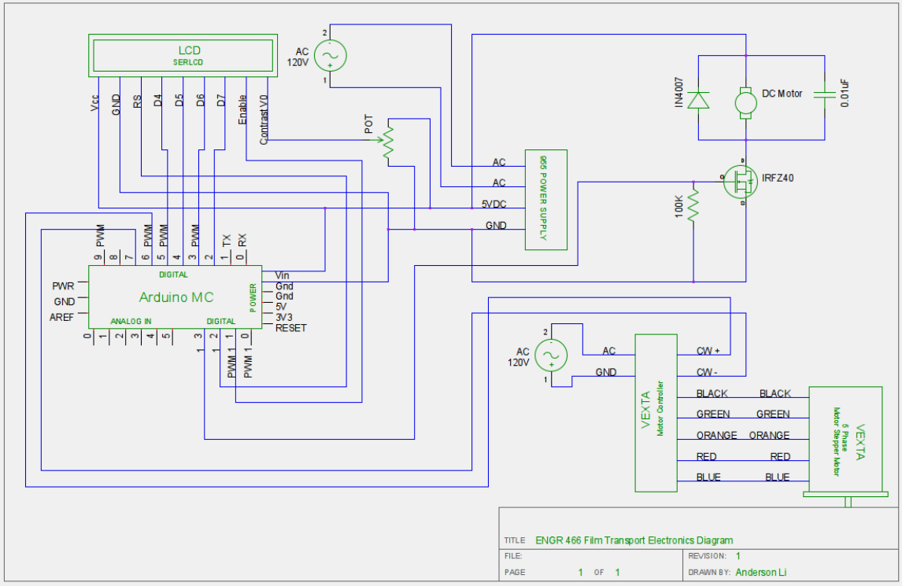

## Programming Flowchart

## 

# Next Week Agenda

|  |  |
| --- | --- |
| Task | Task Lead |
| * Design and model a system frame * Compose a system assembly in order to check that component dimensions for the different parts of the design all fit together properly * Compose a circuit to run the reflectivity sensor to detect the film * Work on the design report 2 | Anderson Li |
| * Machine a new set of sprockets * Machine the shafts for the film reels and the film rollers * Design Report 2   -Sprockets  -Rollers  -Reel Drive  -DC Motor Control (preliminary)  -Actuator power supply  -Component layout | Andrew Bornstein |

# Gantt Chart

