Reference to this post <https://www.pugetsystems.com/labs/hpc/How-to-Install-TensorFlow-with-GPU-Support-on-Windows-10-Without-Installing-CUDA-UPDATED-1419/#Step1)SystemPreparation-NVIDIADriverUpdateandcheckingyourPATHvariable(Possible\>

1. **Update NVIDIA Driver**

Right click on your desktop and then "NVIDIA Control Panel"

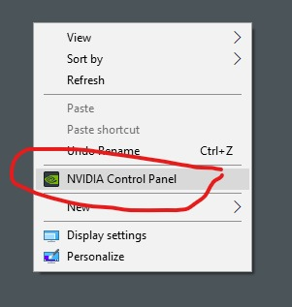

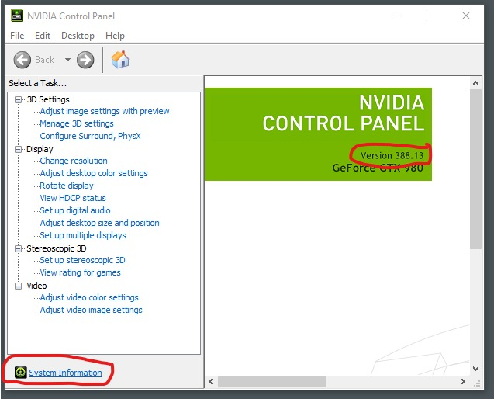

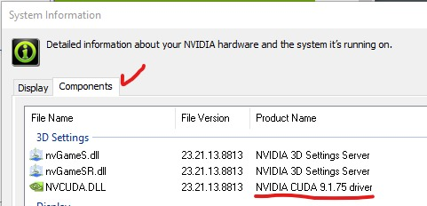

Because it is required that CUDA version be 10.0 or higher which is used with Tensorflow, we need to update NVIDIA driver.

Go to [<https://www.nvidia.com/Download/index.aspx>] and enter the information for your GPU. Then click "search", download and install it.

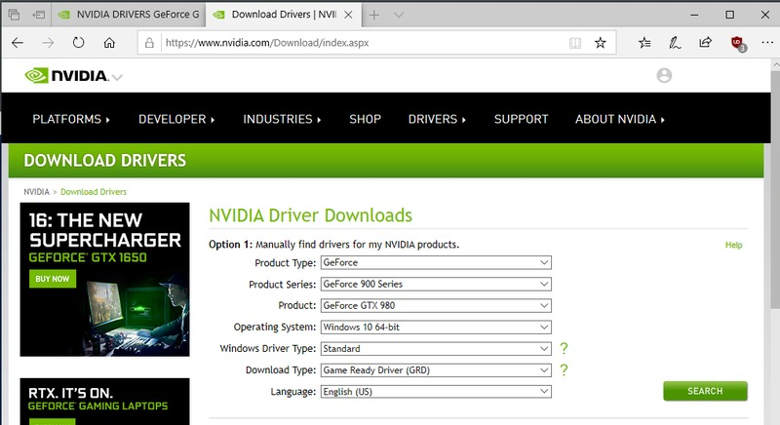

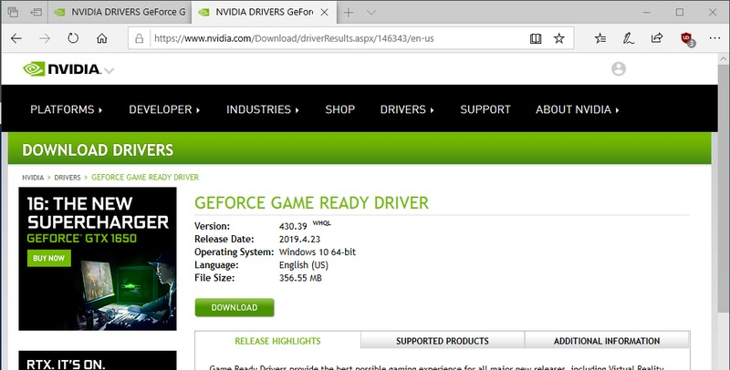

1. **Install Anaconda**

Go to the [Anaconda downloads page https://www.anaconda.com/distribution](https://www.continuum.io/distribution) and get the 64-Bit Python 3.7 (or newer) version.

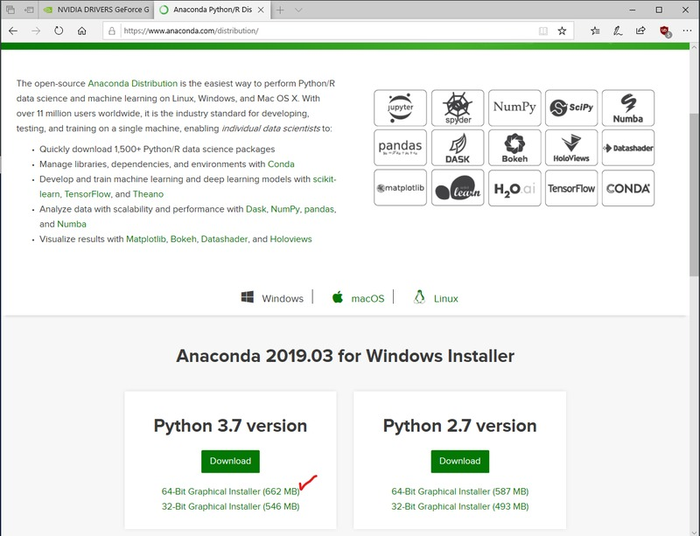

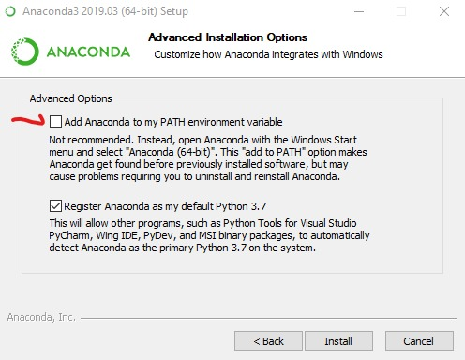

Check and update Anaconda Installation

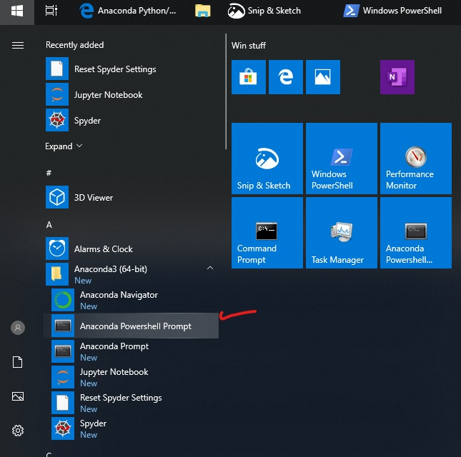

On powershell prompt run some commands.

(base) PS>python

Python 3.7.3 (default, Mar 27 2019, 17:13:21) [MSC v.1915 64 bit (AMD64)] :: Anaconda, Inc. on win32

Type "help", "copyright", "credits" or "license" for more information.

>>>

>>> exit()

conda update conda

conda update anaconda

conda update python

conda update –all

1. **Install Python virtual environment**

conda create --prefix D:\Anaconda3\tf-gpu python=3.6

conda activate "D:\Anaconda3\tf-gpu"

We install a virtual environment on drive D for not making heavy workload on drive C where OS and many software are installed.

1. **Install necessary libraries**

conda install tensorflow-gpu==2.1.0

pip install librosa

Other libraries such as sympy, matplotlib, pandas, seaborn, tqdm, sklearn, pyaudio and so on, could be installed using pip or conda.

1. **Install Spyder as an IDE**

Open Anaconda Naviagator, choose the channel (Python virtual environment) and click button Install under Spyder.

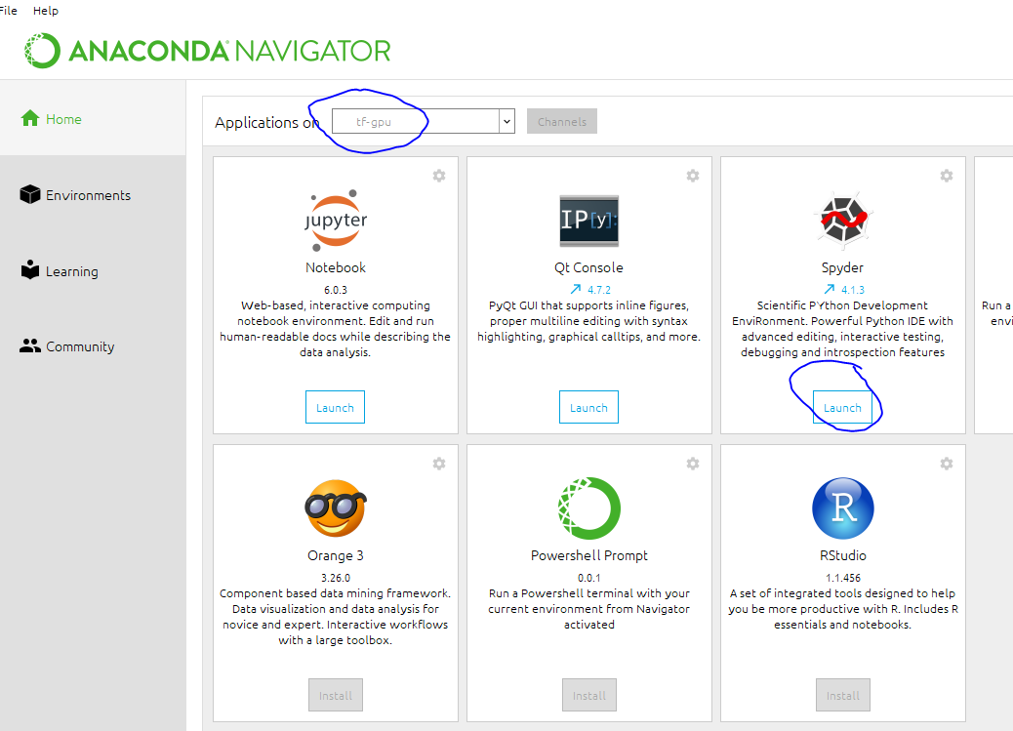

After its installation, we can launch it and start to write Python codes.

