**Two options available to choose:**  
The design of Rpi hat for spore collection device can be integrated with either 24V or 12V pump.  
On board voltage step up regulator steps up the fixed input 12V to 24V (can be used when 24V pump is used in the spore collector device).

**Steps to connect Rpi hat follow:**   
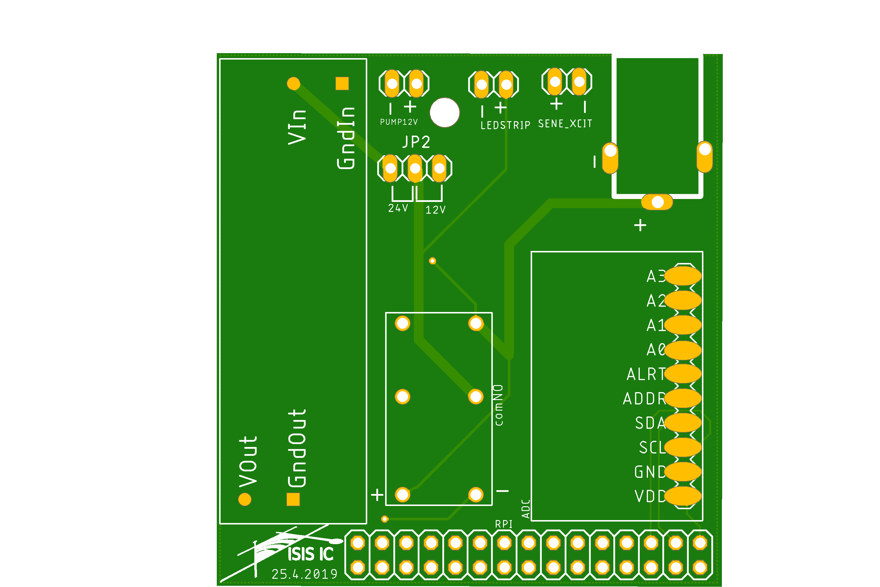  
1. Use a jumper connector to connect the pin pair either 24V or 12V (Red circle) pair depending on the rated - pump voltage installed in the device.   
2. If using a 12V pump, connect the power supply cables of pump to the 12V + - pins on the Rpi hat (blue circle).   
3. If using 24V pump, connect the power supply cables of pump to the Vout and Gndout pins (yellow circle )on the Rpi-hat.  
4. Power supply cables of the Led-strip to the pins in purple circle.  
5. Sensor power supply cables to the respective pins as indicated on the Rpi-hat.  
Note:  
If the jumper pin is connected wrongly then the pump will not be supplied power as it can be seen the outlets for 12V and 24V are different.  
Warning!!|

If pumps are not connected in respect to their designated pins based on their rated voltage malfunctioning of the pump and the Rpi is inevitable.

**Powering the Rpi-hat:**  
Supply 12 V with min 3 amp

**Powering the Rpi:**

The Rpi, itself has to be powered separately with 5V 2.5 amp.