Prototype of Sporecollector with Remote access system

Abstract

Spore sampling and identification are vital for control, assessment of crop health status and also track presence of particular types of plants which are toxic for animal grazing. Early estimation of the credibility of the collected samples can significantly reduce the costs associated with sample transport and analysis. A prototype of a collection device that facilitates collection of spores from crop is created with intention of it being transported by a drone to remote region. Remote access of the real –time information is facilitated by implementing IoT technology.

Keywords: Spore collector, IoT, Remote access, Raspberry pi

Introduction

Plant diseases are responsible for major economic losses in the agricultural industry worldwide. Monitoring plant health and detecting pathogen early are essential to reduce disease spread and facilitate effective management practices.

Manually operated portable spore-collectors are used in the Industry to collect the samples. The collected samples are transported to respective laboratory where the analysis is done. Traditionally there is no means of checking the acceptability of the sample collected and hence forced to transport all the samples for further analysis. Due to lack of communication link between the device and the operator, the operator is forced to depend on the results yet to be announced by the laboratory for further planning of target region sampling.

With current Drone technology, lightweight microscopic camera setup, IoT we setup a new model which overcomes the drawbacks discussed above. This model also increases the farmer’s reaction time to tackle the unexpected changes in the plant health status or to track the presence of plants which are usually harmful for cattle grazing.

An autonomous drone is capable of transporting and controlling the operation of the Spore-collector. IoT enables us to transfer live visual feed from the remote location to client. By incorporating an inbuilt microscopic camera capable of capturing the live feed of the spore collection process to the Spore-collector we establish a link between the client and the Spore-collector itself. This link enables the client to decide if a particular sample is worth sending to the laboratory directly from his workstation. Information about the density of the spores in particular region is also obtained.

Spore collection process

|  |  |  |
| --- | --- | --- |
| Pump type Property | G-24/07-N | 1420VP/12V |
| Max Flow | 18 l/min | 8.2l/min |
| Continuous vacuum | 30% - 0.7 bar | 78% - 0.28 bar |
| Weight | 0.5 Kg | 220 g |
| Ambient temperature | -10 to 40 $̊$ C | 5 to 50 ̊C |
| Power | 19 W | 8.5 W |
| Type | Rotary vane vacuum pump | Diaphragm Pump |

A pump is used to suck in the air through the sieve, where the dust particles including spores are collected. The amount of air sucked in is measured using an Air mass flow sensor at every second and a cumulative sum is obtained which gives the total amount of the air sucked in during a particular time period. Experiments are conducted using two types of pumps which are mentioned along with their specification in the below table 1.  
  
  
  
  
Flow curves of the two pumps are provided below, They play a crucial role in choosing a pump for a particular application. They show the relationship between flow rate, power consumption and atmospheric pressure.

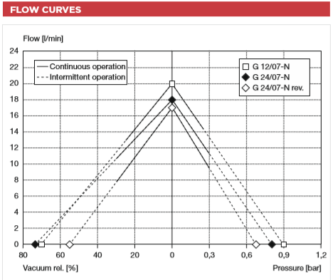

G-24/07-N

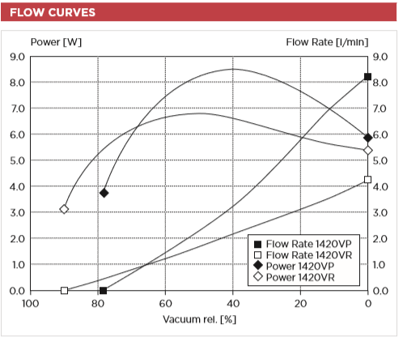

1420VP/12V

Oscilloscope has been used to observe signal fluctuation of the signal output from the Mass air flow sensor to make sure that the influence of the type of the pump on the sensor signal output is negligible.

Spore collection monitoring system

Components used:

Magnifying Objective, Camera Rpiv2, Sieve, Mass Air Flow sensor,LED strip, Rapberry Pi 3, Pcb as Raspberry pi hat designed at ISISIC to control the whole setup.

Libraries used:

Rpi camera v2 ,ADS115 ADC , Rpi GPIO

Monitoring Process:

A light weight widely used on board Raspberry pi camera v2 is used to capture the images and live feed over an objective lens capable of 8 to 130 times magnification during the collection process. Python code making use of libraries for RPi camera v2, Rpi3 GPIO, the ADC is run on a Rapberry pi 3 with a hat designed at ISISIC. When initiated the collection process after reaching the target, air is sucked in to the pre-selected amount, capturing images with pre selected time gaps until the end of the collection process. The visual data is uploaded to a cloud using 4g LTE setup on the drone. From there the client can have direct access to the content either live or later.

Specification of the components:

**Magnification Details**

Lens – objective

C-port zoom lens

Optical Magnification – 0.12 times -2 times (about 8 times -130 times in 21 inch display)

Working distance – 55mm-180mm/2.16-7.08''

Field of view – 2.4mm-18mm/0.09-0.71''

Size – 115mm*40mm/4.52*1.57''

**Camera**

8 Megapixel native resolution sensor-capable of 3280 x 2464 pixel static images

CMOS image sensor (Type ¼ ) - Uses the Sony IMX219PQ image sensor

Supports – 1080p30, 720p60 and 640x480p90 video

Size – 25mm x 23mm x 9mm

Weight – 3g

HD videos and still photography

**Sieve Details**

Supplied by INNOSIEVE Diagnostics BV

Approx Min Size of Particles that can be trapped – 4-5µm

**Mass Air Flow sensor**

Honeywell-sensing-airflow-awm50000-series -AWM5102

Flow range – 0 to 10 SLMP

Excitation Voltage – 10V

Power consumption – 100mW

Temperature Range – -20 to 70 ̊C

Weight – 60g

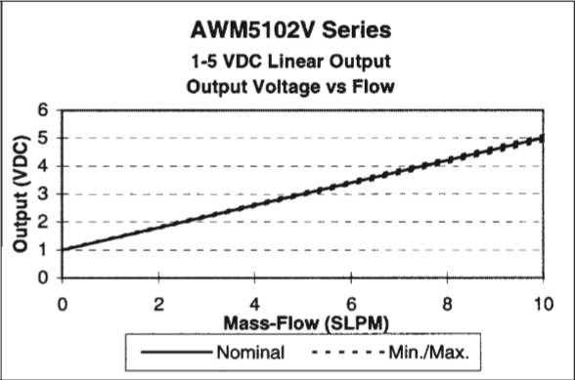

**Microcontroller**

Raspberry Pi

Accompanied by Spore collector Shield designed at ISIS IC

**Experiments**

pollen size $≅6$ µm

**Tasks Achieved**

Can be operated remotely via Internet

Amount of fluid to be sucked in can be adjusted

Number of pictures to be taken during the measurement phase can be adjusted

Pictures taken can be accessed directly on any device having access to Internet

Compatible with 12V and 24V Suction pumps

**Improvements**

Adjusting Light brightness remotely

Live Image access to the Client

More accuracy of the fluid mass sucked in can be achieved

**Mass Air Flow sensor**

sieve

Pump

Air with spores