|  |  |  |
| --- | --- | --- |
|  | G-24/07-N | 1420VP/12V |
| Max Flow | 18 l/min | 8.2l/min |
| Continuous vacuum | 30% - 0.7 bar | 78% - 0.28 bar |
| Weight | 0.5 Kg | 220 g |
| Ambient temperature | -10 to 40 $̊$ C | 5 to 50 ̊C |
| Power | 19 W | 8.5 W |
| Type | Rotary vane vacuum pump | Diaphragm Pump |

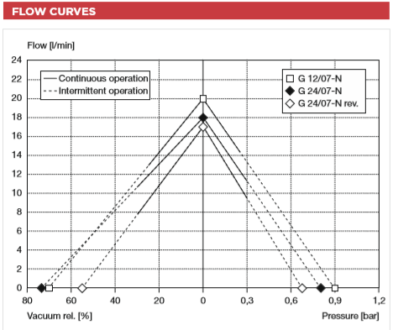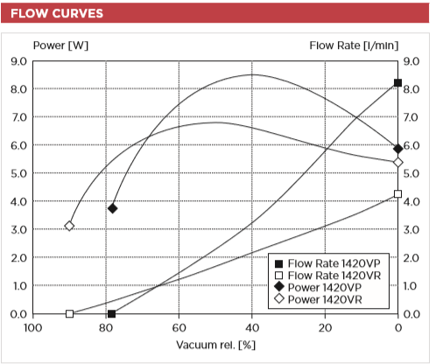

G-24/07-N

1420VP/12V

**Magnification Details**

Lens – objective

C-port zoom lens

Optical Magnification – 0.12 times -2 times (about 8 times -130 times in 21 inch display)

Working distance – 55mm-180mm/2.16-7.08''

Field of view – 2.4mm-18mm/0.09-0.71''

Size – 115mm*40mm/4.52*1.57''

**Camera**

8 Megapixel native resolution sensor-capable of 3280 x 2464 pixel static images

CMOS image sensor (Type ¼ ) - Uses the Sony IMX219PQ image sensor

Supports – 1080p30, 720p60 and 640x480p90 video

Size – 25mm x 23mm x 9mm

Weight – 3g

HD videos and still photography

**Sieve Details**

Supplied by INNOSIEVE Diagnostics BV

Dimensions

Size of Particles that can be trapped

**Mass Air Flow sensor**

Honeywell-sensing-airflow-awm50000-series -AWM5102

Flow range – 0 to 10 SLMP

Excitation Voltage – 10V

Power consumption – 100mW

Temperature Range – -20 to 70 ̊C

Weight – 60g

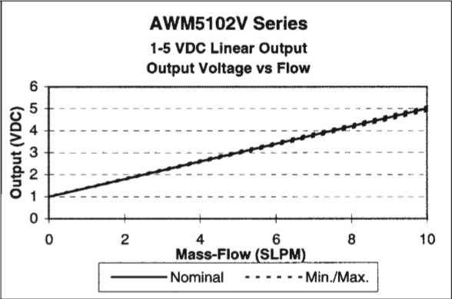

**Microcontroller**

Raspberry Pi

Accompanied by Spore collector Shield designed at ISIS IC

**Experiments**

pollen size $≅6$ µm

**Tasks Achieved**

Can be operated remotely via Internet

Amount of fluid to be sucked in can be set

Number of pictures to be taken during the measurement phase can be set

Pictures taken can be accessed directly on any device having access to Internet

Compatible with 12V and 24V Suction pumps

**Improvements**

Adjusting Light brightness remotely

Live Image access to the Client

More accuracy of the fluid mass sucked in can be achieved