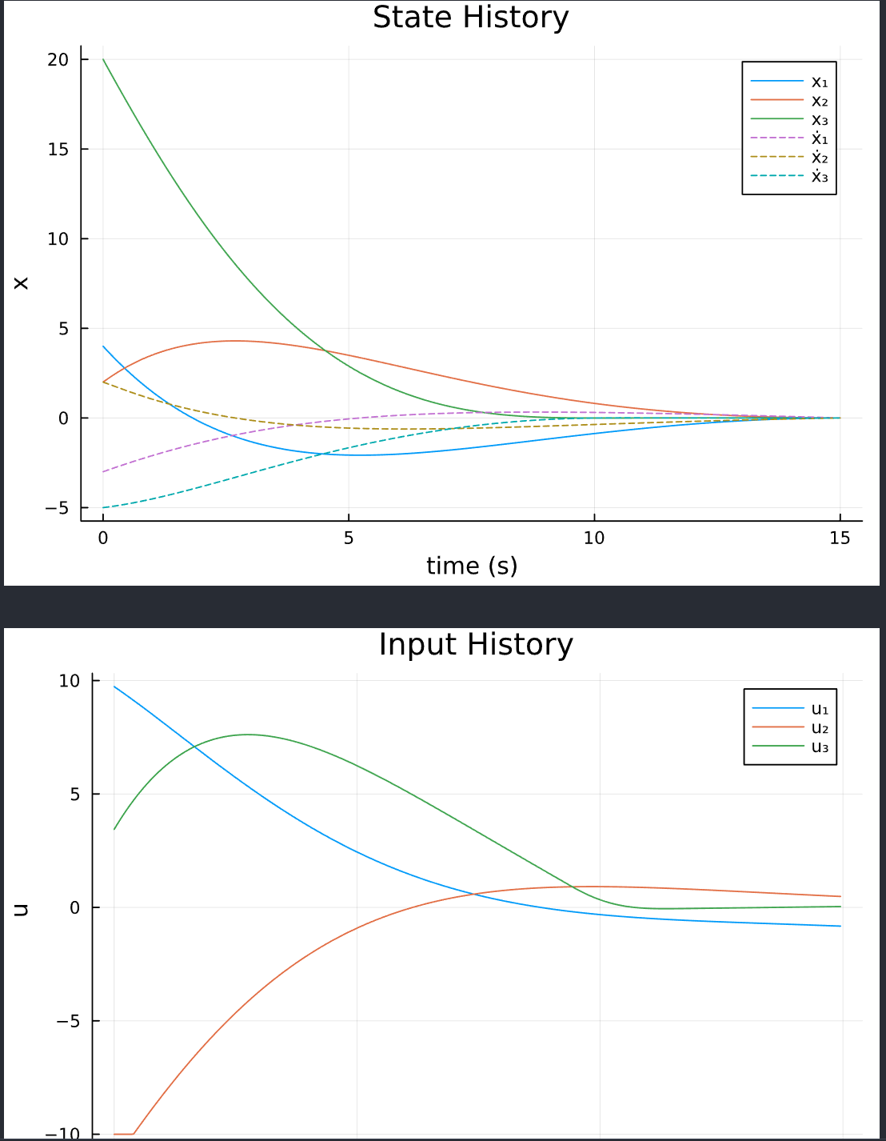
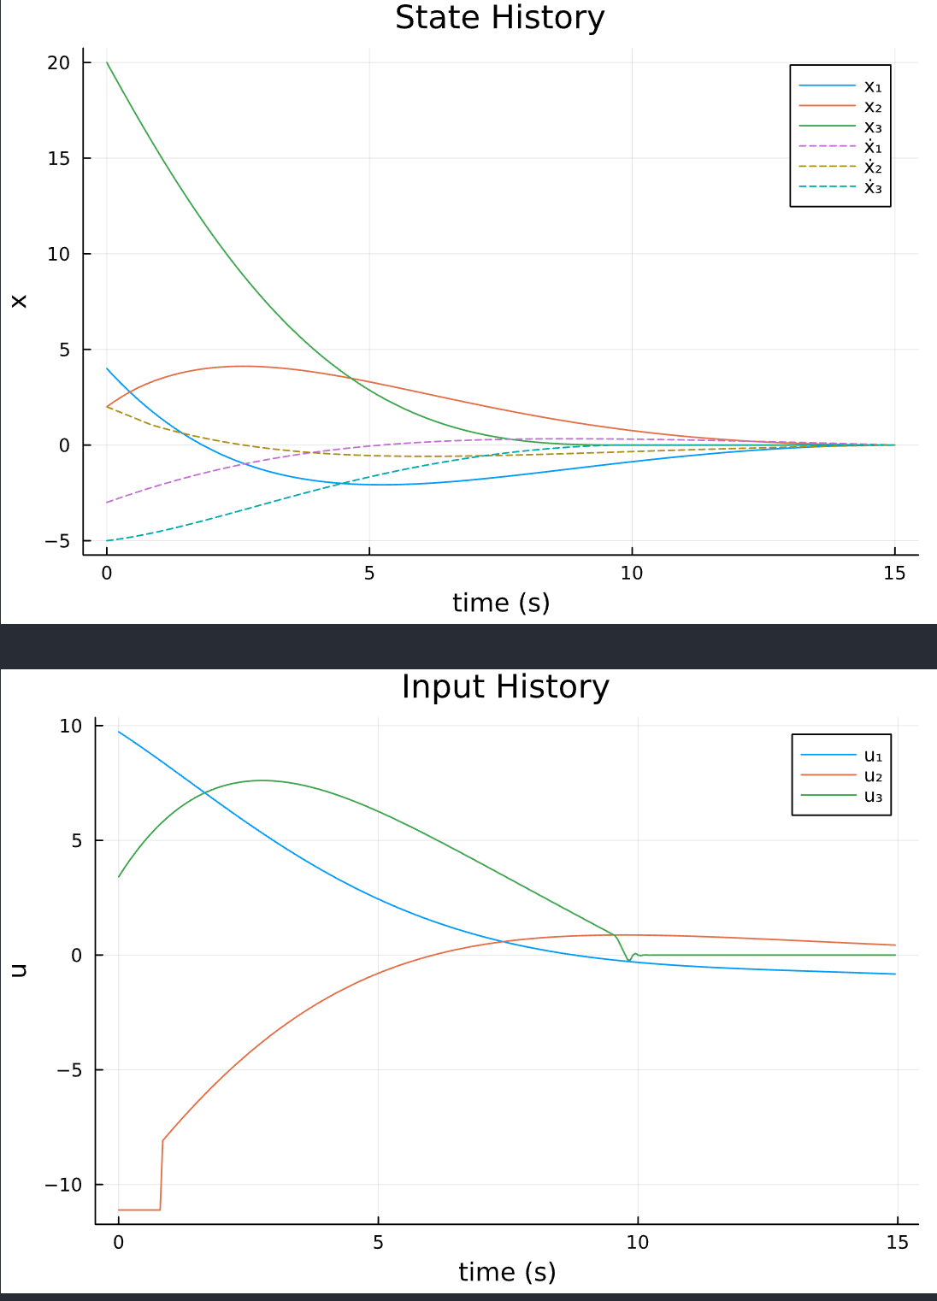
reset penalties and reset duals help dealing with that quirk.
penalty = 0 first to get LQR solution.

