Weekly reports are to be emailed to atbecker@uh.edu by 5:00pm on Tuesdays. The purpose of a weekly report is to: (1) give you text and images for your papers, thesis, and dissertation, (2) document progress, (3) identify if you are stuck or need resources.

Weekly report

1. **My *Goals* from last week**
   * Laser cut name card
   * Build OpenROV
2. **My *Accomplishments* this week**
   1. Project 1: Big Ocean Data

* Deliverable: OpenROV

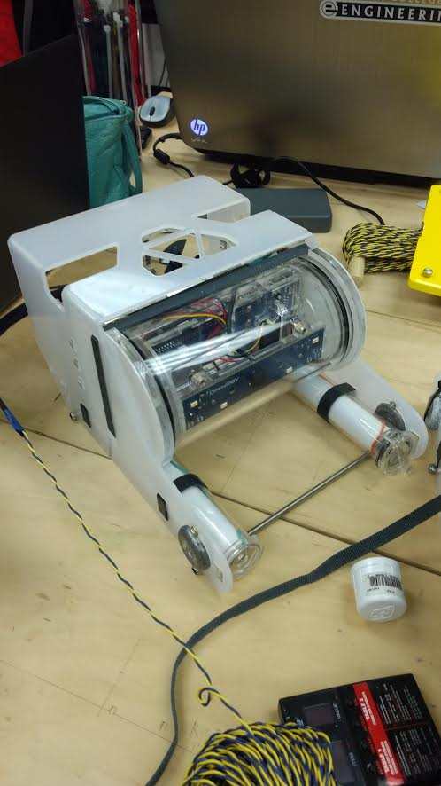

* I tested all motors, lights, camera, and laser. All parts function as expected.
  1. Meeting with Dr. Becker on Tuesday, May 30th, 2017
* Discussed goals for the week: Create a video of functioning ROVs and Surface Ship.

1. **What I need Dr. Becker to do:**
   1. Sign reimbursement forms
   2. Contact Mosquito Lab