Weekly reports are to be emailed to atbecker@uh.edu by 5:00pm on Tuesdays. The purpose of a weekly report is to: (1) give you text and images for your papers, thesis, and dissertation, (2) document progress, (3) identify if you are stuck or need resources.

Weekly report

1. **My *Goals* from last week**
   * To work on $ΔPE$ equation
   * To watch the videos
   * To work on the Mathematica file that Dr,Becker sent to me
2. **My *Accomplishments* this week**
   1. I worked on Magnetic Strength Mathematica file and I found the following:

* $ΔPE$ equation is already calculated there but I am not sure if it includes the trigger and the delivery part or not
* r directly proportional to a certain value then it becomes indirectly proportional, which added restriction on r value.
* n value depends on r value so if r value in the range of directly proportional then n is directly proportional and vise versa as the following figures: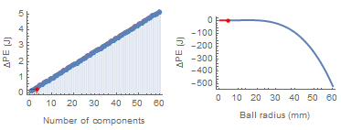

Figure 1: r value in the range of directly proportional so n is directly proportional with $ΔPE$

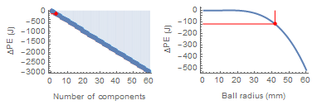

Figure 2: r value in the range of indirectly proportional so n is indirectly proportional with $ΔPE$

1. **My *Goals* for next week**
   * To find a formula that gives me the minimum value for s that required to release the balls with different r’s values
   * After finding that formula I will use it to find optimum values for a, r and n giving L
   * To meet with Julien to ask him some electromagnetic questions
2. **What I need Dr. Becker to do:**
   1. To enjoy his vacation ☺
   2. Questions for the Mathmatica file:

* Does $ΔPE$ equation includes the barrel part only or does it include the trigger and delivery parts?
  1. Is there any cost restriction for my design?
  2. Since the sphere decides the width of the Gaussian gun can I consider that also as a restriction for r value?